Winter survival and urban green space use of the northern cardinal (Cardinalis cardinalis)

Anne-Marie Cousineau

Natural Resource Sciences
Agricultural and Environmental Sciences
McGill University, Montréal

August 2025

A thesis submitted to McGill University in partial fulfillment of the requirements of the degree of Master of Science in Renewable Resources

© Anne-Marie Cousineau, Montreal, Canada, 2025

Table of Contents
Preface 4
Contribution of coauthors 5
Acknowledgements 6
Abstract 7
Résumé 7
Introduction 7
Literature review 8
Research on urbanization’s effects on songbirds 8
Habitat selection and survival of songbirds in urban areas 9
Use of very high frequency (VHF) telemetry in bird research 11
Study species and study sites 13
Knowledge gaps and research objectives 15
Chapter 1: Fine-scale movements of the northern cardinal (Cardinalis cardinalis) across urban green spaces during the non-breeding period 17
Abstract 17
Introduction 18
Materials and methods 22
Study species 22
Study locations 23
Radio tagging, banding & translocation 25
VHF tracking & automated detections 26
Habitat characteristics from open-source datasets 28
Statistical analyses 28
Results 30
Study sites urbanization level 30
Core areas and home ranges 31
Habitat selection scale 32
Resource selection: used vs. available habitats 33
Discussion 35
Wintering home range sizes 36
Habitat selection preferences 38
Conclusion 40
Chapter 2: Seasonal variation in the activity level of the northern cardinal (Cardinalis cardinalis) over the winter 42
Note on this chapter 42
Abstract 42
Introduction 42
Materials and methods 43
Study species 43
Change point analysis 44
Literature cited 46

Preface

This Master’s project was supervised by Dr. Kyle Elliott from the Macdonald campus of McGill University and by Dr. Barbara Frei from the Environment and Climate Change Canada – Science & Technologies Branch. The thesis’ purpose is to investigate how the northern cardinals are using urban green spaces during the winter season, along with their survival and activity levels through the non-breeding season. Northern cardinals are an iconic species in cities of North America, and often one of the few native and colorful bird visible year-round for people living in heavily urbanized locations. Gathering knowledge on how green spaces support resident bird species, such as the northern cardinal, can guide future greening initiatives towards practices that support urban wildlife.

This article-based thesis is divided into two chapters. First, I explored how the northern cardinals are using urban green spaces in winter using a hand-held VHF telemetry tracking device, by deploying radio-tags on cardinals. The long-term, continuous tracking of a passerine’s locations using VHF tags in an environment that is prone to high levels of interference was something that had yet to be tested as an effective method to get small-scale location data of passerine birds. Second, I investigated how the northern cardinal’s daily foraging activities are influenced by winter conditions such as cold temperatures, snow, precipitations, and more. The cardinal is one of the few birds that has been thriving in urban areas and understanding how they’re surviving the harsh conditions of winter may provide insights on how to make our cities more biodiversity friendly.

Contribution of coauthors

I designed, conducted and analyzed all experiments of this thesis with the help of Dr. Kyle Elliott and Dr. Barbara Frei, except for the initial design and collection of northern cardinal tracking data by co-author Barbara Frei during the winter of 2022 and 2023, which served as a pilot project for the first chapter. Field technicians and I collected all the GPS locations and tracking data for the northern cardinals between 2023 and 2025.

The coauthor of chapter two (Andrew Beauchamp from Western University of London – Ontario) contributed significantly by performing changepoint analyses on the data collected through the Motus receiver towers. Andrew also contributed by writing parts of the methods section regarding the processing of the Motus data. I completed the statistical analyses and wrote both chapters with the help of coauthors. I wrote both chapters and the literature review with the help of Dr. Kyle Elliott and Dr. Barbara Frei.

Acknowledgements

First, I would like to thank my incredible supervisors, Kyle Elliott and Barbara Frei, for this opportunity. I am grateful for your unwavering support, encouragement, and guidance through this project. Having you as mentors allowed me to develop valuable skills for my future as a biologist.
I also want to thank the dedicated staff and volunteers at the McGill Bird Observatory, especially Shawna Sevigny, Ana Morales, and Barbara Frei, for banding the northern cardinals, installing Motus tags, assisting with translocations over both years, and teaching me bird banding and tag deployment. Tracking cardinals over eight months was a true team effort—thank you to Mackenzie Guest, Lauren Dobie, Nathanya Goudreau, Florence Piché-Lebel, Laurianne Fallu, Elliana Tomasso, and Mathilde Lefevert for your essential help in the field. Thanks to Jean and Richard Gregson for hosting a Motus tower in their backyard.
Thank you to Concordia University for partnering on the Loyola campus tower installation, and to my committee members, Christina Davy, Carly Ziter, and Marcel Gahbauer, for their valuable feedback. I’m also grateful to my Arctic Ecology Lab mates for their constant support and advice, and to McGill University and SSHRC for funding. Special thanks to Environment and Climate Change Canada for providing 80 nanotags across two field seasons!
Finally, thank you to my family—Patricia, Gilbert, and Xi Chen—for your encouragement and patience with all my cardinal adventures.
And of course, thanks to the northern cardinals for being the best (and most feisty) work companions; these bright red birds will always have a special place in my heart.

Abstract
Winter presents a season of challenges for resident bird species in temperate areas. With lower temperatures, reduced food availability and shorter photoperiods, non-migratory birds must adjust their behaviour and energy expenditures to survive this harsh season. While many species rely on roosting strategies, behavioural flexibility and nighttime fasting, those living in urban environments are introduced to both novel challenges and opportunities. Urban areas provide microclimates acting as refuges and reliable anthropogenic food sources, yet they also bring exposure to habitat fragmentation, pollution artificial lights, and more. Some species are doing better than others in the urban landscape and learning more about the winter ecology of resident birds can provide us with valuable knowledge to design and improve urban green spaces in a way that benefits people and birds, year-round.
In my first thesis chapter, I examined the fine-scale space use of the northern cardinals (Cardinalis cardinalis) across three urban green spaces of varying levels of urbanization during the non-breeding season in Montreal, Canada. Using VHF telemetry, I tracked individual cardinals to evaluate how landscape structure and environmental conditions, such as road density, access to bird feeders and vegetation structure, influence movement patterns and habitat use. My findings show that cardinals select their habitats at a smaller scale (25 m radius) when human presence was more pronounced, compared to a larger scale in our less urbanized location (50 m radius). We have also found that the birds spending winter in our most urban location had on average, home ranges about three times the size of the birds spending winter in less urbanized locations. And finally, I showed that the cardinals select for different features of their habitats, depending on the level of urbanization of the site they’re spending their winter in. These results underscore the importance of small-scale urban green space design and winter resource availability for supporting resident bird populations in urban settings.
In my second chapter, I focused on daily activity patterns of northern cardinals in three urban locations in Montreal, Canada. We tracked the daily activity of the same individuals in chapter 1, this time pulling data from the Motus Wildlife Tracking System. All the study locations had receiver towers continuously recording the signal strength of the VHF tags we deployed for chapter 1. A Change point analysis was performed to precisely identify the moment birds begin their daily activities, along with the time they end said activity. We have used publicly available meteorological data to investigate how the cardinals adjust their winter foraging behaviour to temperature, snow on the ground, precipitation and consecutive days of cold weather. We have found that, across three years of data collected, cumulative lag effects of weather seem to have a stronger explanatory power compared to same-day conditions. We have also found that precipitations have an important, but non-linear effect on both the onset and end of the birds’ activities, while the amount of snow on the ground seems to have a strong and linear effect for the end of the bird’s activity period, with the birds ending their active period earlier as the amount of snow on the ground increases. These findings highlight the behavioural flexibility of northern cardinals towards rough climatic conditions in winter, which may play a crucial role in its winter survival and thriving in urban areas. In summary, my thesis contributes to a growing understanding of how winter resident birds navigate the complex interactions between the urban landscape and the extreme seasonal variations of a temperate region’s climate.

Résumé
L’hiver représente une saison de défis pour les espèces d’oiseaux résidents des régions tempérées. Avec des températures sous zéro, une disponibilité réduite de nourriture et une photopériode raccourcie, les oiseaux qui ne migrent pas doivent adapter leur comportement et dépenses énergétiques pour survivre à cette saison rigoureuse. Si plusieurs espèces comptent sur des stratégies d’agrégation, sur la flexibilité comportementale ou sur le jeûne nocturne, celles vivant en milieu urbain sont confrontées à la fois à de nouveaux défis et à certains avantages. Les milieux urbains offrent des microclimats plus cléments, pouvant servir de refuges et de source d’alimentation stable (via les humains), mais ils exposent aussi les oiseaux à la fragmentation d’habitat, à la pollution, à l’éclairage artificiel, etc. Certaines espèces s’en sortent mieux que d’autres, particulièrement en ville, et mieux comprendre leur écologie hivernale peut nous fournir des connaissances utiles pour concevoir et améliorer les espaces verts urbains afin de favoriser le bien-être des oiseaux, et celui des humains, toute l’année.
Dans le premier chapitre de ma thèse, j’ai examiné l’utilisation de l’espace à fine échelle par le cardinal rouge (Cardinalis cardinalis) dans trois sites aux niveaux d’urbanisation différents à Montréal. À l’aide de la télémétrie VHF, j’ai suivi plusieurs individus pour évaluer comment la structure du paysage et les conditions environnementales — telles que la densité routière, l’accès aux mangeoires et la structure verticale de la végétation — influencent leurs déplacements et l’utilisation de l’habitat. Mes résultats montrent que le cardinal sélectionne son habitat à une plus petite échelle spatiale (rayon de 25 m) dans les milieux plus urbanisés, comparativement à une échelle plus large (rayon de 50 m) dans les sites moins urbanisés. De plus, les oiseaux hivernant dans le site le plus urbanisé présentaient, en moyenne, des domaines vitaux trois fois plus grands que ceux des oiseaux en milieux moins urbanisés. Enfin, j’ai démontré que le cardinal sélectionne différentes composantes de son habitat selon le degré d’urbanisation. Ces résultats soulignent l’importance de la conception à petite échelle des espaces verts urbains et de la disponibilité des ressources hivernales pour soutenir les populations d’oiseaux urbains.
Dans le second chapitre, je me suis intéressée aux patrons d’activité journalière du cardinal rouge dans trois sites urbains de Montréal. J’ai suivi l’activité journalière des mêmes individus que dans le chapitre précédent, cette fois à l’aide du système automatisé Motus Wildlife Tracking System. Tous les sites étaient équipés de tours réceptrices enregistrant en continu la force du signal des émetteurs VHF installés au chapitre 1. Une analyse des points de changement a permis d’identifier les moments où les oiseaux débutaient et terminaient leurs activités quotidiennes. Des données météorologiques publiques ont été utilisées pour examiner comment le cardinal ajuste son comportement d’alimentation en hiver selon la température, la neige au sol, les précipitations et les jours consécutifs de froid. Nous avons constaté que les précipitations ont un effet important, mais non linéaire sur le début et la fin des activités, tandis que la neige influence de manière linéaire la fin de journée : les oiseaux terminent plus tôt quand la neige est abondante. Ces résultats mettent en valeur la flexibilité comportementale du cardinal face aux conditions climatiques hivernales, une adaptation qui pourrait jouer un rôle clé dans leur succès en milieu urbain. En résumé, ma thèse contribue à mieux comprendre les stratégies utilisées par les oiseaux résidents pour composer avec les interactions complexes entre le paysage urbain et les variations saisonnières du climat tempéré.

Introduction

Literature review

Research on urbanization’s effects on songbirds
Urbanization significantly alters the landscape and its composition. Songbirds can be particularly vulnerable to urban development that often reduce species richness while increasing the density of only a few successful species (Seress & Liker, 2015). Nonetheless, cities can present both opportunities and challenges to the avifauna (Isaksson, 2018). Heavily urbanized areas can provide year-round food through bird feeders and human waste while simultaneously providing shelter against some predators that may not be as tolerant to human presence (Eötvös et al., 2018; Liker et al., 2008). In some specific cases, urbanization positively impacted some bird guilds, such as the granivorous and terrestrial species, whose richness increased in human-impacted habitats of Loja, Ecuador (Ordóñez-Delgado et al., 2022).
On the other hand, significant challenges also arise for bird communities using urban areas. Habitat loss and fragmentation can negatively affect birds’ communities and genetic diversity (Palacio et al., 2018; Rodrigues et al., 2018; Shanahan et al., 2014). Research conducted in urban areas of South America has shown that urbanization can act as a filter, favoring certain bird species with specific traits, leading to changes in both the birds community composition, but also in the genetic diversity within a single species (Palacio et al., 2024; Rodrigues et al., 2018). Pollution in various forms in heavily urbanized areas can also affect avian health. Organic compounds can occur in high concentrations due to their use in housing, industrial processes and during the production of a wide range of goods (Kekkonen, 2017). Such compounds affect a multitude of organisms, including birds, which can suffer from reduced clutch sizes, hormonal disturbances, reduced active parenting behaviours and more (Kekkonen, 2017). One example of such substance is polybrominated diphenyl ethers (PBDEs), a brominated flame retardant widely used in many countries to reduce the flammability of consumer products (Chen & Hale, 2010). Because the use of PBDE is highly related to human goods, birds living in or around urbanized areas are often found to be highly contaminated with PBDEs (Elliott et al., 2005, 2015). Light pollution emanating from large urban centers affects migratory and resident bird species. Resident bird species residing in urban-core areas had smaller eyes than their urban-edge counterparts, most likely due to the intense brightness from urban centers (Jones et al., 2023). For long-distance migratory bird species, light pollution can have detrimental effects such as disorientation, disruption of circadian rhythm, changes in flight behaviours and more (Cabrera-Cruz et al., 2018).
When environmental conditions are changing (including via rapid human-induced changes), behavioural traits are often one of the first displayed responses (Lane et al., 2023). For example, males of several songbird species show more aggression in urban habitats compared to their rural counterparts (Lane et al., 2023). Anthropogenic disturbances found in the city may also affect incubation behaviour, a critical life stage not only for the parents, but also for the success of the offspring (Hope et al., 2022; Lane et al., 2023). A study comparing two types of urban development (land-sparing against land-sharing) in European cities found that for ground nesting birds, predation pressures were the highest in land-sharing areas (small, fragmented green areas with low density housing), resulting in a decrease of nest survival (Jokimäki et al., 2020). Urban great tits (Parus major) spent more time incubating, took shorter off-bouts and ended their last nest outing later during the day, compared to the females incubating in the forest (Hope et al., 2022). Population dynamics and gene flow can also be affected by urbanization, as habitat fragmentation is a major side effect of humans’ increasing needs for land and resources (V. N. Brewer et al., 2020). Although these effects can negatively impact gene diversity in songbirds’ populations, Brewer and her team showed that there seems to be an existing threshold, as low-intensity urbanization didn’t have as strong an impact on the genetic diversity of song sparrows (Melospiza melodia) as initially anticipated (V. N. Brewer et al., 2020). These findings highlight the importance of greening in urban areas to counteract the effects of habitat fragmentation on birds’ genetic diversity.
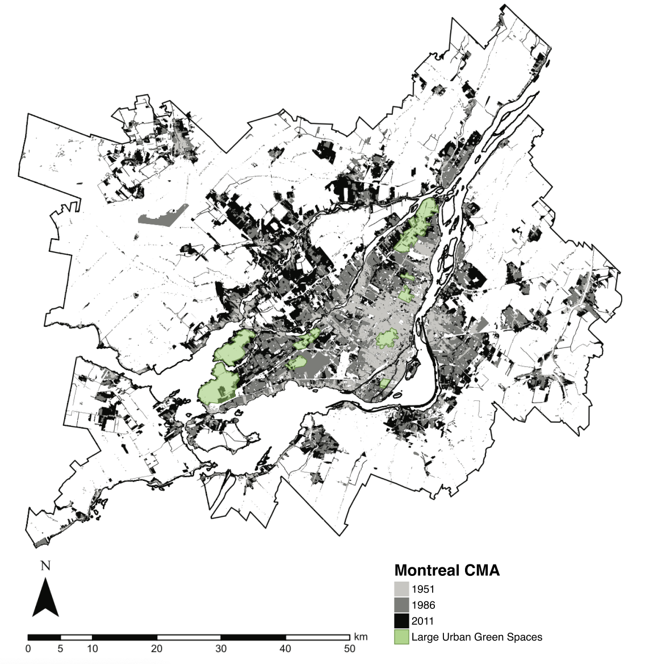
Figure 1. This map was adapted from figure 4, published in a paper by Nazarnia et al. in 2016. It was reproduced under fair dealing for the purpose of research and education only. The map shows the built-up areas in the Montreal CMA (Census Metropolitan Area), in 1951, 1986 and 2011 (Nazarnia et al., 2016). Added in green are the few large urban green spaces left on the island of Montreal.

Habitat selection and survival of songbirds in urban areas
Habitat selection by songbirds in urban environments is influenced by a complex network of ecological and anthropogenic factors. Patch size and habitat fragmentation, which have been shown to directly affect the availability and quality of resources for birds, are among the most widely studied variables. Vegetation composition—including plant species diversity and the physical vertical structure—also plays a significant role in determining habitat suitability, particularly for foraging, shelter and nesting. When creating and managing urban green spaces, stakeholders have to consider the area-heterogeneity trade-off (Chiron et al., 2024). This trade-off stems from the fact that increasing landscape heterogeneity can inadvertently reduce patch sizes for individual habitat types, potentially disadvantaging specialist species (Chiron et al., 2024). Evidence from southern Ontario, Canada, confirmed that area (size) and natural vegetation (in opposition to horticulturally managed parks) within the urban landscape are of great importance to winter birds such as the northern cardinal (Cardinalis cardinalis), downy woodpecker (Dryobates pubescens), black-capped chickadee (Poecile atricapillus) and white-breasted nuthatch (Sitta carolinensis) (Smith, 2007). While it can be challenging to try and create new green corridors through a city, a New Zealand study revealed that the conversion of roofs in urban areas to green roofs supporting birds could improve native birds’ dispersal through the urban landscape (MacKinnon et al., 2023).
In addition to landscape structure, resource availability, and climatic conditions can significantly influence winter survival and habitat occupancy. For instance, supplementary feeding in urban environments has been linked to non-adaptive behavioural strategies and reduced apparent survival in Great tits, highlighting the potential trade-offs of human-provided resources (Krama et al., 2023). Moreover, temperature dynamics are likely to affect winter distributions: northern cardinals were more likely to colonize sites that were warmer relative to the previous year, especially in forested areas (Latimer & Zuckerberg, 2021). Interestingly, while some other common urban species like the House Sparrow and the American Goldfinch show resilience to urban cold, others like the northern cardinal and the American tree sparrow demonstrate cold-driven colonization, suggesting species-specific thermal strategies (Latimer & Zuckerberg, 2021). Winter represents a period of acute and chronic energetic stress for small passerines, particularly in northern latitudes.
Birds must balance reduced food availability and shorter foraging windows, along with an increased thermoregulatory demand during longer, colder nights (Petit et al., 2017). Physiological adaptations, such as the elevated heart rate observed in Eurasian blackbirds during colder temperatures could help preserve energy (Linek et al., 2021). Small passerine birds spending winter at higher latitudes are required to display optimal energy management in a multifaceted way to survive through the harsh conditions (Andreev, 1999; Brodin, 2007; Petit et al., 2017). In addition, weather severity, including extreme wind events, has been linked to increased mortality in wintering seabirds (Louzao et al., 2019). This may also be especially relevant in urban settings, where wind tunnel effects created by buildings can amplify exposure to harsh microclimates (Kamei & Maruta, 1979).

Use of very high frequency (VHF) telemetry in bird research
Telemetry tracking in wildlife research can be defined as a group of techniques used to remotely acquire information (geographical, physiological, environmental, etc.) on animals equipped with various data-collecting devices (Rodgers, 2001; Thohari, 1989). Such devices include the use of VHF/UHF (Very High Frequency and Ultra High Frequency) units, store-on-board units, GPS (Global Positioning System) units and GSM (Global System for Mobile Communication) units, among others. These technologies have significantly improved recently, particularly in satellite telemetry, where animal movements can be tracked with high success rates (Hofman et al., 2019). Moreover, the size and weight of these devices are continuously decreasing as the technology around them improves (smaller batteries with longer runtime, increased memory storage, increased use of microcomputers, etc.), generating many possible applications in the field of wildlife conservation (Hofman et al., 2019).
Some of the earliest published papers mentioning the use of tracking devices to study birds can be traced back to the 1960s. However, it was during the 1990s that telemetry tracking gained a strong interest from ornithologists. Using such devices allowed researchers to acquire valuable information on birds’ movements, behaviours and physiology without the need to restrain the individuals (Harris & Fish, 1990). Radio telemetry, for example, can provide helpful information on birds’ migratory movements, stopover sites, breeding and non-breeding grounds, and local movements (Fuller et al., 2005). This data can be extremely valuable when dealing with cases of avian disease affecting migratory birds and livestock (Fuller et al., 2005). Digital telemetry systems such as Encounternet can also provide more detailed information that can be used to study birds’ behaviour (Mennill et al., 2012). The long-term use of portable receiver stations and digital tags allows researchers to investigate birds’ social behaviours (such as social networks) and reproductive behaviours (such as Lekking and parental care) (Mennill et al., 2012).
This research project will rely heavily on VHF radio-tracking devices for data collection. VHF radio-tracking tags are a particular type of logger that does not record any location data. As the name suggests, they emit a very high-frequency radio signal that can be picked up by receiver stations or hand-held receiver devices. Researchers need to use an antenna and a receiver to get as close to the bird as possible before using a hand-held GPS device to record the location. This is probably the main disadvantage of using VHF radio tags: it’s labour-intensive as it requires the researchers to be within a certain range of the tagged bird to get a precise location (Iverson et al., 2023). Because this type of tag doesn’t include solar panels or devices to record GPS location, they can be extremely small. For example, Lotek’s Nanotags for birds and bats NTQB2-1 weighs only 0.28 grams with a maximum life expectancy of approximately 103 days (www.lotek.com). VHF radio tags are also generally less expensive than other loggers, meaning researchers can have a greater sample size for the same budget. Historically, VHF trackers have been successful at revealing fine-scale movements of birds, such as habitat use and home range sizes (D. E. Brewer et al., 2023; Naguib et al., 2022; O’Connell et al., 2023). It is important to note that the success of using VHF radio trackers at a small scale is dependent on the presence of receiver towers within the vicinity of the marked individuals, along with the researchers ' capacity to have access to the individuals in the field. Getting valuable fine-scale data on tracked birds is possible but highly labour-intensive as the researcher needs to get close enough to the bird to be able to pick up its signal. On the other hand, in areas of the world where there’s an extensive network of receiver towers (such as the Motus Wildlife Tracking network in North America), the use of VHF radio trackers can provide valuable information for long-distance monitoring, such as migration routes and stopover sites.
Although biologgers and tags can provide valuable information, but it’s important to recognize the negative impacts they can have on the organism they’re equipped to.

Study species and study sites
The northern cardinal is a resident bird species that is abundant in many areas of eastern North America (Halkin et al., 2021). It can be found year-round in southern Canada all the way to southern Mexico (Halkin et al., 2021). Northern cardinals have been expanding their range northward since the 1800s, and they can be characterized as urban-tolerant birds that thrive in inhabited areas (Halkin et al., 2021; Robert et al., 2019). The first reported sightings of northern cardinals in Quebec ca be traced back to 1862, when a bird was reportedly captured in Montreal (Robert et al., 2019). A few years later, in 1969, another specimen was caught in Quebec city (Robert et al., 2019). After that, it will take 73 years for another northern cardinal to be recorded in the region (in 1942) and another 14 years for two male cardinals to be spotted in Montreal again (Robert et al., 2019). Finally, 1956 will mark the official beginning of the establishment of the northern cardinals in Quebec, as they’ll be observed every year from now on in the Montreal area (Robert et al., 2019). In southern Quebec, the cardinals are strongly associated with urban and agricultural areas, along with mature deciduous forests, while being rarely found at elevations above 200 meters (Robert et al., 2019). Cardinals have been shown to be 1.7 to 4 times more abundant in urban forests compared to rural ones (Leston & Rodewald, 2006). In a thesis on the reproductive timing of passerine in urban areas conducted in Ohio, the researcher found that the apparent annual survival rate of adult northern cardinals can be estimated to range from 50.5% $±$ 10.3 SE to 78.3% $±$ 7.6 SE (Shustack, 2008). The principal causes of mortality for the cardinals are not well documented, with information on exposure to contaminants, disease and parasites, interspecific and intraspecific competition still fairly unknown (Halkin et al., 2021). Despite this lack of information, it’s possible to assume that predation by raptors, domestic cats and window collisions play an important role in the survival of the northern cardinal (Lopes et al., 2024; Panchana et al., 2025; Tryjanowski et al., 2024). In Tennessee and Iowa, breeding of cardinals can begin as early as April (and in some cases even if there is still snow on the ground), with nest building lasting approximately 2 to 3 weeks and first eggs laid at the end of April or beginning of May (Halkin et al., 2021; Robert et al., 2019). Nest predation for the northern cardinals tends to be quite high, averaging 70% in the early season, with improving success as the breeding season progresses (DeVries & Jawor, 2013; Filliater et al., 1994; Linville et al., 1998). For this reason, cardinals often have a second nest and brood later in the season, with reports of recently fledged young as late as August and September (Laskey, 1944).
The three study locations in this study are within the island of Montreal, the second largest city in Canada (Government of Canada, 2022). The first study site is the McGill Bird Observatory (MBO), a migration monitoring banding station based in Sainte-Anne-de-Bellevue on the western tip of the island (45.43˚N, 73.94˚W), more specifically in the Stoneycroft Wildlife Area, part of the MacDonald campus at McGill University (Gahbauer et al., 2015). MBO was founded in 2004 by graduate students at McGill University and is now operated by the Migration Research Foundation (MRF) (Gahbauer et al., 2015). This banding station is the only one active in southwestern Quebec and also serves as a training facility for students who wish to enhance their skills in field ornithology (Gahbauer et al., 2015). The area covered by MBO is mainly composed of mature and immature forest, wetlands and agricultural fields (Poirier et al., 2024). This study site serves as a control location with minimal human presence. The second location used in this research is the Baie d’Urfé residential area, next to the MacDonald campus of McGill University. It’s located south of MBO near the Saint-Lawrence River (45.41˚N, 73.92˚W). This area was selected as an intermediate urbanized location, as human presence is more pronounced compared to MBO, while remaining one of the greenest neighbourhoods of Montreal. The final study site selected for this project is situated in Notre-Dame-de-Grâce, close to the Concordia University Loyola campus (45.46˚N, 73.64˚W). This site serves as the most urbanized location out of the three sites selected, with a higher average population density.
These three study sites reflect different types of environments a bird may encounter in a large city. It has been shown that fragmentation, heat island effect, noise pollution and loss of habitats can constitute significant challenges for urban birds, and these may be even more challenging when the rough winter weather hits Montreal. Understanding how a resident bird species can use, move and survive across those different types of landscape is crucial to move towards greening efforts that are biodiversity-friendly.

Knowledge gaps and research objectives
Although a considerable body of research has explored the effects of urbanization on bird communities, significant knowledge gaps remain regarding fine-scale, winter-specific movement behaviours of urban-tolerant passerines like the northern cardinal. While urbanization has been linked to changes in behaviour, habitat selection, survival and gene flow, there is a lack of detailed studies examining how individual birds use urban green spaces during the whole non-breeding season at a fine spatial and temporal scale. Most previous work has relied on coarse-resolution data or presence-absence metrics, limiting our understanding of how resident birds interact with habitats or anthropogenic features during periods of heightened energetic stress, such as winter.
In addition, while VHF telemetry has been widely used to monitor birds’ movements, its application has mostly focused on breeding or migratory periods. Studies investigating how resident passerines navigate through fragmented landscapes in winter using manual, ground-based VHF telemetry remain scarce, particularly in northern urban centers where winter conditions and urban microclimates can be quite harsh for the birds. Understanding these dynamics is crucial, especially as climate change and urban expansion continue to reshape winter conditions and resource availability in cities. Thus, the objective of this study is to use fine-scale VHF telemetry data to characterize the space use patterns and habitat preferences of the northern cardinal across three urban locations with varying levels of urbanization on the island of Montreal. By comparing movements with habitat use and proximity to anthropogenic features, this research aims to:
- Quantify winter home range sizes in relation to urban gradient;
- Assess the influence of specific urban features (e.g., bird feeders, population density, etc.) on habitat use;
- Examine potential differences in movement behaviour and space use across sites;
- Assess winter energy expenditure variations according to local climate;
- Inform future conservation planning for urban-tolerant resident birds.
This study seeks to bring novel insights into how individual birds behave within the urban ecosystem during a challenging life-history stage and to inform the planning, design and management of urban green spaces that support wintering bird populations.

Chapter 1: Larger winter home ranges in urban than peri-urban sites for a very short distance migrant, the northern cardinal (Cardinalis cardinalis)

Note on this chapter

Abstract
Urban green spaces (UGS) are critical for maintaining biodiversity and supporting wildlife, especially in heavily urbanized environments. In temperate regions like southern Quebec, winter brings significant challenges for resident bird species, yet little is known about how birds respond to urbanization during the non-breeding season. This study investigates the fine-scale movements and habitat selection of northern cardinals (Cardinalis cardinalis) across three locations in Montreal with varying degrees of urbanization. Using VHF telemetry, manual GPS tracking, and open-source environmental data, we quantified home range sizes, habitat selection scale and assessed habitat preferences across gradients of vegetation structure, road density, human population density, and proximity to bird feeders. We found that cardinals in the most urbanized location exhibited significantly larger home ranges, suggesting larger movement requirements in fragmented habitats. Habitat selection patterns varied across sites: in less urbanized areas, birds selected for vertically complex vegetation and proximity to feeders, while in more urbanized areas, selection was more influenced by anthropogenic features such as road length and proximity to bird feeders. These results indicate that northern cardinals display behavioral plasticity in response to urban environments and highlight the importance of adapting conservation strategies to local urban contexts. As cities expand, understanding these fine-scale ecological responses will be key to designing biodiversity-friendly UGS that support both wildlife and human well-being throughout the year.

Introduction
Urbanization is a global phenomenon that keeps on increasing at a rapid pace (Elmqvist et al., 2013; Simkin et al., 2022; Wang et al., 2012). It’s a process that dramatically alters the landscape, bringing novel challenges to wildlife (Lowry et al., 2013). Some examples include habitat fragmentation, habitat loss, chronic exposure to contaminants, and more (Murray et al., 2019; Seress & Liker, 2015; Vaz et al., 2023). As shown in recent work by Li and collaborators, future global urban expansion projections could lead to 11 to 33 million hectares of natural habitat loss by 2100, as well as cause a disproportionately large increase in habitat fragmentation (G. Li et al., 2022). They stress that this massive urban land conversion may lead to a 34% decline in local within-site species richness (G. Li et al., 2022). In recent years, international institutions and governments have recognized the value of creating and preserving urban green spaces (UGS). The 2022 Convention on Biological Diversity adopted the Kunming-Montreal Global Biodiversity Framework and introduced 23 global targets to be reached by the year 2030 (Stephens, 2023). Target 12 precisely touches on that matter by stating that there’s a need to “significantly increase the area and quality, and connectivity of, access to, and benefits from green and blue spaces in urban and densely populated areas” (Stephens, 2023, p. 880). Numerous studies have investigated the benefits that humans living in urbanized areas can get out of UGS. They include improved mental health, access to clean air from pollution removal by trees, cooling effects during heatwaves, and much more (Buxton et al., 2024; Cox et al., 2017; Jim & Chen, 2008; Skarbit et al., 2024). Access to UGS of high biodiversity brings greater restorative benefits for people, regardless of socio-economic variables like age or ethnic background (Wood et al., 2018). While there are multiple benefits to greening cities, it is important to highlight the challenges faced by urban planners, such as the paradox between greening and gentrification. As efforts are deployed to increase access to urban green space to address health and environmental issues, neighbourhoods become healthier, more aesthetically pleasing, increasing property values and housing costs (Wolch et al., 2014). Urban greening is complex and involves trade-offs – including issues of gentrification, cost and ecological impact – but advancing knowledge in this area remains essential to move towards biodiversity-friendly green spaces that also support human well-being.

Not only are UGS extremely valuable for humans, but they are also crucial for the survival of urban wildlife. Urban forests can host shrub-nesting bird species during the reproduction season, while wintering birds rely on those UGS to survive through the harsh conditions of the non-breeding season (Kelly & Amanda, 2006; Rousseau et al., 2015). UGS also provide a wide range of benefits for the birds that find themselves in the middle of the complex urban landscape. Previous work has shown that a lot of the urban bird species can be supported by interacting with 0.1-0.35 km2 of continuous green space, while forest birds (generally trying to avoid urbanized areas) require larger areas (Chamberlain et al., 2007). What is interesting, however, is that adding just a little bit of additional green space to neighbourhood parks can considerably increase bird species richness. These smaller UGS are nonetheless important as they generate “stepping-stone” habitats that allow for highly mobile species like birds to navigate more easily through the urban matrix (DONNELLY & MARZLUFF, 2004).

Being incredibly mobile animals, birds are especially vulnerable to the challenges that urban areas impose. Over the past five decades, numerous bird species in Canada have experienced a significant decline in their populations (The State of Canada’s Birds Report, 2024). Amongst those groups, urbanization is often cited as a negative factor impacting bird populations (The State of Canada’s Birds Report, 2024). Indeed, numerous studies have highlighted the novel threats that birds are facing in the city: increased risk of collision with manmade structures (Chace & Walsh, 2006), acute predation by domestic cats (Seress & Liker, 2015), nesting disturbances (Bocz et al., 2017), and more. During the breeding period, UGS can provide birds with suitable nesting locations that are also food sources (Cull et al., 2025; Fernandez-Canero & Gonzalez-Redondo, 2010; K. Li et al., 2025). During the winter season, those same spaces can then provide shelter from the cold weather and potential predators (Marlès Magre et al., 2019; Šálek et al., 2024).

In Canada specifically, urban sprawl in major cities such as Montreal, Toronto and Vancouver is a phenomenon in constant expansion (Dupras & Alam, 2015; Filion et al., 2010; Furberg & Ban, 2008). Forest patch size tends to decrease as urbanization increases, leading to a reduction of the ecosystem services associated with those green spaces (Mitchell & Devisscher, 2022). For birds, this often results in an increased cost to travel between patches, lower resource availability and fewer sheltering opportunities. In addition, winters in Canada subject birds to prolonged cold weather periods, adding significant energetic stress for resident birds (Dawson et al., 1983; Swanson & Vézina, 2015). The importance of greening initiatives in heavily urbanized areas is not only crucial for the community experiencing the benefits of urban green spaces, but also for the birds and the wildlife that depend on it to survive even the harsh winters of southern Canada. In the last few years, the city of Montreal has been a leader in its efforts towards urban greening initiatives. The city adopted its Climate Plan 2020-2030 and through it is committing to plant, maintain and protect 500,000 trees, create new parks, green corridors and wetlands, restore shorelines and increase the size of protected areas so they cover 10% of the land within the city limits (City of Montreal, 2020). In the most recent progress report, the city states that as of 2023, approximately 180,000 trees were planted, and 7.6% of the land is categorized as protected and contributing to preserving biodiversity (City of Montreal, 2024). This highlights that while progress is being made, greening efforts need to ramp up in the next few years for the city to reach its goals, meaning that there’s a need to build knowledge on efficient ways to create and restore urban green spaces in a way that’ll promote biodiversity in the city.

While habitat use by breeding birds in urban environments has been well documented, much less is known about fine-scale movement patterns and habitat selection during the non-breeding season at higher latitudes, especially in relation to urbanization. There’s a lack of detailed understanding of how particular variables of the urban environment influence winter season survival and movement in resident bird species. This knowledge gap is especially relevant in temperate regions like southern Quebec, where winter poses extreme challenges for small passerines like the northern cardinal.
We have identified three main hypotheses to investigate through this research:
- If the northern cardinals have to move more often and on greater distances to sustain themselves in urban areas, and their fine-scale movements are recorded through the winter in locations with varying levels of urbanization, then a positive correlation between their average home range size and the urbanization level will be revealed.
- If the northern cardinals spending the winter in urban areas have access to highly fragmented green spaces, and their fine-scale movements are recorded during the non-breeding season in sites with varying levels of urbanization, then the results should show a positive correlation between the scale at which the birds are selecting their habitats and the urbanization level.
- If the northern cardinals are selecting wintering grounds with a complex canopy stratification, and their fine-scale movements are tracked in areas with known vegetation vertical structure, then a positive correlation between the probability of selection of the habitat and the complexity of the canopy stratification should emerge.

Materials and methods

Study species
To answer those questions, we have selected the northern cardinal as being the most suitable species for this type of project. It’s a resident bird in southern Quebec, meaning that it will spend the whole winter season around the Montreal area. It’s also fairly large songbirds (weighing between 42 to 45 grams), which allows for the deployment of radio tags that are large enough to have a battery life that should span the whole duration of the non-breeding period. Finally, the northern cardinal is very well adapted to urban life. They should thus be able to survive and thrive across all of the selected study locations as part of this project. In southern Quebec, the northern cardinal population has seen a steep increase in abundance initiated around the 1970s. The same trends have been reported in southern Ontario, as shown in Figure 1. This expansion of the northern distribution of the cardinal is largely attributed to the increase of people putting out bird feeders on their property, along with increasing winter temperatures, making it easier for the cardinals to remain in the northern part of their distribution range year-round.
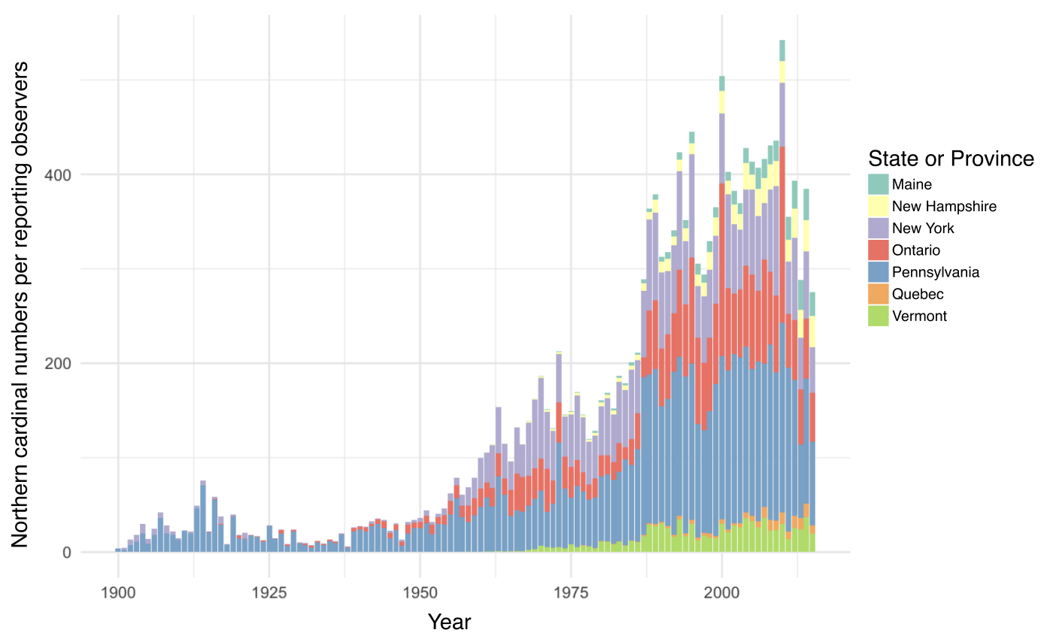
Figure 2. Number of northern cardinal observations per reporting observers by year and state (United States of America) or province (Canada). This chart shows the number of northern cardinals counted by year per observer from Audubon’s Christmas Bird Count. The state or province of the number of cardinals observed is also shown within each year using different colours. There is an overall increasing trend in the number of observations until approximately 2011, and the individual subnational regions mostly increase as well before that time. In Quebec specifically, early sightings can be seen after 1975 and steadily increase thereafter.

Study locations
This research was conducted in three study sites with varying levels of urbanization. Each study site includes two distinct release locations, which were randomly assigned to the individuals. The first study site is at the McGill Bird Observatory (MBO), located on the western end of the island of Montreal (45˚25’51.4”N 73˚56’18.5”W). The MBO site serves as our less urbanized location out of the three, being part of the 30 km² of the Grand parc de l’Ouest. The second study site is in the residential neighbourhood of Baie d’Urfé (BDU) and is considered to have an intermediate level of urbanization (45˚24’39.2”N 73˚55’50.0”W). The final study site is in the Notre-Dame-de-Grâce neighbourhood in Montreal, close to Concordia University’s Loyola campus (45˚27’35.7”N 73˚38’30.2”W). This sector is the most urbanized of the three locations considered for this study. Since the northern cardinal can be found in all three regions, we assumed that the translocated birds would be able to survive and thrive at each selected site.
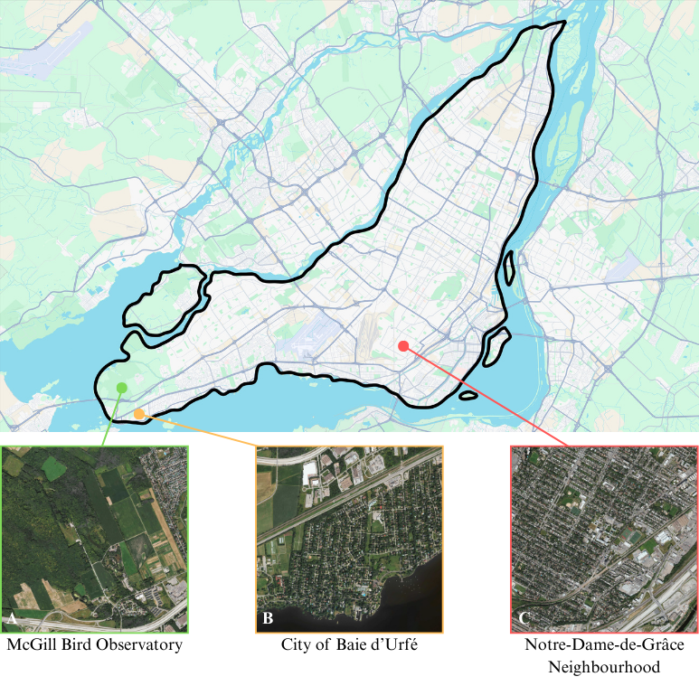
Figure 3. Study locations on the Island of Montreal A) The McGill Bird Observatory (MBO) served as the less urban location out of the three (2% of the area covered by streets and/or roads). It’s located in Sainte-Anne-de-Bellevue on the West side of the island. B) The residential area of Baie d’Urfé (BDU) served as an intermediately urbanized location (5% of the area covered by streets and/or roads). C) The last study site is near Concordia University (CON) in the Notre-Dame-de-Grâce neighbourhood and served as the most urban location (13% of the area covered by streets and/or roads).

Radio tagging, banding & translocation
We netted northern cardinals (males and females) at the MBO during October and November of the year 2022, 2023 and 2024. The birds were intercepted using 30 mm Japanese Nylon nets and placed in small cotton bags to reduce stress before handling. As part of the migration monitoring being done at the MBO, we banded the cardinals with a numbered aluminum band. The individuals were sexed, aged, weighed, and randomly assigned to one of the six possible release sites for translocation by car. In addition to the aluminum band, we fitted the cardinals with a set of coloured plastic bands, each with a unique combination of colours. This allowed visual identification of the individuals without having to resort to a radio tag receiver. Each bird was equipped with a Lotek NanoTag (NTQB-2) weighing 0.8 grams, using soft elastics in a figure 8 harness configuration (the total weight of the tag, harness, and glue was less than 3% of the cardinals’ body weight). All the radio-tags were registered as part of the Motus Wildlife Tracking System (Frei et al., 2024). northern cardinals translocated to the MBO and BDU locations underwent a holding time of 45 minutes before release to standardize treatment amongst individuals. For the winter of the year 2022-2023 (winter 1), we were able to consistently track 20 birds at MBO, which served as a pilot winter to assess the feasibility of the project. During the winter of 2023-2024 (winter 2), a total of 45 birds were tagged and banded, with 15 individuals relocated to CON, 15 relocated to BDU and 15 relocated to MBO. In 2024-2025 (winter 3), a total of 42 birds were tagged and banded, with 5 individuals relocated to MBO, 16 individuals released in BDU and 21 individuals released at CON. All birds were handled with appropriate permits (#####, Scientific permit to capture and band migratory birds 10973 D).

VHF tracking & automated detections
During the first winter, only 2 automated receiver towers from the Motus network were deployed. The first tower is located at the MBO (4525’50.4”N 73˚56’18.6”W), while the second tower is located on top of a faculty building at McGill University’s MacDonald campus (45˚24’28.3”N 73˚56’20.3”W). For the second winter, those two towers were also used for continuous data location, with the addition of a third temporary receiver tower that we installed in BDU (45˚24’39.3”N 73˚55’48.3”W). Finally, during the third winter, a fourth, permanent Motus tower was installed on top of a building at Concordia University’s Loyola campus location (45˚27’32.6”N 73˚38’30.2”W). While these automated receiver towers can detect the presence of the cardinals, they do not record precise GPS locations. We conducted manual radio tracking of each individual as often as possible (approximately once or twice a week) between the months of October and May using a set of portable receivers and antennae. Trackers would cover as much ground as possible at each study location with the goal of recording at least one GPS location for each individual per week using a Garmin ETREX 22x GPS. The portable receivers were either Lotek’s SRX800 or SRX1200. They were operated by setting the frequency to 166.380 MHz (Motus tags’ frequency for the Western hemisphere) and using both the gain and the signal strength to get as close as possible to the tagged individuals. The gain is a value between 0 and 100, representing the amplification of the received signal. By increasing it, the tracker increases how sensitive the receiver is to incoming radio signals. Higher gain values increase the ability to detect weaker signals but are also subject to background noise and interference. Using a lower gain reduces noise but may result in missing weak signals. In urbanized locations, the starting gain will rarely surpass 70-80 as the receiver picks up too much noise and interference. The signal is a value ranging from 0 to 200 for the SRX800 and 0 to 250 for the SRX1200. It represents the strength of the detected transmission from a radio tag, displayed in decibels (dB) on the receiver. A stronger signal indicates that the bird is closer; trackers use this information to estimate distance and direction. Trackers begin their tracking sessions with a gain of 80-70 to increase their chances of detecting nearby individuals. Once the receiver picks up a cardinal’s tag, the tracker moves toward the direction with the strongest signal. Once a threshold of 150 dB (SRX800) or 200 dB (SRX1200) is attained, the trackers then lower the gain by 10 and repeat this process until they reach the tagged individual. The trackers only record a GPS point if the signal strength is 150 or 200 dB, with a gain of 40 or less (the bird is considered close enough when those conditions are met). Once close enough to the bird, a few additional environmental measurements are collected. The wind speed (km/h), current temperature (˚C), along with the angle at which the antenna was pointing (˚) are all collected using free and publicly available smartphone applications. We assessed cloud coverage, with 100% meaning the clouds were completely covering the sky, and 0% meaning the sky was completely unobstructed by clouds. Finally, three snow measurements were taken at designated locations at each of the study sites. The amount of snow on the ground (cm), the snow hardness and the snow water content were estimated using the methods described in The International Classification for Seasonal Snow on the Ground (Fierz et al., 2009).

Habitat characteristics from open-source datasets
A variety of habitat characteristics were integrated in the later-described statistical analyses. We have also extracted a 1-meter resolution map of the vegetation height on the island of Montreal, from the OpenForest interactive platform from the Government and Municipalities of Quebec (Québec Government and Municipalities, 2016). The LiDAR data extracted from OpenForest was collected in 2016 and is the most up-to-date version of this dataset. We have also collected locations of the bird feeders encountered during tracking, and the entire area of the northern cardinals’ home ranges was covered by the field team. A GPS location was recorded using a Garmin ETREX 22x GPS for every bird feeder encountered, whether on private or public property. The population density data (population density per square kilometre) for all of the study sites were extracted in R using the Cancensus package (vonBergmann & Jacobs, n.d.). The last environmental metric sourced from open data is a polygon file of the streets and roads on the island of Montreal (VILLE DE MONTRÉAL, 2018).

Statistical analyses
To begin, we have assessed the urbanization level of each study location by calculating the mean population density, following a bounding box covering the study area. Because the data didn’t meet ANOVA assumptions, we used a non-parametric Kruskal-Wallis Test to assess site differences. This was followed by a Pairwise Wilcoxon Test to identify which specific pairs of relocation sites were different from one another.
We then assessed how the northern cardinals were selecting their habitats using five variables, suspected of having an impact on the birds’ decision-making. Two vegetation-oriented variables were investigated: the mean height of the vegetation, along with the standard deviation of the mean vegetation height for each recorded location. Three human-oriented variables were also included in the models: the population density at all locations, the number of paved roads, and the proximity to the nearest recorded bird feeder. It is important to mention that to account for the bias that may arise from the fact that in urbanized locations, GPS coordinates were mostly recorded on the side of the streets, all of the GPS locations were corrected according to the gain and direction they were taken at, to reflect more accurately where the bird was located.
First, we ran a set of four generalized linear mixed models (GLMMs) for each study location with data extracted from four different radius areas (buffer zones), to assess the northern cardinals’ habitat selection scale. For each model, we included all five of the previously mentioned variables. We evaluated the models using the corrected Akaike Information Criterion (AICc) values, which take into account small sample sizes. Once an optimal habitat selection scale was determined for each location, we conducted a use-availability analysis to investigate the northern cardinals’ habitat preferences based on the five variables mentioned above. For each study site, we ran a “Full model” (Used ~ Mean vegetation height + Sd vegetation height + Population density + Road length + Distance to nearest feeder + (1|Winter) + (1|Site) + (1|ID)), including all of the variables, plus the winter (years of sampling), relocation site and bird ID as random effects. The second model we ran was the “Vegetation height” model (Used ~ Mean vegetation height + (1|Winter) + (1|Site) + (1|ID)), assuming the vertical height of vegetation was a primary factor for decision making. The third model we ran was “Sd vegetation height” (Used ~ Sd vegetation height + (1|Winter) + (1|Site) + (1|ID)), in this case, we assume that the vertical composition was a more predominant decision-making factor compared to height on its own. The fourth model we ran was the “Human model” (Used ~ Population density + Road length + Distance to nearest feeders + (1|Winter) + (1|Site) + (1|ID)), which assumed that the cardinals would rely mostly on human-related cues to select a wintering habitat. The final model we ran was the “Null” model, including only the random effects variables (Used ~ + (1|Winter) + (1|Site) + (1|ID)). We then once again selected the best models according to the corrected Akaike Information Criterion (AICc).
We used the Variance Inflation Factor (VIF) to quantify multicollinearity among the predictor variables of the models selected through the AICc process. VIF values of over 10 were considered very problematic, values between 5 and 10 were considered problematic, and values below or of 5 were considered acceptable. Finally, if the VIF scores are deemed satisfactory, we conducted a Hosmer-Lemeshow Goodness-of-Fit Test (H-L GOF) to evaluate how well the model’s predicted probabilities match the observed data. A high p-value (> 0.05) indicates no evidence of poor fit, meaning the model is likely adequate for the data. On the contrary, a low p-value (< 0.05) will indicate a lack of fit, meaning the model may be mis-specified for the data.

Results

Study sites urbanization level
We found that all translocation sites had a significantly different level of urbanization from one another (p < 0.001). Here, urbanization level is determined using population density data from the Cancensus packages, using census data from the Government of Canada for the year 2021. The McGill Bird Observatory serving as the less urbanized location, has an average population density of 196 people/km² (SE ± 15 people/km²). The Town of Baie d’Urfé area, considered to be an intermediate urbanized location for this study, has an average population density of 918 people/km² (SE ± 12 people/km²). Finally, the Concordia University location serving as the most urbanized location out of the three has an average population density of 5361 ± 15 people/km² (SE ± 83 people/km²). Before moving forward, it is important to acknowledge that all three sites are characterized by relatively high levels of green space compared to the broader urban context of Montreal. As such, this gradient may not fully capture the extent of urbanization present across the entire city and should be interpreted as a localized urbanization gradient within predominantly green neighbourhoods, rather than a representative cross-section of the full urban-rural continuum.

Core areas and home ranges
For all three study sites, we calculated the average home range size using the Kernel Density Estimation (KDE), a non-parametric way to estimate the probability density function of a random variable based on a finite data sample (in the present case, the northern cardinal’s GPS location recorded in the field).
$$K\left(u\right)= \frac{1}{\sqrt{2π}}e^{-\frac{1}{2}u^{2}}$$
Where:
$K(u)$ is the kernel function evaluated at u, providing the weight assigned to a data point based on its distance to the target location.
$u= \frac{x-x_{i}}{h}$ is the standardized distance between the location x (where the density is being estimated) and the observed data point x_{i}, scaled by the bandwidth h.
h is the bandwidth parameter, which determines the smoothness of the resulting density estimate; smaller values of h lead to a rougher estimate, while larger values produce a smoother result.
$\frac{1}{\sqrt{2π}}$ is the normalization constant ensuring that the kernel integrates to one.
e is Euler’s number (approximately 2.718), the base of the natural logarithm.

For all three locations, we calculated the KDE 50 % and 95 %, corresponding respectively to the core area where the bird spent most of its time, and to its total home range, including most of the areas visited in winter, excluding outliers (Figure 3). For the cardinals that spent their winter at MBO (least urbanized location), we found that their core areas (50 % KDE) were on average 0.156 km² with a SE of ± 0.038 km², while their total home ranges (95 % KDE) were on average 0.631 km² with a SE of ± 0.134 km². For the cardinals that were translocated to BDU (intermediate urbanization), we have found that they had, on average, core areas of 0.086 km² with a SE of ± 0.021 km² while their total home ranges were on average 0.572 km² with a SE of ± 0.127 km². Finaly, for the birds that spent winter at CON (most urban location), we found that they had on average core areas of 0.279 km² with a SE of ± 0.117 km² while their total home ranges were on average 1.525 km² with a SE of ± 0.532 km².

Habitat selection scale
For each release site, four different habitat selection scales were investigated, using variables extracted from either a 25-, 50-, 100- or 200-meter radius area. Said variables included the mean vegetation height (in meters), the standard deviation of the mean vegetation height, the mean population density (in people/km²), the mean road length (in meters) and the distance to the closest bird feeder (in meters). The best model for the habitat selection scale of the cardinals relocated to the McGill Bird Observatory is the 50-meter model (> 10 Δ AICc values between all other models; Table 1a). For the birds translocated to the Town of Baie d’Urfé, the best model is the 25-meter one (> 10 Δ AICc values between all other models; Table 1a). Lastly, for the birds relocated at the most urban location (Concordia University), the 25-meter model turned out to be the best (> 10 Δ AICc values among all other models; Table 1a).

Table 1a
AICc of 12 binomial generalized linear model (GLM) with a logit link function comparing habitat selection scales for the 56 northern cardinals tracked at three study locations, based on vegetation vertical structure and anthropogenic variables.

Resource selection: used vs. available habitats
Because each translocation site has a different level of urbanization, model selection was conducted for each of them, at their corresponding habitat selection scale. For the McGill Bird Observatory, the global model, which extracted habitats and anthropogenic measurements from a 50-meter radius around used and available points, was significantly better than the models considering either only the vegetation variables, only the anthropogenic variables or the null model (> 10 Δ AICc values between all other models). For the birds relocated in the Town of Baie d’Urfé, the human covariates model, which extracted only anthropogenic measurements from a 25-meter radius around used and available points, was better than the other models, but with only less than a 2 AICc points difference between the human covariates model and the full model. For the Concordia University location, the full model, which also only extracted variables from a 25-meter radius around used and available points, was the best model, but by less than a 1 AICc point difference with the human covariates model.

Table 1b
Model parameters for the three resource selection models predicting the presence/absence of 56 northern cardinals within (25 or 50 m-radius) areas based on the average vegetation height (in meters) and its standard deviation, along with human-related environmental features such as population density (in people/km²), road length (in meters) and distance to the nearest bird feeder (in meters). The study site, year of sampling (Winter) and the individual’s identification (ID) are included as random effects in each model.

Discussion
The main goal of this research was to provide novel insights regarding the fine-scale movement of a resident passerine species across urban green spaces, revealing how birds navigate and respond to varying degrees of urbanization. By comparing true and random point distributions across multiple landscape features—including vegetation cover, road length, population density and proximity to bird feeders—this work highlights how cardinals utilize human-modified environments during the non-breeding season. These findings contribute to a needed and growing body of work on avian ecology in urban areas, emphasizing the importance of maintaining and creating urban green spaces supporting wintering birds.

Wintering home range sizes
The variation in the cardinal’s home range size that we’re getting highlights the influence of urbanization on the birds’ use of space in winter. As shown in Figure 3, individuals spending winter in our most urban location (CON) had substantially larger total and core home ranges (KDE 95% and 50%, respectively), compared to the birds that spent their winter in a less urbanized location (BDU) or a peri-urban location (MBO). This pattern suggests that the northern cardinals spending the winter in highly urbanized locations may need to traverse greater distances to meet their ecological and/or energetic needs. This could result from a more intense spatial fragmentation as urbanization increases. In opposition to that, the smaller home ranges obtained at both MBO and BDU suggest that more continuous and resource-rich green spaces could enable the cardinals to fulfill their basic requirements with a more restricted area. The relatively low variability in home range estimates at MBO points towards more consistent habitat use, potentially reflecting an environment with reliable food sources and sheltering opportunities. These results align with broader urban ecology literature, suggesting that species thriving in urban areas often exhibit increased movement and space use plasticity as a way to compensate for scattered resources in a fragmented landscape (ADD REFERENCES). Importantly, the larger home ranges in urban settings may come with energetic and survival costs, with implications for winter ecology and conservation strategies aimed at maintaining bird populations in increasingly urbanized landscapes.
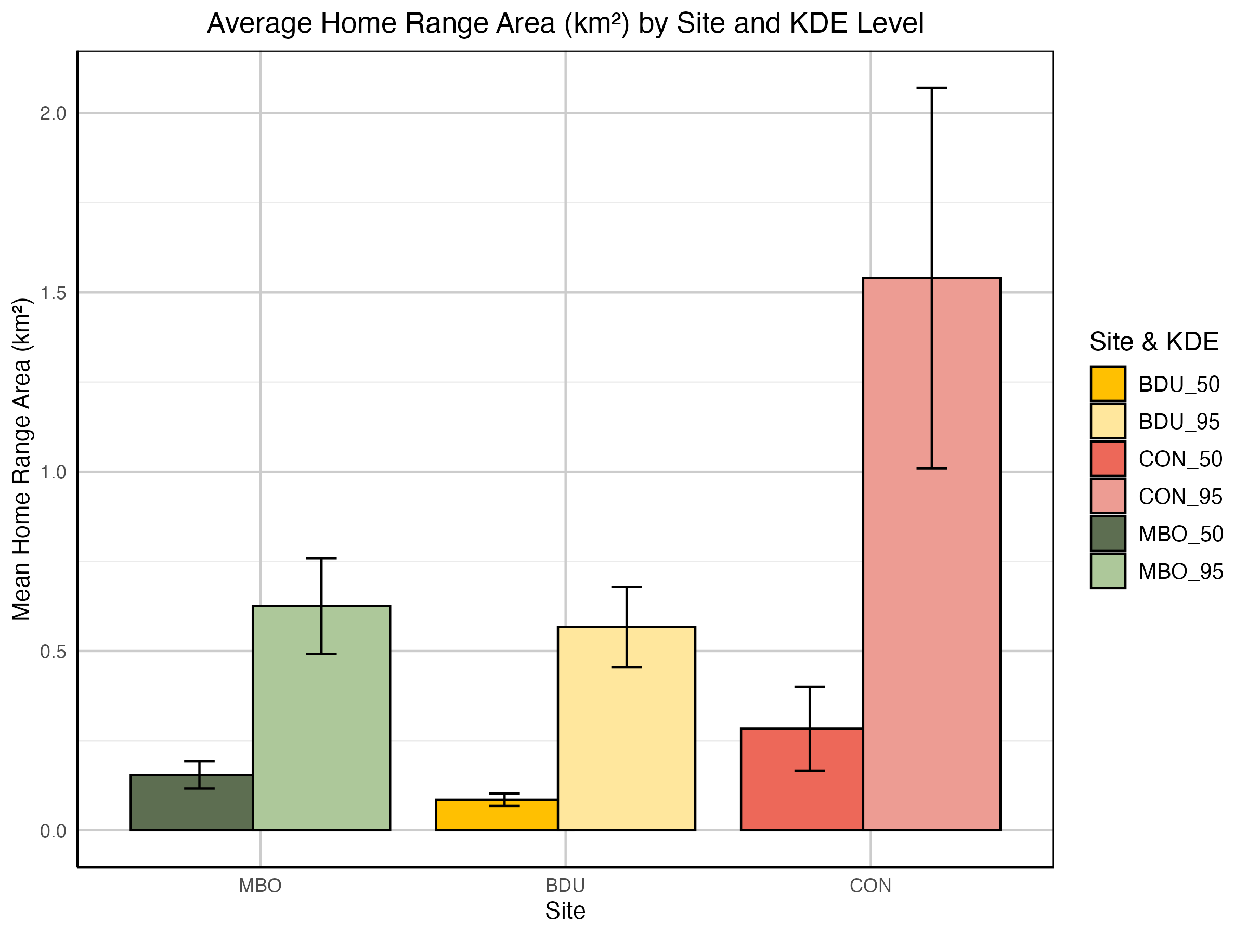
Figure 4. Mean home range areas of the cardinals at each translocation sites (McGill Bird Observatory – MBO, Town of Baie d’Urfé – BDU, Concordia University campus – CON) for both the KDE 50% (representing the core home range of the birds) and the KDE 95% (representing the total home range of the birds).

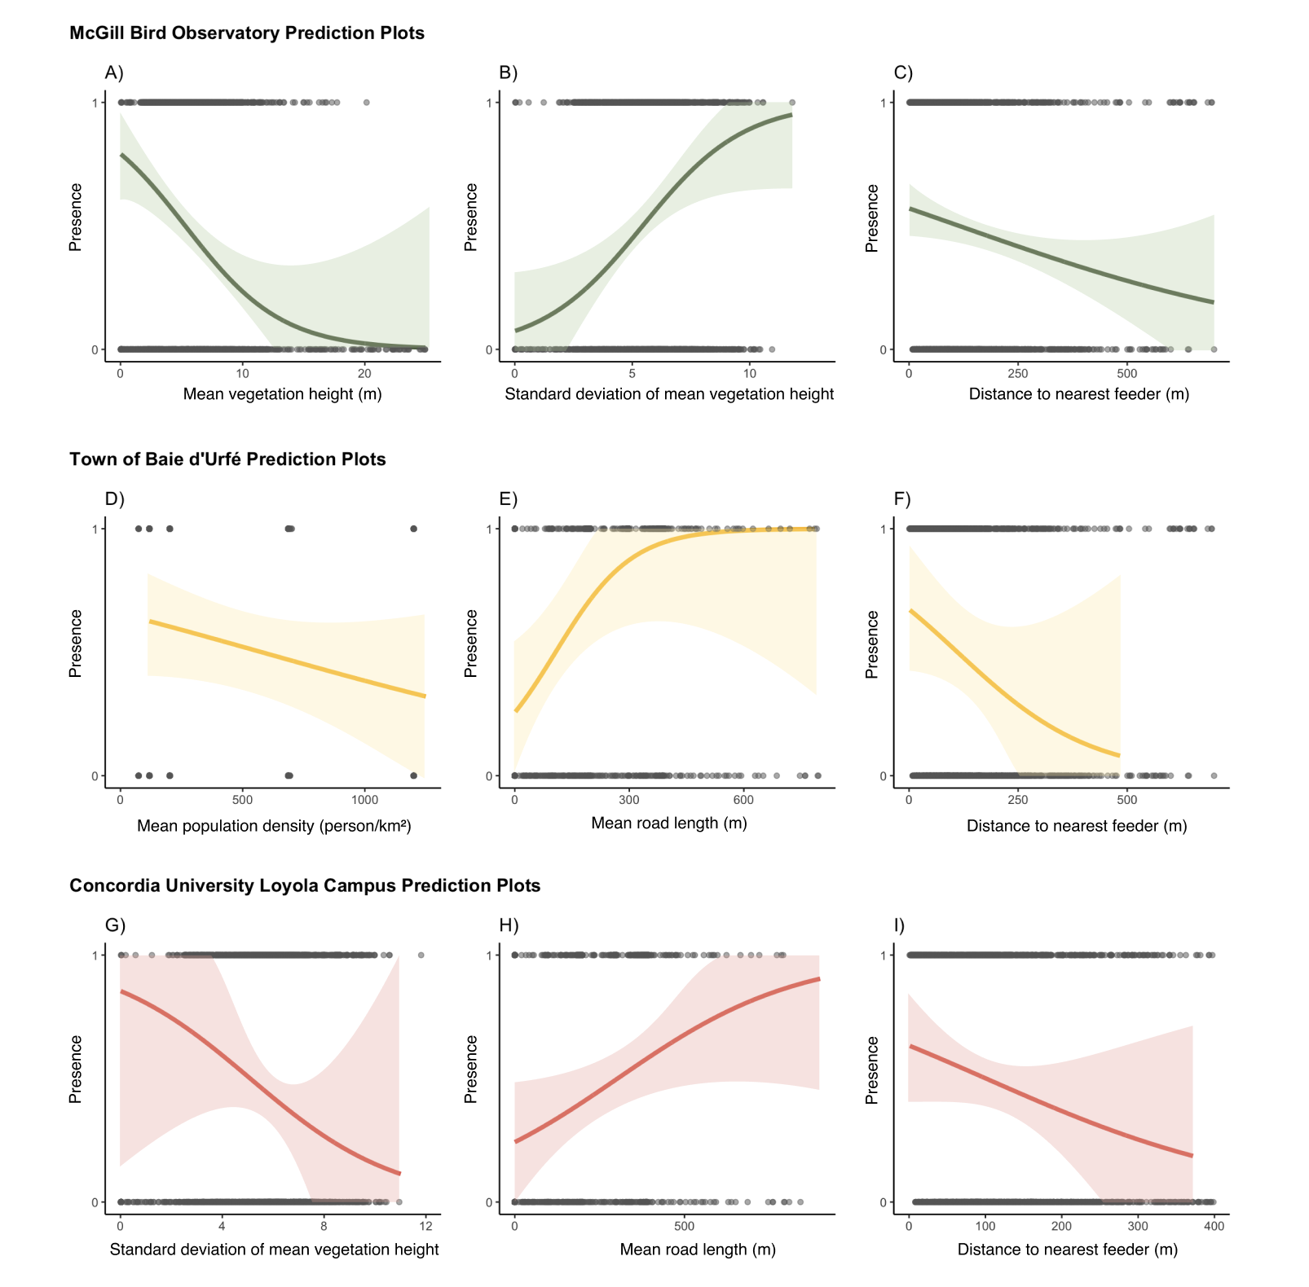
Habitat selection preferences
Figure 5. Probability of presence of northern cardinals in a given radius area, as predicted by a generalized linear mixed effects model. Shaded areas represent 67% confidence intervals around the predicted probabilities. The model’s fixed effect variables are described in Table 1b, and for each model, random effects were sampling years, translocation site and bird ID.
Figure 4 shows the habitat selection preferences of northern cardinals across three sites with varying levels of urbanization—McGill Bird Observatory (MBO), the Town of Baie d’Urfé (BDU), and Concordia University’s Loyola Campus (CON)—as predicted by generalized linear mixed-effects models. These prediction plots reveal distinct habitat use and demonstrate how cardinals select for different variables regarding both environmental and anthropogenic features. At MBO, the cardinals showed a more pronounced positive association for areas with generally lower vegetation (A) and greater structural heterogeneity (B), as reflected by the negative association with mean vegetation height and its standard deviation. This preference could suggest that northern cardinals prefer to use habitats that are vertically complex, yet still mainly composed of shrubs, providing shelter and foraging opportunities. This is not surprising as cardinals are known to favour habitats corresponding to those criteria. In addition, the presence probability drops as the distance from the nearest feeder increases (C), emphasizing the role of supplementary feeding as a reliable food source in this less urbanized location. In contrast, selection patterns in the moderately urbanized BDU site seem to revolve mainly around human-related variables, and less so around the vegetation variables. Here, cardinals tended to avoid areas of high population density (D), while showing a preference for longer road lengths (E), a counterintuitive pattern. This might be reflecting an indirect association with edge habitats or corridors, often seen with suburban street planning. We considered the potential bias that could be induced by recording the GPS locations of the birds from the side of the streets. To assess this issue, the statistical analyses were run on both the unshifted location data and the shifted points, and the resulting model selection remains unchanged. This confirms the robustness of the method used to record cardinal location. The highly urbanized location of CON showed yet another distinct pattern of habitat use. Cardinals were less likely to occupy areas with strong vegetation vertical heterogeneity (G), a pattern opposite to what we’re seeing at MBO. This could indicate a certain avoidance of fragmented, or lower quality patches, in a context where vegetation is already scarce and patchily distributed through the landscape. In addition, the probability of selection increased with road length (H), suggesting that the limited access to vegetated habitats comes with the necessity to navigate along urban features such as roads. Finally, the presence of northern cardinals declined as the distance to the nearest bird feeder increased, highlighting the potential dependence on anthropogenic food resources in highly urbanized areas, where more natural foraging opportunities may be insufficient. Collectively, these findings highlight the context-dependent nature of habitat selection by northern cardinals, suggesting that behavioural flexibility may play a role in their persistence in urban environments through the winter. The varying importance of vegetation structure, anthropogenic disturbances and proximity to supplemental food indicates that conservation strategies for winter birds must be tailored to the local urban context. In less urbanized areas, maintaining large vegetation patches with a complex vertical structure is likely essential, while in urbanized locations, providing access to supplemental food and mitigating the negative impacts of fragmentation may be more critical for sustaining northern cardinals (and potentially other resident bird species) populations during the winter season.

Conclusion
This study provides new insights into how a resident songbird species, the northern cardinal, adapts its movement and habitat selection patterns in response to varying levels of urbanization during the non-breeding season. By combining spatial movement analyses with fine-scale habitat selection models across three sites with varying levels of urbanization, we demonstrate that cardinals seem to exhibit both behavioural plasticity and context-dependent responses to urban landscape features. Larger home ranges in highly urbanized areas suggest increased energetic costs, likely driven by fragmented habitats and sparse natural resources. In contrast, smaller and more consistent home ranges in less urbanized environments reflect a more stable and resource-rich context for the cardinals. Habitat selection varied quite considerably across sites: in peri-urban areas, cardinals favoured structurally complex vegetation and proximity to feeders, while in urban areas, reliance on anthropogenic features was more evident. These findings highlight the importance of flexible behavioural strategies in enabling some species of birds to persist in human-modified environments. From a conservation perspective, we argue that this work emphasizes the importance, in urban environments, to tailor local management efforts to the context they’re in. As urban areas continue to expand globally, understanding such fine-scale responses will be critical for informing urban planning and ensuring a year-round support of our native bird species.

Chapter 2: Seasonal variation in the activity level of the northern cardinal (Cardinalis cardinalis) over the winter

Note on this chapter

Abstract

Introduction
- General background.
  - Importance of studying winter bird behaviour in temperate regions of the world.
  - Seasonal challenges (temperature, food, snow cover, etc.).
  - How urbanisation x climate can influence winter movement\activity
In temperate regions of the globe, winter is still the underdog of ecological research, often described as the stale or dormant time of the year (Sutton et al., 2021). Winter fieldwork also brings its fair number of challenges for researchers, including working in below zero temperatures, finding equipment that tolerates such conditions, dealing with snow and/or ice accumulations on site, etc. This has the unfortunate side-effect of resulting in an underrepresentation of research and experimentation conducted during the coldest months of the year in temperate regions (Marchand, 2014; Studd et al., 2021). Bird species residing in those regions are now facing significant challenges across every season, as climate change affects egg-laying dates, foraging areas location, dates of peak food availability, and much more (Leech & Crick, 2007). Resident birds are thus potentially facing a plethora of such challenges that manifest in both the breeding and non-breeding season. Two of the main factors that are especially critical for the survival of birds in winter are foraging opportunities and energy expenditures. Winter requires birds to have a robust management of the energy available to them, potentially even more so compared to the breeding season (Sgueo et al., 2012).
- Species of interest.
  - Cardinal doesn’t migrate.
  - Territoriality and vocalization in winter.
  - Adaptability to urban environments.
Previous work investigated the northern cardinal’s ability to adapt its energy management to survive the winter. They found no evidence of the use of torpor, but did notice a slight decrease in body temperature in winter, which could potentially lead to a 10-16 % saving in daily energy expenditures (Schaeffer et al., 2015). Another paper highlighted that the cardinals needed to adapt their metabolic systems to survive through the winter season, and that contrary to previously assumed life history theories, the winter season seems to be more energetically demanding compared to the breeding season for birds in temperate climates (Sgueo et al., 2012). This highlights, once again, the importance of growing our knowledge of the ecology of resident bird species in temperate regions.
- Introduce Motus.
  - Fine-scale movement\activity.
  - Highlight benefits (passive + continuous).
  - Acknowledge limitations (radius, interference, coverage in city).
We will investigate three main hypotheses through this research:
- If northern cardinal exhibit increased activity levels in response to higher mean daily temperatures, and we are able to quantify the daily duration of activity for multiple individuals alongside accurate measurements of mean daily temperature, then we should observe a positive relationship between daily activity duration and mean daily temperatures.
- If northern cardinals reduce their activity levels following sudden drops in temperature or during intense snow events, and we can continuously monitor their activity in conjunction with daily meteorological conditions, then we should detect a negative correlation between cardinal activity levels ad rapid temperature declines and/or significant snowfall events.
- If northern cardinals initially suppress activity levels in response to sustained cold temperatures, and we are able to track their movement patterns throughout the winter alongside detailed temperature data, then we should observe a period of decreased activity during prolonged cold, followed by a resumption of normal activity once a critical duration of cold exposure has passed—suggesting a behavioural threshold for thermal tolerance.

Materials and methods

Study species
To answer those questions, we have selected the northern cardinal as being the most suitable

Change point analysis
The onset and end time of diel activity was determined using radio telemetry data collected by the Motus station deployed throughout the Montréal area. Proximity to receiving antenna, transmitter orientation, and environmental obstructions can affect received signal strength, causing high signal strength variation when a tagged individual is active and low signal strength variation during periods of inactivity. Changes in signal strength variation can then be used to determine when a bird becomes active in the morning and quiescent in the evening. Following Morbey et al. (2020), we applied change point analysis to extract the time of activity onset and end based on the characteristic increase and decrease of signal variation respectively. Change points in signal variation were determined using the package “changepoint” in R ver. 4.4.2 (R Core Team, 2024), for the six-hour period centered on local sunrise for activity onset and sunset for activity end (Killick & Eckley, 2014). Sunrise and sunset times were determined for Montréal using the function getSunlightTimes in the package “suncalc” (Thieurmel & Elmarhraoui, 2022).
Unlike previous studies, we extracted activity change points using the combined dataset from multiple stations across the study region. As signals are received near-simultaneous on any stations within range, changes in the variability of received signal strength can be perceived across multiple stations in the same instance. Using the combined regional dataset allowed us to determine activity change points without needing birds to stay within detection range of single focal station or needing to analyse activity data from multiple stations separately. The study region was defined to include all station within the Montréal area, extending from latitudes 44.9655°N to 46.1320°N and longitudes -74.2796°E to -71.9254°E.
Change points were extracted for each day a bird was in the study area by first de-trending values of signal strength (sig) by taking the first differences (d_{i} = sig_{i} - sig_{i-1}, for observation i) for each antenna on each station included in the study area. Values of d among all unique antennas were then pooled and sorted by timestamp, after which the square-root of the absolute value of d (sqrt(|d|)) was calculated. This process reduces the major difference in sig among the receiver antennas as well as difference in signal strength from station proximity as birds move throughout the study region. Square root transformation emphasises the difference in the mean and variance of sig between activity states, further demarcating the change in activity pattern (Morbey et al., 2020).
Using separate automated process for the onset and end of activity, we first filtered any onset or end periods with fewer than 800 detections total to exclude periods with poor signal coverage. The function cpt.meanvar was then used to extract a single change point time (cpt) in the mean and variance of sqrt(|d|) within the six-hour period surrounding sunrise or sunset, specifying an asymptotic penalty value of 0.001 and a minimum segment length of 20. These parameters performed well to reliably identify the transition between activity states. For most change points, mean sqrt(|d|) was < 1 before the cpt and > 0.5 after the onset of activity, and mean sqrt(|d|) ranged between 0 and 2 before the cpt and < 1.5 after for the end of activity.
Post cpt extraction, filtering was conducted to exclude questionable change points, attributable primarily to gaps in the detection record. For activity onset change points, we removed any with a pre-cpt mean sqrt(|d|) > 1, post-cpt mean sqrt(|d|) < 0, a pre-cpt mean sqrt(|d|) > post-cpt mean sqrt(|d|), or a pre-cpt variance sqrt(|d|) > post-cpt variance sqrt(|d|). For activity end change points, we removed any with a pre-cpt mean sqrt(|d|) > 0.25, a post-cpt mean sqrt(|d|) > 1, a pre-cpt mean sqrt(|d|) < post-cpt mean sqrt(|d|), or a pre-cpt variance sqrt(|d|) < post-cpt variance sqrt(|d|).

Literature cited

Andreev, A. V. (1999). Energetics and survival of birds in extreme environments. Ostrich, 70(1), 13–22. https://doi.org/10.1080/00306525.1999.9639745
Bocz, R., Szép, D., Witz, D., Ronczyk, L., Kurucz, K., & Purger, J. J. (2017). Human disturbances and predation on artificial ground nests across an urban gradient. Animal Biodiversity and Conservation, 40(2).
Brewer, D. E., Gehring, T. M., Garcia, M. M., Shirkey, B. T., Simpson, J. W., & Fournier, A. M. V. (2023). King rail (Rallus elegans) home range and microhabitat characteristics in western Lake Erie coastal marshes. Ecology and Evolution, 13(4), 16. https://doi.org/10.1002/ece3.10043
Brewer, V. N., Lane, S. J., Sewall, K. B., & Mabry, K. E. (2020). Effects of low-density urbanization on genetic structure in the Song Sparrow. PLOS ONE, 15(6), e0234008. https://doi.org/10.1371/journal.pone.0234008
Brodin, A. (2007). Theoretical models of adaptive energy management in small wintering birds. Philosophical Transactions of the Royal Society B: Biological Sciences, 362(1486), 1857–1871. https://doi.org/10.1098/rstb.2006.1812
Buxton, R. T., Hudgins, E. J., Lavigne, E., Villeneuve, P. J., Prince, S. A., Pearson, A. L., Halsall, T., Robichaud, C., & Bennett, J. R. (2024). Mental health is positively associated with biodiversity in Canadian cities. Communications Earth & Environment, 5(1), 310. https://doi.org/10.1038/s43247-024-01482-9
Cabrera-Cruz, S. A., Smolinsky, J. A., & Buler, J. J. (2018). Light pollution is greatest within migration passage areas for nocturnally-migrating birds around the world. Scientific Reports, 8(1), 3261.
Chace, J. F., & Walsh, J. J. (2006). Urban effects on native avifauna: A review. Landscape and Urban Planning, 74(1), 46–69.
Chamberlain, D. E., Gough, S., Vaughan, H., Vickery, J. A., & Appleton, G. F. (2007). Determinants of bird species richness in public green spaces. Bird Study, 54(1), 87–97. https://doi.org/10.1080/00063650709461460
Chen, D., & Hale, R. C. (2010). A global review of polybrominated diphenyl ether flame retardant contamination in birds. Environment International, 36(7), 800–811. https://doi.org/10.1016/j.envint.2010.05.013
Chiron, F., Lorrillière, R., Bessa-Gomes, C., Tryjanowski, P., Casanelles-Abella, J., Laanisto, L., Leal, A., Van Mensel, A., Moretti, M., Muyshondt, B., Niinemets, Ü., Ortí, M. A., Pinho, P., Samson, R., & Deguines, N. (2024). How do urban green space designs shape avian communities? Testing the area–heterogeneity trade-off. Landscape and Urban Planning, 242, 104954. https://doi.org/10.1016/j.landurbplan.2023.104954
City of Montreal. (2020). Climate Plan 2020-2030. City of Montreal. https://montreal.ca/en/articles/montreal-climate-plan-objective-carbon-neutral-2050-7613
City of Montreal. (2024). Plan climat 2020-2030 Ville de Montréal—État d’avancement avril 2024. City of Montreal. https://mtl.ged.montreal.ca/constellio/?collection=mtlca&portal=REPDOCVDM#!displayDocument/00000092918
Cox, D. T. C., Shanahan, D. F., Hudson, H. L., Plummer, K. E., Siriwardena, G. M., Fuller, R. A., Anderson, K., Hancock, S., & Gaston, K. J. (2017). Doses of Neighborhood Nature: The Benefits for Mental Health of Living with Nature. BioScience, 67(2), 147–155. https://doi.org/10.1093/biosci/biw173
Cull, C. A., Guest, M. J., Frei, B., & Ziter, C. D. (2025). Human recreational activity does not influence open cup avian nest survival in urban green spaces. Urban Ecosystems, 28(2). https://doi.org/10.1007/s11252-024-01669-0
Dawson, W. R., Marsh, R. L., & Yacoe, M. E. (1983). Metabolic adjustments of small passerine birds for migration and cold. 245(6), R755–R767. https://doi.org/10.1152/ajpregu.1983.245.6.R755
DeVries, M. S., & Jawor, J. M. (2013). Natural variation in circulating testosterone does not predict nestling provisioning rates in the northern cardinal, Cardinalis cardinalis. Animal Behaviour, 85(5), 957–965. https://doi.org/10.1016/j.anbehav.2013.02.019
DONNELLY, R., & MARZLUFF, J. M. (2004). Importance of Reserve Size and Landscape Context to Urban Bird Conservation. Conservation Biology, 18(3), 733–745. https://doi.org/10.1111/j.1523-1739.2004.00032.x
Dupras, J., & Alam, M. (2015). Urban Sprawl and Ecosystem Services: A Half Century Perspective in the Montreal Area (Quebec, Canada). Journal of Environmental Policy & Planning, 17(2), 180–200. https://doi.org/10.1080/1523908X.2014.927755
Elliott, J. E., Brogan, J., Lee, S. L., Drouillard, K. G., & Elliott, K. H. (2015). PBDEs and other POPs in urban birds of prey partly explained by trophic level and carbon source. Science of The Total Environment, 524–525, 157–165. https://doi.org/10.1016/j.scitotenv.2015.04.008
Elliott, J. E., Wilson, L. K., & Wakeford, B. (2005). Polybrominated Diphenyl Ether Trends in Eggs of Marine and Freshwater Birds from British Columbia, Canada, 1979−2002. Environmental Science & Technology, 39(15), 5584–5591. https://doi.org/10.1021/es050496q
Elmqvist, T., Fragkias, M., Goodness, J., Güneralp, B., Marcotullio, P. J., McDonald, R. I., Parnell, S., Schewenius, M., Sendstad, M., & Seto, K. C. (2013). Urbanization, biodiversity and ecosystem services: Challenges and opportunities: A global assessment. Springer Nature.
Eötvös, C. B., Magura, T., & Lövei, G. L. (2018). A meta-analysis indicates reduced predation pressure with increasing urbanization. Landscape and Urban Planning, 180, 54–59. https://doi.org/10.1016/j.landurbplan.2018.08.010
Fernandez-Canero, R., & Gonzalez-Redondo, P. (2010). Green Roofs as a Habitat for Birds: A Review. Journal of Animal and Veterinary Advances, 9(15), 2041–2052.
Fierz, C., Armstrong, R. L., Durand, Y., Etchevers, P., Greene, E., McClung, D. M., Nishimura, K., Satyawali, P. K., & Sokratov, S. A. (2009). The international classification for seasonal snow on the ground.
Filion, P., Bunting, T., Pavlic, D., & Langlois, P. (2010). Intensification and Sprawl: Residential Density Trajectories in Canada’s Largest Metropolitan Regions. Urban Geography, 31(4), 541–569. https://doi.org/10.2747/0272-3638.31.4.541
Filliater, T. S., Breitwisch, R., & Nealen, P. M. (1994). Predation on Northern Cardinal Nests: Does Choice of Nest Site Matter? The Condor: Ornithological Applications, 96(3), 761–768. https://doi.org/10.2307/1369479
Frei, B., Morales, A., Cousineau, A.-M., & Beauchamp, A. (2024). Montreal Northern Cardinal Winter Movements (Project 882) [Dataset]. Motus Wildlife Tracking System, Birds Canada. https://motus.org/
Fuller, M. R., Millspaugh, J. J., Church, K. E., & Kenward, R. E. (2005). Wildlife radiotelemetry. Techniques for Wildlife Investigations and Management. Sixth Edition. The Wildlife Society, Bethesda, Maryland, USA, 377–417.
Furberg, D., & Ban, Y. (2008). Satellite Monitoring of Urban Sprawl and Assessing the Impact of Land-Cover Changes in the Greater Toronto Area. The XXI Congress of ISPRS. Beijing, China. 3-11 July 2008.
Gahbauer, M. A., Duval, S., & Davey, D. (2015). McGill Bird Observatory Annual Program Report 2014.
Government of Canada, S. C. (2022, February 9). Census Profile, 2021 Census of Population. https://www12.statcan.gc.ca/census-recensement/2021/dp-pd/prof/index.cfm?Lang=E
Halkin, S. L., Shustack, D. P., DeVries, M. S., Jawor, J. M., & Linville, S. U. (2021). Northern Cardinal (Cardinalis cardinalis), version 2.0. Birds of the World. https://doi.org/10.2173/bow.norcar.02
Harris, R. B., & Fish, U. S. (1990). Tracking wildlife by satellite.
Hofman, M. P. G., Hayward, M. W., Heim, M., Marchand, P., Rolandsen, C. M., Mattisson, J., Urbano, F., Heurich, M., Mysterud, A., Melzheimer, J., Morellet, N., Voigt, U., Allen, B. L., Gehr, B., Rouco, C., Ullmann, W., Holand, Ø., Jørgensen, N. H., Steinheim, G., … Balkenhol, N. (2019). Right on track? Performance of satellite telemetry in terrestrial wildlife research. Plos One, 14(5), e0216223. https://doi.org/10.1371/journal.pone.0216223
Hope, S. F., Hopkins, W. A., & Angelier, F. (2022). Parenting in the city: Effects of urbanization on incubation behaviour and egg temperature in great tits, Parus major. Animal Behaviour, 194, 1–11. https://doi.org/10.1016/j.anbehav.2022.09.004
Isaksson, C. (2018). Impact of urbanization on birds. Bird Species, 235, 257.
Iverson, A. R., Schaefer, J. L., Skalos, S. M., & Hawkins, C. E. (2023). Global positioning system (GPS) and platform transmitter terminal (PTT) tags reveal fine-scale migratory movements of small birds: A review highlights further opportunities for hypothesis-driven research. Ornithological Applications, 125(3), duad014.
Jim, C. Y., & Chen, W. Y. (2008). Assessing the ecosystem service of air pollutant removal by urban trees in Guangzhou (China). Journal of Environmental Management, 88(4), 665–676. https://doi.org/10.1016/j.jenvman.2007.03.035
Jokimäki, J., Suhonen, J., Benedetti, Y., Diaz, M., Kaisanlahti-Jokimäki, M.-L., Morelli, F., Pérez-Contreras, T., Rubio, E., Sprau, P., Tryjanowski, P., & Ibánez-Álamo, J. D. (2020). Land-sharing vs. Land-sparing urban development modulate predator–prey interactions in Europe. Ecological Applications, 30(3), e02049. https://doi.org/10.1002/eap.2049
Jones, T. M., Llamas, A. P., & Phillips, J. N. (2023). Phenotypic signatures of urbanization? Resident, but not migratory, songbird eye size varies with urban‐associated light pollution levels. Global Change Biology, 29(23), 6635–6646.
Kamei, I., & Maruta, E. (1979). Study on wind environmental problems caused around buildings in Japan. Journal of Wind Engineering and Industrial Aerodynamics, 4(3), 307–331. https://doi.org/10.1016/0167-6105(79)90010-2
Kekkonen, J. (2017). Pollutants in urbanized areas: Direct and indirect effects on bird populations. Ecology and Conservation of Birds in Urban Environments, 227–250.
Kelly, A. A., & Amanda, D. R. (2006). The Value of Urban Forests to Wintering Birds. Natural Areas Journal, 26(3), 280–288. https://doi.org/10.3375/0885-8608(2006)26[280:TVOUFT]2.0.CO;2
Killick, R., & Eckley, I. A. (2014). changepoint: An R Package for Changepoint Analysis. Journal of Statistical Software, 58, 1–19. https://doi.org/10.18637/jss.v058.i03
Krama, T., Krams, R., Popovs, S., Trakimas, G., Rantala, M. J., Freeberg, T. M., & Krams, I. A. (2023). Permanent Ad-lib Feeders Decrease the Survival of Wintering Great Tits (Parus major). Birds, 4(2), Article 2. https://doi.org/10.3390/birds4020019
Lane, S. J., VanDiest, I. J., Brewer, V. N., Linkous, C. R., Fossett, T. E., Goodchild, C. G., & Sewall, K. B. (2023). Indirect effects of urbanization: Consequences of increased aggression in an urban male songbird for mates and offspring. Frontiers in Ecology and Evolution, 11. https://doi.org/10.3389/fevo.2023.1234562
Laskey, A. R. (1944). A STUDY OF THE CARDINAL IN TENNESSEE. 56(1).
Latimer, C. E., & Zuckerberg, B. (2021). Habitat loss and thermal tolerances influence the sensitivity of resident bird populations to winter weather at regional scales. Journal of Animal Ecology, 90(2), 317–329. https://doi.org/10.1111/1365-2656.13332
Leech, D. I., & Crick, H. Q. P. (2007). Influence of climate change on the abundance, distribution and phenology of woodland bird species in temperate regions. Ibis, 149(s2), 128–145. https://doi.org/10.1111/j.1474-919X.2007.00729.x
Leston, L. F. V., & Rodewald, A. D. (2006). Are urban forests ecological traps for understory birds? An examination using Northern cardinals. Biological Conservation, 131(4), 566–574. https://doi.org/10.1016/j.biocon.2006.03.003
Li, G., Fang, C., Li, Y., Wang, Z., Sun, S., He, S., Qi, W., Bao, C., Ma, H., Fan, Y., Feng, Y., & Liu, X. (2022). Global impacts of future urban expansion on terrestrial vertebrate diversity. Nature Communications, 13(1), 1628. https://doi.org/10.1038/s41467-022-29324-2
Li, K., Hu, W. H., Chen, X., Zhang, M. Y., Ye, K. M., Zhu, H., & Zhao, H. B. (2025). More fruits, more birds? How plant traits attract birds feeding in urban green spaces during winter. Urban Forestry & Urban Greening, 107. https://doi.org/10.1016/j.ufug.2025.128748
Liker, A., Papp, Z., Bókony, V., & Lendvai, Á. Z. (2008). Lean birds in the city: Body size and condition of house sparrows along the urbanization gradient. Journal of Animal Ecology, 77(4), 789–795. https://doi.org/10.1111/j.1365-2656.2008.01402.x
Linek, N., Volkmer, T., Shipley, J. R., Twining, C. W., Zúñiga, D., Wikelski, M., & Partecke, J. (2021). A songbird adjusts its heart rate and body temperature in response to season and fluctuating daily conditions. Philosophical Transactions of the Royal Society B: Biological Sciences, 376(1830), 20200213. https://doi.org/10.1098/rstb.2020.0213
Linville, S. U., Breitwisch, R., & Schilling, A. J. (1998). Plumage brightness as an indicator of parental care in northern cardinals. Animal Behaviour, 55(1), 119–127. https://doi.org/10.1006/anbe.1997.0595
Lopes, A. C., Rocha, G. O. C., de Oliveira Passos, M. F., Barçante, L., & de Azevedo, C. S. (2024). The Influence of Building Surroundings and Glass Cover in Bird Collisions. Birds, 5(4), Article 4. https://doi.org/10.3390/birds5040048
Louzao, M., Gallagher, R., García-Barón, I., Chust, G., Intxausti, I., Albisu, J., Brereton, T., & Fontán, A. (2019). Threshold responses in bird mortality driven by extreme wind events. Ecological Indicators, 99, 183–192. https://doi.org/10.1016/j.ecolind.2018.12.030
Lowry, H., Lill, A., & Wong, B. B. (2013). Behavioural responses of wildlife to urban environments. Biological Reviews, 88(3), 537–549.
MacKinnon, M., Pedersen Zari, M., & Brown, D. K. (2023). Improving Urban Habitat Connectivity for Native Birds: Using Least-Cost Path Analyses to Design Urban Green Infrastructure Networks. Land, 12(7), Article 7. https://doi.org/10.3390/land12071456
Marchand, P. J. (2014). Life in the Cold: An Introduction to Winter Ecology, fourth edition. UPNE.
Marlès Magre, J., Boada Juncà, M., Campanera, J. M., Bach Pagès, A., Ruiz Mallén, I., Maneja Zaragoza, R., Sánchez Mateo, S., Pallarès Barberà, M., & Barriocanal Lozano, C. (2019). How urban green management is influencing passerine birds’ nesting in the Mediterranean: A case study in a Catalan city. Urban Forestry & Urban Greening, 41, 221–229. https://doi.org/10.1016/j.ufug.2019.03.012
Mennill, D. J., Doucet, S. M., Ward, K.-A. A., Maynard, D. F., Otis, B., & Burt, J. M. (2012). A novel digital telemetry system for tracking wild animals: A field test for studying mate choice in a lekking tropical bird. Methods in Ecology and Evolution, 3(4), 663–672. https://doi.org/10.1111/j.2041-210X.2012.00206.x
Mitchell, M. G. E., & Devisscher, T. (2022). Strong relationships between urbanization, landscape structure, and ecosystem service multifunctionality in urban forest fragments. Landscape and Urban Planning, 228, 104548. https://doi.org/10.1016/j.landurbplan.2022.104548
Morbey, Y. E., Beauchamp, A. T., Bonner, S. J., & Mitchell, G. W. (2020). Evening locomotor activity during stopover differs on pre-departure and departure days in free-living songbirds. Journal of Avian Biology, 51(11). https://doi.org/10.1111/jav.02448
Murray, M. H., Sánchez, C. A., Becker, D. J., Byers, K. A., Worsley‐Tonks, K. E., & Craft, M. E. (2019). City sicker? A meta‐analysis of wildlife health and urbanization. Frontiers in Ecology and the Environment, 17(10), 575–583.
Naguib, M., Titulaer, M., Waas, J. R., van Oers, K., Sprau, P., & Snijders, L. (2022). Prior territorial responses and home range size predict territory defense in radio-tagged great tits. Behavioral Ecology and Sociobiology, 76(3), 12. https://doi.org/10.1007/s00265-022-03143-3
Nazarnia, N., Schwick, C., & Jaeger, J. A. G. (2016). Accelerated urban sprawl in Montreal, Quebec City, and Zurich: Investigating the differences using time series 1951–2011. Ecological Indicators, 60, 1229–1251. https://doi.org/10.1016/j.ecolind.2015.09.020
O’Connell, M. J., Squirrell, F. I., & Greening, M. (2023). A preliminary study of the winter roosting behaviour of four woodland passerines. Bird Study, 70(4), 243–250. https://doi.org/10.1080/00063657.2023.2269329
Ordóñez-Delgado, L., Iñiguez-Armijos, C., Díaz, M., Escudero, A., Gosselin, E., Waits, L. P., & Espinosa, C. I. (2022). The good, the bad, and the ugly of urbanization: Response of a bird community in the neotropical Andes. Frontiers in Ecology and Evolution, 10, 844944.
Palacio, F. X., Ibañez, L. M., Maragliano, R. E., & Montalti, D. (2018). Urbanization as a driver of taxonomic, functional, and phylogenetic diversity losses in bird communities. Canadian Journal of Zoology, 96(10), 1114–1121.
Palacio, F. X., Ibañez, L. M., Maragliano, R. E., & Montalti, D. (2024). (PDF) Urbanization as a driver of taxonomic, functional, and phylogenetic diversity losses in bird communities. ResearchGate. https://doi.org/10.1139/cjz-2018-0008
Panchana, K., Herrera, I., Vargas, A., Mella-Méndez, I., & Flores-Peredo, R. (2025). Whiskers in the city: Domestic cat predation in Ecuadorian coastal cities and associated factors. Urban Ecosystems, 28(1), 1–18. https://doi.org/10.1007/s11252-024-01628-9
Petit, M., Clavijo-Baquet, S., & Vézina, F. (2017). Increasing Winter Maximal Metabolic Rate Improves Intrawinter Survival in Small Birds. Physiological and Biochemical Zoology, 90(2), 166–177. https://doi.org/10.1086/689274
Poirier, V., Elliott, K. H., & Frei, B. (2024). Peri-urban forest margins are important stopover sites for moult-migrating songbirds. Journal for Nature Conservation, 77, 126539. https://doi.org/10.1016/j.jnc.2023.126539
Québec Government and Municipalities. (2016). Lidar—Digital models (terrain, canopy, slope, level curve)—Open Government Portal (Carte Interactive Nos. 1fb86026-791c-45d2-88d7-58754ecebd73) [HTML]. https://open.canada.ca/data/en/dataset/5e5d2750-d129-4952-b9fc-f824c5e480b4
R Core Team. (2024). R: A Language and Environment for Statistical Computing (Version 4.4.2) [Computer software]. R Foundation for Statistical Computing. https://www.R-project.org/
Robert, M., Hachey, M.-H., Lepage, D., & Couturier, A. R. (Eds.). (2019). Second atlas of the breeding birds of Southern Québec. Regroupement QuébecOiseaux.
Rodgers, A. R. (2001). Chapter 4—Recent Telemetry Technology. In J. J. Millspaugh & J. M. Marzluff (Eds.), Radio Tracking and Animal Populations (pp. 79–121). Academic Press.
Rodrigues, A. G., Borges-Martins, M., & Zilio, F. (2018). Bird diversity in an urban ecosystem: The role of local habitats in understanding the effects of urbanization. Iheringia. Série Zoologia, 108, e2018017.
Rousseau, J. S., Savard, J.-P. L., & Titman, R. (2015). Shrub-nesting birds in urban habitats: Their abundance and association with vegetation. Urban Ecosystems, 18(3), 871–884. https://doi.org/10.1007/s11252-014-0434-4
Šálek, M., Bažant, M., Vrána, J., Grill, S., & Václav, R. (2024). Urban refuges in winter: The role of habitat characteristics and supplementary feeding in shaping bird occupancy and abundance. Urban Ecosystems, 28(1), 67. https://doi.org/10.1007/s11252-024-01632-z
Schaeffer, P., Komer, M. C., & Corder, K. (2015). Energy savings due to the use of shallow body temperature reduction in overwintering Northern Cardinals. ResearchGate, 3(1). https://doi.org/10.1186/s40317-015-0078-z
Seress, G., & Liker, A. (2015). Habitat urbanization and its effects on birds. Acta Zoologica Academiae Scientiarum Hungaricae, 61(4), 373–408.
Sgueo, C., Wells, M. E., Russell, D. E., & Schaeffer, P. J. (2012). Acclimatization of seasonal energetics in northern cardinals (Cardinalis cardinalis) through plasticity of metabolic rates and ceilings. Journal of Experimental Biology, 215(14), 2418–2424. https://doi.org/10.1242/jeb.061168
Shanahan, D. F., Strohbach, M. W., Warren, P. S., & Fuller, R. A. (2014). The challenges of urban living. Avian Urban Ecology, 3–20.
Shustack, D. P. (2008). Reproductive Timing of Passerines in Urbanizing Landscapes [The Ohio State University]. http://rave.ohiolink.edu/etdc/view?acc_num=osu1217601092
Simkin, R. D., Seto, K. C., McDonald, R. I., & Jetz, W. (2022). Biodiversity impacts and conservation implications of urban land expansion projected to 2050. Proceedings of the National Academy of Sciences, 119(12), e2117297119. https://doi.org/doi:10.1073/pnas.2117297119
Skarbit, N., Unger, J., & Gál, T. (2024). Evaluating the Impact of Heat Mitigation Strategies Using Added Urban Green Spaces during a Heatwave in a Medium-Sized City. Sustainability, 16(8), 17. https://doi.org/10.3390/su16083296
Smith, P. G. (2007). Characteristics of Urban Natural Areas Influencing Winter Bird Use in Southern Ontario, Canada. Environmental Management, 39(3), 338–352. https://doi.org/10.1007/s00267-005-0028-2
Stephens, T. (2023). The Kunming–Montreal Global Biodiversity Framework. International Legal Materials, 62(5), 868–887. https://doi.org/10.1017/ilm.2023.16
Studd, E. K., Bates, A. E., Bramburger, A. J., Fernandes, T., Hayden, B., Henry, H. A. L., Humphries, M. M., Martin, R., McMeans, B. C., Moise, E. R. D., O’Sullivan, A. M., Sharma, S., Sinclair, B. J., Sutton, A. O., Templer, P. H., & Cooke, S. J. (2021). Nine Maxims for the Ecology of Cold-Climate Winters. BioScience, 71(8), 820–830. https://doi.org/10.1093/biosci/biab032
Sutton, A. O., Studd, E. K., Fernandes, T., Bates, A. E., Bramburger, A. J., Cooke, S. J., Hayden, B., Henry, H. A. L., Humphries, M. M., Martin, R., McMeans, B., Moise, E., O’Sullivan, A. M., Sharma, S., & Templer, P. H. (2021). Frozen out: Unanswered questions about winter biology. Environmental Reviews, 29(4), 431–442. https://doi.org/10.1139/er-2020-0127
Swanson, D. L., & Vézina, F. (2015). Environmental, ecological and mechanistic drivers of avian seasonal metabolic flexibility in response to cold winters. Journal of Ornithology, 156(1), 377–388. https://doi.org/10.1007/s10336-015-1192-7
The State of Canada’s Birds Report. (2024).
Thieurmel, B., & Elmarhraoui, A. (2022). suncalc: Compute Sun Position, Sunlight Phases, Moon Position and Lunar Phase (Version 0.5.1) [R packag]. https://CRAN.R-project.org/package=suncalc
Thohari, M. (1989). Wildlife Tracking by Telemetry.
Tryjanowski, P., Mikula, P., & Morelli, F. (2024). Dynamic interactions at birdfeeders: Attracting both prey and predators across urban and rural habitats. Basic and Applied Ecology, 79, 84–89. https://doi.org/10.1016/j.baae.2024.06.005
Vaz, S., Manes, S., Khattar, G., Mendes, M., Silveira, L., Mendes, E., de Morais Rodrigues, E., Gama-Maia, D., Lorini, M. L., Macedo, M., & Paiva, P. C. (2023). Global meta-analysis of urbanization stressors on insect abundance, richness, and traits. Science of The Total Environment, 903, 165967. https://doi.org/10.1016/j.scitotenv.2023.165967
VILLE DE MONTRÉAL. (2018). Chaussée agrégée et intersection (Base de données des actifs de voirie) (Jeu de données Nos. a2810949-7335-49e2-84af-1c5da4ff6342). Données Québec. https://www.donneesquebec.ca/recherche/dataset/vmtl-voirie-chaussee-intersection
vonBergmann, J., & Jacobs, A. (n.d.). cancensus: Access, Retrieve, and Work with Canadian Census Data and Geography (Version 0.5.3) [Computer software]. Retrieved May 5, 2025, from https://CRAN.R-project.org/package=cancensus
Wang, H., He, Q., Liu, X., Zhuang, Y., & Hong, S. (2012). Global urbanization research from 1991 to 2009: A systematic research review. Landscape and Urban Planning, 104(3–4), 299–309.
Wolch, J. R., Byrne, J., & Newell, J. P. (2014). Urban green space, public health, and environmental justice: The challenge of making cities ‘just green enough.’ Landscape and Urban Planning, 125, 234–244. https://doi.org/10.1016/j.landurbplan.2014.01.017
Wood, E., Harsant, A., Dallimer, M., Cronin de Chavez, A., McEachan, R. R. C., & Hassall, C. (2018). Not All Green Space Is Created Equal: Biodiversity Predicts Psychological Restorative Benefits From Urban Green Space. Frontiers in Psychology, 9. https://doi.org/10.3389/fpsyg.2018.02320

