INDIA TECH
CAREER INTELLIGENCE
Analytical Workflow & Technical Methodology Specification
HACKATHON WORKFLOW REPORT | OCTOBER 2026
Team: Gradient Gods (Team 23) | Institution: DIET Path 2 | Event: Manthan Hackathon — Calibo AI Academy
Team Members: Anne Mukesh Balaji • Kesiboyina Chandrika • Chinnam Joshitha • Chennam Divya
100,000  JOB POSTINGS | 33  DATA ATTRIBUTES | 8  PROBLEM STATEMENTS

Executive workflow summary
Students and early-career tech professionals face significant information overload when navigating India's dynamic technology employment landscape. Job titles vary across companies, skill lists are extensive, and entry-level requirements are frequently misunderstood. Team Gradient Gods (Team 23) established an end-to-end, reproducible exploratory data analysis (EDA) workflow across 100,000 technology postings in India.
Our analytical pipeline investigates the dataset across five core dimensions: data hygiene and provenance, job role taxonomies, technical skills demand, corporate and geospatial clustering, and independent compensation modeling. The entire workflow strictly complies with challenge guidelines using pure descriptive analytics (NumPy, Pandas, Matplotlib, Seaborn). All observations represent empirical distributions within this snapshot and serve as transparent decision support for academic leadership and students.
79.7%  REMOTE + HYBRID | ₹8.50 LPA  FULL-TIME MEDIAN MIDPOINT | ₹29,959  INTERNSHIP MEDIAN / MONTH

Core workflow objective: Deliver an evidence-grounded, chart-backed technical workflow that bridges academic curricula and technology employment.

01 | SCOPE & ARCHITECTURE

Problem Understanding & Workflow Architecture
Transforming unverified vacancy data into structured, actionable workforce intelligence

Why this matters
College career cells and graduating students require empirical clarity rather than anecdotal hype. Navigating technical roles demands understanding which skills bundle together, what contractual pathways exist (internships vs full-time), where opportunities are located, and what realistic compensation benchmarks apply.
ROLE  What jobs exist? | SKILLS  What should I learn? | PATHWAY  How do I prepare?

Dataset & Technical Scope
100K  ROWS / POSTINGS | 33  ATTRIBUTES | IT  INDUSTRY SECTOR

Scope: Pure descriptive EDA using Python, Pandas, NumPy, Matplotlib, and Seaborn. Per official hackathon guidelines, predictive models, machine learning, clustering, and black-box NLP were placed out of scope to ensure fully transparent and reproducible findings.

Five-Phase Workflow Lifecycle across Problem Statements
Workflow Phase & Scope | Core Methodological Deliverables
Phase 1: Hygiene Audit (PS 1) | Preserve raw provenance, audit duplicates (0 found), impute probation nulls (33.5%) with 'Not Specified', normalize 27 text cols, parse datetimes, validate timeline sequence.
Phase 2: Taxonomy & Skills (PS 2 & 3) | Categorize 6 domains (16.4%–16.9%), 24 titles, evaluate 60:40 full-time to internship split, tokenize 684k skills, NumPy concordance test, and map 6 discrete skill bundles.
Phase 3: Scale & Geospatial (PS 4 & 5) | Evaluate 12 balanced employers, corporate tiers (50.1% MNCs, 33.3% Startups), 100% IT boundary disclosure, 8 metropolitan hubs (~12.5% each), and 79.7% remote/hybrid flexibility.
Phase 4: Statistical Modeling (PS 6 & 7) | Independent modeling of full-time salary midpoint (median ₹8.50 LPA) and monthly stipends (median ₹29,959/mo), experience requirements (0–1 vs 2–4 yrs), and degree equity.
Phase 5: Strategy & Guidance (PS 8) | Synthesize 3 evidence-backed career insights with sample sizes, caveats, and next steps, and establish a 7-step actionable institutional roadmap for college career cells.

Methodological boundary: All observations reflect empirical distributions within this snapshot of 100,000 listings. Postings reflect platform data rather than an absolute census of India's labor market.

02 | DATA PREPARATION

Data Preparation & Engineering Pipeline
Auditing 100,000 listings across 33 attributes for empirical reliability (Problem Statement 1)

Data Ingestion & Integrity Auditing
- Provenance: Raw Provenance: Preserved raw CSV untouched ('indian_tech_career_intelligence_2026.csv', 100k rows × 33 cols) and executed cleaning on working copy ('df'), exporting to cleaned CSV.
- Duplicate Audit: Duplicate Row Audit: Audited with df.duplicated().sum(). Confirmed exactly 0 duplicate listings across all 33 attributes, establishing that every row is a distinct posting.
- Probation Period: Missing Value Imputation: Audited with df.isnull().sum(). Exactly 32 of 33 columns exhibited 100% completeness. Only 'probation_period' contained missing values (33,499 nulls, 33.50%). Imputed as 'Not Specified' to avoid row loss or legal fabrication.

Normalization, Datetime Parsing & Sanity Bounds
- Whitespace: Text Normalization: Applied .astype(str).str.strip() across all 27 string columns to eliminate whitespace and prevent category fragmentation.
- Timeline: Datetime Sequence: Parsed dates into pd.datetime64[ns] (%d-%m-%Y). Vectorized check (deadline < posted_date).sum() yielded 0 anomalies across 100k records.
- Sanity Bounds: Bounds & Currency: Stripped '%' from career_growth_index and cast to float. Verified 100% currency is 'INR', salary_minimum <= salary_maximum (0 inverted bounds), and non-negativity.

Official Data Cleaning Decision Log
Attribute | Audit Finding | Action Applied | Analytical Rationale
Raw Integrity | Must not be modified | df = df_raw.copy(); exported cleaned CSV | Preserves raw data provenance.
Duplicate Rows | Evaluated .duplicated().sum() | 0 duplicates detected; 0 rows dropped | Confirms all 100k rows are unique.
probation_period | 33,499 nulls (33.5%) | Imputed with constant 'Not Specified' | Avoids dropping 33.5% rows or fabricating terms.
String Columns (27) | Risk of whitespace mismatch | Applied .astype(str).str.strip() across 27 cols | Eliminates accidental category duplicates.
Dates & Deadlines | Stored as DD-MM-YYYY string | Parsed with pd.to_datetime(%d-%m-%Y) | Enables chronological ordering checks.
Timeline Sequence | Audited deadline < posted_date | 0 violations detected across 100,000 rows | Confirms valid chronological sequence.
career_growth_index | Stored as string with '%' | Stripped '%' and cast to float | Enables mathematical aggregation.
Compensation Sanity | Evaluated min, max, stipends | Checked min <= max, non-negativity, 100% INR | Zero inverted ranges; zero negative values.

03 | ROLES, SKILLS & WORK MODES

Domain Taxonomies, Skills & Workplaces
Structural patterns across roles, technical tooling, and work arrangements (PS 2, 3, 4, 5)
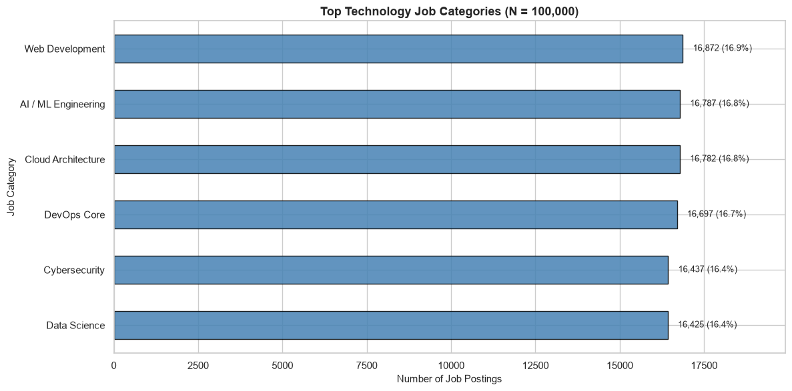
Figure 1. Job-category representation across 100,000 listings.

Role Taxonomy & The 60:40 Contract Split (Problem Statement 2)
- Categories: Job Categories: Evaluated 6 balanced technology domains (~16.4%–16.9% each): Web Dev (16,872), AI/ML (16,787), Cloud (16,782), DevOps (16,697), Cyber (16,437), Data Science (16,425).
- Job Titles: Granular Titles: 24 distinct titles led by Full Stack Developer (4,321), ML Engineer (4,286), and Cloud Architect (4,258).
- Contract Split: The 60:40 Contract Split: Cross-tabulating job categories against contract types reveals that 59.9% of listings are Full-Time Permanent (59,871) while 40.1% are Contractual Internships (40,129). Job titles appear identically across both contract types; title alone does not define contract type.

Skills Extraction & Vectorized Validation (Problem Statement 3)
- Skill Demand: Demand Ranking: Extracted 684,285 mentions. Python leads with 33,212 mentions (spanning Data Science and AI/ML), followed by Linux with 33,134 mentions (DevOps and Cyber).
- Concordance Test: Vectorized Concordance: Applied np.where(df['skill_count'] != parsed_length, 1, 0). Verified 0 mismatches across all 100,000 records (mean = 6.84 skills, median = 7.0).
- Bundle Mapping: Skill Bundles: Discovered exactly 6 predefined skill bundles mapping 1-to-1 to categories, documented as a synthetic benchmark artifact.

Work Mode Flexibility & Geospatial Distribution (Problem Statements 4 & 5)
- Flexibility: Work Mode Flexibility: 79.7% of postings support location flexibility (40.0% Remote, 39.7% Hybrid), while strictly On-site roles comprise just 20.3% (20,328 listings).
- Geographic Hubs: Geographic Hubs: Opportunities are evenly distributed across 8 Tier-1 hubs (~12.5% each) led by Chennai (12,636) and Noida (12,622). Maharashtra leads state-wise with 24,895 postings (24.9%). Top 12 employers contribute ~8.3% each; 100% of listings belong to IT.

04 | COMPENSATION & PRE-REQUISITES

Compensation Modeling & Candidate Indicators
Independent empirical benchmarks for full-time salaries and internship stipends (PS 6 & 7)
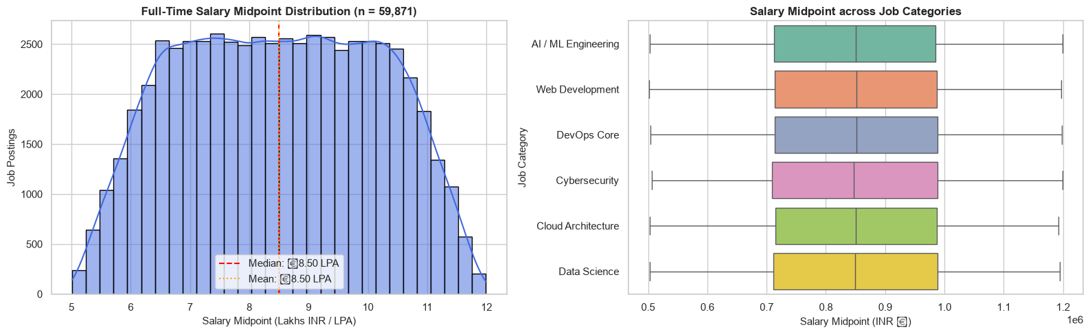
Figure 2. Full-time salary midpoint distribution (n = 59,871).

Independent Compensation Modeling (Problem Statement 6)
For full-time roles (n = 59,871), derived salary_midpoint = (min + max) / 2 exhibits a median midpoint of ₹8.50 LPA (Mean: ₹8.50 LPA; IQR: ₹7.12 LPA to ₹9.87 LPA), ranging from ₹3.00 LPA to ₹18.00 LPA. Monthly internship stipends (n = 40,129) span ₹15,000 to ₹44,999 with a median of ₹29,959/month (IQR: ₹22,464 to ₹37,392/month).
Category | Unit | Min | Q1 | Median | Q3 | Max | IQR Spread
Full-Time Permanent (n = 59,871) | Annual CTC (LPA) | ₹300,004 | ₹712,482 | ₹849,819 (₹8.50 LPA) | ₹987,195 | ₹1,799,992 | ₹274,714 (₹2.75 LPA)
Internship Contractual (n = 40,129) | Monthly Stipend (₹) | ₹15,000 | ₹22,464 | ₹29,959/month | ₹37,392 | ₹44,999 | ₹14,928/month

Compensation caveat: Stipends represent fixed monthly sums for early-career students and cannot be annualized or conflated with full-time CTC. Take-home pay cannot be deduced from advertised gross figures.

Experience & Educational Prerequisites (Problem Statement 7)
- Experience Mapping: Experience Level Demographics: Exactly 100% of internships require 0–1 Years (Entry Level), while 100% of full-time roles require 2–4 Years (Mid-Senior Level).
- Education Equity: Academic Qualification Equity: Educational requirements are distributed equally across Bachelor's Degree (33.4%), MCA / MSc (33.3%), and B.E. / B.Tech (33.2%), guaranteeing degree equity for graduates from all computing backgrounds.
- Snapshot Metrics: Snapshot Metrics: Applicant counts range between 15 and 479 (Median: 247). Career Growth Index spans 65% to 98% (Median: 82.0%). Both are descriptive platform metadata rather than selection probabilities.

05 | ACTION & RESPONSIBLE USE

Evidence-Backed Recommendations & Governance
Translating exploratory data into strategic guidance for students and placement cells (PS 8)

Three Core Evidence-Backed Insights
- 1. Domain Stacks: Domain-Specific Stacks (n = 100,000): Python (33.2k) and Linux (33.1k) are foundational pillars. Each category requires an integrated, cohesive stack of 6–8 domain-specific tools; students must master complete domain stacks.
- 2. Work Flexibility: Remote/Hybrid Flexibility (n = 100,000): 79.7% of listings support location flexibility (40% Remote, 39.7% Hybrid) across 8 Tier-1 hubs. Career cells should prepare students for distributed engineering cultures.
- 3. Internship Conduit: The Internship Conduit (n = 59,871 FT, n = 40,129 Internships): Full-time roles require 2–4 years (median ₹8.50 LPA); internships require 0–1 years (median ₹30,000/mo) and serve as the essential talent conduit into engineering.

Strategic Action Plan for College Career Cells
- 1. Pre-Placement MoUs: Formalize Pre-Placement MoUs: Target the 40.1% internship market as a primary conversion conduit.
- 2. End-to-End Tracks: Curriculum Stacks: Replace isolated tool courses with capstone tracks (MERN, Cloud DevOps, AI pipelines).
- 3. Remote Engineering: Remote Collaboration: Embed Git workflows, code reviews, Docker, and Agile tracking into undergraduate labs.
- 4. Contract Scrutiny: Contract Scrutiny: Counsel students to inspect contract type and probation clauses rather than assuming full-time status.
- 5. Core Enablers: Foundational Enablers: Mandate Python, SQL, and Linux for 100% of engineering students regardless of branch.
- 6. Degree Equity: Degree Equity: Actively invite non-traditional computing streams (B.Sc, BCA, MCA) to on-campus placement drives.

Methodological Limitations & Conclusion
- Limitations: Dataset appears synthetic or balanced; findings represent platform listings and not a complete national census of India's labor market. All 100,000 records represent the Information Technology sector.
Final Synthesis: This Analytical Workflow Report delivers comprehensive technical documentation of our exploratory data analysis across 100,000 technology postings in India. By executing all eight problem statements under pure descriptive EDA standards, Team Gradient Gods (Team 23) has established an end-to-end, reproducible framework bridging academic preparation and industry hiring demand.
Compliance statement: EDA-based decision support, not hiring prediction. Team Gradient Gods (Team 23) — DIET Path 2.

