INDIA TECH
CAREER INTELLIGENCE
Turning job-market data into actionable career insights
HACKATHON BUSINESS REPORT | OCTOBER 2026
Team: Gradient Gods (Team 23) | Institution: DIET Path 2 | Event: Manthan Hackathon — Calibo AI Academy
Team Members: Anne Mukesh Balaji • Kesiboyina Chandrika • Chinnam Joshitha • Chennam Divya
100,000  JOB POSTINGS | 34  DATA ATTRIBUTES | 6  TECH DOMAINS

Executive summary
Students often face information overload when choosing a technology career: job titles vary, skill lists are long, and it is hard to identify what to learn first. India Tech Career Intelligence turns a large job-posting dataset into clear career signals through exploratory data analysis (EDA).
The analysis highlights six domain-linked skill profiles, a strong presence of remote and hybrid listings, and different internship and full-time role patterns. It translates these patterns into practical preparation recommendations—while clearly noting that the dataset appears synthetic or balanced and is not a live-market forecast.
79.7%  REMOTE + HYBRID | ₹8.50 LPA  FULL-TIME MEDIAN MIDPOINT | ₹29,959  INTERNSHIP MEDIAN / MONTH
Core value: make career exploration simpler, evidence-based, and actionable.

01 | CONTEXT

The career-choice problem
From scattered vacancy information to structured guidance

Why this matters
Students need more than lists of trending technologies. They need to connect a target role with its core skills, understand early-career pathways, and make realistic preparation choices.
ROLE  What jobs exist? | SKILLS  What should I learn? | PATHWAY  How do I prepare?

Project objective
Analyze job postings to identify patterns in roles, skills, companies, locations, work modes, compensation, experience, and education—and convert them into concise recommendations for students and career-support teams.

Dataset at a glance
100K  Rows / postings | 34  Columns / attributes | IT  Industry represented
Scope: descriptive EDA using Python, Pandas, NumPy, Matplotlib and Seaborn. No predictive model was trained.

Preparation & quality checks
- Checked full-row duplicates: none found.
- Trimmed text whitespace; parsed posting and deadline dates.
- Converted career-growth index from percentage text to numeric.
- 33.5% missing probation values labeled “Not Specified.”
The dataset’s unusually balanced distributions are treated as a limitation—not as proof of real-world market share.

02 | ROLE LANDSCAPE

Six domains, 24 job titles
A quick map of the technology roles represented in the dataset
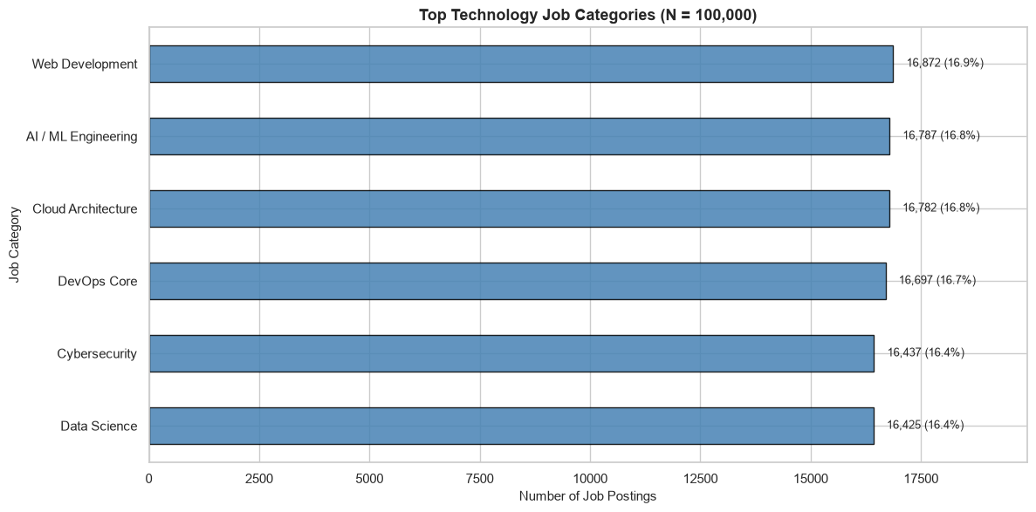
Figure 1. Job-category representation across the dataset.

What stands out
- The six categories are nearly evenly represented: 16.4%–16.9% each.
- Web Development is largest (16,872; 16.9%), followed by AI / ML Engineering (16,787; 16.8%) and Cloud Architecture (16,782; 16.8%).
- Across 24 titles, Full Stack Developer (4,321) and Machine Learning Engineer (4,286) are among the most frequent.

Career interpretation
Use job titles as a starting point, then inspect responsibilities and skill requirements. Similar titles may differ across employers; a domain-level view helps students compare paths without relying on title alone.
Dataset caution: category and title counts are unusually uniform, suggesting balanced or synthetic construction.

03 | SKILLS

Build a connected skill stack
The useful question is not “How many tools?” but “Which skills work together?”
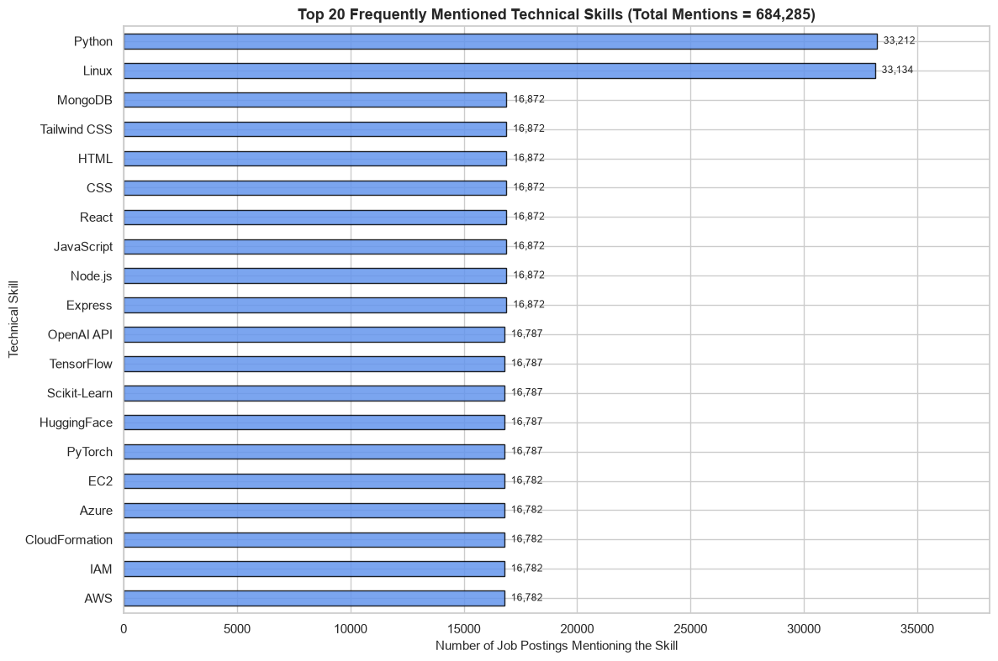
Figure 2. Frequently mentioned technical skills.

Skill signals
33,212  PYTHON MENTIONS | 33,134  LINUX MENTIONS | 6  PREDEFINED SKILL BUNDLES

Domain-to-skill examples
DOMAIN | EXAMPLE SKILLS
Web Development | HTML • CSS • JavaScript • React • Node.js
AI / ML | Python • PyTorch • TensorFlow • Scikit-learn
Cloud | AWS • Azure • IAM • EC2 • S3
DevOps | Docker • Kubernetes • Jenkins • CI/CD • Linux
Cybersecurity | Network Security • Wireshark • OWASP • Linux
Data Science | Python • SQL • Pandas • NumPy • Power BI

Interpretation
Python and Linux span adjacent domains, making them useful foundations. However, the dataset contains exactly six predefined skill bundles mapped one-to-one to six categories; skill co-occurrence is therefore not independent evidence of employer demand.

04 | WHERE & HOW

Flexible work is prominent
Work mode and location patterns in the dataset
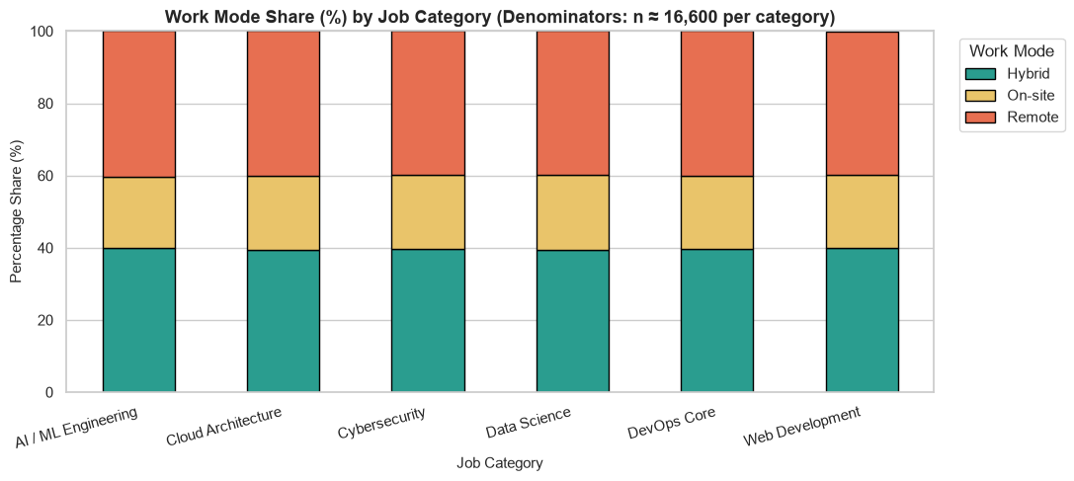
Figure 3. Work-mode distribution.
40.0%  REMOTE | 39.7%  HYBRID | 20.3%  ON-SITE

Geography snapshot
Eight listed cities are represented at roughly 12.4%–12.6% each. Chennai (12,636) and Noida (12,622) are among the highest counts; Maharashtra contributes 24,895 records (24.9%).

What students can do
- Prepare for collaboration across work modes: Git, clear documentation, task tracking and communication.
- Keep location flexibility in mind when exploring opportunities; do not assume one city dominates this dataset.
- Filter actual vacancies by location and work arrangement before making relocation or remote-work decisions.
Interpretation caution: city counts are also unusually balanced; treat them as dataset patterns, not a definitive ranking of India’s tech hubs.

05 | EARLY-CAREER & COMPENSATION

Internships and full-time roles differ
Separate the two pathways when interpreting experience and compensation
59.9%  FULL-TIME | 59,871 | 40.1%  INTERNSHIP | 40,129

Role profile
TYPE | EXPERIENCE | CONTRACT
Full-time | 2–4 years | Permanent
Internship | 0–1 years | Contractual

Compensation snapshot
Full-time salary midpoint (derived from range endpoints): median ₹8.50 LPA; middle 50% spans ₹7.12–₹9.87 LPA.
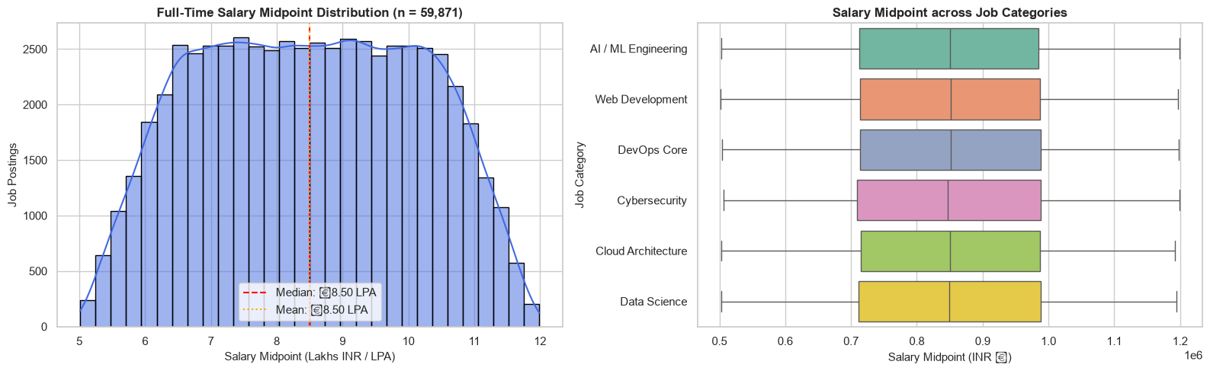
Figure 4. Full-time salary midpoint distribution.
Internship stipend: ₹15,000–₹44,999 per month; median ₹29,959.

Other indicators
Education is nearly evenly split among Bachelor’s (33.4%), MCA / MSc (33.3%), and B.E. / B.Tech (33.2%). Median applicant count is 247. Median career-growth index is 82%, but its definition is undocumented.

06 | ACTION & RESPONSIBLE USE

Turn patterns into preparation
Three evidence-backed recommendations for students and career-support teams

1. Choose a domain, then build a project
Evidence: six domain-linked skill bundles; Python and Linux recur across adjacent areas.
Action: select a target role and build one end-to-end project demonstrating a coherent stack—not a disconnected collection of tools.

2. Prepare for flexible collaboration
Evidence: 79.7% of listings are remote or hybrid.
Action: practice Git, documentation, asynchronous updates, and presenting project decisions; remain open to multiple work modes.

3. Treat internships as a distinct pathway
Evidence: internships are associated with 0–1 years and median stipend ₹29,959/month; full-time postings show 2–4 years and median salary midpoint ₹8.50 LPA.
Action: check eligibility, hands-on experience, stipend, contract type, and learning outcomes—not compensation alone.

Limitations
- Dataset appears synthetic / balanced; findings may not represent live market share.
- Skill bundles are predefined; frequency is not independent proof of demand.
- Salary midpoint is not verified pay or take-home salary; stipend is separate.
- Applicant counts are snapshots; career-growth index is undocumented and not predictive.
- All records are IT; cross-industry comparison is not possible.

Conclusion & next step
The project converts complex vacancy data into a readable career map. Next: refresh with independently sourced job postings, validate skill extraction, build an interactive explorer, and test usefulness with students and placement teams.
India Tech Career Intelligence | EDA-based decision support, not hiring prediction

