Current Trends of Artificial Intelligence Patents in Precision Psychiatry: A Systematic Evaluation of the Patent Landscape

Anne-Kathrin Kleine, Julia Cecil, Eva Lermer, & Susanne Gaube

# Introduction

Much of the difficulty in treating mental illnesses may be attributed to the poor knowledge we have about the pathophysiology of mental disorders. Symptoms overlap between multiple diseases, and symptom severity or presence may vary significantly among patients falling into one diagnostic category (Fernandes et al. 2017; Kendler 2016; Newson, Hunter, and Thiagarajan 2020). Consequently, individuals suffering from mental illnesses are often treated for several months or even years before receiving appropriate medication or adequate psychotherapeutic support (Bzdok and Meyer-Lindenberg 2018). For example, only about one-third of major depressive disorder patients experience a remission of symptoms after the initial treatment with antidepressants. One-third respond after an increased dosage or a supplemented therapy, and one-third experience no improvement in symptoms before discontinuing the treatment Souery et al. (2011). These changes in treatment regimens or ineffective treatment may impact patients’ quality of life and lead to high healthcare costs (Zanardi et al. 2021).

Precision psychiatry offers remedies against the trial-and-error approach in mental healthcare. Analogous to precision medicine, precision psychiatry takes individual variability in biological, environmental, and lifestyle into account to make adequate treatment recommendations (Council et al. 2011; Fernandes et al. 2017; Salazar de Pablo et al. 2021). In contrast to the conventional goal of psychiatric research to develop new treatments effective for a *majority* of patients, precision psychiatry shifts the focus to the precise selection of an existing therapy for *a single* patient or a small group of patients (**rush_etal06?**; Bzdok and Meyer-Lindenberg 2018; Fernandes et al. 2017). For example, a specific antidepressant may be more effective for one patient than another, even if both suffer from major depressive disorder (Adam Mourad Chekroud et al. 2016). Similarly, a particular psychotherapeutic approach may work better for some individuals than others (Lutz et al. 2022). By using information from multiple sources (e.g., biological markers, brain imaging, physiological records, environmental exposures, demographic information, and self-reported experience), precision psychiatry facilitates understanding complex disease mechanisms that are difficult to reconstruct using traditional diagnostic instruments alone (Fernandes et al. 2017; Salazar de Pablo et al. 2021). Sophisticated modeling techniques may be applied to predict mental conditions being present (diagnostic approach), the development of a condition in the future (prognostic approach), and the response to a specific treatment (predictive approach) at the individual subject level (Salazar de Pablo et al. 2021). Even moderately successful predictive models offer starting points for treatment selection, thus solving some problems associated with conventional trial-and-error treatment approaches (Bzdok and Meyer-Lindenberg 2018).

The task of deriving individual-level predictions may be accomplished particularly well using artificial intelligence (AI) through machine learning (ML) (Bzdok and Meyer-Lindenberg 2018). Ml algorithms can be used to identify complex patterns in observational data with the aim of predicting quantitative (e.g., symptom severity) and categorical (e.g., disease subgroups) phenotypes in clinical settings. The big advantage of ML approaches compared to classical inferential statistic is the three-step procedure of training an algorithm on a dataset, fine-tuning the algorithm until its predictions are sufficiently accurate, and leveraging the learned insight by making predictions for unknown data or unknown future events (Bzdok and Meyer-Lindenberg 2018; Dwyer, Falkai, and Koutsouleris 2018; **lin_etal20?**). Over the past years, researchers have put considerable efforts into developing highly accurate ML-based predictions applicable in precision psychiatry. For example, based on a large set of predictors derived from brain imaging data, Yahata et al. (2016) identified a small number of functional connections separating typically developed individuals from individuals with autism. They tested the models on an independent dataset. The model accurately classified 85% of the individuals in the validation sample. As another example, using functional imaging data from a large dataset of mental health patients, Drysdale et al. (2017) showed that patients might be clustered into four neurophysiological depression subtypes defined by distinct patterns of dysfunctional connectivity in limbic and frontostriatal networks. The accuracy of their classification model reached 86% in an independent sample. The authors also showed that these subtypes were associated with different clinical symptoms and varying responsiveness to transcranial magnetic stimulation therapy.

Despite the potential benefits of using AI to strengthen psychiatric and psychotherapeutic practice through precision psychiatry, implementing these techniques into practice is still at an early stage (Lee et al. 2021; Sendak et al. 2020; Adam M. Chekroud et al. 2021). In fact, until 2021, no FDA-approved or FDA-cleared AI applications existed in psychiatry (Lee et al. 2021). However, in recent years, tremendous research efforts have been put into developing effective AI-enabled diagnostic, predictive, prognostic, and treatment tools (Shatte, Hutchinson, and Teague 2019; Aafjes-van Doorn et al. 2021; Vaidyam et al. 2019; Miller and Polson 2019; Nahavandi et al. 2022). As a result, a number of precision psychiatry tools are now commercially available. For example, *Cognoa* offers digital diagnostic and therapeutic products that include personalized treatment plans based on neuro-imaging data (Vaughan Brent and Abbas Abdelhalim 2019). Given the increasing relevance of AI for implementing precision psychiatry into practice, we use patent analysis to shed light on recent developments regarding AI-enabled diagnostic, prognostic, and predictive tools in the mental health domain. The global market for mental health software is expected to increase from USD 1.9 billion in 2020 to USD 5.1 billion by 2027 (Markets 2022). Patent analysis helps comprehend the technology development of AI-enabled tools in mental healthcare and identify solutions that have the greatest chances of market adaptation (Ailia et al. 2022; Krestel et al. 2021).

# Materials and Methods

## Database Search

This study was performed in accordance with the Preferred Reporting Items for Systematic Reviews and Meta-Analyses (PRISMA). We used the Derwent Innovation (DI) database and its smart search function for the patent search. The Derwent World Patents Index (DWPI) of DI offers the option to extract additional information on patent novelty, use, advantage, and technical focus. The smart search function analyses word strings semantically and automatically expands keywords including related relevant terms. For the final search, we used smart search terms referring to precision psychiatry, artificial intelligence, and mental illness. Since we intended to provide insight into current developments, we limited our search to patents published after the 1st of January, 2015. Terms relating to precision psychiatry were collected from a systematic review on the same topic (Salazar de Pablo et al. 2021). For the keywords relating to mental illness, we collected the mental illness groups mentioned in the DSM-V-TR manual (Association 2022). We refined the search term by requiring keywords relating to mental illness to be mentioned in the patent abstract. The DI database was searched up until October 2022 using the search query:

SSTO[1]=(“risk prediction”) OR SSTO=(“predictive”) OR SSTO=(“prognostic”) OR SSTO=(“diagnostic”)) AND (SSTO=(“artificial intelligence”) OR SSTO=(“machine learning”)) AND (SSTO=(“psychiatrist”) OR SSTO=(“psychotherapist”) OR SSTO=(“mental health”) OR SSTO=(“mental illness”)) AND (ABO[2]=(“psychiatr*”) OR ABO=(psychotherap*) OR ABO=(“mental health”) OR ABO=(“mental illness”) OR ABO=(“mood disorder*”) OR ABO=(“affective disorder*”) OR ABO=(depress*) OR ABO=(Neurodevelopmental) OR ABO=(autis*) OR ABO=(“ADHD”) OR ABO=(“conduct disorder*”) OR ABO=(“mood dysregulation”) OR ABO=(“gender dysphoria”) OR ABO=(“gaming disorder*”) OR ABO=(“paraphilic disorder*”) OR AB=(“bipolar”) OR ABO=(anxi*) OR ABO=(obsess*) OR ABO=(trauma*) OR ABO=(posttrauma*) OR ABO=(“learning disorder*”) OR ABO=(“social communication disorder*”) OR ABO=(“somatic symptom disorder*”) OR ABO=(dissociat*) OR ABO=(“eating”) OR ABO=((“sleep”) NOT (“sleep apnea”)) OR ABO=(“sexual disorder*”) OR ABO=(addict*) OR ABO=(substance) OR ABO=(“personality”) OR ABO=(“psychosis”) OR ABO=(psychot*) OR ABO=(“schizo”)) AND DP[3]>=(20150101)

We extracted DWPI patent families. DWPI patent families group together patent records for the same invention filed in different jurisdictions, thus avoiding the retrieval of duplicate entries for the same invention. Please see here for more information on DWPI patent families: <https://support.clarivate.com/Patents/s/article/Derwent-Innovation-Patent-Family-Collapse-FAQ?>.

## Patent Selection and Coding of Patent Information

We summarized the search and review process in Figure Figure 1. First, we removed all remaining duplicate entries. Next, the titles, abstracts, descriptions, and claims (DWPI and original) of all patents were examined by AK and X. We included patents if 1) they reported on a diagnostic (predicting the presence of a condition), prognostic (predicting clinical outcomes in the absence of therapy), predictive (predicting treatment outcomes), or a precision treatment tool; 2) the described tool was designed to make predictions for mentally ill individuals, defined according to established psychometric criteria; 3) AI was used for making predictions; 4) the tool could be used by mental health practitioners. This led to the exclusion of tools that were used only for the management of mental health records (*n* = ; e.g., …); tools not targeted towards mentally ill patients (*n* = ; e.g.,…); tools that did not involve AI to make predictions (*n* = ; e.g., …); tools that may not be used by mental health practitioners (*n* = ; e.g., …).

|  |
| --- |
| Figure 1: Patent search and selection according to PRISMA guidelines. |

In addition to the information obtained from the DI patent database, AK and JC additionally scanned the abstracts, claims, and patent descriptions to retrieve information on the targeted illness group, the type of precision psychiatry used (i.e., diagnostic, predictive, prognostic, or precision treatment), the type of treatment provided, and the main data sources used to make predictions.

## Data Analysis

The data was analysed using Excel (Version X) and R (Version X). We analysed information about the targeted illness group, the type of precision psychiatry used, the type of treatment provided, and the main data sources used to make predictions. Moreover, we analysed the annual trend of patent publications between January 2015 and October 2022, the regional distribution of patent publications, top 15 assignees, distribution of IPC classes, patent relevancy (based on DI intelligence), patent strategic importance (based on DI intelligence), probability of grant (based on DI intelligence), domain influence (based on DI intelligence), and the number of citing patents. In addition, we conducted text analyses of DWPI abstracts, patent novelty, patent use, and the generated advantage.

# Results

## Read in data  
library("readxl")  
data <- read_excel("Search_results/2022-10-21_exported.xlsx")

# remove all rows that contain "exclude" in Include/exclude column  
data <- data[!grepl("Exclude", data$`Include/exclude`),]

# remove unnecesssary string  
data$`Reason exclude` <- gsub("\\s*\\([^\\)]+\\)","",as.character(data$`Reason exclude`))  
data$`Treatment, treatment recommendation, treatment adjustment (in case of management system)` <- gsub("\\s*\\([^\\)]+\\)","",as.character(data$`Treatment, treatment recommendation, treatment adjustment (in case of management system)`))  
data$Data <- gsub("\\s*\\([^\\)]+\\)","",as.character(data$Data))

## Frequencies

library(tidyverse)

── Attaching packages ─────────────────────────────────────── tidyverse 1.3.2 ──  
✔ ggplot2 3.3.6 ✔ purrr 0.3.4  
✔ tibble 3.1.7 ✔ dplyr 1.0.9  
✔ tidyr 1.2.0 ✔ stringr 1.4.0  
✔ readr 2.1.2 ✔ forcats 0.5.1  
── Conflicts ────────────────────────────────────────── tidyverse_conflicts() ──  
✖ dplyr::filter() masks stats::filter()  
✖ dplyr::lag() masks stats::lag()

# create illness group strings  
illness_groups <- unlist(strsplit(data$`Illness group`, ",")) %>% str_trim(., side = "both") %>% tolower(.) %>% na.omit(.)

# create frequency table  
illness_groups_freq <- data.frame(illness_groups) %>% count(illness_groups) %>% data.frame() %>% arrange(-n)  
  
# plot frequency table   
ggplot(illness_groups_freq, aes(x = reorder(illness_groups,-n), y = n)) +   
 geom_bar(stat = "identity", color = "black", fill = "grey") +  
 scale_x_discrete(labels = function(x)   
 stringr::str_wrap(x, width = 10))+  
 labs(title = "Frequency by illness group", x = "\nIllness group", y = "Frequency\n") +  
 theme_classic()

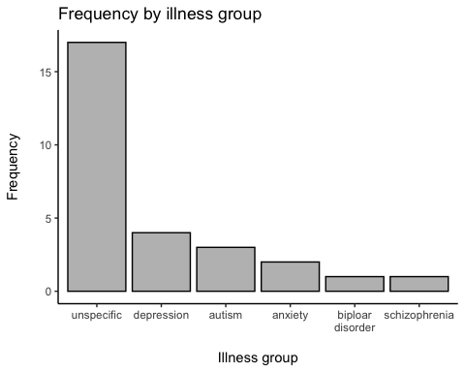

# create precision psychiatry group strings  
precision_groups <- unlist(strsplit(data$`Precision psychiatry domain`, ",")) %>% str_trim(., side = "both") %>% tolower(.) %>% na.omit(.)

# create frequency table  
precision_groups_freq <- data.frame(precision_groups) %>% count(precision_groups) %>% data.frame() %>% arrange(-n)  
  
# plot frequency table   
ggplot(precision_groups_freq, aes(x = reorder(precision_groups, -n), y = n)) +   
 geom_bar(stat = "identity", color = "black", fill = "grey") +  
 labs(title = "Frequency by precision psychiatry group", x = "\nPrecision psychiatry domain", y = "Frequency\n") +  
 theme_classic()

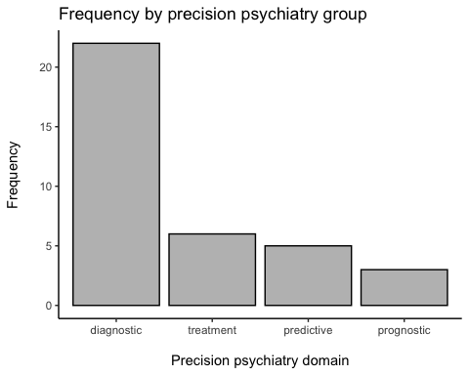

# create precision treatment groups strings  
treatment_groups <- unlist(strsplit(data$`Treatment, treatment recommendation, treatment adjustment (in case of management system)`, ",")) %>% str_trim(., side = "both") %>% tolower(.) %>% na.omit(.)

# create frequency table  
treatment_groups_freq <- data.frame(treatment_groups) %>% count(treatment_groups) %>% data.frame() %>% arrange(-n)  
  
# plot frequency table   
ggplot(treatment_groups_freq, aes(x = reorder(treatment_groups, -n), y = n)) +   
 geom_bar(stat = "identity", color = "black", fill = "grey") +  
 scale_x_discrete(labels = function(x)   
 stringr::str_wrap(x, width = 10))+  
 labs(title = "Frequency by precision treatment group", x = "\nPrecision treatment group", y = "Frequency\n") +  
 theme_classic()

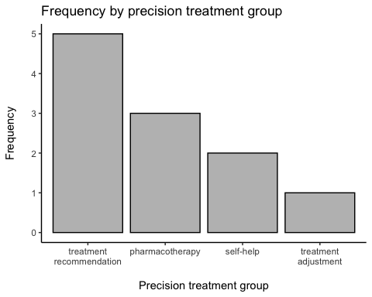

# create data type groups  
data_types <- unlist(strsplit(data$Data, ",")) %>% str_trim(., side = "both") %>% tolower(.) %>% na.omit(.)

# create frequency table  
data_types_freq <- data.frame(data_types) %>% count(data_types) %>% data.frame() %>% arrange(-n)  
  
# plot frequency table   
ggplot(data_types_freq, aes(x = reorder(data_types, -n), y = n)) +   
 geom_bar(stat = "identity", color = "black", fill = "grey") +  
 scale_x_discrete(labels = function(x)   
 stringr::str_wrap(x, width = 10))+  
 labs(title = "Frequency by data types", x = "\nData type", y = "Frequency\n") +  
 theme_classic()

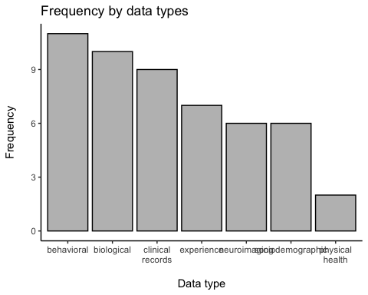

# create CPC groups  
cpc <- unlist(strsplit(data$`CPC - Current - DWPI`, " | ")) %>% str_trim(., side = "both") %>% tolower(.) %>% na.omit(.)   
cpc <- cpc[cpc != "|"];  
  
CPC_short <- substr(cpc, 1, 4)

# create frequency table  
CPC_freq <- data.frame(CPC_short) %>% count(CPC_short) %>% data.frame() %>% arrange(-n) %>% head(., n = 10)  
  
# plot frequency table   
ggplot(CPC_freq, aes(x = reorder(CPC_short, -n), y = n)) +   
 geom_bar(stat = "identity", color = "black", fill = "grey") +  
 scale_x_discrete(labels = function(x)   
 stringr::str_wrap(x, width = 10))+  
 labs(title = "Frequency by CPC group", x = "\nCPC group", y = "Frequency\n") +  
 theme_classic()

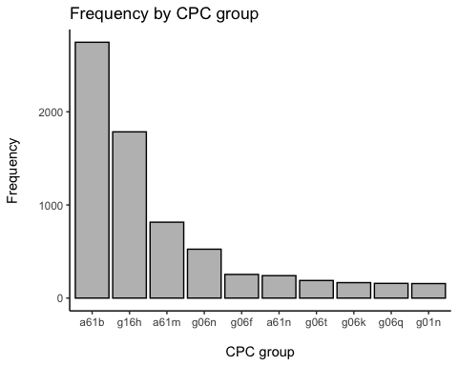

## Trend data

data <- data %>%  
 mutate("Publication Date" = as.Date(data$`Publication Date`, format = "%Y-%m-%d"))  
  
data$Pub_year <- format(data$`Publication Date`, format = "%Y")  
  
  
# create frequency table  
trend_freq <- data.frame(data$Pub_year) %>% count(data.Pub_year) %>% data.frame() %>% arrange(-n)  
  
  
# create trend plot   
trend_freq %>%  
ggplot(aes(x = data.Pub_year, y = n, group = 1)) +  
 geom_point(color = "darkorchid4") +  
 geom_line() +   
 labs(title = "Annual trend data",  
 y = "Frequency\n",  
 x = "\nPatent publication year") +   
 theme_bw(base_size = 15)

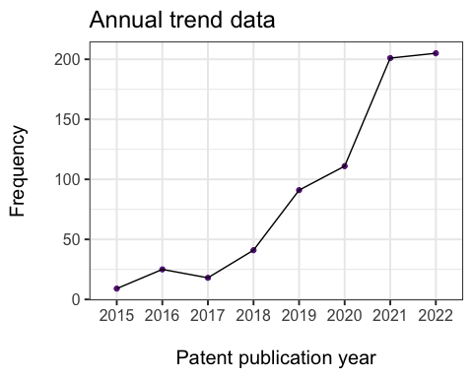

Aafjes-van Doorn, Katie, Céline Kamsteeg, Jordan Bate, and Marc Aafjes. 2021. “A Scoping Review of Machine Learning in Psychotherapy Research.” *Psychotherapy Research* 31 (1): 92–116. <https://doi.org/10.1080/10503307.2020.1808729>.

Ailia, Muhammad Joan, Nishant Thakur, Jamshid Abdul-Ghafar, Chan Kwon Jung, Kwangil Yim, and Yosep Chong. 2022. “Current Trend of Artificial Intelligence Patents in Digital Pathology: A Systematic Evaluation of the Patent Landscape.” *Cancers* 14 (10): 2400. <https://doi.org/10.3390/cancers14102400>.

Association, American Psychiatric. 2022. *Diagnostic and Statistical Manual of Mental Disorders*. 5th ed., text rev. <https://doi.org/10.1176/appi.books.9780890425787>.

Bzdok, Danilo, and Andreas Meyer-Lindenberg. 2018. “Machine Learning for Precision Psychiatry: Opportunities and Challenges.” *Biological Psychiatry: Cognitive Neuroscience and Neuroimaging* 3 (3): 223–30. <https://doi.org/10.1016/j.bpsc.2017.11.007>.

Chekroud, Adam M., Julia Bondar, Jaime Delgadillo, Gavin Doherty, Akash Wasil, Marjolein Fokkema, Zachary Cohen, et al. 2021. “The Promise of Machine Learning in Predicting Treatment Outcomes in Psychiatry.” *World Psychiatry* 20 (2): 154–70. <https://doi.org/10.1002/wps.20882>.

Chekroud, Adam Mourad, Ryan Joseph Zotti, Zarrar Shehzad, Ralitza Gueorguieva, Marcia K Johnson, Madhukar H Trivedi, Tyrone D Cannon, John Harrison Krystal, and Philip Robert Corlett. 2016. “Cross-Trial Prediction of Treatment Outcome in Depression: A Machine Learning Approach.” *The Lancet Psychiatry* 3 (3): 243–50. <https://doi.org/10.1016/S2215-0366(15)00471-X>.

Council, National Research, Division on Earth and Life Studies, Board on Life Sciences, and Committee on A. Framework for Developing a New Taxonomy of Disease. 2011. *Toward Precision Medicine: Building a Knowledge Network for Biomedical Research and a New Taxonomy of Disease*. National Academies Press.

Drysdale, Andrew T, Logan Grosenick, Jonathan Downar, Katharine Dunlop, Farrokh Mansouri, Yue Meng, Robert N Fetcho, et al. 2017. “Resting-State Connectivity Biomarkers Define Neurophysiological Subtypes of Depression.” *Nature Medicine* 23 (1): 28–38. <https://doi.org/10.1038/nm.4246>.

Dwyer, Dominic B., Peter Falkai, and Nikolaos Koutsouleris. 2018. “Machine Learning Approaches for Clinical Psychology and Psychiatry.” *Annual Review of Clinical Psychology* 14 (1): 91–118. <https://doi.org/10.1146/annurev-clinpsy-032816-045037>.

Fernandes, Brisa S., Leanne M. Williams, Johann Steiner, Marion Leboyer, André F. Carvalho, and Michael Berk. 2017. “The New Field of ‘Precision Psychiatry’.” *BMC Medicine* 15 (1): 80. <https://doi.org/10.1186/s12916-017-0849-x>.

Kendler, Kenneth S. 2016. “The Nature of Psychiatric Disorders.” *World Psychiatry* 15 (1): 5–12. <https://doi.org/10.1002/wps.20292>.

Krestel, Ralf, Renukswamy Chikkamath, Christoph Hewel, and Julian Risch. 2021. “A Survey on Deep Learning for Patent Analysis.” *World Patent Information* 65 (June): 102035. <https://doi.org/10.1016/j.wpi.2021.102035>.

Lee, Ellen E., John Torous, Munmun De Choudhury, Colin A. Depp, Sarah A. Graham, Ho-Cheol Kim, Martin P. Paulus, John H. Krystal, and Dilip V. Jeste. 2021. “Artificial Intelligence for Mental Health Care: Clinical Applications, Barriers, Facilitators, and Artificial Wisdom.” *Biological Psychiatry: Cognitive Neuroscience and Neuroimaging* 6 (9): 856–64. <https://doi.org/10.1016/j.bpsc.2021.02.001>.

Lutz, Wolfgang, Anne-Katharina Deisenhofer, Julian Rubel, Björn Bennemann, Julia Giesemann, Kaitlyn Poster, and Brian Schwartz. 2022. “Prospective Evaluation of a Clinical Decision Support System in Psychological Therapy.” *Journal of Consulting and Clinical Psychology* 90 (1): 90–106. <https://doi.org/10.1037/ccp0000642>.

Markets, Research and. 2022. “Mental Health Software - Global Market Trajectory & Analytics.” <https://www.researchandmarkets.com/reports/5140364/mental-health-software-global-market-trajectory>.

Miller, Evonne, and Debra Polson. 2019. “Apps, Avatars, and Robots: The Future of Mental Healthcare.” *Issues in Mental Health Nursing* 40 (3): 208–14. <https://doi.org/10.1080/01612840.2018.1524535>.

Nahavandi, Darius, Roohallah Alizadehsani, Abbas Khosravi, and U Rajendra Acharya. 2022. “Application of Artificial Intelligence in Wearable Devices: Opportunities and Challenges.” *Computer Methods and Programs in Biomedicine* 213 (January): 106541. <https://doi.org/10.1016/j.cmpb.2021.106541>.

Newson, Jennifer J., Daniel Hunter, and Tara C. Thiagarajan. 2020. “The Heterogeneity of Mental Health Assessment.” *Frontiers in Psychiatry* 11. <https://www.frontiersin.org/articles/10.3389/fpsyt.2020.00076>.

Salazar de Pablo, Gonzalo, Erich Studerus, Julio Vaquerizo-Serrano, Jessica Irving, Ana Catalan, Dominic Oliver, Helen Baldwin, et al. 2021. “Implementing Precision Psychiatry: A Systematic Review of Individualized Prediction Models for Clinical Practice.” *Schizophrenia Bulletin* 47 (2): 284–97. <https://doi.org/10.1093/schbul/sbaa120>.

Sendak, Mark P., Joshua D’Arcy, Sehj Kashyap, Michael Gao, Marshall Nichols, Kristin Corey, William Ratliff, and Suresh Balu. 2020. “A Path for Translation of Machine Learning Products into Healthcare Delivery.” *EMJ Innovations*, January. <https://doi.org/10.33590/emjinnov/19-00172>.

Shatte, Adrian B. R., Delyse M. Hutchinson, and Samantha J. Teague. 2019. “Machine Learning in Mental Health: A Scoping Review of Methods and Applications.” *Psychological Medicine* 49 (9): 1426–48. <https://doi.org/10.1017/S0033291719000151>.

Souery, Daniel, Alessandro Serretti, Raffaella Calati, Pierre Oswald, Isabelle Massat, Anastasios Konstantinidis, Sylvie Linotte, et al. 2011. “Switching Antidepressant Class Does Not Improve Response or Remission in Treatment-Resistant Depression.” *Journal of Clinical Psychopharmacology* 31 (4): 512–16. <https://doi.org/10.1097/JCP.0b013e3182228619>.

Vaidyam, Aditya Nrusimha, Hannah Wisniewski, John David Halamka, Matcheri S. Kashavan, and John Blake Torous. 2019. “Chatbots and Conversational Agents in Mental Health: A Review of the Psychiatric Landscape.” *The Canadian Journal of Psychiatry* 64 (7): 456–64. <https://doi.org/10.1177/0706743719828977>.

Vaughan Brent, CA, US, and CA Abbas Abdelhalim US. 2019. PLATFORM AND SYSTEM FOR DIGITAL PERSONALIZED MEDICINE, issued January 2019. <https://www.derwentinnovation.com/tip-innovation/>.

Yahata, Noriaki, Jun Morimoto, Ryuichiro Hashimoto, Giuseppe Lisi, Kazuhisa Shibata, Yuki Kawakubo, Hitoshi Kuwabara, et al. 2016. “A Small Number of Abnormal Brain Connections Predicts Adult Autism Spectrum Disorder.” *Nature Communications* 7 (1): 11254. <https://doi.org/10.1038/ncomms11254>.

Zanardi, Raffaella, Dario Prestifilippo, Chiara Fabbri, Cristina Colombo, Eduard Maron, and Alessandro Serretti. 2021. “Precision Psychiatry in Clinical Practice.” *International Journal of Psychiatry in Clinical Practice* 25 (1): 19–27. <https://doi.org/10.1080/13651501.2020.1809680>.

1. DWPI smart search term
2. original abstract
3. publication date