Exercise

Anne

# Preprocessing

## Reading data in

## Manipulating data

## Exporting data

For a cleaner look, all the above steps could also be performed in a separate “data_preprocessing.R” file that may be stored in the R folder.

## Storing and sourcing custom functions from the R folder

Now, we need to source our custom functions and read in the preprocessed data.

# Tables and visualisations

## Reading in data

## Creating a correlation table

In the following, we display the correlations between the core model variables.

### Creating composites

## Creating the correlation table

Age anxty1 gattAI1 SocInf1 soctechblind  
Age   
anxty1 -0.03   
gattAI1 0.00 0.16*   
SocInf1 0.12 -0.11 0.17*   
soctechblind 0.09 0.30*** 0.30*** -0.03   
trust1 -0.06 -0.21** 0.12 0.57*** -0.22**

| *Correlations between core model variables* | | | | |
| --- | --- | --- | --- | --- |
| Age | anxty1 | gattAI1 | SocInf1 | soctechblind |
|  |  |  |  |  |
| -0.03 |  |  |  |  |
| 0.00 | 0.16* |  |  |  |
| 0.12 | -0.11 | 0.17* |  |  |
| 0.09 | 0.30*** | 0.30*** | -0.03 |  |
| -0.06 | -0.21** | 0.12 | 0.57*** | -0.22** |
| *Note.* An example datase. | | | | |
| * p < .05, ** p < .01, *** p < .001 | | | | |

## Creating plots

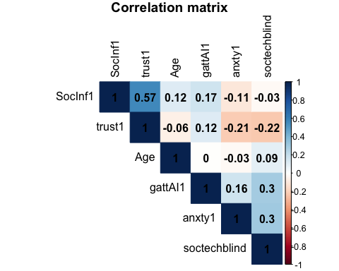

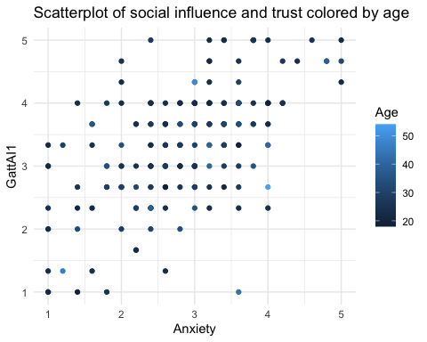

# Theory

## Theoretical background

As reported by Al-Antari et al. (2020), students are eager to receive formal training on how to use AI Chatbots for their studies.

## Methods

We used the questionnaire developed by G. Andrejková et al. (2021) to measure the readiness to use AI among medical students.

# References

Al-Antari, M. A., Han, S.-M., & Kim, T.-S. (2020). Evaluation of deep learning detection and classification towards computer-aided diagnosis of breast lesions in digital x-ray mammograms. *Computer Methods and Programs in Biomedicine*, *196*(doh, 8506513), 105584. <https://doi.org/10.1016/j.cmpb.2020.105584>

G. Andrejková, Ľ. Antoni, E. Bruoth, P. Bugata, D. Gajdoš, J. Guniš, Š. Horvát, D. Hudák, V. Kmečová, S. Krajči, O. Krídlo, M. Opiela, V. Pristaš, A. Szabari, R. Staňa, M. Staňková, Ľ. Šnajder, D. Šveda, & G. Vozáriková. (2021). *2021 19th international conference on emerging eLearning technologies and applications (ICETA)*. 12–17. <https://doi.org/10.1109/ICETA54173.2021.9726253>