**How to respond to issues with GitHub’s Issue Tracker**

Step 1: go to the repository in question and click on ‘Issues’

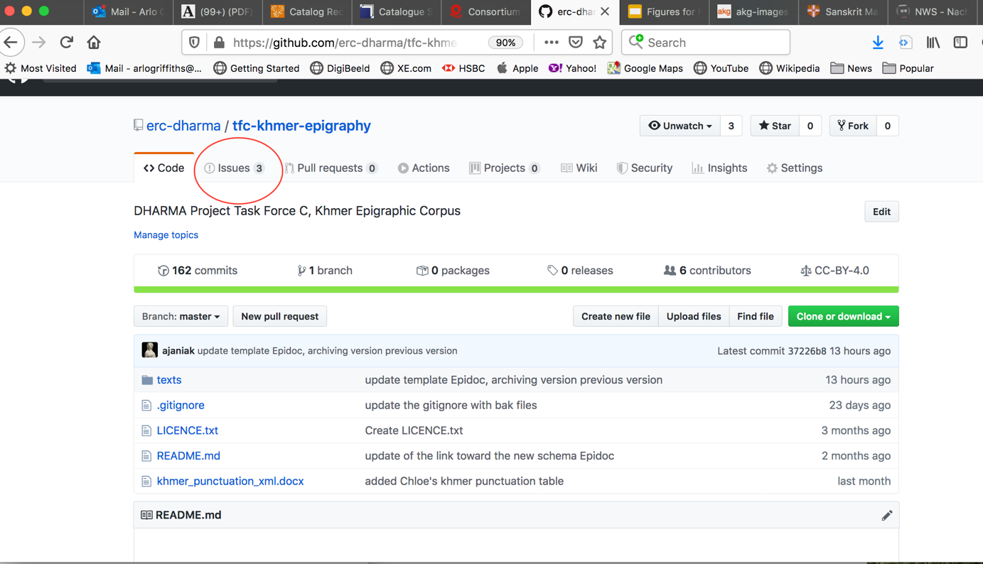

Step 2: Identify the issue by its number, and see whether it has been assigned to anyone specific

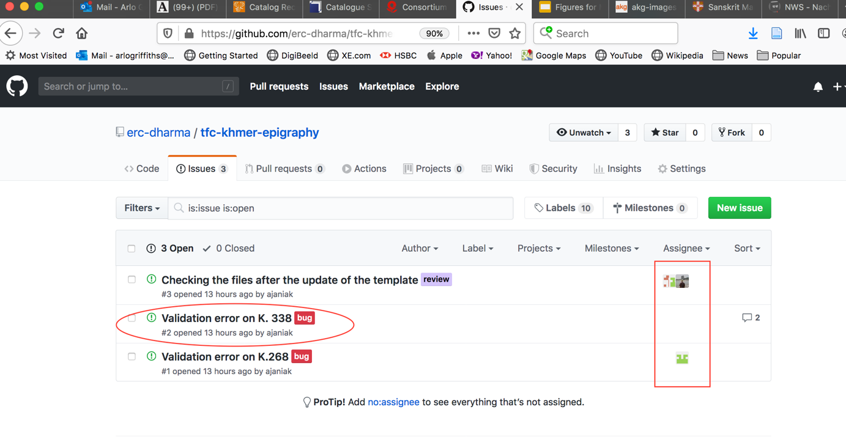

Step 3: See what comments have been made on the issue

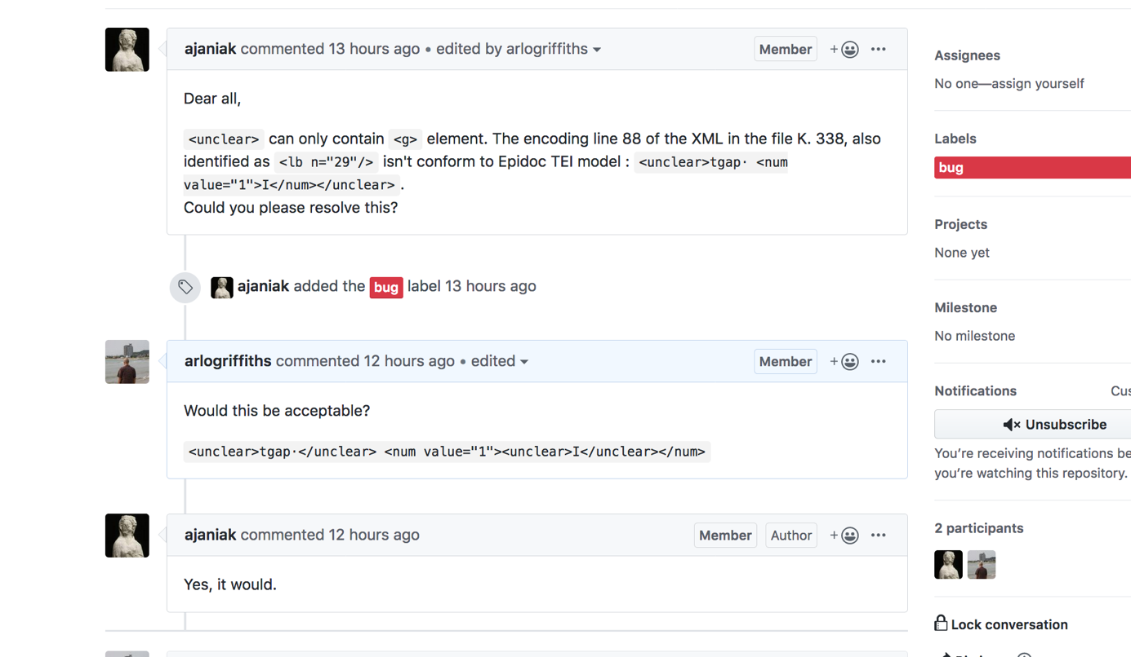

Step 4: Make the necessary changes in the relevant XML file, and record all changes made by adding a new <change> entry to <revisionDesc>

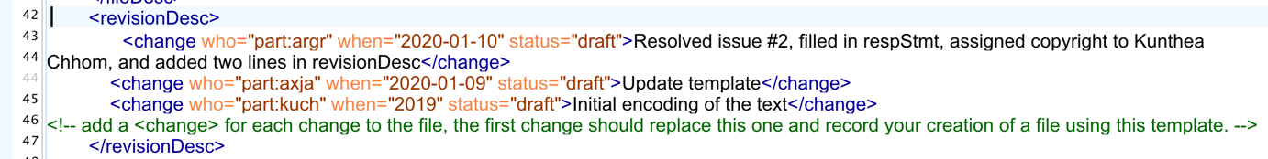

Step 5: Save the file, add and commit it to the repository, applying a commit message that makes explicit which issue number (#) has been treated, and push the commit.

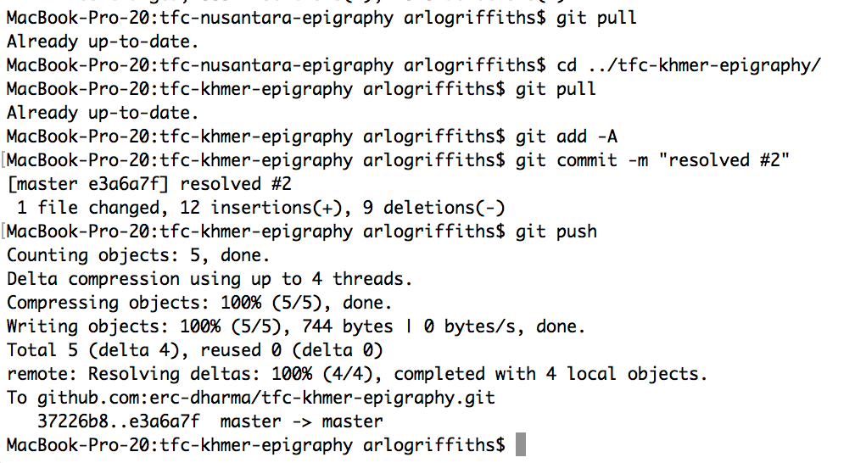

Step 6: This automatically communicated to GitHub that the issue has been resolved, as you will almost instantly see on GitHub’s interface.

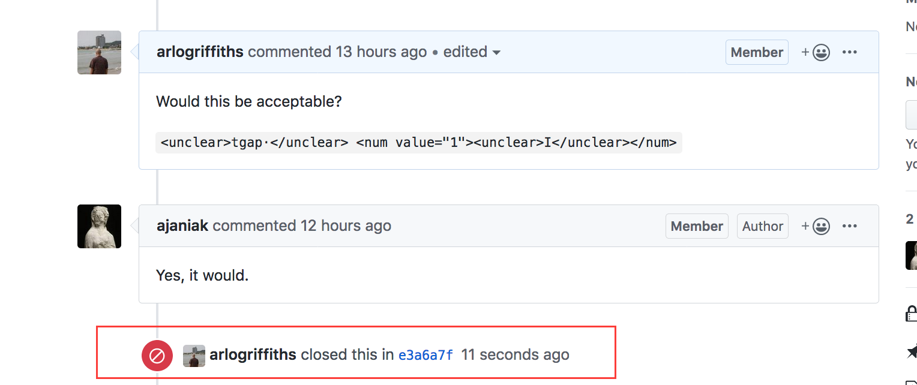

It is, however, also possible to use a different commit message and close on issue manually on GitHub’s interface.