# PLS-DA all data

|  |  |  |  |
| --- | --- | --- | --- |
|  |  | Aqueous | Organic |
|  | Coma vs Ctmax |  |  |
|  | Temperature |  | PLSScore2DImage |
|  | Location |  | PLSScore2DImage |

# PLS-DA location specific

|  |  |  |
| --- | --- | --- |
|  | Aqueous | Organic |
| Betta | PLSScore2DImage | PLSScore2DImage |
| Karasburg | PLSScore2DImage | PLSScore2DImage |
| Otavi | PLSScore2DImage | PLSScore2DImage |
| Stampriet | PLSScore2DImage | PLSScore2DImage |

All temperature aq

Otavi aq

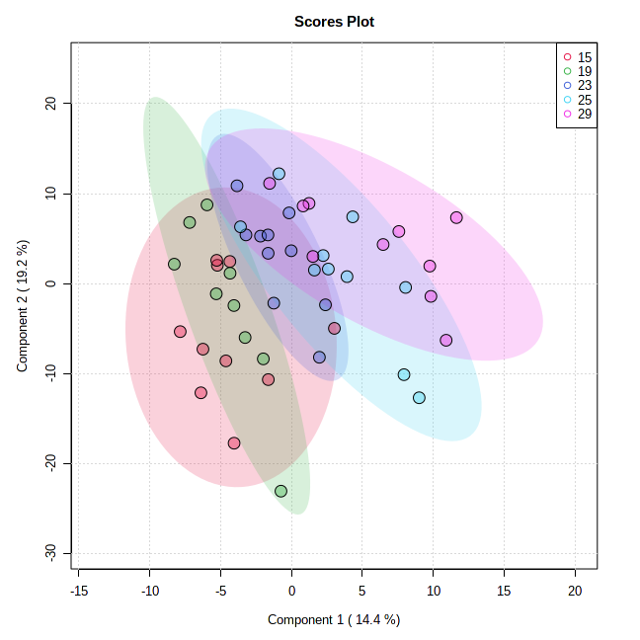

Betta aq

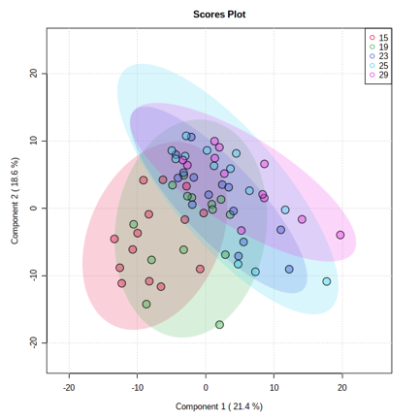

All Temperature only 15 and 29

Aqeous

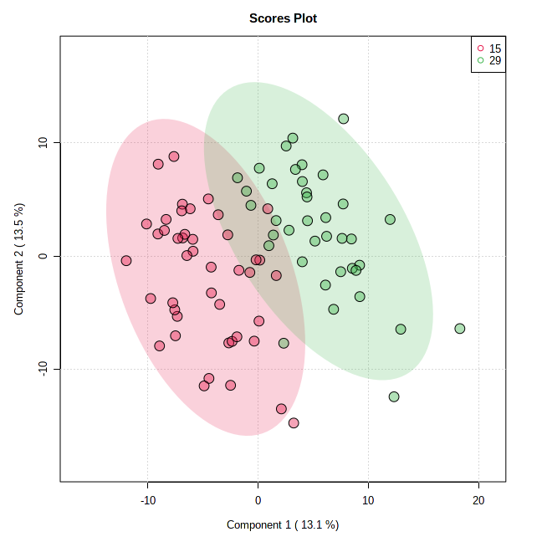

Organic

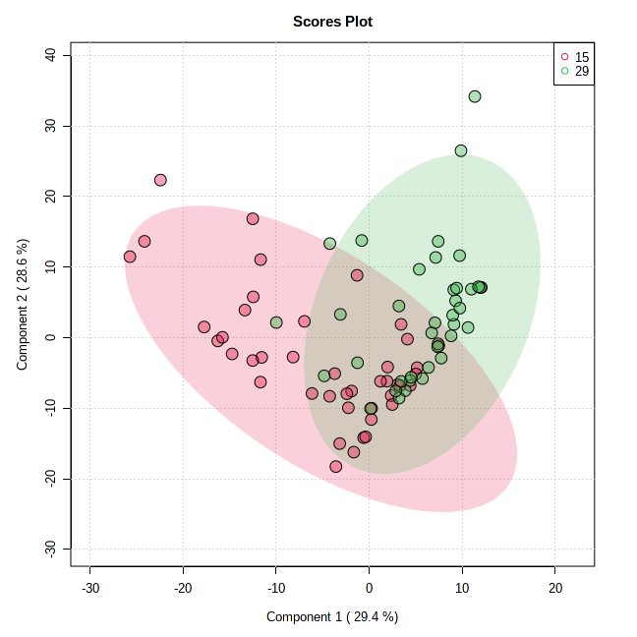

|  |  |
| --- | --- |
| Thomas | Kirsten |
|  |  |

Kirstens temperaturdata

PCA

