Linear mixed models

Annegreet Veeken

2023-11-09

## Nutrients and environment (Linear mixed model)

### N

formula: log(N) ~ MAT + I(MAT^2) + MAP + I(MAP^2) + ndep + soil_age + lith_simp + (1|cell)

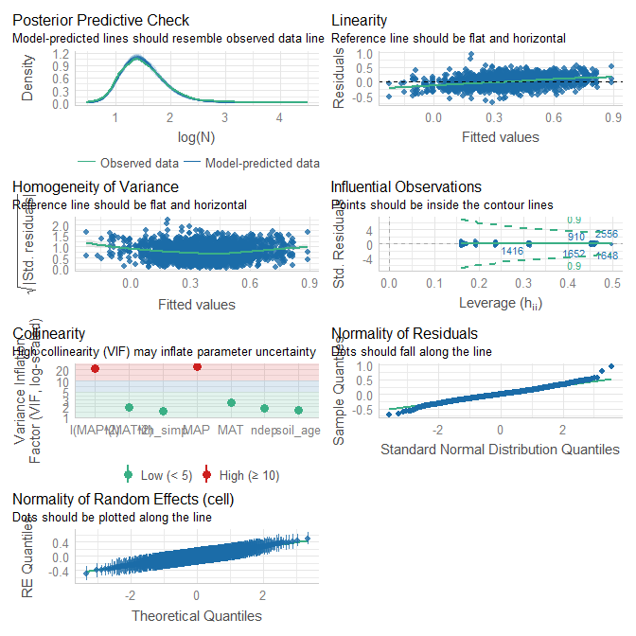

## Warning: Heteroscedasticity (non-constant error variance) detected (p < .001).

## OK: No outliers detected.  
## - Based on the following method and threshold: cook (0.9).  
## - For variable: (Whole model)

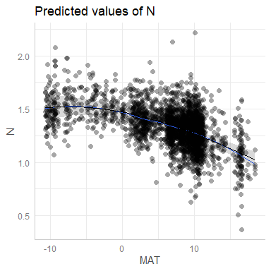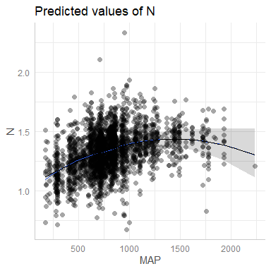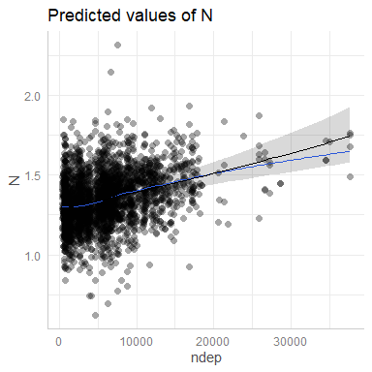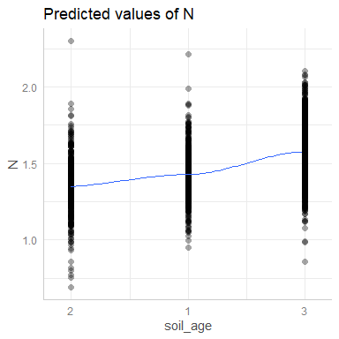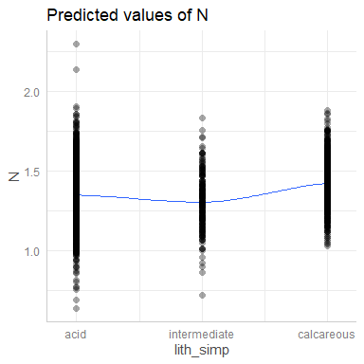

| Parameter | Coefficient | SE | CI | CI_low | CI_high | p | Effects |
| --- | --- | --- | --- | --- | --- | --- | --- |
| (Intercept) | 0.0777 | 0.0498 | 0.95 | -0.0199 | 0.1752 | 0.1186 | fixed |
| MAT | -0.0089 | 0.0018 | 0.95 | -0.0125 | -0.0053 | 0.0000 | fixed |
| I(MAT^2) | -0.0006 | 0.0002 | 0.95 | -0.0009 | -0.0003 | 0.0002 | fixed |
| MAP | 0.0004 | 0.0001 | 0.95 | 0.0002 | 0.0007 | 0.0000 | fixed |
| I(MAP^2) | 0.0000 | 0.0000 | 0.95 | 0.0000 | 0.0000 | 0.0016 | fixed |
| ndep | 0.0000 | 0.0000 | 0.95 | 0.0000 | 0.0000 | 0.0000 | fixed |
| soil_age1 | 0.0565 | 0.0229 | 0.95 | 0.0116 | 0.1014 | 0.0136 | fixed |
| soil_age3 | 0.1546 | 0.0183 | 0.95 | 0.1187 | 0.1906 | 0.0000 | fixed |
| intermediate | -0.0336 | 0.0251 | 0.95 | -0.0829 | 0.0156 | 0.1809 | fixed |
| calcareous | 0.0525 | 0.0162 | 0.95 | 0.0208 | 0.0843 | 0.0012 | fixed |
| SD (Intercept) | 0.1702 | NA | 0.95 | NA | NA | NA | random |
| SD (Observations) | 0.1880 | NA | 0.95 | NA | NA | NA | random |

|  | x |
| --- | --- |
| Conditional R2 | 0.5163775 |

|  | x |
| --- | --- |
| Marginal R2 | 0.1197906 |

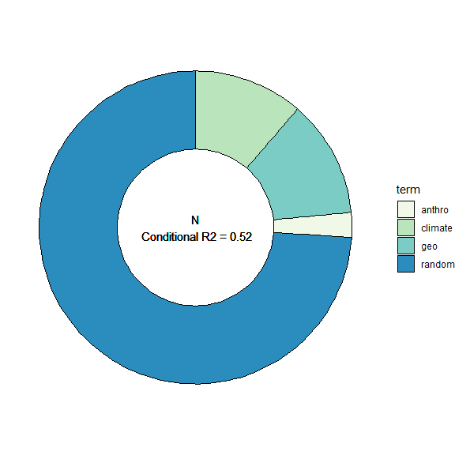

### P

formula:log(P) ~ MAT + I(MAT^2) + MAP + I(MAP^2) + ndep + soil_age + lith_simp + (1|cell)

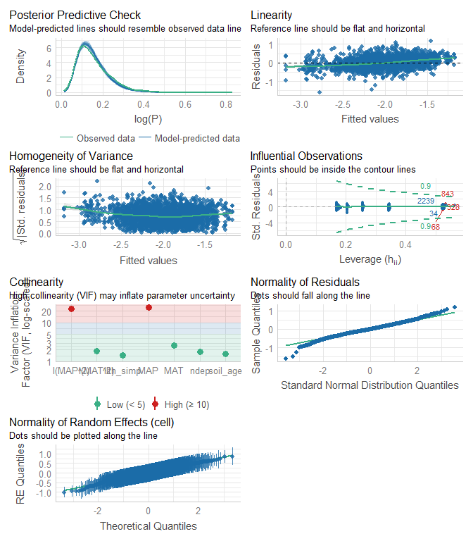

## OK: Error variance appears to be homoscedastic (p = 0.728).

## 3 outliers detected: cases 68, 328, 843.  
## - Based on the following method and threshold: cook (0.9).  
## - For variable: (Whole model).

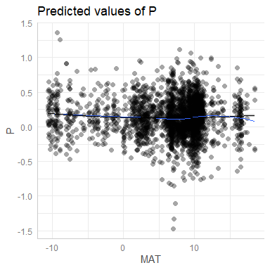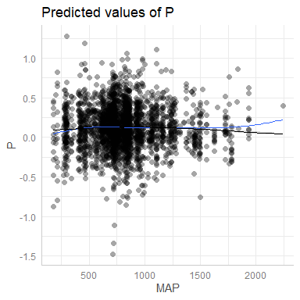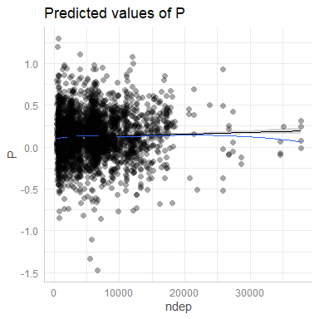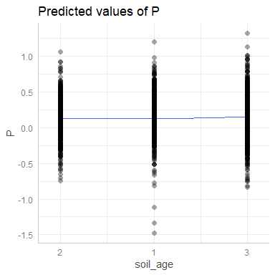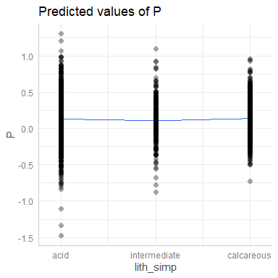

| Parameter | Coefficient | SE | CI | CI_low | CI_high | p | Effects |
| --- | --- | --- | --- | --- | --- | --- | --- |
| (Intercept) | -2.5959 | 0.0956 | 0.95 | -2.7833 | -2.4085 | 0.0000 | fixed |
| MAT | -0.0184 | 0.0035 | 0.95 | -0.0253 | -0.0115 | 0.0000 | fixed |
| I(MAT^2) | 0.0016 | 0.0003 | 0.95 | 0.0010 | 0.0022 | 0.0000 | fixed |
| MAP | 0.0012 | 0.0002 | 0.95 | 0.0008 | 0.0015 | 0.0000 | fixed |
| I(MAP^2) | 0.0000 | 0.0000 | 0.95 | 0.0000 | 0.0000 | 0.0000 | fixed |
| ndep | 0.0000 | 0.0000 | 0.95 | 0.0000 | 0.0000 | 0.0001 | fixed |
| soil_age1 | -0.0182 | 0.0439 | 0.95 | -0.1043 | 0.0680 | 0.6791 | fixed |
| soil_age3 | 0.1344 | 0.0351 | 0.95 | 0.0656 | 0.2033 | 0.0001 | fixed |
| intermediate | -0.1520 | 0.0481 | 0.95 | -0.2463 | -0.0577 | 0.0016 | fixed |
| calcareous | 0.0578 | 0.0309 | 0.95 | -0.0028 | 0.1185 | 0.0618 | fixed |
| SD (Intercept) | 0.3433 | NA | 0.95 | NA | NA | NA | random |
| SD (Observations) | 0.3292 | NA | 0.95 | NA | NA | NA | random |

|  | x |
| --- | --- |
| Conditional R2 | 0.5694354 |

|  | x |
| --- | --- |
| Marginal R2 | 0.1013918 |

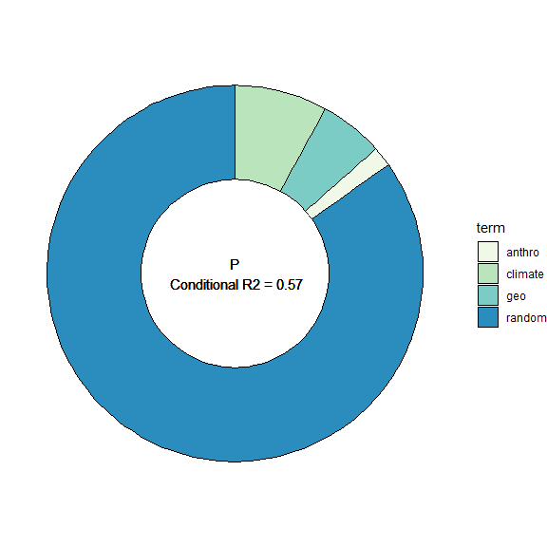

### NP

formula:log(NP) ~ MAT + I(MAT^2) + MAP + I(MAP^2) + ndep + soil_age + lith_simp + (1|cell)

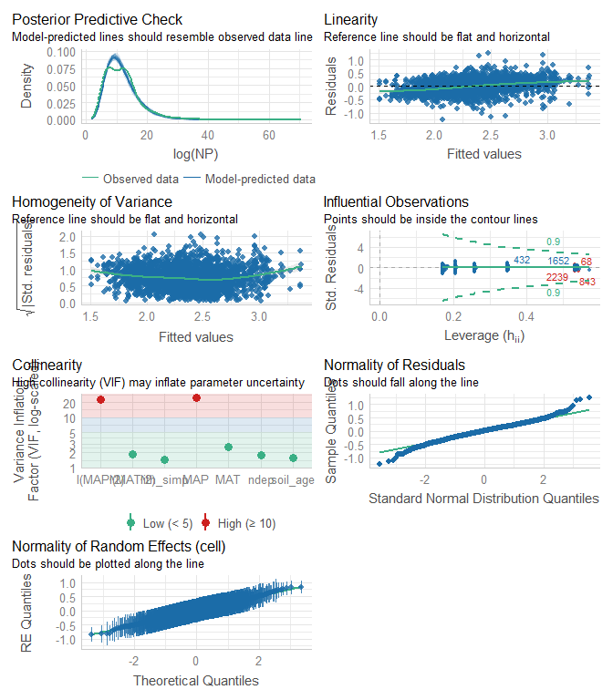

## OK: Error variance appears to be homoscedastic (p = 0.931).

## 3 outliers detected: cases 68, 843, 2239.  
## - Based on the following method and threshold: cook (0.9).  
## - For variable: (Whole model).

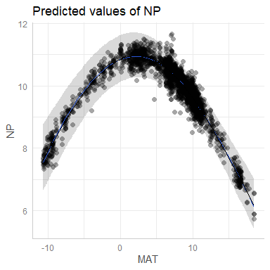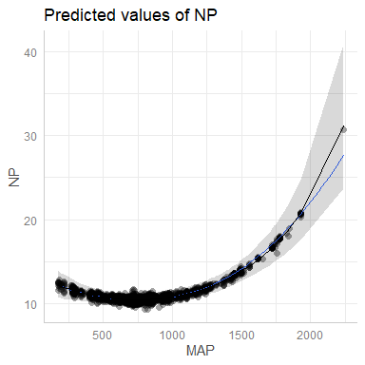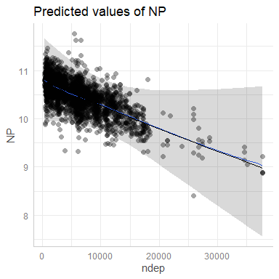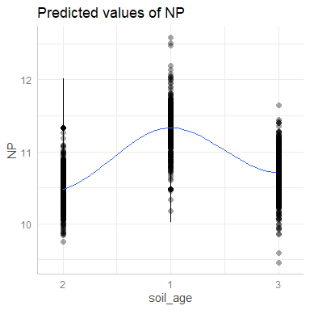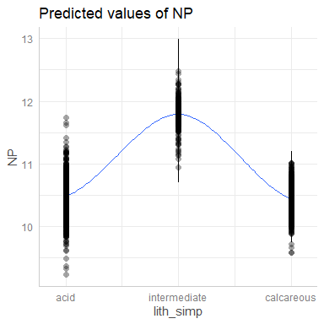

| Parameter | Coefficient | SE | CI | CI_low | CI_high | p | Effects |
| --- | --- | --- | --- | --- | --- | --- | --- |
| (Intercept) | 2.6752 | 0.0873 | 0.95 | 2.5041 | 2.8463 | 0.0000 | fixed |
| MAT | 0.0098 | 0.0032 | 0.95 | 0.0034 | 0.0161 | 0.0025 | fixed |
| I(MAT^2) | -0.0022 | 0.0003 | 0.95 | -0.0027 | -0.0016 | 0.0000 | fixed |
| MAP | -0.0007 | 0.0002 | 0.95 | -0.0011 | -0.0004 | 0.0001 | fixed |
| I(MAP^2) | 0.0000 | 0.0000 | 0.95 | 0.0000 | 0.0000 | 0.0000 | fixed |
| ndep | 0.0000 | 0.0000 | 0.95 | 0.0000 | 0.0000 | 0.1112 | fixed |
| soil_age1 | 0.0785 | 0.0401 | 0.95 | -0.0001 | 0.1571 | 0.0504 | fixed |
| soil_age3 | 0.0219 | 0.0320 | 0.95 | -0.0409 | 0.0847 | 0.4943 | fixed |
| intermediate | 0.1179 | 0.0439 | 0.95 | 0.0318 | 0.2039 | 0.0073 | fixed |
| calcareous | -0.0036 | 0.0282 | 0.95 | -0.0589 | 0.0517 | 0.8986 | fixed |
| SD (Intercept) | 0.3152 | NA | 0.95 | NA | NA | NA | random |
| SD (Observations) | 0.2969 | NA | 0.95 | NA | NA | NA | random |

|  | x |
| --- | --- |
| Conditional R2 | 0.5904161 |

|  | x |
| --- | --- |
| Marginal R2 | 0.1289014 |

