CS 4398

RR1: Anneka Bath, Colton Eastland, David Erickson

Description of acceptance testcases

Upon opening the website the user is greeted by the homepage:

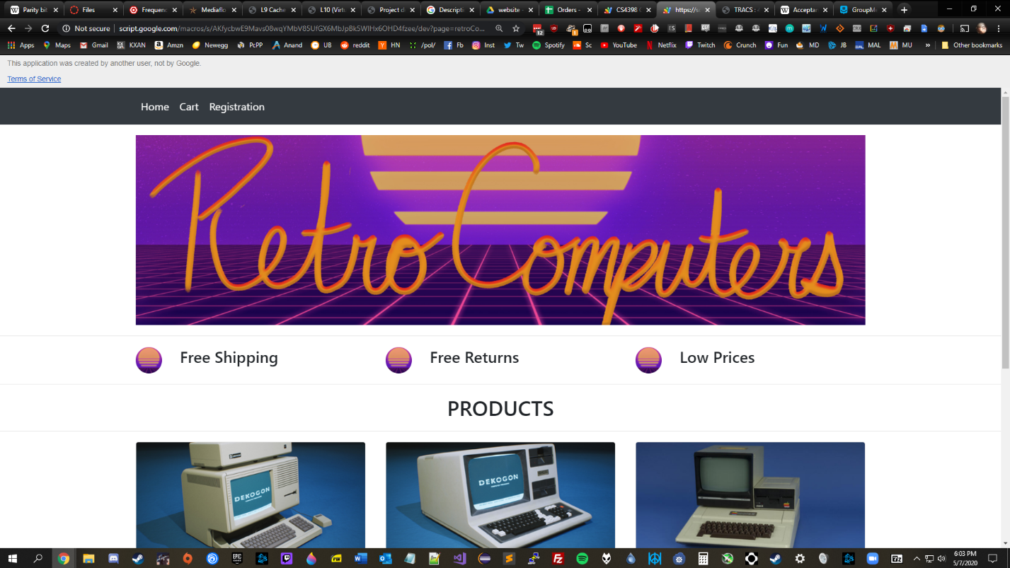

The user can then click “Order” under any of the images to add the specified quantity to the cart:

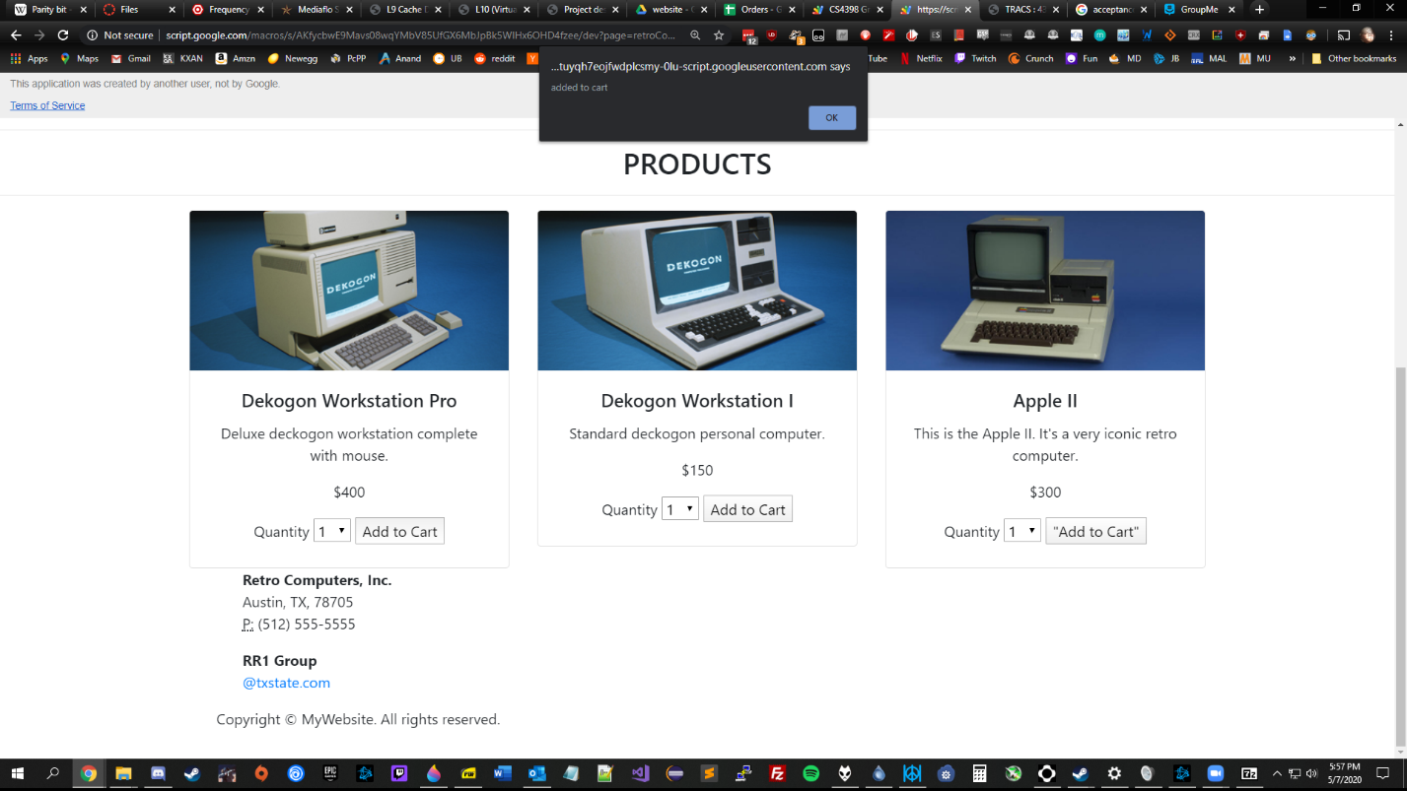

The user is notified that the item has been added to the cart. Checking the cart brings you to this page: 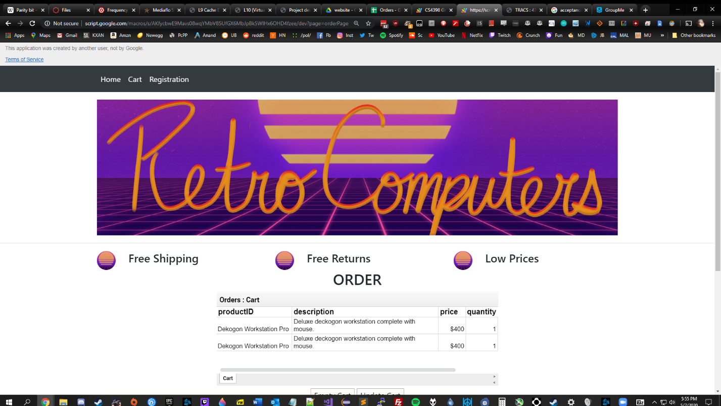

Here you can enter your personal information and click submit order to update the database:

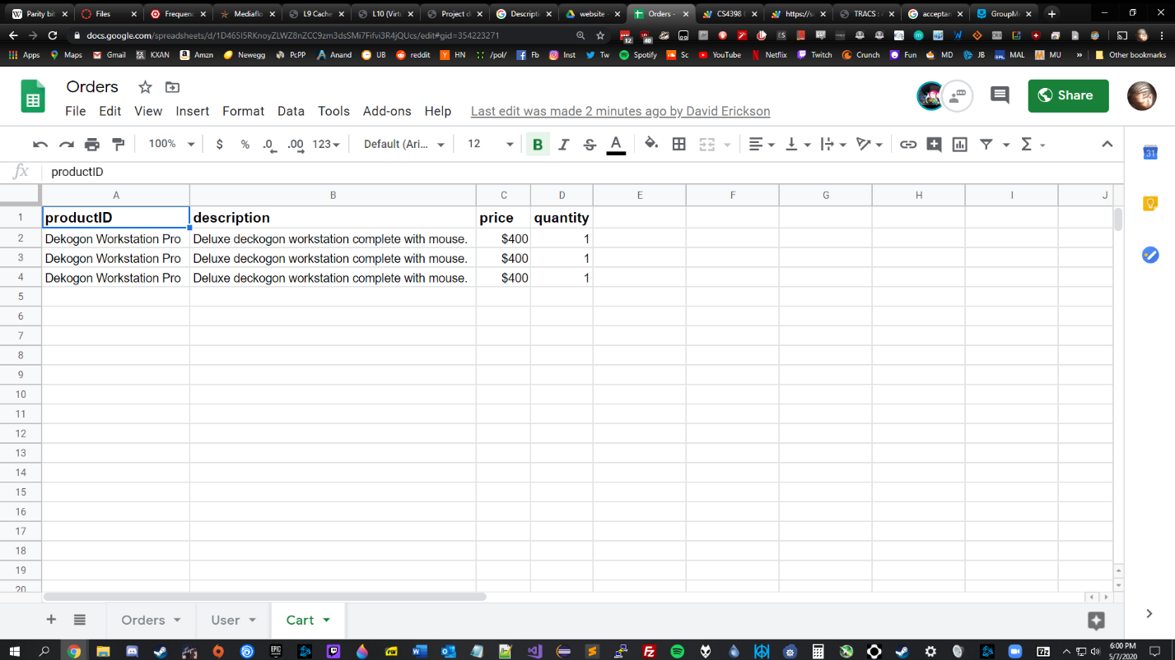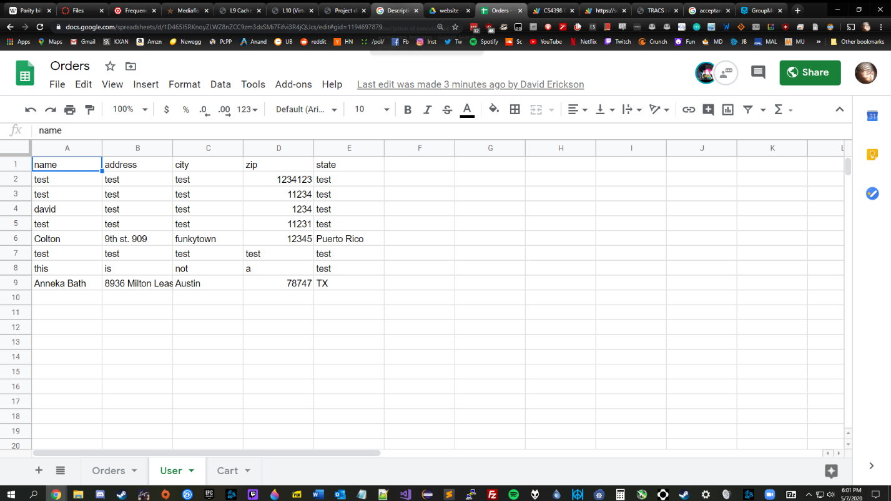

Which are then combined into the Orders sheet:

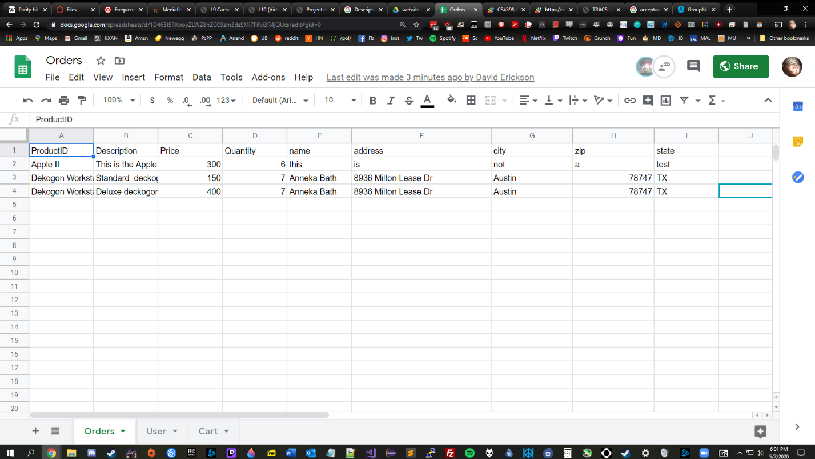

The user can also click the registration button on the top ribbon to register their account: 