Astra.

SeedProd

Divi

OceanWP

Ultra

Spencer

Indigo

Hellomouse

Parallax

Presence

Neve

________________________________________________________________________________-

Astra

Avada

Divi

Hello

OceanWP

GeneratePress

The7

Betheme

Enfold

X

Neve

Flatsome

Bridge

Jupiter

Salient

Divi

Ultra

SeedProd

Astra

OceanWP

Divi – Best For Most

Soledad – Best For Bloggers

Jevelin – Best WordPress Theme

Kalium – Best For Minimalistic Websites

WoodMart – Best For eCommerce

TheGem – Best For Business

Webify – Best For Landing Pages

Uncode – Best For Creatives

Oshine – Best For Simple Websites

Total – Best For Timeless Websites

Divi

Astra

Avada

Enfold

Ultra

OceanWP

Astra

Jayla

Tusant

OceanWP

Astra

Hestia

Neve

Simple

**Valitut teemat:**

**-Astra**

The Most Popular Theme of All Time

Fastest, Lightweight, and Highly Customizable WordPress Theme.

Astra is fast, fully customizable & beautiful WordPress theme suitable for blog, personal portfolio, business website and WooCommerce storefront. It is very lightweight (less than 50KB on frontend) and offers unparalleled speed. Built with SEO in mind, Astra comes with Schema.org code integrated and is Native AMP ready so search engines will love your site. It offers special features and templates so it works perfectly with all page builders like Elementor, Beaver Builder, Visual Composer, SiteOrigin, Divi, etc. Some of the other features: # WooCommerce Ready # Responsive # RTL & Translation Ready # Extendible with premium addons # Regularly updated # Designed, Developed, Maintained & Supported by Brainstorm Force. Looking for a perfect base theme? Look no further. Astra is fast, fully customizable and WooCommerce ready theme that you can use for building any kind of website!

Version: 3.7.9

Last updated: 3. maaliskuuta 2022

Active Installations: 1+ million

Astra is among the most popular and fastest-loading WordPress multipurpose themes. It can be used to build all kinds of websites. Whether you’re creating a blog, a business website, or an eCommerce store, you can make your site look great using Astra.

Astra gives you color options, typography choices, multiple layouts, stylish headers, and more. You can use their pre-made demo sites and import them to get a head start on building your website.

Plus, Astra is designed for good SEO (search engine optimization). This helps your site to rank well in Google and other search engines.

**-Divi, 3 vaihtoehto**

Divi is the most popular WordPress theme ever released, with over 1M users worldwide. The motto of this theme is “The sky is the limit.” In short, Divi offers you UNLIMITED customization features and superior functionality. The Divi Builder is a feature that will help you create the layout of your dreams.

The Divi layout builder will allow you to CHANGE ANYTHING in your layout, from colors and icons, to page and post formats. It is based on a drag & drop interface, so everyone can use it.

You can install the theme and start uploading content in less than an hour.

Divi is a drag and drop WordPress page builder and a multipurpose theme from Elegant Themes. It can be used to build any type of website that you want by making your changes in the intuitive front-end editor.

You can pick from their 100s of pre-made layouts and customize your site using the drag and drop builder. Alternatively, you can also start from scratch and build a completely custom theme.

Divi layouts are mobile-responsive and have all the features you need like gallery, shop, landing pages, social buttons, and more.

**-OceanWP**

Version: **3.1.4**

Last updated**: 7. maaliskuuta 2022**

Active Installations: **700 000+**

WordPress Version: **5.6 or higher**

PHP Version: **7.2 or higher**

OceanWP on täydellinen teema projektillesi. Kevyt ja erittäin laajennettavissa oleva, se mahdollistaa sinun luoda melkein minkä tyyppinen sivusto tahansa kuten blogi, portfolio, yrityssivusto ja WooCommerce-verkkokauppa kauniilla ja ammattimaisella muotoilulla. Erittäin nopea, responsiivinen, oikealta vasemmalle tekstin ja käännöksiin valmis, parhaat hakukoneoptimointikäytännöt, ainutlaatuiset WooCommerce-ominaisuudet lisäävät konversioita ja paljon muuta. Voit jopa muokata asetuksia mobiililaitteille, joten sivustosi näyttää hyvältä joka laitteella. Toimii suosituimpien sivustonrakentajien kuten Elementorin, Beaver Builderin, Brizyn, Visual Composerin, Divin, SiteOriginin ja muiden kanssa. Kehittäjät tulevat rakastamaan laajennettavissa olevaa koodipohjaa, joka tekee mukauttamisesta ja laajentamisesta ilon. Elementorin ja WooCommercen paras ystävä. Etsitkö monikäyttöistä teemaa?

**Comparisons:**

<https://winningwp.com/astra-vs-oceanwp-wordpress-themes/>

Astra and OceanWP are two of the most popular WordPress Themes on the market today.

Both Astra and OceanWP offer professional designs, many customisation options and support for third-party WordPress plugins. The themes can be downloaded free of charge via the official WordPress themes directory (use the search feature to find them), but premium plugin extensions that expand functionality are available.

**Astra is also recognised by Google** as being an AMP-ready WordPress theme. An open-source HTML framework, AMP (Accelerated Mobile Pages) helps you to create user-friendly fast-loading web pages. The fact that Google promotes the design on its official AMP WordPress website is a testament to Astra’s quality of coding.

It’s difficult to pick a clear winner between Astra and OceanWP when it comes to design.

The quality of designs on offer with Astra is slightly better.

More than 70 pre-made designs are available in both themes. However, OceanWP only offers 13 to free users.

OceanWP gives you more options for customising your website design.

Ideally, you should check the designs available for Astra and OceanWP and make a shortlist of the ones you like. You can then install them on a test website and spend time customising them to see if they meet your requirements.

Both themes have native support for WooCommerce, optimisation for fast-loading websites, SEO-friendly markup code and great support for drag-and-drop page builders.

The themes are also ready for translation, and have support for right-to-left languages such as Arabic, Hebrew and Persian.

Astra and OceanWP both have features that will help WordPress users to build websites. There’s fantastic support for third-party plugins — from WooCommerce to drag-and-drop page builders such as Divi.

When it comes to building a modern WordPress website, you can’t go wrong with either WordPress theme. However, OceanWP offers considerably more customisation options for your website.

So, how do the free versions of Astra and OceanWP compare?

As we’ve already seen, both WordPress themes share a lot of the same features, such as fast-loading pages, WooCommerce support and support for the WordPress theme customiser.

Both themes also come with a selection of free pre-made designs.

I believe the quality of pre-made designs available for both themes is excellent — although Astra slightly edges it for me.

From a variety point of view, Astra is undoubtedly ahead as it offers 35 free theme demos compared with the 13 free theme demos available with OceanWP. However, OceanWP gives you many more options within the WordPress theme customiser.

OceanWP falls behind Astra in a few areas, though.

**The installation process of OceanWP, for example, has to be revisited by the developers. At the moment, a message is displayed after activating OceanWP that states that Ocean Extra is a recommended plugin.**

**This suggests the plugin is optional, but if a user doesn’t install the plugin they can’t go through the setup wizard, import theme demos or access the theme options panel. All of which are essential to using the theme.**

The problem with OceanWP is that all of its free themes require the use of at least one premium extension to function correctly. Without them, key aspects of the designs are missing.

The number of options available within the WordPress theme customiser area of OceanWP is impressive, but the implementation of the theme demo system is fundamentally flawed. If you want to use an OceanWP free design, you need to either purchase the required premium extensions for it or be content with using the design with features missing.

Because of these issues, I believe Astra is a better choice for free users.

Both themes have many great features and have affordable upgrade options.

Because OceanWP’s free theme demos require premium plugin extensions to work correctly, I believe Astra is the better free option. More theme demos are made available to you too. These criticisms aren’t valid if you upgrade to the OceanWP Core Extensions Bundle, though, as all premium plugins and designs are unlocked.

Similarly, the free version of OceanWP gives you many more customisation options than Astra, so, if theme customisation is important to you, OceanWP may be the best choice for you. Again, these criticisms aren’t as relevant if you’re planning to upgrade to Astra Pro, as that adds hundreds of additional design and layout options.

<https://www.collectiveray.com/astra-vs-oceanwp>

Their premium versions are also among the best of the best. Both have extensive customization options allowing anyone to design their website the way they want without writing a single line of code. Their WooCommerce support is top-notch and the page builder integration they offer is of a high standard. You can’t go wrong with either.

While they’re both great, there are some key differences between the two. These differences will heavily affect your final choice. The aim of this comparison between Astra vs OceanWP is to walk you through those key differences allowing you to understand what a theme is best used for so that you can pick the perfect one for your needs.

Just a reminder, we’re strictly comparing their premium versions only. This means that many options and items we’ll cover here will not be present when you try out their free versions.

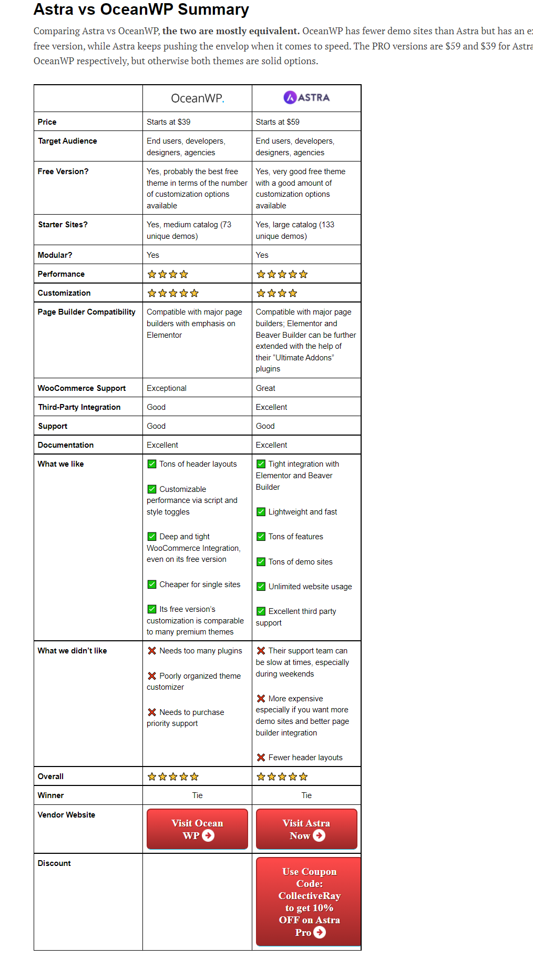

Their pricing models, at a first glance, one’s a better choice than the other but the terms make it hard to make the best choice.

Overall, Astra is aimed at developers who need unlimited website usage. Their mini agency and agency bundles give users the ability to built many websites with ease, thanks to the wide selection of starter sites.

However, that’s not to say that Astra isn’t a good choice for individuals. Astra Pro’s impressive feature set, good WooCommerce support and ease of use makes it a great choice for individuals and one-time projects.

OceanWP on the other hand is the theme for those who want to set up a WooCommerce shop. The impressive customization options for WooCommerce allows anyone to customize their shop without writing a single line of code.

In addition, OceanWP is cheaper than Astra for single site usage ($39 vs $59), and even on the lowest tier plan, all premium starter sites are available to you. However, keep in mind that the starter sites all use Elementor, so if you plan to use a different page builder, you might want to consider Astra instead, or you can just build your dream site from scratch — which should be easy thanks to OceanWP’s impressive number customization options.

The final choice is yours. Think about what type of site you want to build, how many sites you want to use the theme on, and whether you want to focus solely on WooCommerce or not and the answer should be within your grasp.

<https://wpmarmalade.com/astra-vs-oceanwp/>

One standout point is they’re both free to download, which means you can install and test what they have to offer before using them on a live website. Many website owners do stick with the free version of Astra and OceanWP, but those who want the full version can test the themes thoroughly before upgrading.

To change designs in Astra, you need to install the WordPress plugin Astra Starter Templates. This includes around a hundred free high-quality designs that have been created using Elementor, Beaver Builder, Brizy and the WordPress block editor.

I find it baffling that the functionality of Ocean Extra isn’t incorporated into the core theme, as OceanWP can’t be used without it. If you don’t activate Ocean Extra, you won’t see the OceanWP theme panel, settings pages and theme demos.

The quality of designs is high for both themes, but Astra is the clear winner here. Its Starter Templates WordPress plugin offers around a hundred free designs for four different page builders, and if you switch to another WordPress theme you can continue using the plugin.

In contrast, OceanWP has a smaller library of designs and you need to use Elementor to use them. There’s no way to delete imported content either, and free users can’t use the 13 available designs correctly without paying to upgrade.

Astra is a highly customizable WordPress theme that offers dozens of configuration options within the WordPress Theme Customizer. However, OceanWP gives you more flexibility as it lets you disable specific customizer sections, scripts and styles.

Astra Pro does give you more options in the theme customizer than the full version of OceanWP, but OceanWP’s additional control over how you style individual pages gives it a slight edge.

Astra and OceanWP both have great support for WordPress page builders, but be sure to pay attention to which page builder was used to create any pre-made website designs you choose.

All of the free plugins and pro modules that were created for Astra add additional styling options to the WordPress Customizer, add more layout options or add support for third-party products. OceanWP’s plugin extensions are useful, but they don’t really enhance the core theme.

Astra’s module system also means you can increase website functionality without drastically increasing the number of activated WordPress plugins on your website.

Despite its confusing sales policy, OceanWP has the cheapest single website plan. Astra’s entry-level plan is not only more expensive, but it doesn’t include any additional premium website templates.

OceanWP does charge more for using its theme on multiple websites, though, so, if you have multiple websites and like the additional plugins and designs on offer by Astra, it may be the better option.

From a design point of view, I believe Astra is doing things better. There’s a larger selection of designs to choose from and these designs can be used with four different WordPress page builders, not just one. OceanWP only offers 13 Elementor-based designs to free users, and these designs won’t work correctly unless you upgrade to the OceanWP Core Extensions Bundle.

Of course, this isn’t a problem for those who upgrade to the full version of OceanWP, and all OceanWP users do have the option of using Astra’s Starter Templates plugin and importing the same pre-made website designs as Astra users. So, don’t let OceanWP’s flawed demo system put you off, as the theme has many useful features and settings that are not found in Astra.

The cost of using Astra and OceanWP will depend on what features and functionality you need, what designs you like and how many websites you plan to use them on.

For single-license website owners, it’s cheaper to upgrade to the full version of OceanWP, and doing so gives you access to 60 premium designs and a dozen premium plugins.

Astra Pro is a little more expensive for single-license website owners, but could prove to be cheaper for those of you who own many websites, as usage isn’t restricted. Its module system also saves you from having to install many WordPress plugins, and I believe these modules enhance the core theme more than OceanWP’s premium extensions do.

The main downside to Astra Pro’s pricing policy is that you need to purchase one of the agency plans to gain access to the 55 additional pre-made designs that are available. However, these agency plans also include other high-quality WordPress plugins from the developers, so the overall package is better.

**https://athemes.com/reviews/astra-vs-oceanwp/**

**Astra vs OceanWP: Which One Should You Use?**

Well, first there’s some good news:

No matter which theme you choose, you won’t make a “wrong” decision. These are both excellent themes, so in all likelihood, you will be happy either way.

However, if I had to recommend just one of these options for most people, I would say Astra is my top pick.

Here’s why:

It’s more lightweight in terms of out-of-the-box performance.

It has more demo sites and you can choose from different builders. You also get a lot more demos in the free version.

While OceanWP might have a slight edge in terms of customization options, Astra still has enough flexibility for the vast majority of people.

Astra’s Customizer experience is more user-friendly.

Astra’s new drag-and-drop header/footer builder is really nice.

It has deeper integrations for more plugins, such as LifterLMS and LearnDash.

For advanced users, Astra’s Custom Layouts feature is a little more flexible than Ocean Hooks.

It’s more affordable if you need a theme for multiple sites since it allows unlimited site usage.

However, that’s just the recommendation for “most” people. I do think there are some specific situations where you might want OceanWP instead:

You want to use a free theme and configure everything from scratch. OceanWP’s free version gives you more customization options. And since you’re building from scratch, you won’t care about the lack of demo sites.

You want all those nitty-gritty customization options. OceanWP does give you more flexibility when it comes to Customizer options and page-level controls. I don’t think most people need that extra flexibility. But if you do, OceanWP might be better.

You’re building a WooCommerce store. I think OceanWP is a little more flexible for WooCommerce, though Astra is great as well.

DIVI+OceanWP

Picking a winner between Divi and OceanWP isn’t an easy thing to do.

Frankly, neither theme is an overall better solution than the other on all fronts.

Both Divi and OceanWP will give you a visual builder interface — Divi via its own solution, and OceanWP via Elementor.

Both will let you pick from a selection of starter sites. (A slight edge to Divi.)

Both will allow you to customize your website at a really granular level. (A slight edge to OceanWP.)

Both will take you through great onboarding processes with tutorials and videos.

Neither expect you to know how to code.

The choice isn’t an easy one, but here’s what I’d advise:

💸 If you’re on a budget, go with OceanWP. Divi doesn’t have a free version at all, so that’s that.

🔧 OceanWP does more to cater to both developers and website owners working on their sites the DIY way. So, if endless customizations are high on your list of required features, OceanWP is probably going to be the better solution for you.

🎨 Divi, on the other hand, bets on a great catalog of ready-made website designs that are as close to plug-and-play as possible. For that reason, casual users will benefit more using Divi, and will be able to build a great-looking website more quickly and easily.