|  |  |
| --- | --- |
| **Astra** | **OceanWP** |
| Fast, Lightweight and Highly Customizable | Kevyt ja erittäin laajennettavissa oleva, nopea |
| suitable for business website | yrityssivustollekin sopiva |
| Built with SEO in mind | parhaat hakukoneoptimointikäytännöt |
| works perfectly with all page builders like Elementor | works perfectly with all page builders like Elementor |
| Responsive | Responsive |
| Translation ready | Translation ready |
| Regularly updated | Regularly updated |
| Last updated: 3. maaliskuuta 2022 | Last updated: 7. maaliskuuta 2022 |
| Active Installations: 1+ million | Active Installations: 700 000+ |
| Astra is also recognised by Google |  |
|  |  |
|  |  |
|  |  |
| Starter Sites: https://wpastra.com/starter-templates/?page-builder=elementor | Demos: https://oceanwp.org/oceanwp-starter-wordpress-website-templates/ |
| https://wpastra.com/ | https://oceanwp.org/ |

Astra and OceanWP are two of the most popular.

The quality of designs on offer with Astra is slightly better. More than 70 pre-made designs are available in both themes. However, OceanWP only offers 13 to free users(Astra 35). OceanWP gives you more options for customising your website design. (Astra calls its pre-made designs Starter Sites and OceanWP calls them theme demos.)

To change designs in Astra, you need to install the WordPress plugin Astra Starter Templates. This includes around a hundred free high-quality designs that have been created using Elementor, Beaver Builder, Brizy and the WordPress block editor.

The installation process of OceanWP, for example, has to be revisited by the developers. At the moment, a message is displayed after activating OceanWP that states that Ocean Extra is a recommended plugin. This suggests the plugin is optional, but if a user doesn’t install the plugin they can’t go through the setup wizard, import theme demos or access the theme options panel. All of which are essential to using the theme.

The problem with OceanWP is that all of its free themes require the use of at least one premium extension to function correctly. Without them, key aspects of the designs are missing.

The number of options available within the WordPress theme customiser area of OceanWP is impressive, but the implementation of the theme demo system is fundamentally flawed. If you want to use an OceanWP free design, you need to either purchase the required premium extensions for it or be content with using the design with features missing.( It’s disappointing that to work correctly, every single free theme demo requires a premium plugin extension. In that respect, the full version of OceanWP is a better representation of what OceanWP can do. Each premium plugin extension is priced at $29.99 per year. However the bundle where you get them all at $34 is the better buy.)

Because of these issues, I believe Astra is a better choice for free users.

OceanWP has the cheapest single website plan. The cost of using Astra and OceanWP will depend on what features and functionality you need, what designs you like and how many websites you plan to use them on. For single-license website owners, it’s cheaper to upgrade to the full version of OceanWP, and doing so gives you access to 60 premium designs and a dozen premium plugins.

Astra Pro is a little more expensive for single-license website owners, but could prove to be cheaper for those of you who own many websites, as usage isn’t restricted. Its module system also saves you from having to install many WordPress plugins, and I believe these modules enhance the core theme more than OceanWP’s premium extensions do.

OceanWP:

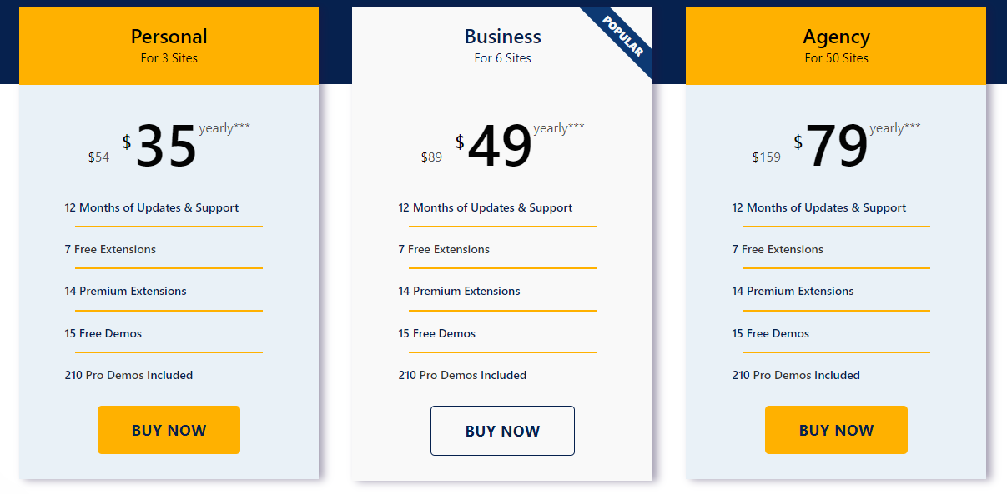

Astra:

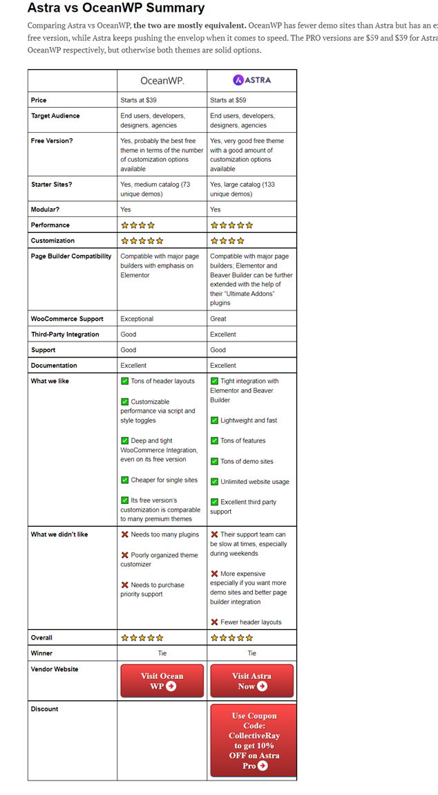

In addition, OceanWP is cheaper than Astra for single site usage ($39 vs $59), and even on the lowest tier plan, all premium starter sites are available to you. However, keep in mind that the starter sites all use Elementor, so if you plan to use a different page builder, you might want to consider Astra instead, or you can just build your dream site from scratch — which should be easy thanks to OceanWP’s impressive number customization options.

Lähteet: <https://winningwp.com/astra-vs-oceanwp-wordpress-themes/>, <https://www.collectiveray.com/astra-vs-oceanwp>, <https://wpmarmalade.com/astra-vs-oceanwp/>, <https://athemes.com/reviews/astra-vs-oceanwp/>, <https://www.kasareviews.com/astra-theme-review-pro-vs-free-comparison/>, <https://www.kasareviews.com/oceanwp-theme-review-free-paid/>, <https://www.kasareviews.com/astra-vs-oceanwp-theme-comparison/>