Introduction

I selected a dataset containing police incidents across the United States. This database has information on police altercations across the nation. The scope will cover the victims, police officer(s) charged if applicable, the prosecutor and information about those three as well as context about the altercation itself. Based on this data we'll be able to find trends in police altercations across the nation, and how certain attributes can affect their outcome.

It would be relevant to mostly the general public, lawyers/attorneys and new stations. It would allow families moving into an area to see whether or not the area is safe/welcoming. It would also be relevant for judging officials in power and seeing how crime has changed while they were in power. One example would be during elections when people want to base their vote on whether or not they feel safe under their current governing officials. This would also help attorneys/lawyers defend their clients against illegal bias with statistics backing up claims of disproportionate arrests due to discrimination.

It may also help justify or plan changes in budgeting for police forces across different areas. Taking funding for safer places and putting it towards places that aren’t as safe in order to strengthen the police department. It could also help in academics and research to spot long term trends under different circumstances, like political parties in power or class discrimination. This will make it harder for corrupt officials to lie and push false agendas onto the general public.

Database Description
Logical Design

Through some deliberation Prof. Dewitt and I came up with this layout for the database tables. Since our dataset is exceptionally large, I will focus on variables and factors that are relevant for gathering and determining information and or trends based on the goals listed above in the target audience section. A lot of victims/rows do not contain all the data for all the columns listed above, I will only be using victims/rows with data in all the necessary columns. In other words, rows with no NULL values.
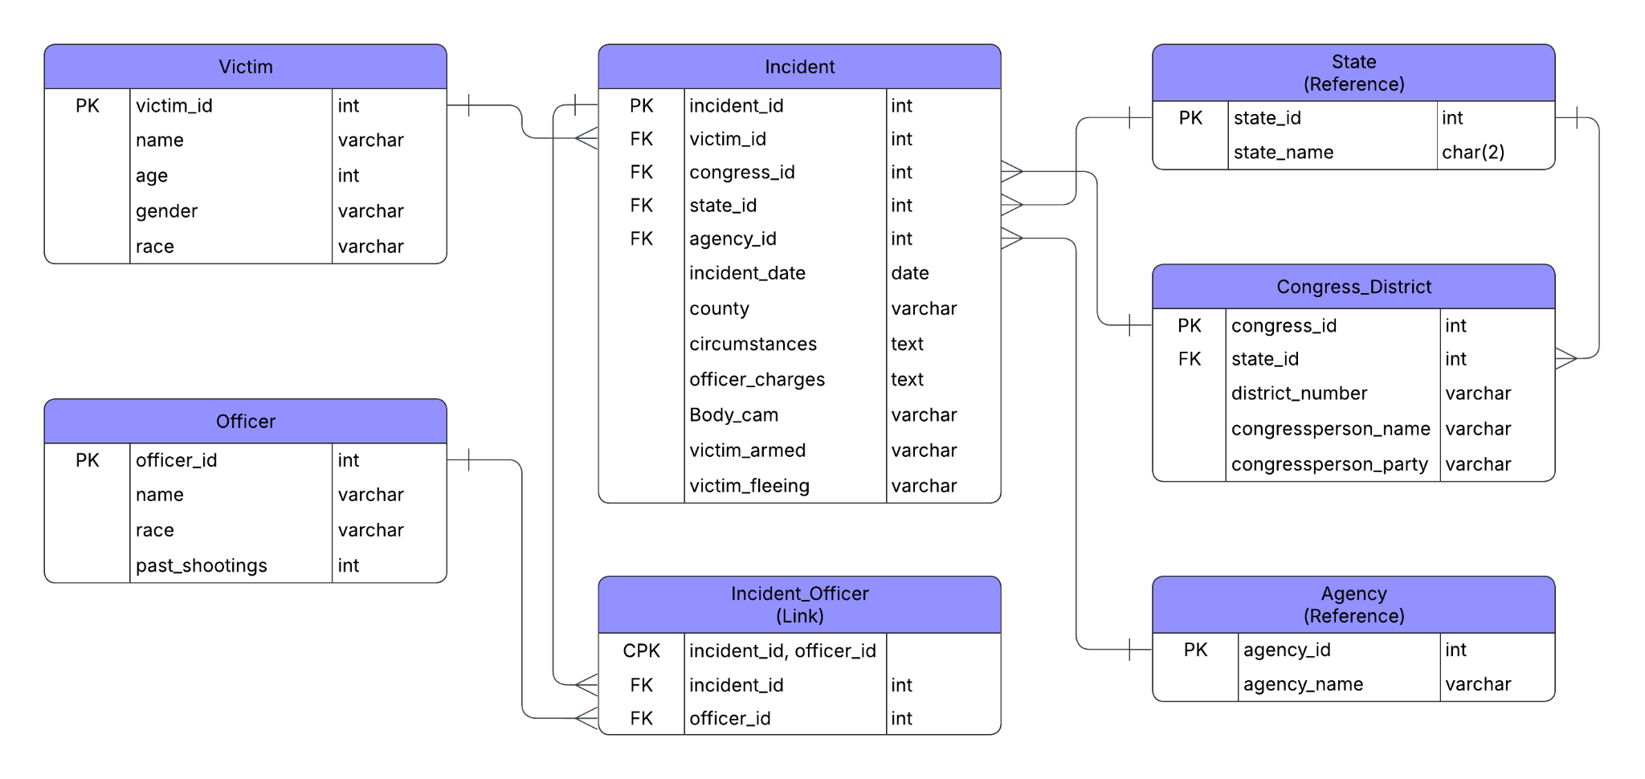

There are tables for victims, officers, congress districts and incidents. I have agencies and states as reference tables to cut down on repetitiveness from attributes across the database. Lastly, there is the incidentOfficer table acting as a bridge, this is because one incident can involve multiple officers.

Physical Database

Our finished database includes 9 tables with thousands of samples for each, connected via primary and foreign keys. After completing the database, I tested the import process and validated that the schema, relationships, and queries functioned correctly.

Sample Data

Rather than limiting the project to the required sample data, I chose to import and standardize as much of the original dataset as possible. Due to that each table has thousands of rows. I went through a massive amount of standardization, and cleaning involving table, power queries, column splitting and duplicate removal, with some having to be manual to ensure little to no errors.

I got rid of most titles like sergeant, detective, deputy, corporal, trooper and detective. We also fixed special characters, filtered out single named officers to avoid unnecessary repetitiveness. Some rows had the officer agency and/or county included by their name so that had to be removed since that could affect the duplicate removal process. For victims I decided not to include any with no names, or were missing 2 of the other 3 attributes, those being age, race and gender. This was to avoid clutter from less usable/valuable data.

Views/Queries
View Name | JOIN (4) | FILTER (3) | AGGREGATE (2) | LINKING (1) | SUBQUERY (1)
Query 1 |  |  | X |  | X
Query 2 | X |  | X |  | X
Query 3 | X | X | X | X | X
Query 4 | X | X | X
Query 5 | X | X | X | X

Query 1:
This query shows the race percentages of the total victims in the dataset in descending order.

Query 2:
This query shows the percentages of incidents by districts represented by their congress persons political party, in descending order.

Query 3:
This query shows the race percentages of officers involved in incidents during 2024 in descending order.

Query 4:
This query shows how many incidents there were per county in Texas specifically.

Query 5:
This query shows the number of incidents per agency during 2024.
Changes Made
During development, I expanded the original design by adding two bridge tables: IncidentVictim and IncidentAgency. The former was to provide a bridge between incident and victim attributes, and the latter was because multiple agencies could be involved in a single incident. I also decided to exclude 5 columns from our original ERD. Those columns being; past shootings from the officer table, victim armed and victim fleeing, as well as officer charges and circumstances from the incidents table. I also decided to include rows that had null values for an attribute as they could still provide valuable data. An example would be the congress district table. I included rows that were only missing either the party or the district number. I also mentioned something similar earlier for the victims’ table rows. Here is the updated ERD:
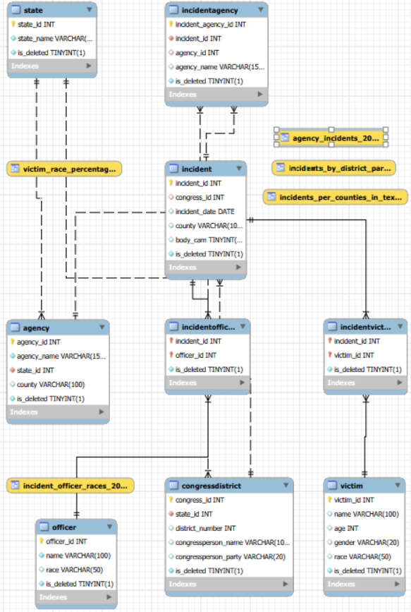
Agency jurisdiction data (county/state) was preserved as provided in the original dataset. While some entries may appear inconsistent, they may reflect local naming conventions, no assumptions were made to alter or correct these values in order to maintain data integrity.

Database Ethics
At first, I considered not including the victims’ names because we thought it may be insensitive to family or friends and could be disrespectful. However, once I started standardizing the data I realized that without names the victim ids were more of a category than a person: White, 32, Male and/or Black, 45, Female. It seemed dehumanizing to treat them as a statistic that way, so I ended up using their names. Officer and congress representatives' names were included. Given their positions I decided that this was not an invasion of privacy since the public is owed transparency.

The biggest concern I had with our database was how it could be taken out of context to push certain agendas. The analysis that can be drawn from a database like this can have dire consequences if misrepresented to the public. That is why I considered the circumstances column to be essential. However, no matter what I did I could not get the column to successfully import. I tried cleaning it and trimming it multiple times, getting rid of special characters and commas. I tried reading it with different encoding, latin, ufc-16, cp. I even tried opening the csv file in the notepad app to try and manually fix anything that was being misread.

Lessons Learned
One mistake that I had to course correct later on was not importing in the proper order. By that I don’t mean importing in the wrong reliance order, I mean I tried to configure all the table sheets in excel before importing anything. This led to problems with id reliance since we didn’t have them yet. I should have imported as I went along to make things easier instead of leaving one sheet half-way done and continuing to the next, then coming back to edit after importing and receiving ids. Other than that, I learned a lot about excel and how to use it to manipulate data. Looking back, I would import and validate each stage before moving on to the next, reducing the possibility of lookup drift and simplifying the ETL process.

Potential Future Work
The next best step would be to figure out how to incorporate the circumstances column, as well as other columns in the original that didn’t make it due to time constraints such as past shootings, and victim armed/fleeing. Other than that, I think this would be a great opportunity to use as an example to set standards for data inputting so that this level of cleaning/standardization is not always required. It would also be beneficial to build on this database, adding more recent years into the database all the way up to current day.

Citations
Build, M. (2026, June 2). Use power query to transform data - power query. Power Query | Microsoft Learn. https://learn.microsoft.com/en-us/power-query/power-query-ui
Lucidchart. (n.d.). Diagramming powered by intelligence. https://www.lucidchart.com/pages
Mapping Police Violence. (2026, April 23). Data and methodology. mappingpoliceviolence.org. https://mappingpoliceviolence.org/methodology
*Note: The dataset I selected is an older version and doesn’t match the current one.

