Exercise 5

Task1

1. What is the name to be given to this file?

-TestTriangle

2. Compile this file. If you get any error, it means that you haven’t typed correctly the given codes.

3. After a successful compilation, now try to run. Explain what happened and why.

-Run compiler cause no main method called.

Task2

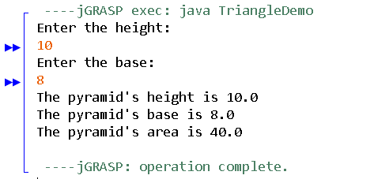

1. Compile this file. If you get any error, it means that you haven’t typed correctly the given codes.

2. After a successful compilation, now try to run. What’s the output?

3. List ALL the following items based on the Triangle class:

a) object

- Triangle

b) user-defined methods with return value

- getHeight()

-getBase()

-getArea()

c) user-defined methods with passing-parameters

- set(height,base) => set (double len, double b)

d) accessor methods

-setHeight()

-setBase()

-set(double len, double b)

e) mutator methods

-getHeight()

-getBase()

-getArea()

Task3

