**CS205 C/ C++ Programming - Lab Assignment4**

**Name**: 何宜芮(Yirui He)

**SID**: 11811031

**Part 1 – Analysis**

First, the file require us to read and load a file, called “Blocks.txt”. Then load information in it in to a array which is used to store structures of blocks.

Then read the file that we need to analysis and analyze it, if one character appear one times, then we add 1 to count. Finally, we find which blocks’count is max and print the name of the block.

To analyze the file, I need to know how to use the function“utf8_to_codepoint”first. Then use the function.

**Part 2 – Code**

#include **<iostream>**#include **<string>**#include **<fstream>**#include **<sstream>**#include **<algorithm>**#include **<vector>**#include **<cmath>**#include **<cstring>**#include **"utf8.h"  
  
using namespace** std;  
  
string trim(string);  
  
**char** *inputString(FILE *fp, size_t size);  
  
**struct** block {  
 string name;  
 **unsigned long** start;  
 **unsigned long** end;  
};  
  
**int** main() {  
 block blockAr[300];  
 string str;  
 ifstream fin(**"Blocks.txt"**);  
 **if** (!fin.good()) {  
 cout << **"Fail to open the file."**;  
 **return** 0;  
 }  
 **int** count = 0;  
 **while** (getline(fin, str)) {  
 str = trim(str);  
 **if** (str.find(**'#'**) == 0)**continue**;  
 **if** (str.length() == 0)**continue**;  
 istringstream sin(str);  
 string name, start, end;  
 getline(sin, start, **'.'**);  
 getline(sin, end, **'.'**);  
 getline(sin, end, **';'**);  
 getline(sin, name);  
 sin.clear();  
  
  
 stringstream s1, s2;  
 s1 << hex << trim(start);  
 s1 >> blockAr[count].start;  
 s2 << hex << trim(end);  
 s2 >> blockAr[count].end;  
 blockAr[count].name = trim(name);  
 count++;  
 }  
 count--;  
 fin.close();  
  
  
 **unsigned char** *p;  
 **int** bytes_in_char;  
 **int** i;  
 **unsigned long** codepoint;  
 **unsigned long long** countAr[300];  
 **for** (**int** k = 0; k < 300; ++k) {*//Initialize* countAr[k] = 0;  
 }  
 **char** *input;  
  
 input = inputString(stdin, 100);  
  
 p = (**unsigned char** *) (&input[0]);  
 **while** (*p) {  
 p++;  
 }  
 p = (**unsigned char** *) (&input[0]);  
 **while** (*p) {  
 codepoint = utf8_to_codepoint(p, &bytes_in_char);  
 **if** (codepoint) {  
 i = 0;  
 **while** (codepoint > blockAr[i].end)i++;  
 **if** (codepoint <= blockAr[i].end && blockAr[i].start <= codepoint) {  
 countAr[i]++;  
 }  
 *// p += bytes_in_char; // Same as the line that follows* _utf8_incr(p);  
 } **else** {  
 p++; *// Try the next character* }  
 }  
  
  
 **unsigned long long** max = 0;  
 **int** maxIn;  
 **for** (**int** j = 0; j < 300; j++) {  
*// if(countAr[j]!=0)cout << j<<": "<<countAr[j] << " ";* **if** (countAr[j] > max) {  
 maxIn = j;  
 max = countAr[j];  
 }  
 }  
 cout << blockAr[maxIn].name << endl;  
 free(input);  
}  
  
string trim(string st) {  
 **while** (isspace(st[0])) {  
 st = st.substr(1, st.length() - 1);  
 }  
 **while** (isspace(st[st.length() - 1])) {  
 st = st.substr(0, st.length() - 1);  
 }  
 **return** st;  
}  
  
*//This function is found in Stackoverflow, the webside is: https://stackoverflow.com/questions/16870485/how-can-i-read-an-input-string-of-unknown-length***char** *inputString(FILE *fp, size_t size) {  
*//The size is extended by the input with the value of the provisional* **char** *str;  
 **int** ch;  
 size_t len = 0;  
 str = (**char** *) realloc(NULL, **sizeof**(**char**) * size);*//size is start size* **if** (!str)**return** str;  
 **while** (EOF != (ch = fgetc(fp))) {*//&& ch != '\n'* str[len++] = ch;  
 **if** (len == size) {  
 str = (**char** *) realloc(str, **sizeof**(**char**) * (size += 16));  
 **if** (!str)**return** str;  
 }  
 }  
 str[len++] = **'\0'**;  
 **return** (**char** *) realloc(str, **sizeof**(**char**) * len);  
}

**Part 3 - Result & Verification**

**Test case #1:**

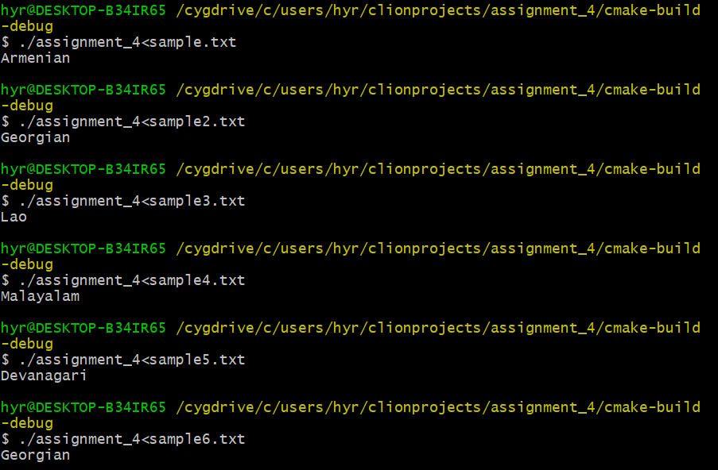

**The answer is correct.**

**Test case #2(remove the “Blocks.txt”)**

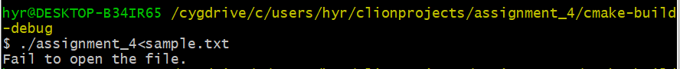

**The answer is correct. And the program terminated.**

**Part 4 - Difficulties & Solutions**

1. First, I do not know whether I need to download the “Blocks.txt” by myself or

make the program download itself. So I asked my classmates.

1. At the beginning, I do not understand what is the meaning of:

“Read a file from the standard input - that means that your program will be called like

this: ./your_program < name_of_file_to_analyze”. I asked my classmates.

1. I do not know how to compile C++ and C together, so I searched first. However, I did not get the right answer. After asking SA, I know how to do it right.