**CS205 C/ C++ Programming Lab Assignment**

**Name**: 何宜芮(He Yirui)

**SID**: 11811031

**Part 1 –Analysis**

This assignment requires us to design a class called “Box”.

1. The default constructor of the class should initialize l, b, and h to 0.
2. The parameterized constructor Box (int length, int breadth, int height) should

initialize Box's l, b and h to length, breadth and height.

1. The copy constructor Box (const Box& b) should set l, b and h to B's l, b and h,

respectively.

1. int getLength().
2. int getBreadth().
3. int getHeight().
4. long long CalculateVolume().
5. Overload the operator“<”.
6. Overload the operator“=”.

**Part 2 – Code**

#ifndef **BOX_HPP**#define **BOX_HPP**#include **<iostream>  
  
class** Box {  
**private**:  
 **int** l;  
 **int** b;  
 **int** h;  
**public**:  
 *//Constructors:* Box() {  
 l = 0;  
 b = 0;  
 h = 0;  
 }  
  
 Box(**int** length, **int** breadth, **int** height) {  
 l = length;  
 b = breadth;  
 h = height;  
 }  
  
 Box(**const** Box &B) {  
 l = B.l;  
 b = B.b;  
 h = B.h;  
 }  
  
 *//Get methods:* **int** getLength() { **return** l; };  
  
 **int** getBreadth() { **return** b; };  
  
 **int** getHeight() { **return** h; };  
  
 **long long** CalculateVolume() {  
 **long long** v;  
 v = ((**long long**) l * b * h);  
 **return** v;  
 };  
  
 *//Overloading methods:* **bool operator**<(Box B) {  
 **if** (**this**->l < B.l) { **return true**; }  
 **else if** (**this**->b < B.b && **this**->l == B.l) { **return true**; }  
 **else if** (**this**->h < B.h && **this**->b == B.b && **this**->l == B.l) { **return true**; }  
 **else return false**;  
 };  
  
 **friend** std::ostream &**operator**<<(std::ostream &os, **const** Box &B) {  
 **return** os << B.l << **" "** << B.b << **" "** << B.h << std::endl;  
 };  
  
};  
  
#endif

**Part 3 - Result & Verification**

Case：

Test Code：

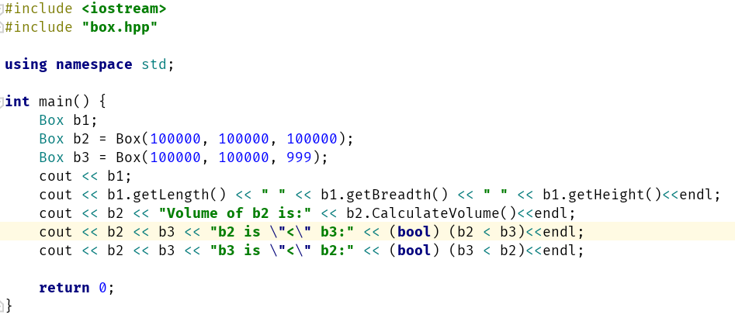

result：

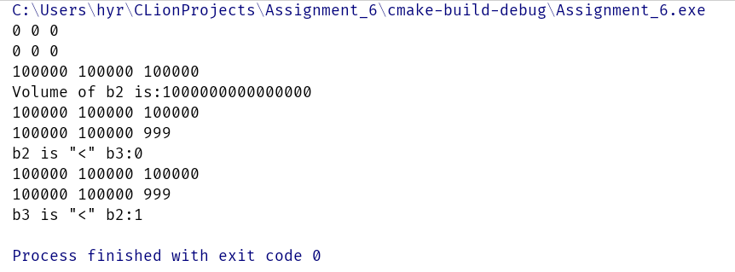

The output is correct.

**Part 4 - Difficulties & Solutions**

I forget how to overload “<<”, so I saw out slides and get the right solution.