Compare products from datacube.

Usage:

- start VDI

- module use /g/data/v10/public/modules/modulefiles, if it is not automatically loaded when starting VDI.

- module load agdc-py3-prod

- run the compare_products_opensource.ipynb notebook

Select products and load them from datacube

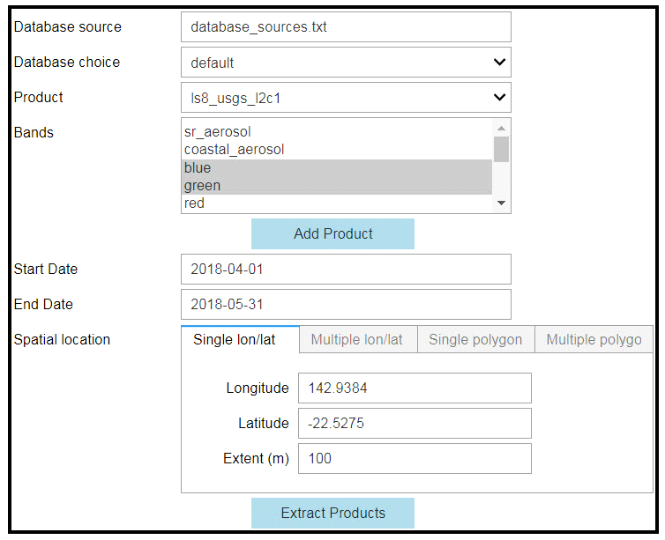

- 1. Set up the ***Database source*** by inputting the file name then pressing ***Enter***.

- 2. After the database source is set up, the available databases are shown in the ***Database choice*** drop down menu. Select one database. The 'default' database in Geoscience Australia is the operational database and can be used for comparing USGS level 2 data and GA ARD.

- 3. After selecting the database, all available products in the database are shown in the ***Product*** dropdown menu. Select one product, e.g. ls8_ard.

- 4. After the product is selected, its available bands are shown in the ***Bands*** drop down menu. Select one or more bands for this product, e.g. nbar_blue, nbar_green for ls8_ard.

- 5. Click the ***Add Product*** button.

- 6. Repeat step 1 to 5, to add more products, e.g. las8_usgs_l2c1.

- 7. After adding all products, set ***Start date***, ***End date***, and ***Spatial location*** by selecting one of four choices: single window cantering a location, multiple windows at multiple locations, single shape file, or multiple shape files.

- 8. Click ***Extract Products*** button to load all selected products from datacube.

- 9. Run the next cell in the Jupyter notebook, another GUI is produced for plotting.

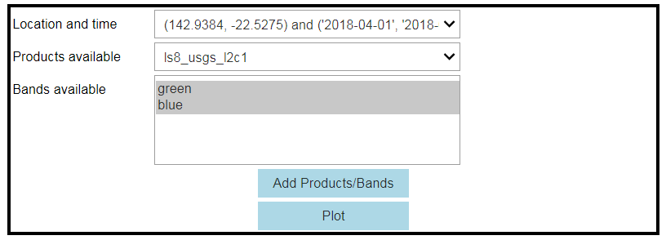

- 10. Based on the products loaded earlier, in this GUI, the available pairs of location and time are shown in the ***Location and time*** drop down menu. Select one of the location and time of your interest.

- 11. All products available for this pair of location and time are shown in the ***Products available*** drop down menu. Select the product of interest.

- 12. After the product is selected, its previously loaded bands are shown for users to select one or more bands for plotting.

- 13. Click the ***Add Products/Bands*** button to add the product with the selected bands for plotting.

- 14. Repeat step 10 to 13 to select all previously loaded products of interest for plotting.

- 15. After all products are selected, click the ***Plot*** button to plot these products.

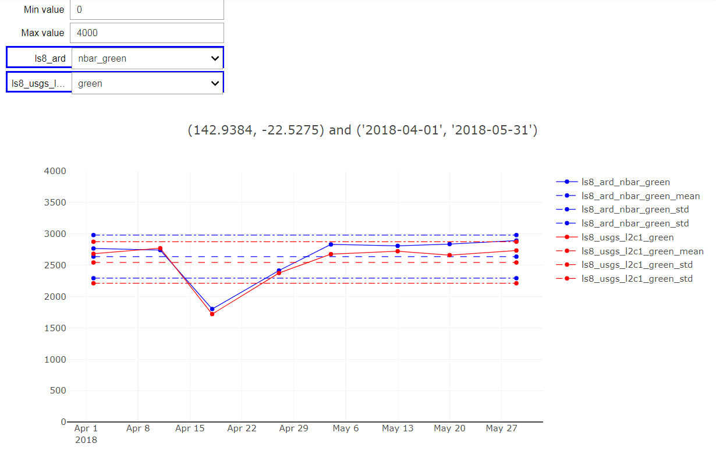

- 16. Then the time series data for one band for each product is drawn.

- 17. The data value range can be adjusted by typing the minimum value in the ***Min value*** box, and maximum value in the ***Max value*** box.

- 18. From the drop down menu for each product user can select different band at one time to draw.