Methods for generating post recommendations and push notifications for social media sites

Yuan-chen Liao, Annette Li-an Chiu, Yu-jui Wan ,Wei-ting Liao, Adam Hou*
Department of Industrial Engineering and Engineering Management, National Tsing Hua University
*adamhou@ie.nthu.edu.tw

Abstract
People routinely convey and receive information via online social media, and those with common interests and traits often form various online social networks. However, the immense amount of complex information on the internet often prevents social network members from efficiently obtaining the information that they seek. This creates the need for a post recommendation mechanism to help social media users find the posts that they want from the all-encompassing content of social media. Popular time periods during which social network members are more likely to browse posts, the relevancy of information to the interests of social network members, and the connections among users often have a direct impact on the acceptance of social network members and posts. If social media managers can effectively identify time periods during which social network members are active, and then interact them during this time, they can maximize post exposure. This study developed a post recommendation and push notification model combining methodologies to gauge post similarity and identify popular post interaction periods. The degree of similarity between posts is determined based on the responses made by social network members, whereas time period of increased interactions are identified based on the numbers of responses made to posts at different time periods. It is hoped that the proposed model can help social network members and social media managers clarify and categorize member preferences and identify critical time periods for social interaction.

Keywords: social network analysis, Recommendation algorithms

Table of Contents

1. Research motives and objectives………………………………………………………….. 3
2. Methodology to gauge article similarity………………………………………………….. 5
3.Methodology to identify time period of increased interactions………………………...…. 8
4. Case analysis………………………………………………………………………...…… 11
5. Methodology validation…………………………………………………………………... 13
6. Conclusions and future research………………………………………………………... 14
7. References……………………………………………………………………...… 13
- Research motives and objectives

In today’s internet environment, social networks contain immense quantities of complex information. Social network members generally need to spend long periods of time to find relevant information from among the all-encompassing content of social networks. From the perspective of social media managers, the social media users post at random times. With no effective mechanism to identify popular post-reading periods, social media managers may miss the time periods when social media users are active. This might render them unable to effectively interact with them.
This study developed methodologies to gauge post similarity and identify popular post interaction times for a post recommendation and push notification model. It is hoped that these methodologies can help social network members and social media managers clarify and categorize member preferences and identify critical time periods for social interaction.
In existing models, social network members generally browse posts aimlessly and receive information at random. However, much of this information is not needed and does not interest the user. This study mainly involves two methodologies to gauge post similarity and identify popular post interaction periods, which managers can use to manage online social media. The degree of similarity between posts is determined based on responses to historical posts, whereas time period of increased interactions are identified based on the numbers of responses made to posts at different time periods. With the information obtained using the methodology, social media managers can grasp the time periods in which social network members are active and often make posts. With the methodology to gauge post similarity, systems can automatically recommend posts that interest social network members and better meet their needs.
To gauge the degree of similarity between posts, historical response data is collected and converted into a matrix. The distributions of responses to a post can then be derived from the matrix. Finally, the angle between the vectors of two posts is calculated to represent the correlation between post distributions.
Time period of increased interactions are identified based on the number of responses to posts at different times. The data is converted into a matrix to represent the frequencies of responses made by social network members to various posts at various time periods. Next, the response data is organized to determine time period of increased interactions.
With the methodology to identify time period of increased interactions, social media managers can grasp the time periods in which social network members are active and often post comments. With the methodology to gauge post similarity and a post recommendation function, social media systems can recommend relevant posts to associated social network members.

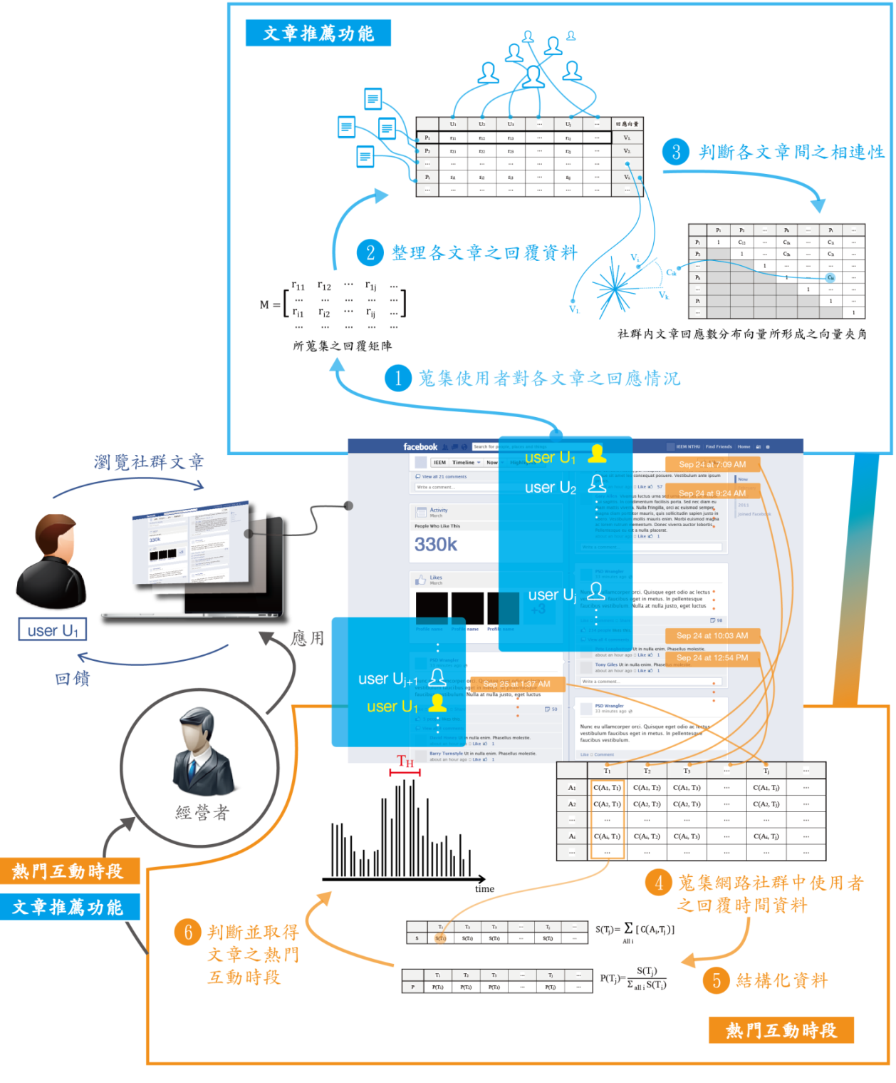

Fig. 1 Schematic of post recommendation and push notification model

1. Methodology to gauge post similarity

This methodology determines the degree of similarity between various posts based on the responses of all social network members to the posts. The greater the similarity between the responders and response frequencies of two posts is, the greater the similarity between the two posts. The purpose of this is to provide reference for future post recommendations; when a social network member responds to a post, the system will automatically recommend similar posts.
Before we explain the methodology to gauge post similarity, we first define relevant nomenclature:
M The response matrix formed by the numbers of responses from members to each post
r_{ij} The number of responses from member j to post i
V_{i∙} The vector formed by the numbers of responses from members to post i
P_{i} Post i in social network
U_{j} Member j in social network
C_{ik} The degree of similarity between P_{i} and P_{j}

Below, we explain the details of the three major steps of the methodology to gauge post similarity.

Step A1: Obtain response conditions of social network members to various posts
In this step, the response conditions of each post are converted into a matrix to represent the relationships between responses, social network members and articles. First, the numbers of responses made to post P_{i} by members U₁, U₂, …, and U_{j} , which are expressed as r_{i1}, r_{i2}, …, and r_{ij}, are calculated. After the numbers of responses made by social network members to posts P₁, P₂, …, and P_{i} are obtained, the response matrix M for a social network member can be constructed:

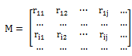

Step A2: Collate response distributions for each post
When two posts show great similarity in terms of responders and response frequencies, it can be assumed that the contents of such posts have similar qualities. Thus, the primary objective of this step is to obtain response distributions for each post.
Specifically, for post P_{i}, this means deriving the vector V_{i∙}, which comprises r_{i1}, r_{i2}, …, and r_{ij}, the numbers of responses made by social network members, from the response matrix M obtained in the previous step. This clarifies which social network members responded so the post in question and how often they responded to it. The corresponding numerical formula is as follows:

V_{i.}=

Similarly, the response vectors V₁, V_{2.}, …, V_{i.} , … corresponding to posts P₁, P₂, …, P_{i}, … can be obtained, the results of which are presented in Table 1.

Step A3: Calculate correlation between posts using post response distributions
With the response vectors derived in the previous step, we can determine whether two posts are similar based on the similarity between their responders and response frequencies. In this step, the angle between the response vectors of two posts indicates the degree of similarity between them. The smaller the angle, the more similar the two posts are.
Specifically speaking, suppose the response vectors of posts P_{i} and P_{k} are V_{i.}= and V_{k.}=, respectively. The inner product of the two vectors divided by the product of the distances of the two vectors gives C_{ik}, the angle between the two vectors. A smaller C_{ik} indicates a higher degree of similarity between the two posts. The corresponding mathematical formula is:

C_{ik}=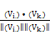,

Similarly, we can obtain the angles between vectors of posts P₁, P₂, …, P_{i}, … and other posts in the social network. These results are presented in Table 2.

Table 1 Response vectors corresponding to each post
 | U₁ | U₂ | U₃ |  | U_{j} |  | Response vector
P₁ | r₁₁ | r₁₂ | r₁₃ |  | r_{1j} |  | V_{1.}
P₂ | r₂₁ | r₂₂ | r₂₃ |  | r_{2j} |  | V_{2.}
P_{i} | r_{i1} | r_{i2} | r_{i3} |  | r_{ij} |  | V_{i.}

Table 2 Angles between vectors formed by response distributions of each post in the social network
 | P₁ | P₂ |  | P_{k} |  | P_{i}
P₁ | 1 | C₁₂ |  | C_{1k} |  | C_{1i}
P₂ |  | 1 |  | C_{2k} |  | C_{2i}
 |  |  | 1
P_{k} |  |  |  | 1 |  | C_{ki}
 |  |  |  |  | 1
P_{i} |  |  |  |  |  | 1
 |  |  |  |  |  |  | 1

Conclusion
Using the procedure above, this study gauged the degree of similarity between two posts based on interactions among social network members. We believe that this approach will facilitate post recommendations to social network members with similar preferences. When a social network member responds to a post, the system will use this approach to recommend similar posts that the social network member has not yet responded to.

3. Methodology to identify time period of increased interactions

This methodology sorts the responses to a post by time to identify times when social network members are more likely to interact with a post. The objective of this methodology is to help social media managers use online social networks more effectively. Social media managers can then select these time periods to interact with social network members and maximize post exposure.
Before we explain the methodology to identify time period of increased interactions, we first define relevant nomenclature:
A_{i} Post i
T_{j} Time point j
C(A,T) Frequency of responses to post A at time point T
S(T) Total frequency of responses to all posts at time point T
P(T) Ratio of total frequency of responses to all posts at time point T to total frequency of responses to all posts during all of the time
α Preset ratio of total response frequency during popular time period to total response frequency (also referred to as the threshold value)
β Ratio of total response frequency during target time period to total response frequency (also referred to as the cumulative ratio)
R_{i} ith ratio of ratios of total response frequencies to total response frequency during all of the time ranked in descending order
L_{i} ith ratio of ratios of total response frequencies during preliminary time period of increased interaction to total response frequency during all of the time ranked in descending order
To_{H} Preliminary time period of increased interaction
T_{H} Refined time period of increased interaction

Below, we explain the five major steps of the methodology used to identify time period of increased interactions:

Step B1: Obtain frequencies of responses of social network members to various posts at different time periods
The objective of this methodology is to determine when social network members are most likely to interact with a post in the time cycle. To do this, we must obtain data for the frequencies of member responses to each post during different time periods.
For post A_{i}, the response frequencies at time periods T₁, T₂, …, T_{j}, … are C(A_{i},T₁), C(A_{i},T₂), …, C(A_{i},T_{j}), …. In the same manner, the response frequencies for posts A₁, A₂, …, A_{j}, … can be obtained, the results of which are presented in Table 3.

Table 3 Response frequencies of social network members at various time periods
 | T₁ | T₂ | T₃ |  | T_{j}
A₁ | C(A₁, T₁) | C(A₁, T₂) | C(A₁, T₃) |  | C(A₁, T_{j})
A₂ | C(A₂, T₁) | C(A₂, T₂) | C(A₂, T₃) |  | C(A₂, T_{j})
A_{i} | C(A_{i}, T₁) | C(A_{i}, T₂) | C(A_{i}, T₃) |  | C(A_{i}, T_{j})

Step B2: Obtain total response frequencies of all posts for all time periods
Based on the data derived from the previous step, the sum of the response frequencies of all the posts at all time periods is calculated to obtain the total response frequencies at different time periods. Specifically speaking, the frequencies of responses to posts A₁, A₂, …, A_{j}, … at time point T_{j}, which are C(A₁,T_{j}), C(A₂,T_{j}), …, C(A_{i},T_{j}), ... are summed to obtain S(T_{j}), the total response frequency at time point T_{j}. The formula is as follows:

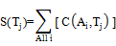

In the same manner, the total response frequencies for time periods T₁, T₂, …, T_{j}, … can be obtained, the results of which are presented in Table 4.

Table 4 Total response frequencies at different time periods
 | T₁ | T₂ | T₃ |  | T_{j}
S | S(T₁) | S(T₂) | S(T₃) |  | S(T_{j})

Step B3: Obtain ratios for total response frequencies of all posts for all time periods
This step uses the results from the previous step to calculate the ratios for total response frequencies at various time periods to the total response frequency, the results of which will facilitate the popular time period identification process in the next step. Specifically speaking, the total response frequency at time point T_{j}, which is S(T_{j}), is divided by the total response frequency to calculate P(T_{j}), the ratio of the total response frequency at said time point. The formula is as follows:

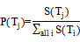

In the same manner, the total response frequencies for time periods T₁, T₂, …, T_{i}, … can be obtained, the results of which are presented in Table 5.

Table 5 Ratios for total response frequencies at different time periods
 | T₁ | T₂ | T₃ |  | T_{j}
P | P(T₁) | P(T₂) | P(T₃) |  | P(T_{j})

Step B4: Identify preliminary time periods with increased interaction
Based on the results obtained in Step A3, this step uses the highest and second highest ratios for response frequencies as the upper and lower limits of time period and sums the ratios of the total response frequencies at various time periods during said time period to derive the ratio of the total response frequency within this period to the total response frequency for all posts. Next, if the ratio of the total response frequency within the time period to the total response frequency for all posts reaches the preset threshold value, then said period is identified as a time period of increased interaction. In contrast, if the ratio of the total response frequency within the time period to the total response frequency for all posts does not reach the preset threshold value, then we take the third highest ratio of response frequencies to different posts at different time periods into consideration. The longest time period formed by the three highest ratios is used to recalculate the cumulative ratio. If the cumulative ratio reaches the preset threshold value, then the period is deemed to be a time period of increased interaction; otherwise, this step is repeated until a time period of increased interaction is found.
Specifically, we first take the time periods with the highest and second highest response frequency ratios, and , as the upper and lower limits of the time period, with R₁={a | P(T_{a})=} and R₂={b | P(T_{b})=}. The response frequency ratios of all the time periods between and are summed to obtain cumulative ratio β, the corresponding formula of which is as shown below:

β=, if R₁<R₂
or β=, if R₁>R₂

When cumulative ratio β is not less than threshold value α (i.e., β≥α), then time period [] is considered a preliminary time period of increased interaction. In contrast, β≤α means that cumulative ratio β does not reach threshold value α, then the time point with the third highest frequency response ratio, , is taken into consideration, with R₃={c | P()=}. The cumulative ratio β of the longest time period formed by , , and is calculated. If cumulative ratio β is not less than threshold value α, then the corresponding time period is considered a time period of increased interaction. If cumulative ratio β still does not reach threshold value α, then this step is repeated until cumulative ratio β is not less than threshold value α. Suppose that with P(), cumulative ratio β begins to be greater than threshold value α, which means that P()+ P()+…+P()≥α. Given that, P()≥P()≥…≥P(), P()+P()+…+P()<α≤P()+ P()+…+P() is also true. Thus, the preliminary time period of increased interaction can be expressed as

T_{H}=T_{OH}=[T_{Min},T_{Max}]
where T_{Max}=Max(,,…,)
T_{Min}=Min(,,…,)

Step B5: Refine the preliminary time period of increased interaction
Using the results obtained in Step B4, this step refines the preliminary time period of increased interaction. If the ratio of the total response frequency for the preliminary time period of increased interaction to the total response frequency for all posts equals the preset threshold value, then the preliminary time period of increased interaction is the refined time period of increased interaction. In contrast, if the cumulative ratio of the preliminary time period of increased interaction is greater than the preset threshold value, then revisions are required to bring the cumulative ratio closer to the preset threshold value. Based on the results obtained in Step B4, the time point with the lowest response frequency ratio in the preliminary time period of increased interaction is first eliminated to reduce the cumulative ratio and bring it closer to the threshold value. If the cumulative ratio declines so far as to fall below the threshold value, then said time point should not be removed, and the remaining time period is the refined time period of increased interaction. If the cumulative ratio is still greater than the preset threshold value after the elimination of time periods with the lowest response frequency ratios, then the time point with the next lowest response frequency ratio is eliminated and the cumulative ratio recalculated. Again, if the removal causes the cumulative ratio to become lower than the threshold value, then the time point should not be eliminated and the remaining time period becomes the final confirmed time period of increased interaction. In contrast, if the cumulative ratio is still greater than the preset threshold value, then this step is repeated until a time point cannot be removed without causing the cumulative ratio to fall below the preset threshold value.
Specifically, to refine preliminary time period of increased interaction T_{OH}, the time point with the lowest response frequency ratio P() is first removed from time period T_{OH}, and the cumulative ratio β is recalculated. If β is less than the threshold value (i.e., β<α), then the time period before the removal of this time point is the refined time period of increased interaction T_{H}. Here, the refined time period of increased interaction remains the same as the preliminary time period of increased interaction T_{OH}. The results can be expressed as follows:

T_{H}=T_{OH}=[T_{Min},T_{Max}]
where T_{Max}=Max(,,…,)
T_{Min}=Min(,,…,)

In contrast, if cumulative ratio β is still greater than the threshold value (i.e., β>α), then the time point with the next lowest response frequency ratio P() should be removed, and the cumulative ratio β is recalculated. If β is less than the threshold value (i.e., β<α), then the time period before the removal of this time point is the refined time period of increased interaction, which can be expressed as

T_{H}=[T_{Min},], [, T_{Max}]
where T_{Max}=Max(,,…,)
T_{Min}=Min(,,…,)

Following the revision, the refined time period of increased interaction becomes two periods.
If cumulative ratio β is still greater than the threshold value (i.e., β>α), then this step is repeated until the removal of a time point causes cumulative ratio β to fall below preset threshold value α.

Conclusion
This methodology uses the procedure above to identify the time periods of increased interaction. Posting information updates during these time periods will maximize exposure among users of a social network. The information that results from this methodology can also be helpful when gauging post similarity so that the social network automatically recommends posts and gives new information to social network users when they are more active.

4. Case analysis

In our case analysis, we examined responses to 43 comics called “Sad for You,” which were authored by Yellow Book and posted on Facebook. This study recorded the responses that community members made to the posts from March 18th, 2013, to April 18th, 2013. By the end of this period, Yellow Book had received 160,387 likes, and 18,564 people were talking about the posts.

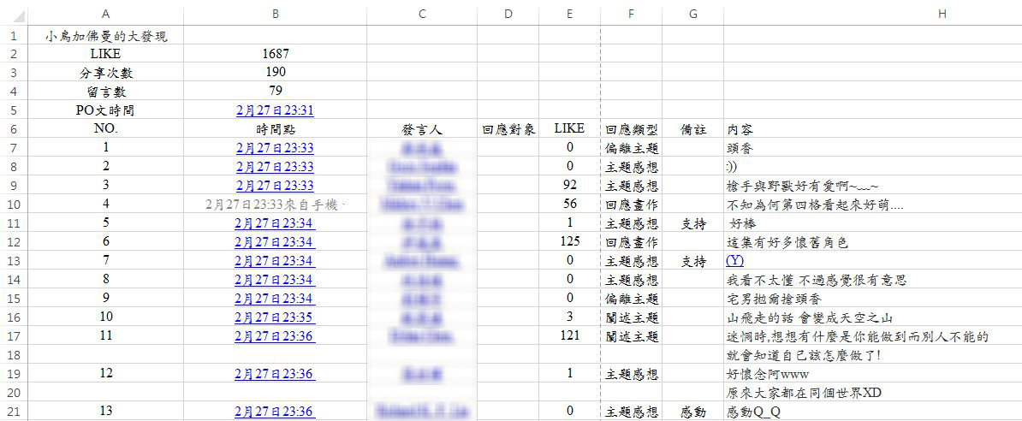

Fig. 2 Original response data

Figure 3 presents the response conditions by hour from 1 AM to midnight. We collected data regarding the number of responses to the posts and the ratios of the frequencies at each time point to the total response frequency.

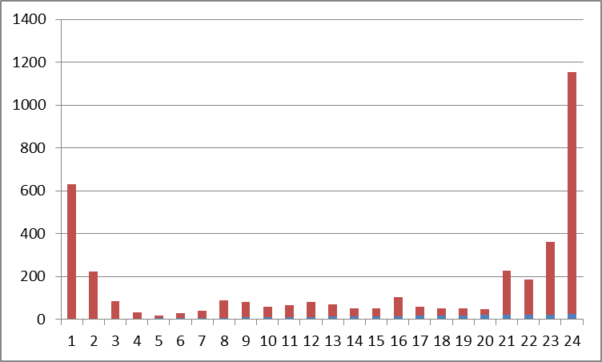

Horizontal axis: Time (hr), Vertical axis: Number of responses

Fig. 3 Total response frequencies of all posts during all time periods

We recorded the number of responses to the 43 posts in the “Sad for You” series as follows: Post P1 responses were r_{i1} =1, r_{i7} =1, r_{i8} =1, …. Table 6 presents the response conditions, which were converted into a response matrix. By calculating the angles between the response vectors, we gauged the degree of similarity between posts, as shown in Table 7.
Table 6 Response relationships between social network members and posts
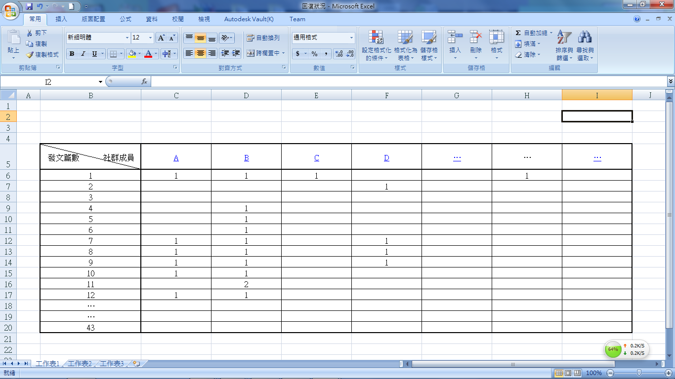

Horizontal axis: Member Vertical axis: Post

Table 7 Angles between vectors formed by response distributions of each post

 | P₁ | P₂ | P₃ | P₄ | P₅ |  | P_{i}
P₁ | 1 | 0.490 | 0.439 | 0.624 | 0.087 |  | C_{1i}
P₂ |  | 1 | 0.321 | 0.098 | 0.235 |  | C_{2i}
P₃ |  |  | 1 | 0.721 | 0.211
P₄ |  |  |  | 1 | 0.867 |  | C_{ki}
P₅ |  |  |  |  | 1
 |  |  |  |  |  | 1
P_{i} |  |  |  |  |  |  | 1
 |  |  |  |  |  |  |  | 1

5. Methodology validation

To verify whether the methodology to gauge post similarity could successfully recommend posts that would really meet the needs of social network members, we took nine posts from Yellow Book’s fan page on Facebook. We then recruited participants to read benchmark post P₁, compare it with the other eight posts, P₂, P₃, …, and P₉, and recommend the one that they felt was most similar to P₁.
The participants comprised 60 individuals in total, including 31 males and 29 females. According to 26 participants, P₄ was the most similar to P₁, accounting for 43.33% of the total. The recommendations of the remaining participants are as shown in Fig. 4.

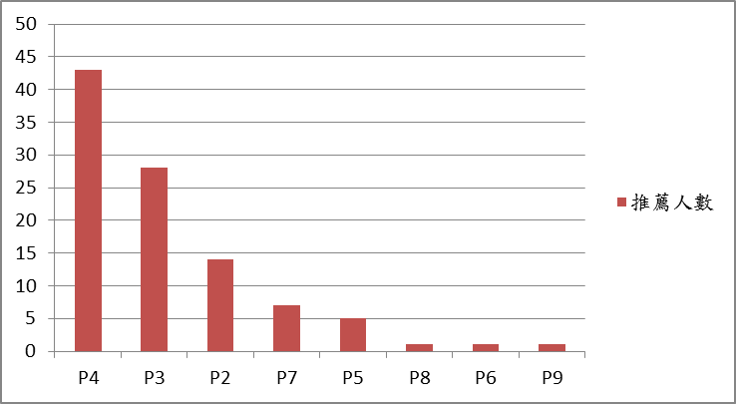

Horizontal axis: Posts, Vertical axis: Number of recommendations

Fig. 4 Recommendations for post most similar to P₁

We ranked posts P₂, P₃, …, and P₉ based on the subjective recommendations made by the participants and used the methodology to gauge post similarity to rank them as well. The results are compared in Table 8.

Table 8 Response relationships among posts and social network members

Post | Number of recommendations | Percentage | Post correlation coefficient | Rank based on participant recommendations | Rank based on proposed post similarity methodology
P₄ | 26 | 43.33% | C₁₄=0.634 | 1 | 1
P₃ | 13 | 21.66% | C₁₃=0.439 | 2 | 3
P₂ | 12 | 20.00% | C₁₂=0.491 | 3 | 2
P₇ | 4 | 6.66% | C₁₇=0.072 | 4 | 5
P₅ | 2 | 3.33% | C₁₅=0.087 | 5 | 4
P₈ | 1 | 1.66% | C₁₈=0.055 | 6 | 6
P₆ | 1 | 1.66% | C₁₆=0.073 | 7 | 8
P₉ | 1 | 1.66% | C₁₉=0.093 | 8 | 7

Conclusion
Comparisons of the results obtained using the proposed methodology and the subjective judgment of actual social network members revealed discrepancies in three of the 28 pairs, thereby presenting an accuracy rate of 89.3%. This confirms that the proposed methodology for gauging post similarity has reference value for post recommendations.

6. Conclusion and future prospects
Today, social network members browse social media websites every day to receive the latest news and read articles that they are interested in. However, due to a glut of information, social network members cannot be sure whether the post they are beginning to read will meet their expectations in terms of content and quality, let alone whether they should read more of the posts. As a result, they may waste a lot of time reading posts that are not helpful to them and even have difficulty deciding what they are interested in. To resolve this issue, we developed methodologies to gauge post similarity and identify time periods of increased interaction. This knowledge can then be applied to post recommendation functions. This will enable social media systems to automatically recommend posts that will be meaningful to users at opportune moments. The contributions of this study are as follows:
- Methodology to gauge article similarity: The types of responses made by social network members to various posts are first collated to derive response distributions that can be used to calculate the degree of correlation between posts. This provides reference for post recommendations.
- Methodology to identify time periods of increased interaction: The total response frequency for all posts at all time periods is obtained. Then, the ratios of the response frequencies are derived to obtain the time periods of highest interaction.
Over the course of this research, we found several issues that require further investigation. Methods that prevent repeated recommendations must be developed, and it would be helpful to develop a mechanism for establishing more refined and useful post recommendations. These issues involve identifying interactive information of members, such as liking, sharing, and posts already read. The methodologies to gauge post similarity and identify time periods of increased interaction can support the post recommendation models and enhance post exposure in social media.

參考文獻(References)

- 許暐羚 (2013)，以文件內容架構為基礎之評論文件價值評估模式，碩士論文，國立清華大學，新竹，臺灣。
- 廖婕安 (2013)，文件內容擴增實境之視覺化模式，碩士論文，國立清華大學，新竹，臺灣。
- 駱孝倫 (2013)，以文件內容架構為基礎之評論文件價值評估模式，碩士論文，國立清華大學，新竹，臺灣。
- 2011，哀傷浮游，網址：https://www.facebook.com/Official.YellowBook?ref=ts&fref=ts。
- Google+內容推薦機制，網址如下：http://techcrunch.com/2013/05/13/google-launches-content-recommendation-service-for-mobile-sites-powered-by-google/。
- 陳貞伶(2013)，Session-Based Recommendation System for Social Network – Case Study on Tencent Weibo，資訊工程研究所博碩士論文，國立中央大學。
- 黃河銓，王群元(2010)，以社會網路與電影本體為架構之電影推薦系統，臺灣博碩士論文。
- 張原誠(2012)，虛擬社群意識與社群忠誠度對持續使用行為及推薦傾向影響之研究--以Facebook為例，臺灣博碩士論文。
- 楊建武，梁汝鋒，趙增峰，” 一種網絡文章傳播影響力的評價系统及方法”，中國專利，專利號碼：CN102541912 A，2010。
- 劉建，羅侃，楊志峰，” 一種相關文章的推薦處理方法和處理系统”，中國專利，專利號碼：CN 103049440 A，(2013)。
- Perny, P. and J. D. Zucker. Preference-based Search and Machine Learning for Collaborative Filtering: the ``Film-Conseil'' recommender system. Information, Interaction , Intelligence, 1(1):9-48, 2001.
- Herlocker , Jonathan L., Joseph A. Konstan , Loren G. Terveen , John T. Riedl, (2004) Evaluating collaborative filtering recommender systems, ACM Transactions on Information Systems (TOIS), v.22 n.1, p.5-53, January 2004.
- Golbeck, Jennifer (2005) "Computing and Applying Trust in Web-Based Social Networks," Ph.D. Dissertation, University of Maryland, College Park.

