


Der Erste Engel, das bundesweite Covid19 Gesundheitsdatenportal in der Cloud

Beim Ersten Engel handelt es sich um eine nicht-kommerzielle, open-source Neuentwicklung eines Teams, das sich für den #WirvsVirus Hackathon zusammengefunden hat.

Technical Documentation: Erster Engel

Frontend:
The frontend was built along the lines of an existing application called MyDataMixer developed by buschjo on github (https://github.com/buschjo/myDataMixer).
The frontend is structured as follows:
>Docs
>images
app.js
index.html
manifest.json
sw_registration.js
sw.js

Images
Images contains two files in png format. One in 192x192 px and one in 512x512 px format.
Both are used by the manifest.json. The 192x192 format is also used as favicon.

App.js

Root Vue.js: App
The root app takes three options on initialization.

Option: el
Is used to identify the corresponding html container in index.html (Index.html)

Option: router
Is the router instance that is used for the page navigation. (Routing)

Option: data
Contains two arrays. Symptomnames is the array containing all symptom names used for the graph creation. Entries is an array containing example entries. This data is requested from aws using a the fetch api on the created event of the instance.

Routing
There are three routes available.
View Name | Url | Vue Component
Home | /#/ | Collect
Collect | /#/collect | Collect
Overview | /#/graphs | Graphs

The routes are defined in the const routes.
const routes = [{
name: 'home',
path: '/',
component: Collect
}, {
name: 'collect',
path: '/collect',
component: Collect
}, {
name: 'graphs',
path: '/graphs',
component: Graphs
}];
The object is given to an instance of VueRouter:
const router = new VueRouter({
routes
});

The router instance is given to the Vue.js root instance on initialization.
About the VueRouter see: https://router.vuejs.org/
About the implementation of the router in the index see: Index.html

Graphs Vue.js Component
The graphs component is used for the Overview View.
It renders two graphs on the mounted event, created using plot.ly (https://plot.ly/javascript/)
Symptom names are extracted from the root component and sorted into symptoms that store Booleans and those that don’t. At the moment only temperature is a non-boolean symptom.
All Boolean symptoms will be plotted in the same plot. The temperature is plotted in a separate plot. The space where the plot will be plotted is identified using an id. The id is set on the div elements inside the template option of the Vue Component.
The graphs are created using the entries stored in app.entries (Vue.js root component). Each entry is either sorted into the Boolean or non-boolean symptoms group. In the Boolean group, each value that is false will be replaced with undefined each true value is replaced with the symptom name. All symptoms are added as a trace to the plot.ly plot. This results in the following graph for Boolean symptoms.
The temperature values are not changed but just taken as they are and plotted as one trace. This result in a plot looking like this:
In both plots, the symptoms are plotted on the y / vertical axis and the dates are mapped to the x/horizontal axis.

Collect Vue.js Component

The Collect component is used for the Collect View.

It renders a form with multiple input fields asking for the user’s symptoms.

It asks for the input with the following format:

Feeling: Number
Throat Itches: Boolean
Cold: Boolean
Limb Pain: Boolean
Headache: Boolean
Dry Cough: Boolean
Nauseous: Boolean
Fever: Number
Age: Number
Pre-existing conditions: String
Postal Code: String

All input fields are optional.

After filling out the form, the user can hit submit. On submit, all the input data will be collected into a JSON object. The JSON object will then be sent to the AWS backend via POST request. The method for this post request is located in app.js and is called addEntry(payload).

Index.html
Inside the index.html body element the first div element is used for the root Vue.js component. It is identified using the id.
The router-view elements are used to render the components that correspond to the url. (See Routing). The router-link elements are represented as a elements when rendered and are the navigation for the site.

Hosting:
Application is available via:
https://annettehellbach.github.io/Covd19bundesweitesGesundheitsdatenportal/#/

Progressive Web App

Manifest.json
This is the web app manifest it contains meta information for the application. This info is used by the service worker when the app gets installed.
{
"name": "Erster Engel",
"short_name": "Fancy",
"icons": [{
"src": "images/logo_192x192.png",
"sizes": "192x192",
"type": "image/png"
}, {
"src": "images/logo_512x512.png",
"sizes": "512x512",
"type": "image/png"
}],
"start_url": "index.html",
"display": "standalone",
"background_color": "#3E4EB8",
"theme_color": "#2F3BA2"
}

SW.js
The service worker lists the files to cache:
const FILES_TO_CACHE = [
'index.html',
'images/logo_192x192.png',
'images/logo_512x512.png',
];

And three event listeners.
On the install event the files to cache are cached.
On activate cached data from previous installations are removed.
On fetch network requests are handled. If the request can be served from the cache it is, otherwise it will be forwarded to the network.

Sw_registration.js
Here the service worker is registered after the load event was fired.

Backend
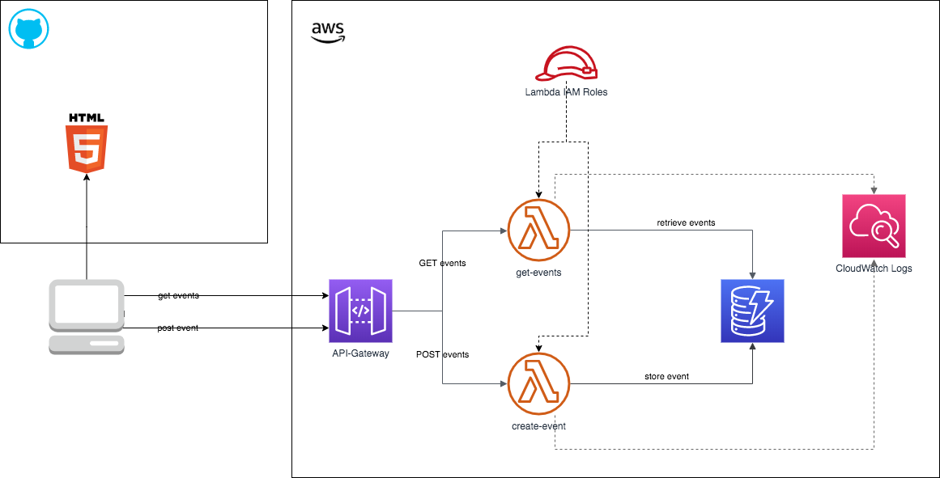

Das Backend ist komplett in der AWS umgesetzt.

Für den Prototypen ist es möglich die vom Benutzer erfasste Symptome und weitere Daten in einer AWS DynamoDB abzulegen.
Es gibt zwei AWS Lambda Funktionen. Eine zum Lesen und eine zum Schreiben der Daten.
Hier vor ist ein einfaches AWS API Gateway gesetzt. Dieses bietet die entsprechenden REST-Methode (GET/PUT) für den Zugriff auf die AWS Lambda Funktionen an.

Für die Erstellung der einzelnen Komponenten in der AWS diente der folgende Artikel als Blaupause:
https://medium.com/better-programming/how-to-build-a-serverless-api-with-dynamodb-aws-lambda-and-api-gateway-d61ac63c27dd

Die

Das Datenmodell besteht aktuell aus einer simplen Tabelle in einer DynamoDB.

Feld | Beschreibung | Datentyp
id | Id der Meldung - wird automatisch vergeben | String
age | Alter | Number
cold | Symptom: Schnupfen | Boolean
dryCough | Symptom: Trockner Husten | Boolean
feeling | Wie fühle ich mich heute | Boolean
headache | Symptom: Kopfschmerzen | Boolean
limbPain | Symptom: Gliederschmerzen | Boolean
nauseous | Symptom: Überlkeit | Boolean
temperature | Symptom: Temperatur | Number
throatItches | Symptom: Halskratzen | Boolean
timestamp | Zeitstempel | Date
zipCode | Postleitzahl | String
preExistingConditions | Vorerkrankungen | String

REST-API

Endpoint: https://p8qa1235xe.execute-api.eu-central-1.amazonaws.com/test/events
(Endpoint kann sich ändern, in einem nächste Schritt muss eine Domain besorgt werden und diese z.B. in AWS Route53 auf das API Gateway verweisen)

Swagger Documentation: https://app.swaggerhub.com/apis/MaLu44/Covid19bundesweitesGesundheitsdatenportal/0.2

Beschreibung | Speicher einer Meldung
HTTP-Method | POST
Path-Parameter | /{stage} - f.ex. test or production
Query-Parameter | ---
Request-Body | Example:  {  "zipCode": "90234",  "age": 45,  "preExistingConditions": "high blood pressure",  "feeling": 1,  "temperature": 36.5,  "dryCough": true,  "cold": false,  "limbPain": false,  "headache": false,  "throatItches": true,  "nauseous": true  }
Path | https://p8qa1235xe.execute-api.eu-central-1.amazonaws.com/test/events

Description | Lesen der Meldungen
HTTP-Method | GET
Path-Parameter | /{stage} - f.ex. test or production
Query-Parameter | ---
Request-Body | ---
Path | https://p8qa1235xe.execute-api.eu-central-1.amazonaws.com/test/events
Response | Example  {  "statusCode": 200,  "body": [  {  "id": "eaf40a085f4427cf977e29871e385c11",  "zipCode": "10117",  "age": 53,  "feeling": 2,  "timestamp": "2020-03-22 11:02:36",  "symptoms": [  {  "cold": false  },  {  "headache": false  },  {  "dryCough": true  },  {  "temperature": 38.2  },  {  "limbPain": false  },  {  "throatItches": true  },  {  "nauseous": false  }  ]  },  {  "id": "067f56ab1e0fcdc87aa6e1b84946ca77",  "zipCode": "90234",  "age": 45,  "feeling": 1,  "preExistingConditions": "high blood pressure",  "timestamp": "2020-03-22 11:02:40",  "symptoms": [  {  "cold": false  },  {  "headache": false  },  {  "dryCough": true  },  {  "temperature": 36.5  },  {  "limbPain": false  },  {  "throatItches": true  },  {  "nauseous": true  }  ]  }  ]  }

