1. **qui đinh ma gia**

BEGIN

IN DONG CHU (hello moi nguoi)

END

cau truc

BEGIN

//di ngu

END

-------------------------------------------------------------------------------------------------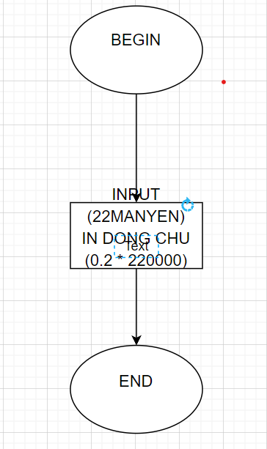

1. **INPUT**

BEGIN

INPUT (22MANYEN)

IN DONG CHU (0.2 * 220000)

END

-------------------------------------------------------------------------------------------------

**3**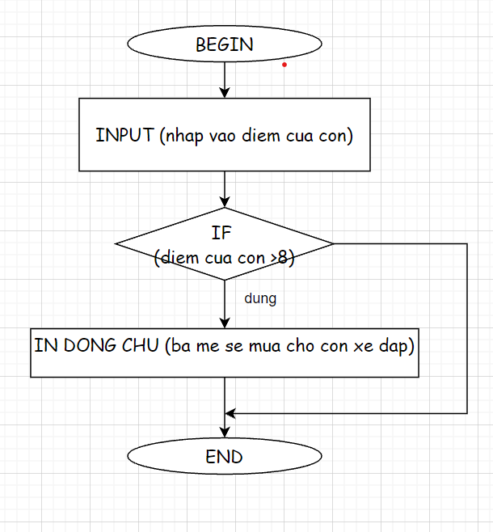

BEGIN

INPUT (nhap vao diem cua con)

IF (diem cua con >8)

IN DONG CHU (ba me se mua cho con xe dap)

END

END

--------------------------------------------------------------------------------------------------

Nhap vao so a neu a chia het cho 3 thi in ra so chia het cho 3

BEGIN

INPUT (nhap vao so a)

IF (a MOD 3 = 0)

IN DONG CHU (so chia het cho 3)

END

END

NHAP VAO DIEM SO NEU DIEM LON HON 8 THI IN RA DONG CHU “HOC SINH GIOI” NGUOC LAI THI IN RA DONG CHU “KHONG PHAI HOC SINH GIOI”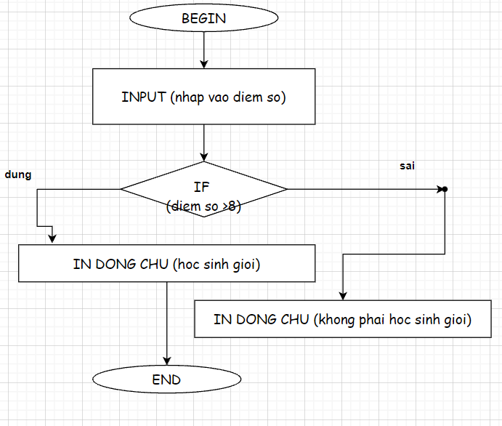

BEGIN

INPUT (nhap vao diem so)

IF (diem so > 8)

IN DONG CHU (hoc sinh gioi)

ELSE

IN DONG CHU (khong phai hoc sinh gioi)

END

END

----------------------------------------------------------------------------------------

NHAP VAO DIEM SO XEM SO DO CO CHIA HET CHO 5 HAY KHONG? CO THI IN DONG CHU “CHIA HET CHO 5” NGUOC LAI “KHONG CHIA HET CHO 5”

BEGIN

INPUT (nhap vao so a)

IF (a MOD 5 = 0)

IN DONG CHU (so chia het cho 5)

ELSE

IN DONG CHU (so khong chia het cho 5)

END

END

---------------------------------------------------------------------------------------------

NHAP VAO MOT SO XEM SO DO VUA CHIA HET CHO 4 VA VUA CHIA HET CHO 6 HAY KHONG?

a.CACH1

BEGIN

INPUT (nhap vao so a)

IF (a MOD 4 = 0)

IF (a MOD 6 = 0)

IN DONG CHU (so vua chia het cho 4 vua chia het cho 6)

END

END

END

b.CACH2

BEGIN

INPUT (nhap vao so a)

IF (a MOD 4 = 0) AND (a MOD 6 = 0)

IN DONG CHU (so vua chia het cho 4 vua chia het cho 6)

END

END

--------------------------------------------------------------------------------

LAI NHAP DIEM

>8 HOC SINH GOI

6<=A<8 HOC SINH KHA

<6 HOC SINH TRUNG BINH

GIAI

BEGIN

INPUT (nhap vao so a)

IF (diem so > 8)

IN DONG CHU (hoc sinh gioi)

ELSE

IF (DIEM >=6)

IN DONG CHU (HOC SINH KHA)

ELSE

IN DONG CHU (HOC SINH TRUNG BINH)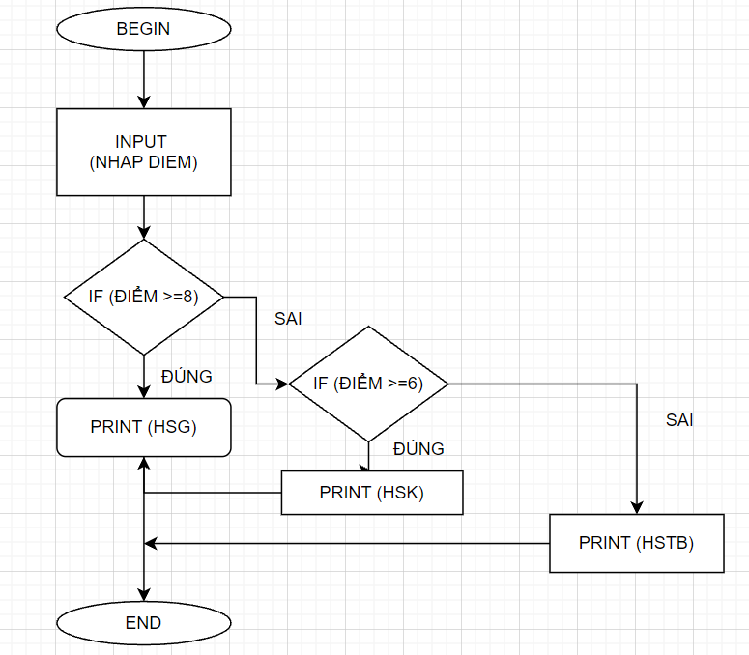

END

END

END