**ICTCP Project Progress**

During our work, we figured out the detailed implementing method of ICTCP project, we also finished part of our work.

**1. What we plan to do**

**1.1** After going through the literature in detail, we found that there are some difficulties we would face. Firstly, we cannot build a real data center with 47 servers obviously. Secondly, it is hard to develop ICTCP in OS kernel. Moreover, ideally ICTCP should be integrated in transportation layer to achieve better performance. Therefore, it is natural for us to decide to implement ICTCP and perform our experiment on ns-3, a discrete event network simulator.

**1.2** To understand the scope and limitations of the ns-3 module we are trying to deal with, we will walk through the ns-3 tutorial first, including installation, tweaking modules, building topologies and so on.

**1.3** After we know what we can do and what we cannot do, we are going to setup the virtual data center and build the topology. The paper uses one switch with 47 servers. Under consideration of efficiency, we plan to start with 8 servers and add up to 47 servers when we finish the ICTCP implementation.

**1.4** Before extending TCP module, we have to understand the code of TCP module in ns-3 and figure out where does our extension fit in TCP module. To be more specific, we will draw a diagram to illustrate the design of TCP module and the logic behind it. After that, we will modify the part of receive window size, because ICTCP essentially adjusts the receive window size before packets drop occurs.

**1.5** To highlight the impact of ICTCP, we will record the normal situation. Normally, in the high-bandwidth, low latency situation, if we have one switch with many servers, and these servers want to send message to the same receiver at the same time, it will have loss, which called the Incast Congestion.

**1.6** We will follow the paper to do the optimization for our environment. The result of the paper is “no loss”. We will use the way that paper presents to do the optimization.

**1.7** After we get a good result that we want, we will compare the result with the normal one.

**1.8** Comprise ICTCP with TCP, see what is the exact advantage of the ICTCP.

**2. What we have done**

**2.1** The first thing we have to do is configuring the environment of NS-3. We learnt that NS-3 can only run under Linux kernel. However, both our team use windows system. Therefore, we use Fedora under virtual box based on the instruction provided by official document of NS-3, and installed NS-3 successfully.

**2.2** Then we made ourselves familiar with NS-3 by going through the tutorial of NS-3. We also read and test a lot of open source code of NS-3.

**2.3** After getting familiar with NS-3, we started to simulate a datacenter using NS-3. Figure 1 shows the topology of datacenter in the paper.

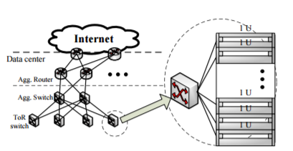

Figure 1

Followed an open source example on Github, we simulate a datacenter locally on our computer. Figure 2 shows the datacenter we simulated.

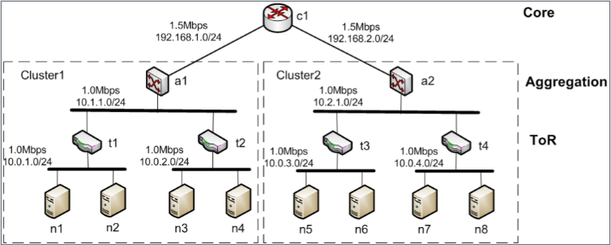

Figure 3

In the future, we plan to expand this topology to 47 servers.

**2.4** After building the topology, we started to read the TCP module of Ns-3. After understanding how NS-3 implementing different TCP, we can add the ICTCP into the TCP module of NS-3.