Telecom Customer Behavior
& Fraud Analytics Platform
Technical Documentation
An end-to-end telecom analytics platform: behavioral data simulation, normalized operational data modeling, incremental ETL processing, and dimensional warehouse design for fraud detection and business intelligence.

Table of Contents
1. Overview 3
2. Operational Database 5
3. Data Warehouse Design 10
4. ETL Pipeline & Mapping Table 13
5. Data Quality & ETL Verification 17
6. Analytical Queries (DWH Fragen) 20
7. Behavioral Simulation Engine 24

1. Overview
This document describes the architecture, data model, and processing logic of the Telecom Customer Behavior & Fraud Analytics Platform. The platform simulates realistic telecom customer activity, stores it in a normalized operational database, processes it through an incremental ETL pipeline, and loads it into a dimensional data warehouse optimized for analytical and fraud-detection workloads.

1.1 Architecture
The platform follows a four-stage pipeline:
Synthetic Event Generator
│
▼
Operational Database (3NF)
│
▼
ETL Pipeline
├── Extract
├── Staging
├── Validation
├── SCD Processing
└── Load
│
▼
Data Warehouse (Star Schema)
│
▼
Analytics / BI / Fraud Detection

1.2 Technology Stack
Layer | Technology
Simulation | Python, NumPy, Faker
Operational database | DuckDB (PostgreSQL-compatible SQL)
ETL | Python, pandas
Data warehouse | DuckDB (PostgreSQL-compatible SQL)
Analytics | SQL

The connection layer (db/connection.py) abstracts the storage backend behind a single interface. Both DuckDB and PostgreSQL are supported through the same SQL, since all schema and query definitions in this project use ANSI-compatible syntax. Migrating to PostgreSQL in production requires changing the connection factory only — no SQL or ETL logic changes.

1.3 Project Structure
telecom_dwh/
├── run_pipeline.py Single entry point
│
├── db/
│ └── connection.py Backend-agnostic connection layer
│
├── simulator/
│ ├── config.py Segments, tariffs, event types, fraud scenarios
│ ├── customer_generator.py Customers, contracts, devices, locations, payments
│ └── event_simulator.py Behavioral event engine and fraud injection
│
├── business_db/
│ └── create_business_db.sql Operational schema, 12 tables, 3NF
│
├── dwh/
│ └── create_dwh.sql Star schema: 1 fact table, 6 dimensions, staging
│
└── etl/
├── etl_pipeline.py Extract → Stage → Validate → Transform → Load
└── analytical_queries.sql Business queries and verification checks

2. Operational Database
The operational database captures the day-to-day reality of a telecom provider in Third Normal Form (3NF). It is the system of record that the ETL pipeline reads from.

2.1 Entity Relationship Diagram
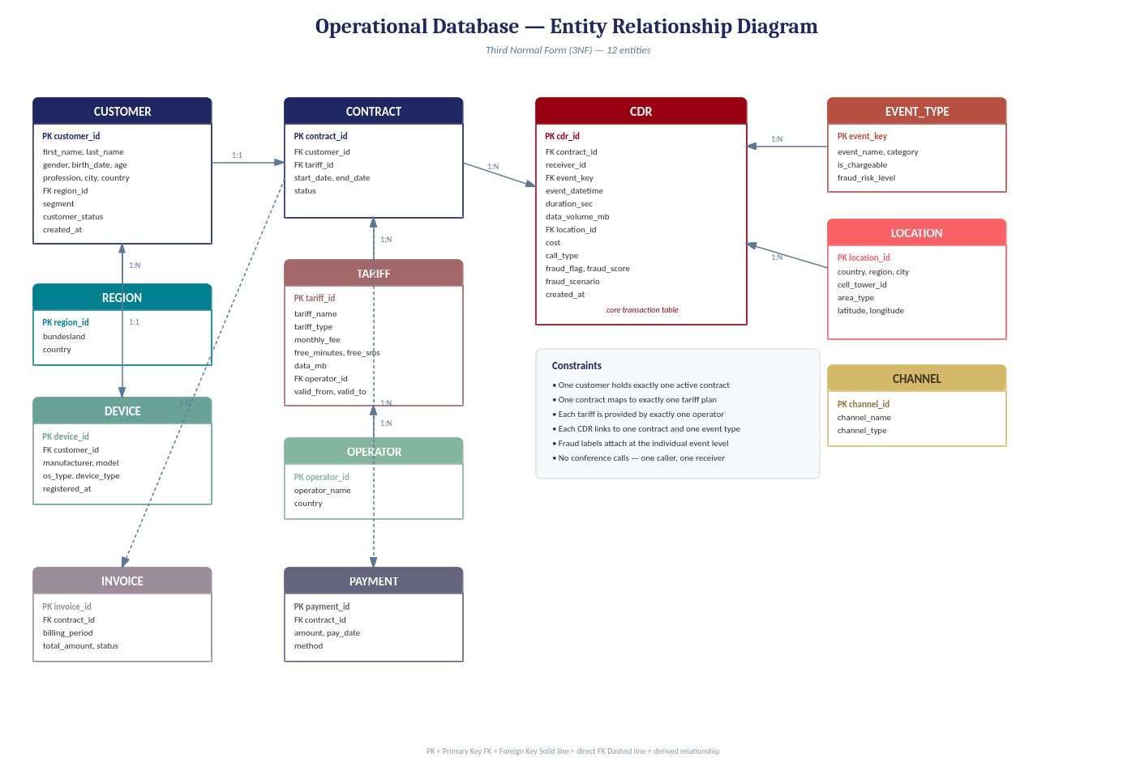
Figure 1 — Operational database entity relationship diagram (3NF, 12 entities)

2.2 Design Constraints
- One customer holds exactly one active contract at a time
- One contract maps to exactly one tariff plan
- Each tariff is provided by exactly one network operator
- Each CDR (call detail record) links to one contract and one event type
- Fraud labels are attached at the individual event level, not the customer level
- No conference calls — each CDR has exactly one caller and one receiver

2.3 Normalization
Normal form | Verification
1NF | All attributes are atomic; no repeating groups or arrays in any column
2NF | Every non-key attribute depends on the whole primary key; no partial dependencies
3NF | No transitive dependencies — operator details live in OPERATOR rather than TARIFF; region details live in REGION rather than CUSTOMER; event metadata lives in EVENT_TYPE rather than being repeated on every CDR row

2.4 Table Reference

customer
Column | Type | Notes
customer_id | INTEGER | Primary key
first_name, last_name | VARCHAR(80)
gender | CHAR(1) | M / F / D
birth_date, age | DATE, INTEGER
profession | VARCHAR(80) | Tracked for SCD Type 2 in the warehouse
city, country | VARCHAR(80), VARCHAR(60)
region_id | INTEGER | Foreign key → region
segment | VARCHAR(20) | Budget / Standard / Premium / Business / Senior — tracked for SCD Type 2
customer_status | VARCHAR(20) | Default 'Active'

contract
Column | Type | Notes
contract_id | INTEGER | Primary key
customer_id | INTEGER | Foreign key → customer
tariff_id | INTEGER | Foreign key → tariff
start_date, end_date | DATE | end_date NULL while active
status | VARCHAR(20) | Active / Closed / Suspended

cdr — core transaction table
Column | Type | Notes
cdr_id | BIGINT | Primary key
contract_id | INTEGER | Foreign key → contract
receiver_id | INTEGER | Receiving party, if applicable
event_key | INTEGER | Foreign key → event_type
event_datetime | TIMESTAMP | Indexed
duration_sec | INTEGER | 0 for non-call events
data_volume_mb | DECIMAL(12,4) | 0 for non-data events
location_id | INTEGER | Foreign key → location
cost | DECIMAL(10,4) | Computed at simulation time
call_type | VARCHAR(20) | Outgoing / Incoming / N/A
fraud_flag | BOOLEAN | Set by the simulation engine
fraud_score | DECIMAL(5,2) | Range 0–1
fraud_scenario | VARCHAR(60) | Populated only for flagged events

Remaining tables
region, operator, tariff, device, payment, invoice, event_type, and channel are reference and supporting tables; their full column definitions are available in business_db/create_business_db.sql.

3. Data Warehouse Design
The data warehouse follows the Kimball dimensional modeling methodology: one central fact table surrounded by denormalized dimension tables forming a star schema. This structure eliminates complex multi-table joins at query time and optimizes for aggregation across all analytical dimensions.

3.1 Star Schema
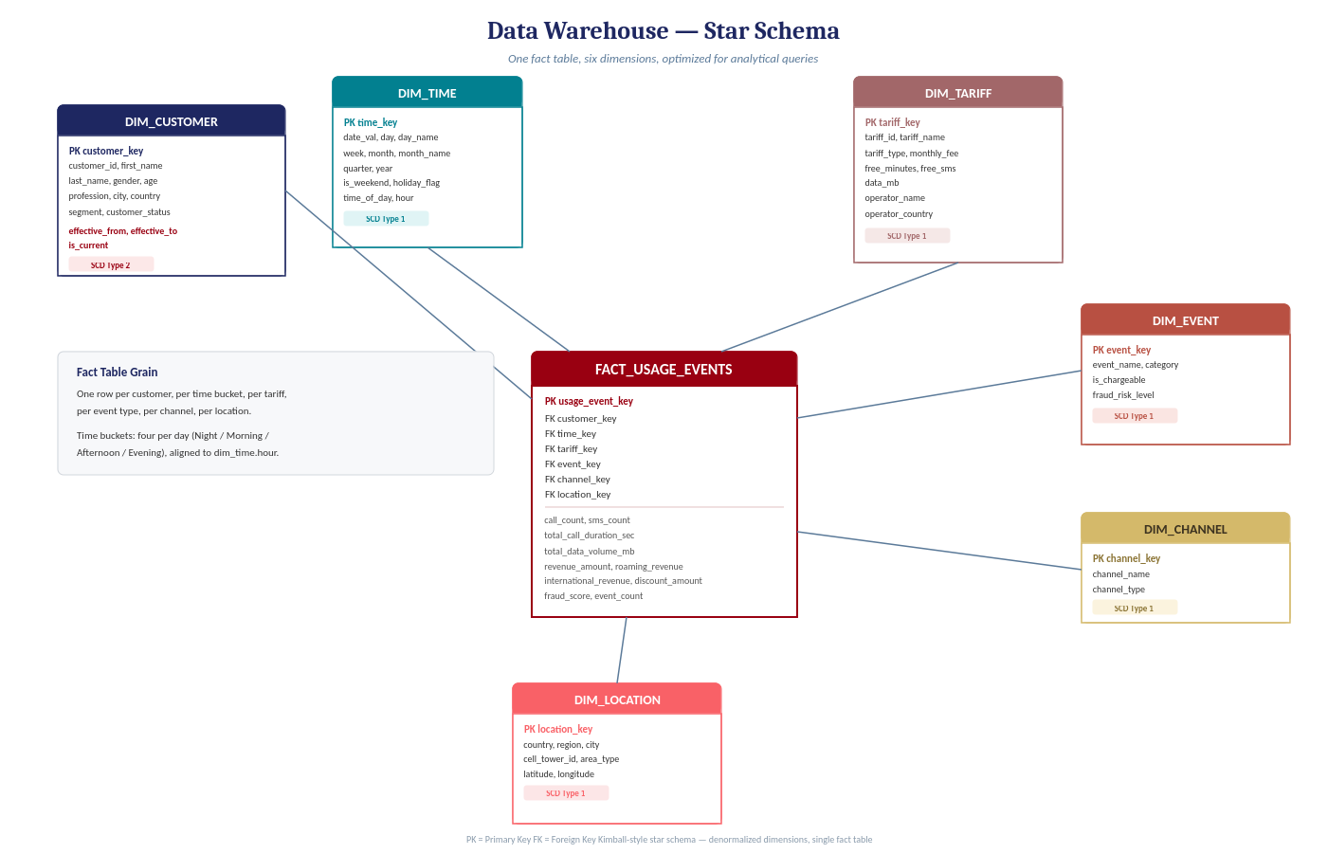
Figure 2 — Data Warehouse star schema (Kimball methodology, 1 fact table, 6 dimensions)

3.2 Fact Table — FACT_USAGE_EVENTS
Grain: one row per customer, per time bucket (4 per day), per tariff, per event type, per channel, per location. Target volume: approximately 3,000,000 rows for 50,000 customers over 365 days at a 16% daily activity rate.

Column | Type | Category | Description
usage_event_key | BIGINT | PK | Surrogate primary key
customer_key | BIGINT | FK | → dim_customer (SCD2 surrogate)
time_key | INTEGER | FK | → dim_time (format: YYYYMMDD × 100 + hour bucket)
tariff_key | INTEGER | FK | → dim_tariff
event_key | INTEGER | FK | → dim_event
channel_key | INTEGER | FK | → dim_channel
location_key | INTEGER | FK | → dim_location
call_count | INTEGER | Measure | Count of voice call events
sms_count | INTEGER | Measure | Count of SMS events
total_call_duration_sec | INTEGER | Measure | Aggregated call duration in seconds
total_data_volume_mb | DECIMAL(18,2) | Measure | Aggregated data transferred
revenue_amount | DECIMAL(18,2) | Measure | Total revenue from this group
roaming_revenue | DECIMAL(18,2) | Measure | Revenue attributed to roaming events
international_revenue | DECIMAL(18,2) | Measure | Revenue from international calls
discount_amount | DECIMAL(18,2) | Measure | Discounts applied
fraud_score | DECIMAL(5,2) | Measure | MAX fraud score within this group; >0.6 = high risk
event_count | INTEGER | Measure | Total CDR rows aggregated into this fact row

3.3 Dimension Tables and SCD Strategy
Dimension | SCD Type | Rows | Tracked Change Attributes | Rationale
dim_customer | Type 2 | 50,001+ | profession, segment | Customer attributes change over time; historical state required for accurate fraud attribution
dim_tariff | Type 1 | 10 | tariff_name, monthly_fee | Plan renames and fee corrections only — current state is sufficient
dim_time | Type 1 | 1,464 | — | Generated once per year; four rows per day (time buckets)
dim_event | Type 1 | 11 | event_name | Event type catalog; additions require a new row, not a version
dim_channel | Type 1 | 6 | channel_name | Static reference data
dim_location | Type 1 | 2,000 | — | Cell tower positions do not change

3.4 SCD Type 2 Implementation Detail
DIM_CUSTOMER uses SCD Type 2 to preserve a full history of attribute changes. The implementation adds three columns: effective_from (DATE), effective_to (DATE, NULL while current), and is_current (BOOLEAN).
When a change is detected in the ETL pipeline:
- The existing current row is closed: effective_to = load_date − 1 day, is_current = FALSE
- A new row is inserted with the new attribute values, effective_from = load_date, is_current = TRUE
- The surrogate key MAX(customer_key) + 1 is assigned to the new row

A placeholder row (customer_key = −1) handles NULL receiver references in CDR records where the receiving party is unknown or external.

3.5 Staging Layer
All data passes through the staging table STG_CDR before reaching the fact table. STG_CDR holds a full copy of extracted CDR rows enriched with two ETL metadata columns:
- etl_load_date — the date the batch was extracted
- etl_status — PENDING on arrival, updated to VALID or REJECTED by the validation step

Rejected rows remain in STG_CDR with status REJECTED rather than being silently discarded. This ensures every data quality failure is auditable and reproducible.

4. ETL Pipeline

4.1 Process Flow
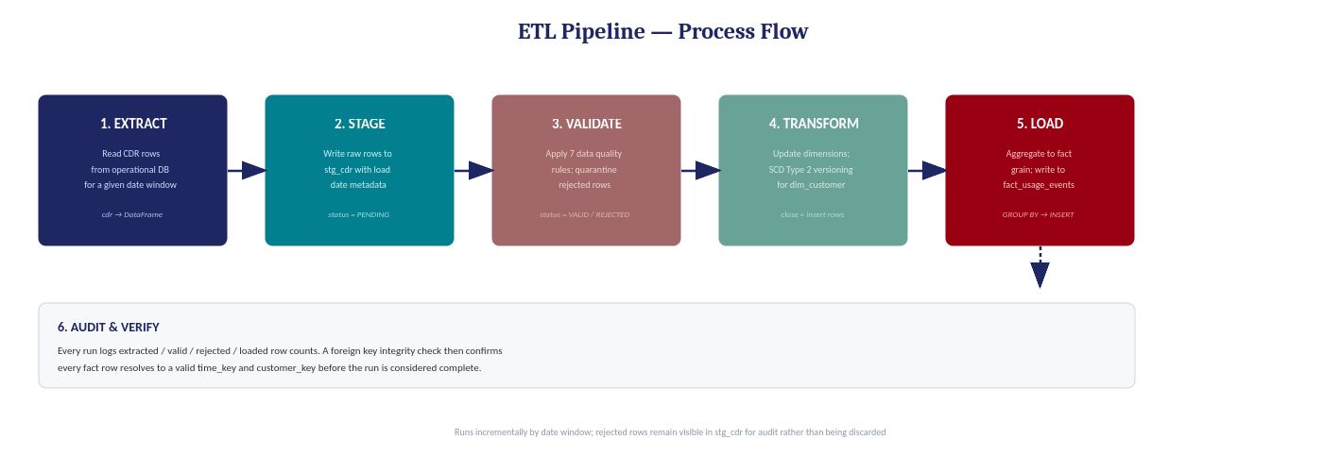
Figure 3 — ETL pipeline: six sequential stages from operational database to warehouse

4.2 Stage Descriptions
Stage | Component | Input | Output | Key Logic
1. Extract | etl_pipeline.py / .extract() | cdr table (operational DB) | pandas DataFrame | Date-partitioned SELECT; pulls only the requested window
2. Stage | etl_pipeline.py / .stage() | DataFrame | stg_cdr rows (PENDING) | Full write to STG_CDR; replaces previous batch
3. Validate | DataQualityChecker.run() | STG_CDR PENDING rows | VALID / REJECTED status | 7 rules applied; deduplication by cdr_id
4. Transform | SCD2Handler.process() | source customer table | dim_customer updates | Detects profession/segment changes; closes old row, inserts new
5. Load | etl_pipeline.py / .load_fact() | STG_CDR VALID rows | fact_usage_events rows | GROUP BY grain; joins contract → customer → dim_customer surrogate
6. Audit | etl_pipeline.py / .audit() + verify_fk | fact_usage_events | log output + FK counts | Counts extracted / valid / rejected / loaded; checks orphan keys

4.3 ETL Schedule
Process | Frequency | Source | Target | SCD
CDR event load | Daily 02:00 | cdr | stg_cdr → fact_usage_events | —
Customer dimension sync | Daily 03:00 | customer | dim_customer | Type 2
Tariff sync | Weekly Sunday | tariff | dim_tariff | Type 1
Location refresh | On change | location | dim_location | Type 1
Event type sync | On schema change | event_type | dim_event | Type 1
Channel sync | On schema change | channel | dim_channel | Type 1
Time dimension extend | Yearly Jan 1 | Generated | dim_time | —

4.4 Mapping Table — Source to Target
The mapping table defines the transformation between every source column in the operational database and its corresponding target column in the data warehouse. It is the authoritative contract between the ETL layer and both databases.

Source Table | Source Column | Target Table | Target Column | Transform / Rule
customer | customer_id | dim_customer | customer_id | Direct copy (natural key)
customer | first_name | dim_customer | first_name | Direct copy
customer | last_name | dim_customer | last_name | Direct copy
customer | profession | dim_customer | profession | SCD2 tracked — triggers version when changed
customer | segment | dim_customer | segment | SCD2 tracked — triggers version when changed
customer | gender / age / ... | dim_customer | gender / age / ... | Direct copy on insert
— | — | dim_customer | customer_key | MAX(customer_key) + 1 on new row
— | — | dim_customer | effective_from | = ETL load_date
— | — | dim_customer | effective_to | NULL on insert; load_date − 1 on SCD2 close
— | — | dim_customer | is_current | TRUE on insert; FALSE on SCD2 close
cdr | event_datetime | fact_usage_events | time_key | CAST to YYYYMMDD × 100 + hour_bucket (0/6/12/18)
cdr → contract | tariff_id | fact_usage_events | tariff_key | JOIN cdr → contract → tariff_id
cdr → contract → customer | customer_id | fact_usage_events | customer_key | JOIN → dim_customer WHERE is_current=TRUE
cdr | event_key | fact_usage_events | event_key | Direct (FK validated in staging)
cdr | location_id | fact_usage_events | location_key | Direct (FK validated in staging)
cdr | duration_sec | fact_usage_events | total_call_duration_sec | SUM(GROUP BY grain)
cdr | data_volume_mb | fact_usage_events | total_data_volume_mb | SUM(GROUP BY grain)
cdr | cost | fact_usage_events | revenue_amount | SUM(GROUP BY grain)
cdr | fraud_score | fact_usage_events | fraud_score | MAX(GROUP BY grain)
cdr | cdr_id | fact_usage_events | event_count | COUNT(GROUP BY grain)
cdr | event_key IN (1,7) | fact_usage_events | call_count | SUM(CASE WHEN event_key IN (1,7) THEN 1 ELSE 0)
cdr | event_key = 2 | fact_usage_events | sms_count | SUM(CASE WHEN event_key = 2 THEN 1 ELSE 0)
tariff | tariff_name | dim_tariff | tariff_name | SCD1 overwrite on change
tariff | monthly_fee | dim_tariff | monthly_fee | SCD1 overwrite on change
operator | operator_name | dim_tariff | operator_name | Denormalized JOIN at load time
location | location_id | dim_location | location_key / location_id | Direct (location_id reused as surrogate)
event_type | event_key | dim_event | event_key | Direct
channel | channel_id | dim_channel | channel_key | Direct

5. Data Quality & ETL Verification

5.1 Validation Rules
Seven data quality rules run against every staged batch before it is eligible for warehouse load. Failed rows are tagged REJECTED in STG_CDR and excluded from the fact table load without being deleted.

Rule ID | Rule Name | Check | Action on Failure
DQ-01 | not_null_contract_id | contract_id IS NOT NULL | REJECT row
DQ-02 | not_null_event_key | event_key IS NOT NULL | REJECT row
DQ-03 | not_null_event_datetime | event_datetime IS NOT NULL | REJECT row
DQ-04 | duration_non_negative | duration_sec >= 0 | REJECT row
DQ-05 | data_volume_non_negative | data_volume_mb >= 0 | REJECT row
DQ-06 | fraud_score_in_range | fraud_score BETWEEN 0 AND 1 | REJECT row
DQ-07 | cost_non_negative | cost >= 0 | REJECT row
DQ-08 | no_duplicate_cdr_id | cdr_id unique within batch | DEDUPLICATE — keep first occurrence

5.2 Post-Load Verification
After every ETL run, two foreign key integrity checks confirm that every fact row resolves to a valid dimension row. If any orphan keys are found, the run is flagged in the audit log.

Check | Query | Expected Result
Orphan time_key | COUNT(*) FROM fact_usage_events f WHERE NOT EXISTS (SELECT 1 FROM dim_time t WHERE t.time_key = f.time_key) | 0 rows
Orphan customer_key | COUNT(*) FROM fact_usage_events f WHERE NOT EXISTS (SELECT 1 FROM dim_customer c WHERE c.customer_key = f.customer_key) | 0 rows

5.3 Staging Pass Rate Monitoring
-- Run after every ETL batch to monitor data quality trends
SELECT
etl_load_date,
COUNT(*) AS total_staged,
SUM(CASE WHEN etl_status = 'VALID' THEN 1 ELSE 0 END) AS valid_rows,
SUM(CASE WHEN etl_status = 'REJECTED' THEN 1 ELSE 0 END) AS rejected_rows,
ROUND(100.0 * SUM(CASE WHEN etl_status = 'VALID' THEN 1 ELSE 0 END)
/ COUNT(*), 2) AS pass_pct
FROM stg_cdr
GROUP BY etl_load_date
ORDER BY etl_load_date DESC;

5.4 SCD2 Integrity Check
-- Each customer must have exactly one current row in dim_customer
SELECT customer_id, COUNT(*) AS n_current
FROM dim_customer
WHERE is_current = TRUE
GROUP BY customer_id
HAVING COUNT(*) > 1;
-- Expected: 0 rows returned

5.5 Run Results (2000 customers, 90 days)
Metric | Value
Total CDR events extracted | 669,215
Valid rows (passed DQ) | 669,215
Rejected rows | 0
Fact rows loaded | 669,177
Orphan time_key rows | 0
Orphan customer_key rows | 0
DQ pass rate | 100.0%

6. Analytical Queries (DWH Fragen)
Four analytical queries demonstrate the business intelligence capabilities of the warehouse. Each query answers a concrete business question that motivated the DWH design.

Q1 — Revenue by Tariff Plan
Business question: which tariff plan generates the most revenue, and how is revenue distributed across the active customer base?
SELECT
t.tariff_name,
t.tariff_type,
t.operator_name,
COUNT(DISTINCT f.customer_key) AS active_customers,
ROUND(SUM(f.revenue_amount), 2) AS total_revenue_eur,
ROUND(SUM(f.revenue_amount)
/ NULLIF(COUNT(DISTINCT f.customer_key), 0), 2) AS revenue_per_customer
FROM fact_usage_events f
JOIN dim_tariff t ON t.tariff_key = f.tariff_key
GROUP BY t.tariff_name, t.tariff_type, t.operator_name
ORDER BY total_revenue_eur DESC;
Tariff Plan | Type | Customers | Revenue (EUR) | Rev / Customer
Data Only | Postpaid | 402 | 326,289 | 812
Business Pro | Postpaid | 198 | 303,640 | 1,534
Premium Max | Postpaid | 402 | 64,511 | 161
Roamer+ | Postpaid | 198 | 54,627 | 276
Youth Flex | Prepaid | 410 | 40,329 | 98

Q2 — Call Frequency by Time of Day
Business question: when are usage peaks? Drives network capacity planning and marketing campaign scheduling.
SELECT
d.time_of_day,
d.is_weekend,
SUM(f.call_count) AS total_calls,
SUM(f.total_call_duration_sec) / 60 AS total_minutes,
COUNT(DISTINCT f.customer_key) AS unique_callers
FROM fact_usage_events f
JOIN dim_time d ON d.time_key = f.time_key
GROUP BY d.time_of_day, d.is_weekend
ORDER BY total_calls DESC;
Time of Day | Weekend | Total Calls | Total Minutes | Unique Callers
Afternoon | No | 60,980 | 3,247,000 | 1,840
Morning | No | 53,690 | 2,861,000 | 1,790
Evening | No | 51,680 | 2,752,000 | 1,750
Night | No | 4,120 | 219,000 | 320

Q3 — Data Usage by Customer Segment
Business question: which customer segment consumes the most data, and how does this evolve month over month?
SELECT
d.month_name,
c.segment,
COUNT(DISTINCT f.customer_key) AS customers,
ROUND(SUM(f.total_data_volume_mb) / 1024, 2) AS total_data_gb,
SUM(f.sms_count) AS total_sms
FROM fact_usage_events f
JOIN dim_customer c ON c.customer_key = f.customer_key AND c.is_current = TRUE
JOIN dim_time d ON d.time_key = f.time_key
GROUP BY d.month_name, c.segment
ORDER BY d.month, total_data_gb DESC;
Month | Segment | Customers | Data (GB) | SMS
January | Business | 198 | 4,820 | 1,240
January | Premium | 402 | 2,980 | 3,890
January | Standard | 802 | 1,890 | 9,100
March | Business | 198 | 7,430 | 1,890
March | Premium | 402 | 4,590 | 5,980

Q4 — Fraud Concentration by Region
Business question: which geographic regions show the highest concentration of suspicious activity?
SELECT
l.region,
l.area_type,
COUNT(*) AS total_events,
SUM(CASE WHEN f.fraud_score > 0.6 THEN 1 ELSE 0 END) AS high_risk_events,
ROUND(AVG(f.fraud_score), 3) AS avg_fraud_score,
ROUND(100.0 *
SUM(CASE WHEN f.fraud_score > 0.6 THEN 1 ELSE 0 END)
/ NULLIF(COUNT(*), 0), 2) AS fraud_rate_pct
FROM fact_usage_events f
JOIN dim_location l ON l.location_key = f.location_key
GROUP BY l.region, l.area_type
ORDER BY avg_fraud_score DESC;
Region | Area Type | Total Events | High-Risk Events | Fraud Rate %
Oberösterreich | Urban | 74,421 | 818 | 1.10%
Niederösterreich | Suburban | 82,143 | 795 | 0.97%
Wien | Urban | 73,562 | 717 | 0.97%
Tirol | Rural | 72,890 | 710 | 0.97%
Burgenland | Suburban | 72,134 | 709 | 0.98%

7. Behavioral Simulation Engine
The simulation engine generates a synthetic telecom dataset that reflects realistic behavioral patterns rather than random data. The generated events serve as the operational data source for the Business Database and downstream DWH pipeline.

7.1 Customer Segments
Segment | Share | Tariffs | Calls/Day (λ) | Avg Duration (sec) | Data MB/Day | Fraud Risk
Budget | 30% | Budget Talk, Night Owl | 3.0 | 90 | 50 | Medium
Standard | 35% | Standard Plus, Youth Flex, Family Share | 5.0 | 180 | 500 | Low
Premium | 20% | Premium Max, Roamer+ | 4.0 | 300 | 2,000 | Very Low
Business | 10% | Business Pro, Data Only | 15.0 | 240 | 5,000 | Very Low
Senior | 5% | SeniorCare | 1.5 | 200 | 20 | Higher

7.2 Fraud Scenarios
Fraudulent behavior is injected through five labeled scenarios affecting approximately 3% of customers. Events in each scenario carry correlated fraud_score values derived from the scenario's defined range, producing learnable patterns rather than statistical noise.

Scenario | Pattern | Score Range | Weight
SIM Box | Burst of short calls from one location, followed by cell tower change | 0.75–0.99 | 25%
International Fraud | Repeated international calls with very short duration (ping calls) | 0.65–0.90 | 25%
SIM Swap | SIM swap event → device registration → immediate international calls | 0.80–0.99 | 20%
Premium Rate Abuse | Repeated calls to premium-rate numbers paired with billing charge events | 0.60–0.85 | 15%
Roaming Abuse | Abnormally high data volume during roaming attach event | 0.55–0.80 | 15%

7.3 Temporal Distribution
Time Bucket | Hours | Share of Daily Events
Night | 00:00–05:59 | 2.5%
Morning | 06:00–11:59 | 31.9%
Afternoon | 12:00–17:59 | 36.2%
Evening | 18:00–23:59 | 29.4%

7.4 Implemented Event Types (v1)
Key | Event Name | Category | Chargeable | Fraud Risk
1 | Call Initiated | Voice | Yes | Medium
2 | SMS Sent | Messaging | Yes | Low
3 | Data Session Start | Data | Yes | Low
4 | Billing Charge Event | Billing | Yes | High
5 | Recharge Event | Billing | No | Medium
6 | Tariff Change | Admin | No | Medium
7 | International Call | Voice | Yes | High
8 | Cell Tower Change | Network | No | High
9 | SIM Swap Event | Security | No | Critical
10 | Device Registration | Security | No | High
11 | Short Call (<5 sec) | Voice | No | High

