Summary of CASA After-sales Meeting:

1. Regarding the issues with the 12 batteries currently, Esysunhome attaches great importance. From pre-sales to after-sales, research and development department, we are all join to investigate the problems. Mr.Li, our CEO, has emphasis importance multiple times and give his directive advice to promptly respond to customer after-sale needs. On behalf of the customer service team, I sincerely apologize for any dissatisfaction caused during this after-sales service. We will adhere to a customer-first, service-first approach to further improve the quality of after-sales service and better serve our partners.
2. Root Cause Analysis: The HM6 system is a sophisticated device, but due to the diverse and complex application scenarios of installed systems, some specific scenarios were not covered initially at first time. But now this has been addressed. Additionally, we will gradually upgrade current installed system to regularly check everything is working fine. Try to keep all in the latest version we delivered in the future.
3. Among our partners, routine installation and commissioning work usually require technical personnel from your company to handle independently. Currently, many of our partners have undergone 2-3 training sessions and are capable of independently performing system installation, commissioning and upgrades. However, CASA’s performance in this regard needs improvement. We hope to emphasize technical training and will arrange on-site or remote training until your technical personnel are proficient in routine work. This is our job to teach you familiar with our products. We will show an example from one of our partner, who has installed nearly 90 units, with only the initial eight receiving technical support from us, while the rest were handled independently by their technical personnel.

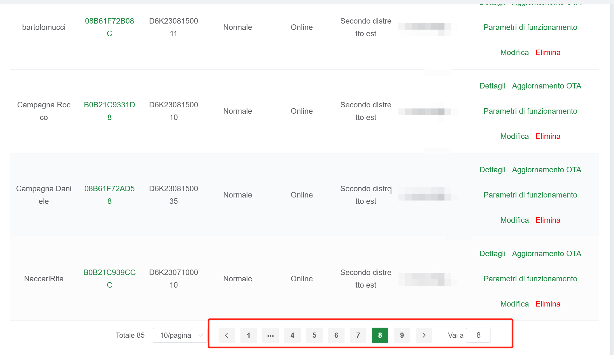

1. The warranty agreement has been finalized and will be sent to you after the meeting. CASA is an important partner, and we value our bilateral cooperation. We expect your company to adhere to the warranty agreement. We commit to providing replacement services for any after-sales issues due to the product quality within 90 days of installation. You will also notice in the warranty agreement that require to keep the devices online for our service team to regular maintenance and remote upgrades in the after-sales service.
2. Finally, we highly value our strategic partnership with CASA. Mr.Li has personally issued directives to improve service quality multiple times. We will offer more comprehensive installation training activities in the future. We also hope your company put more efforts in the technical area, allowing us to jointly build the high-quality, customer-centric brand image of Esysunhome, facilitating win-win cooperation.