**Remote Setting via AmazonCloud**

**Applicability :** Esysunhome HM6 series(HM6-05,HM6-10,HM6-15,HM6-20,HM6-25,HM6-30)

**Communication Device Requirements:**

Table 1: Communication Device Requirements

|  |  |
| --- | --- |
| **Inverter Type** | **Communication Device** |
| Single-Phase(Grid-connected&Hybrid) | WiFi-IOT Pro(WiFi Dongle) |

Our ESY Energy storage integration system allows installers to remotely install and update settings at a click of a button. This feature greatly saves their time instead of going to site to change a few settings.

Therefore, this document will outline the necessary steps for effectively accessing and modifying the inverter settings through the online web portal.

**Introduction:**

On Equipment management, the relevant device can show on the web. We can use Device name, SN code, Serial number, Installer name to find the right device and proceed further.

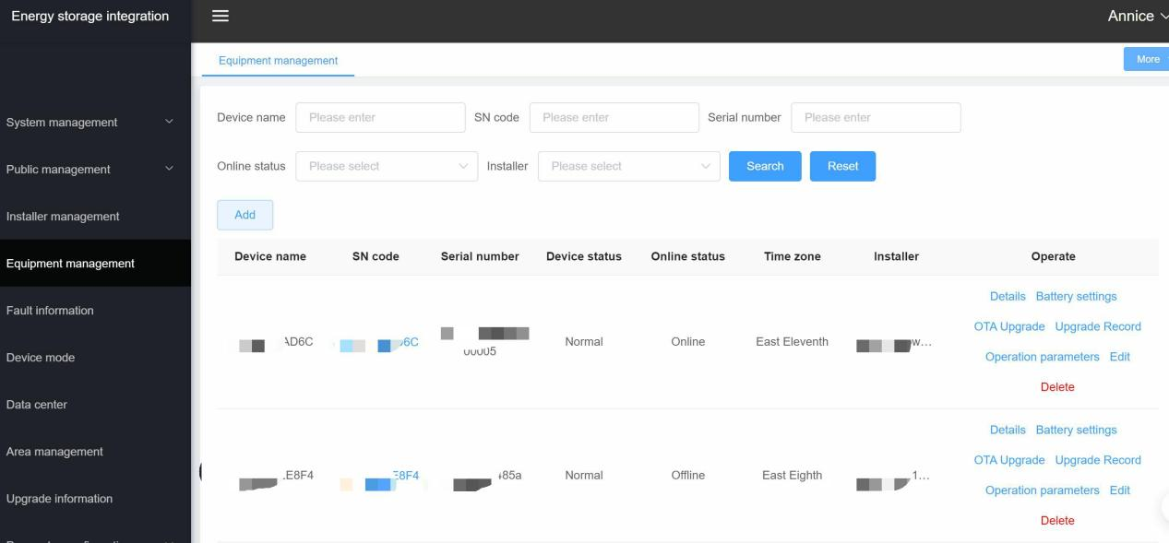

Figure 1 Equipment management

**Viewing the Settings:**

Before any settings can be changed, it is important to check the existing values. Once we find the device, we click on Operation parameters. We can see the operation information in the page. Then we click on System settings. (Figure 2)

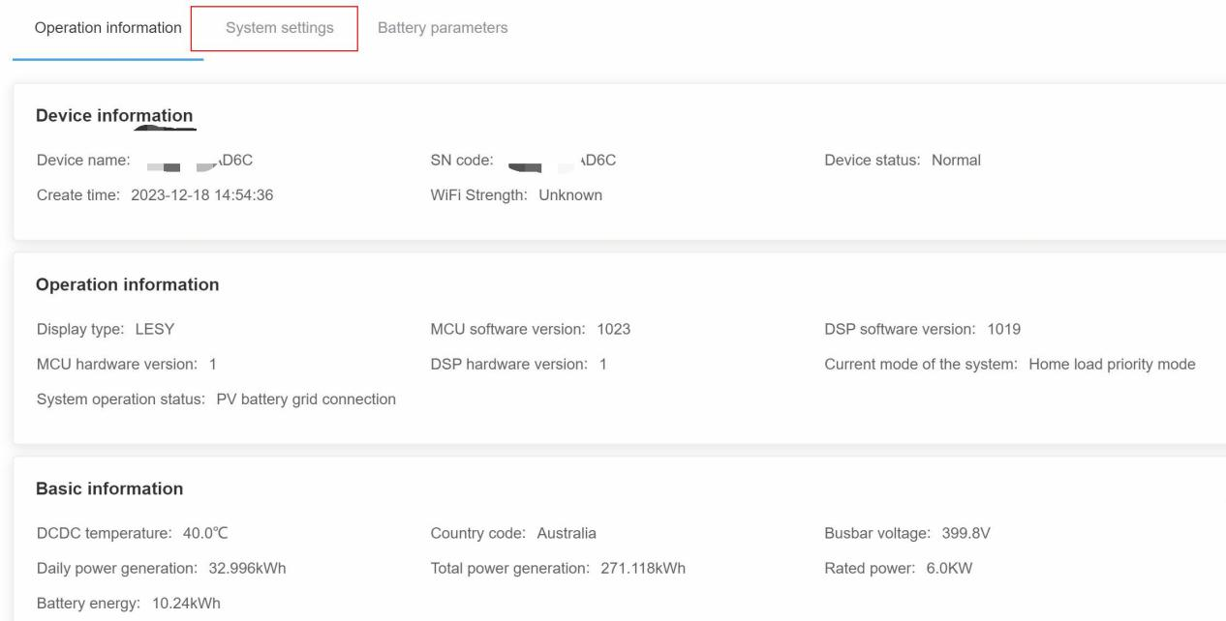

Figure 2 Operation parameters

In the System settings, we can do either common or advance settings. (Figure 3 and Figure 4) In Figure 3, we can do Power-on and Power-off Command.

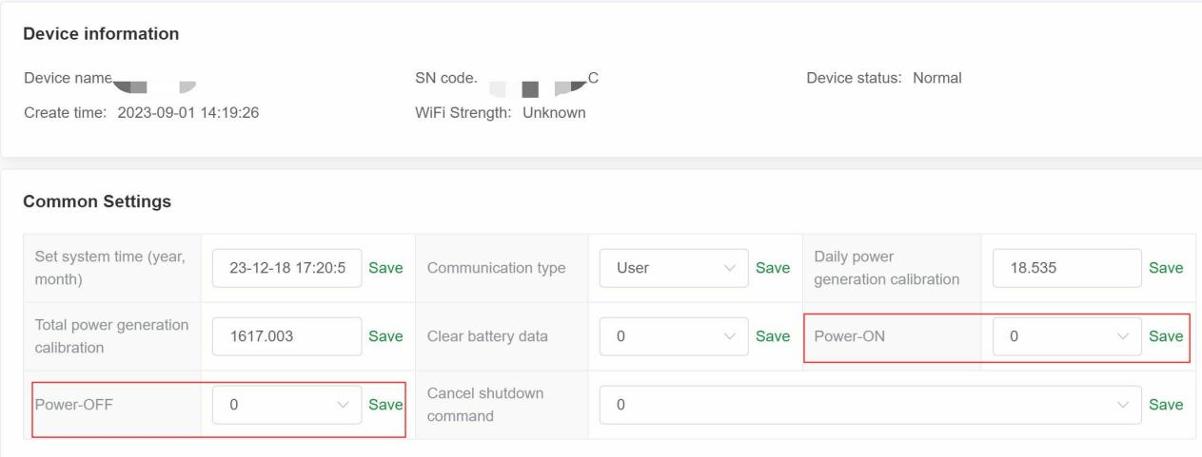

Figure 3 Common Setting Under System settings

**Changing the Settings:**

In the Advanced Setting, We have Grid connection mode and Anti backflow mode. The parameter settings can vary depending on the model of the inverter and real case.

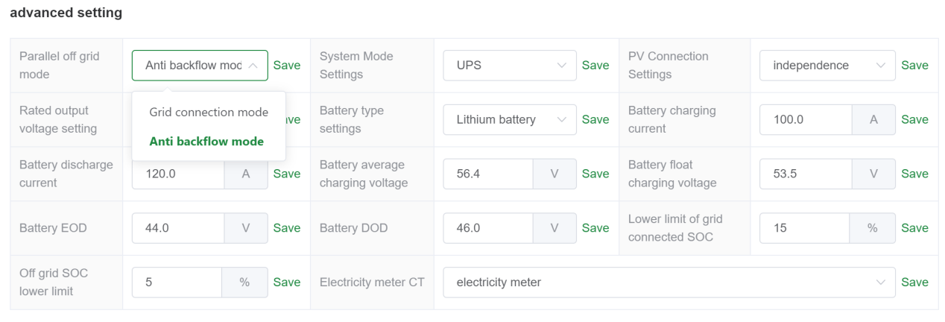

Figure 4 Advanced setting Under System settings

In the Other settings, the inverter can set the country code. (Figure 5) When clicking Save will quickly update the value and status of the inverter. And there has a pop-up information to confirm saved successfully at top. (Figure 6)

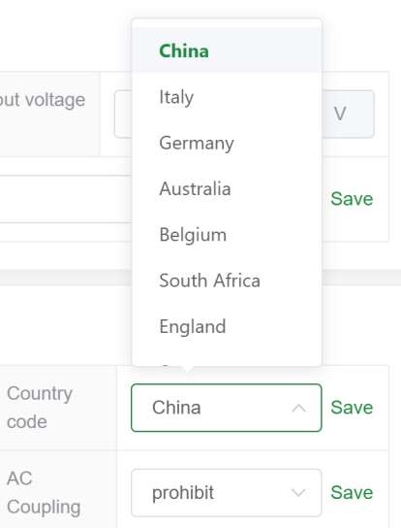

Figure 5 Country code setting



Figure 6 Save successfully window

When all suitable parameter settings done, check all the operation parameters correct (Figure 2). Then use Fault information to track and troubleshooting for alarm. If issues arise, please refer to the troubleshooting manual for guidance. (Figure 7)

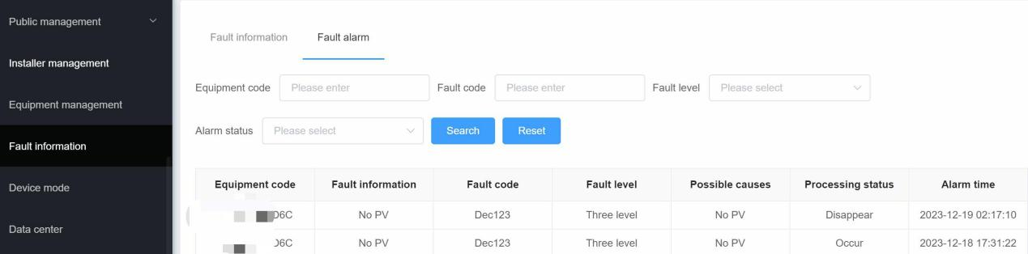

Figure 7 Troubleshooting