因子入池筛选

# 一、因子库筛选规则

1、中性化规则：  
 Barra因子只进行行业及市值中性化；  
 技术指标和基本面因子均进行行业、市值、Barra中性化，其中Barra中性化是对相关性0.3以上的Barra因子再做中性化。

2、相关性筛选规则：  
 对相关性大于0.9的因子视为相同因子进行剔除，取多空回测夏普较高的因子进行保留。

3、因子指标筛选规则:   
 Barra因子: 因子RankIC均值需大于0.01、t值需大于1.96、方向延续概率需大于0.5，因子多空组合年化收益率需大于0.03、t值需大于1.96、夏普需大于0.6、胜率需大于0.5；  
 技术面因子：因子RankIC均值需大于0.03、t值需大于2.58、方向延续概率需大于0.5，因子多空组合年化收益率需大于0.15、t值需大于2.58、夏普需大于1.2、胜率需大于0.5；  
 基本面因子：因子RankIC均值需大于0.01、t值需大于1.64、方向延续概率需大于0.5，因子多空组合年化收益率需大于0.08、t值需大于1.64、夏普需大于0.3、胜率需大于0.4；

# 二、Neutralized factor correlation

## Heatmap of factor correlations after neutralization

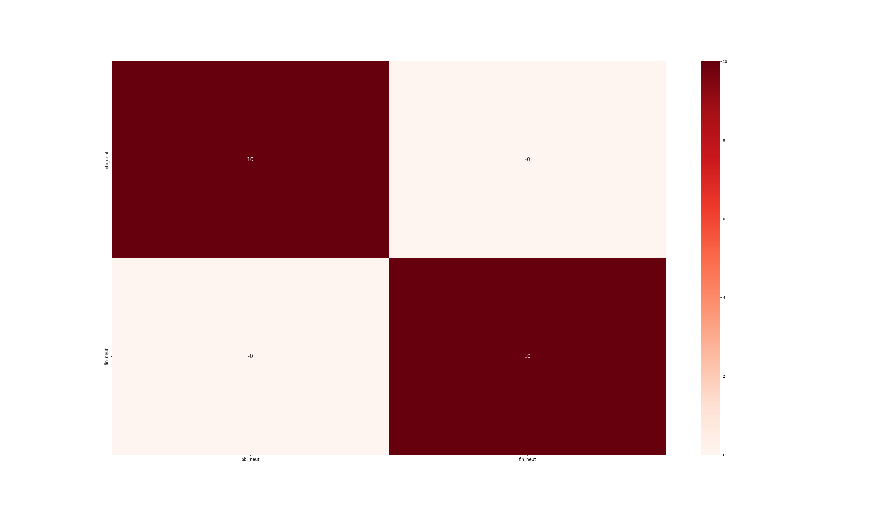

# 二、Factor performance

## 1、Barra factor performance

|  |  |  |  |  |  |  |  |  |  |  |  |  |  |  |  |  |  |  |  |  |  |
| --- | --- | --- | --- | --- | --- | --- | --- | --- | --- | --- | --- | --- | --- | --- | --- | --- | --- | --- | --- | --- | --- |
| 因子 | | | 覆盖度 | RankIC | | | | | | | | 多空组合 | | | | | 多头超额 | | | | |
| 因子名 | 分类 | 方向 | 均值 | 均值 | IC_IR | t值 | p值 | 正显著比例 (2%) | 不显著比例 | 负显著比例 (-2%) | 方向延续概率 | 年化收益 | 收益率t值 | 夏普比 | 胜率 | 最大回撤 | 年化超额 | 超额t值 | 夏普比 | 胜率 | 最大回撤 |

## 2、Technical factor performance

|  |  |  |  |  |  |  |  |  |  |  |  |  |  |  |  |  |  |  |  |  |  |
| --- | --- | --- | --- | --- | --- | --- | --- | --- | --- | --- | --- | --- | --- | --- | --- | --- | --- | --- | --- | --- | --- |
| 因子 | | | 覆盖度 | RankIC | | | | | | | | 多空组合 | | | | | 多头超额 | | | | |
| 因子名 | 分类 | 方向 | 均值 | 均值 | IC_IR | t值 | p值 | 正显著比例 (2%) | 不显著比例 | 负显著比例 (-2%) | 方向延续概率 | 年化收益 | 收益率t值 | 夏普比 | 胜率 | 最大回撤 | 年化超额 | 超额t值 | 夏普比 | 胜率 | 最大回撤 |

## 3、Fundamental factor performance

|  |  |  |  |  |  |  |  |  |  |  |  |  |  |  |  |  |  |  |  |  |  |
| --- | --- | --- | --- | --- | --- | --- | --- | --- | --- | --- | --- | --- | --- | --- | --- | --- | --- | --- | --- | --- | --- |
| 因子 | | | 覆盖度 | RankIC | | | | | | | | 多空组合 | | | | | 多头超额 | | | | |
| 因子名 | 分类 | 方向 | 均值 | 均值 | IC_IR | t值 | p值 | 正显著比例 (2%) | 不显著比例 | 负显著比例 (-2%) | 方向延续概率 | 年化收益 | 收益率t值 | 夏普比 | 胜率 | 最大回撤 | 年化超额 | 超额t值 | 夏普比 | 胜率 | 最大回撤 |

# 三、Factor screening results

### (1) Selected factor performance

|  |  |  |  |  |  |  |  |  |  |  |  |  |  |  |  |  |  |  |  |  |  |
| --- | --- | --- | --- | --- | --- | --- | --- | --- | --- | --- | --- | --- | --- | --- | --- | --- | --- | --- | --- | --- | --- |
| 因子 | | | 覆盖度 | RankIC | | | | | | | | 多空组合 | | | | | 多头超额 | | | | |
| 因子名 | 分类 | 方向 | 均值 | 均值 | IC_IR | t值 | p值 | 正显著比例 (2%) | 不显著比例 | 负显著比例 (-2%) | 方向延续概率 | 年化收益 | 收益率t值 | 夏普比 | 胜率 | 最大回撤 | 年化超额 | 超额t值 | 夏普比 | 胜率 | 最大回撤 |

### (2) Reasons for the exclusion of unselected factors

|  |  |  |
| --- | --- | --- |
| 因子 | 分类 | 未通过原因 |
| bbi | 技术面 | 因子RankIC的均值过低；因子多空组合收益率过低；因子多空组合夏普比过低； |
| fin | 技术面 | 因子RankIC的均值过低；因子RankIC的t值过低；因子多空组合收益率过低；因子多空收益率的t值过低；因子多空组合夏普比过低；因子多空组合胜率过低； |

# 四、Individual factor performance

## 1、bbi factor performance

### (1) Return backtest

|  |  |  |  |  |  |  |  |  |  |  |  |  |  |  |  |  |  |  |  |  |  |
| --- | --- | --- | --- | --- | --- | --- | --- | --- | --- | --- | --- | --- | --- | --- | --- | --- | --- | --- | --- | --- | --- |
| 因子 | | | 覆盖度 | RankIC | | | | | | | | 多空组合 | | | | | 多头超额 | | | | |
| 因子名 | 分类 | 方向 | 均值 | 均值 | IC_IR | t值 | p值 | 正显著比例 (2%) | 不显著比例 | 负显著比例 (-2%) | 方向延续概率 | 年化收益 | 收益率t值 | 夏普比 | 胜率 | 最大回撤 | 年化超额 | 超额t值 | 夏普比 | 胜率 | 最大回撤 |
| bbi |  | 负向 | 97.18% | 0.5% | 0.05 | 2.89 | 0.0039 | 44.25% | 14.93% | 40.82% | 51.28% | 4.6% | 5.74 | 0.67 | 53.5% | 37.54% | 1.58% | 1.54 | 0.18 | 47.22% | 93.35% |

### (2) Top 10 factor correlations

|  |  |
| --- | --- |
| index | fin |
| bbi_neut | -0.0 |

### (3) Factor backtest curve

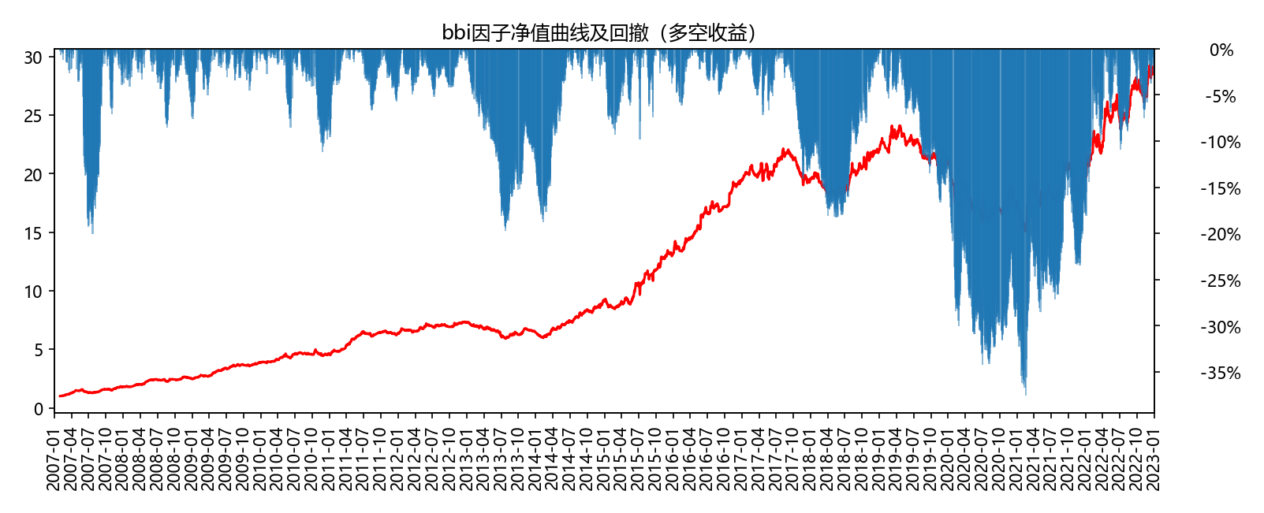

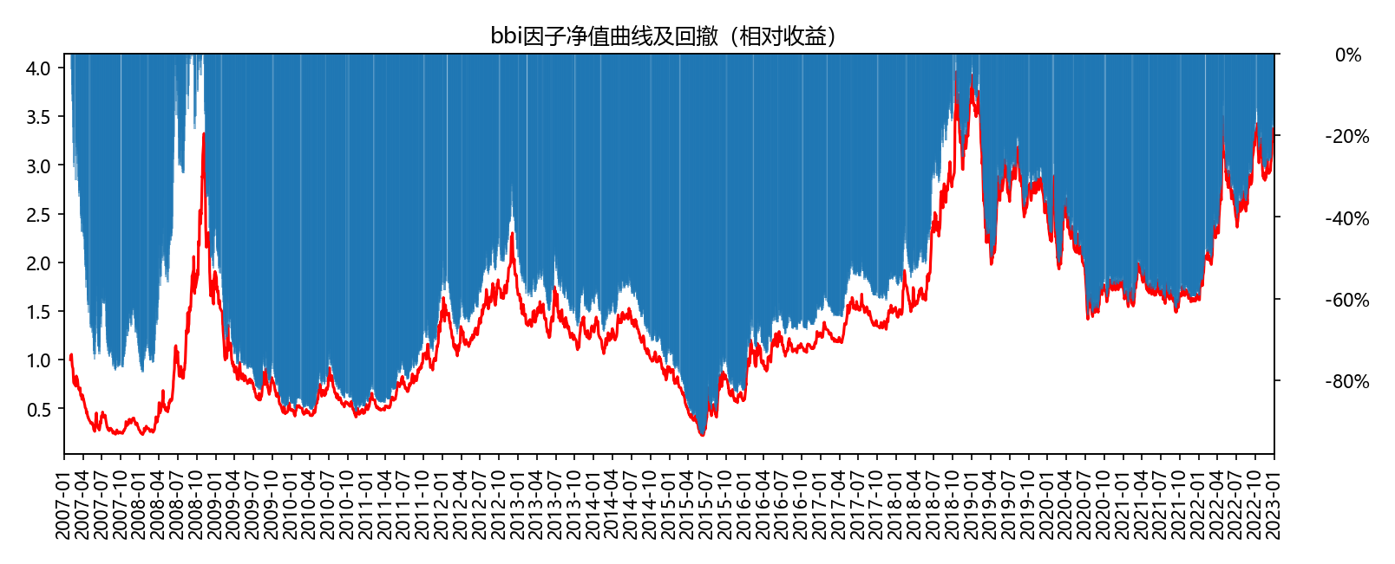

## 2、fin factor performance

### (1) Return backtest

|  |  |  |  |  |  |  |  |  |  |  |  |  |  |  |  |  |  |  |  |  |  |
| --- | --- | --- | --- | --- | --- | --- | --- | --- | --- | --- | --- | --- | --- | --- | --- | --- | --- | --- | --- | --- | --- |
| 因子 | | | 覆盖度 | RankIC | | | | | | | | 多空组合 | | | | | 多头超额 | | | | |
| 因子名 | 分类 | 方向 | 均值 | 均值 | IC_IR | t值 | p值 | 正显著比例 (2%) | 不显著比例 | 负显著比例 (-2%) | 方向延续概率 | 年化收益 | 收益率t值 | 夏普比 | 胜率 | 最大回撤 | 年化超额 | 超额t值 | 夏普比 | 胜率 | 最大回撤 |
| fin |  | 正向 | 97.18% | -15.03% | -1.15 | -71.33 | 0.0 | 9.58% | 5.04% | 85.38% | 80.91% | -54.0% | -66.11 | -7.66 | 9.92% | 100.0% | -36.67% | -17.54 | -2.03 | 32.96% | 100.0% |

### (2) Top 10 factor correlations

|  |  |
| --- | --- |
| index | bbi |
| fin_neut | -0.0 |

### (3) Factor backtest curve

