New Wheels Project

Introduction to SQL

Problem Statement
Business Context
A lot of people in the world share a common desire: to own a vehicle. A car or an automobile is seen as an object that gives the freedom of mobility. Many now prefer pre-owned vehicles because they come at an affordable cost, but at the same time, they are also concerned about whether the after-sales service provided by the resale vendors is as good as the care you may get from the actual manufacturers.
New-Wheels, a vehicle resale company, has launched an app with an end-to-end service from listing the vehicle on the platform to shipping it to the customer's location. This app also captures the overall after-sales feedback given by the customer.
Objective
New-Wheels sales have been dipping steadily in the past year, and due to the critical customer feedback and ratings online, there has been a drop in new customers every quarter, which is concerning to the business. The CEO of the company now wants a quarterly report with all the key metrics sent to him so he can assess the health of the business and make the necessary decisions.
As a data analyst, you see that there is an array of questions that are being asked at the leadership level that need to be answered using data. Import the dump file that contains various tables that are present in the database. Use the data to answer the questions posed and create a quarterly business report for the CEO.

Business Questions

Question 1: Find the total number of customers who have placed orders. What is the distribution of the customers across states?
Solution Query:
select
coalesce(c.state, 'Grand Total') as state,
count(distinct o.customer_id) as customers_with_orders
from newwheels_order_t o
join newwheels_customer_t c
on o.customer_id = c.customer_id
group by c.state with rollup
order by
c.state is not null,
customers_with_orders desc;
Output:
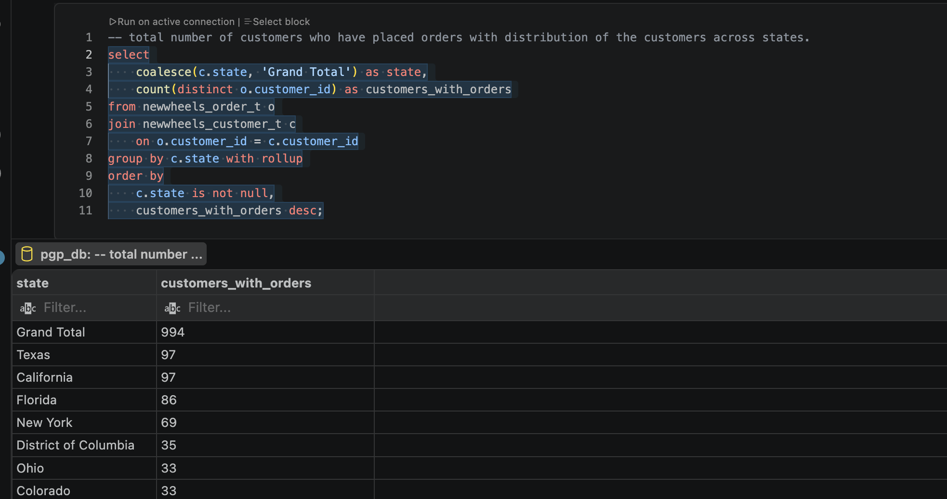
Observations and Insights:
- A total of 994 unique customers placed orders.
- California and Texas have the highest number of customers, with 97 each.
- Florida follows with 86 customers, while New York has 69.
- Customer concentration is therefore noticeably higher in a few large states.
Insights: California, Texas, Florida and New York represent important customer markets. Sales and marketing activity could be prioritised in these states while investigating opportunities to grow lower-performing regions.

Question 2: Which are the top 5 vehicle makers preferred by the customers?
Solution Query:
select p.vehicle_maker,
count(distinct o.customer_id) as customer_count
from newwheels_order_t o
join newwheels_product_t p on o.product_id = p.product_id
group by p.vehicle_maker
order by customer_count desc
limit 5;

Output:
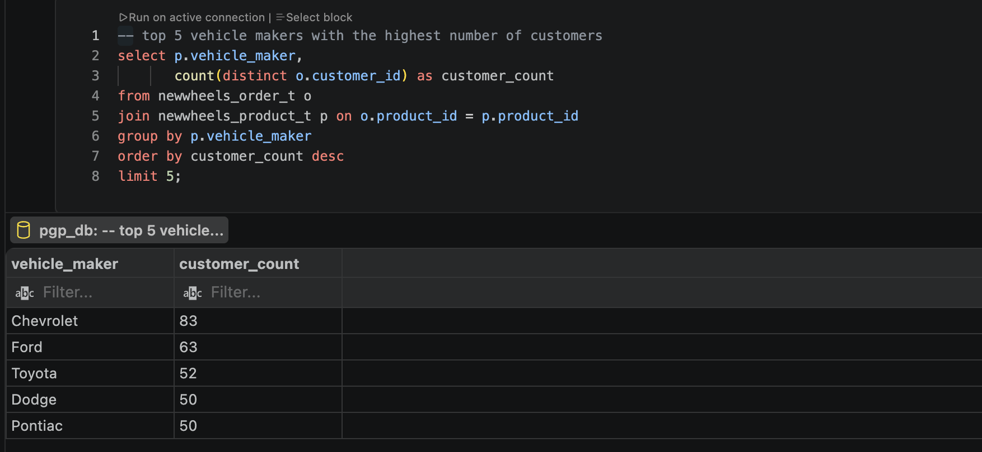
Observations and Insights:
- Chevrolet is the most preferred maker with 83 customers.
- Ford ranks second with 63, followed by Toyota with 52.
- Dodge and Pontiac are tied with 50 customers each.
- Chevrolet has a clear lead over the other top manufacturers.
Insights: Chevrolet, Ford and Toyota appear to have the strongest customer demand. Inventory, promotions and supplier relationships could therefore place greater emphasis on these manufacturers.

Question 3: Which is the most preferred vehicle maker in each state?
Solution Query:
with maker rank as (
select c.state, p.vehicle_maker, count(distinct o.customer_id) as customer_count,
dense_rank() over (
partition by c.state
order by count(distinct o.customer_id) desc
) as rnk
from newwheels_order_t o
join newwheels_customer_t c
on o.customer_id = c.customer_id
join newwheels_product_t p
on o.product_id = p.product_id
group by c.state, p.vehicle_maker
)
select state, vehicle_maker, customer_count
from maker_rank
where rnk = 1
order by customer_count desc, state;
Output:
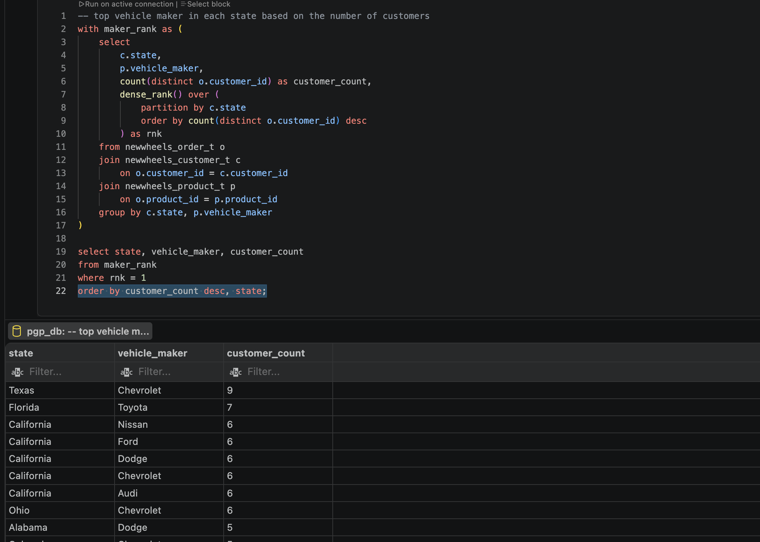
Observations and Insights:
- Vehicle preferences differ considerably between states.
- Florida's leading maker is Toyota with 7 customers, while Texas favours Chevrolet with 9.
- Several states have more than one maker tied for first place.
- 22 states have ties for their highest-ranked maker, so there is not always a single dominant brand.
Insights: Vehicle preference has a strong geographical dimension. State-level demand should therefore be considered when planning inventory rather than applying the same product mix nationally.

Question 4: Find the overall average rating given by the customers. What is the average rating in each quarter?
Solution Query:
select
round(avg(field(lower(customer_feedback),
'very bad', 'bad', 'okay', 'good', 'very good')), 1) as overall_avg_rating,
round(avg(case when quarter_number = 1 then
field(lower(customer_feedback),
'very bad', 'bad', 'okay', 'good', 'very good') end), 1) as q1_avg,
round(avg(case when quarter_number = 2 then
field(lower(customer_feedback),
'very bad', 'bad', 'okay', 'good', 'very good') end), 1) as q2_avg,
round(avg(case when quarter_number = 3 then
field(lower(customer_feedback),
'very bad', 'bad', 'okay', 'good', 'very good') end), 1) as q3_avg,
round(avg(case when quarter_number = 4 then
field(lower(customer_feedback),
'very bad', 'bad', 'okay', 'good', 'very good') end), 1) as q4_avg
from newwheels_order_t;
Output:
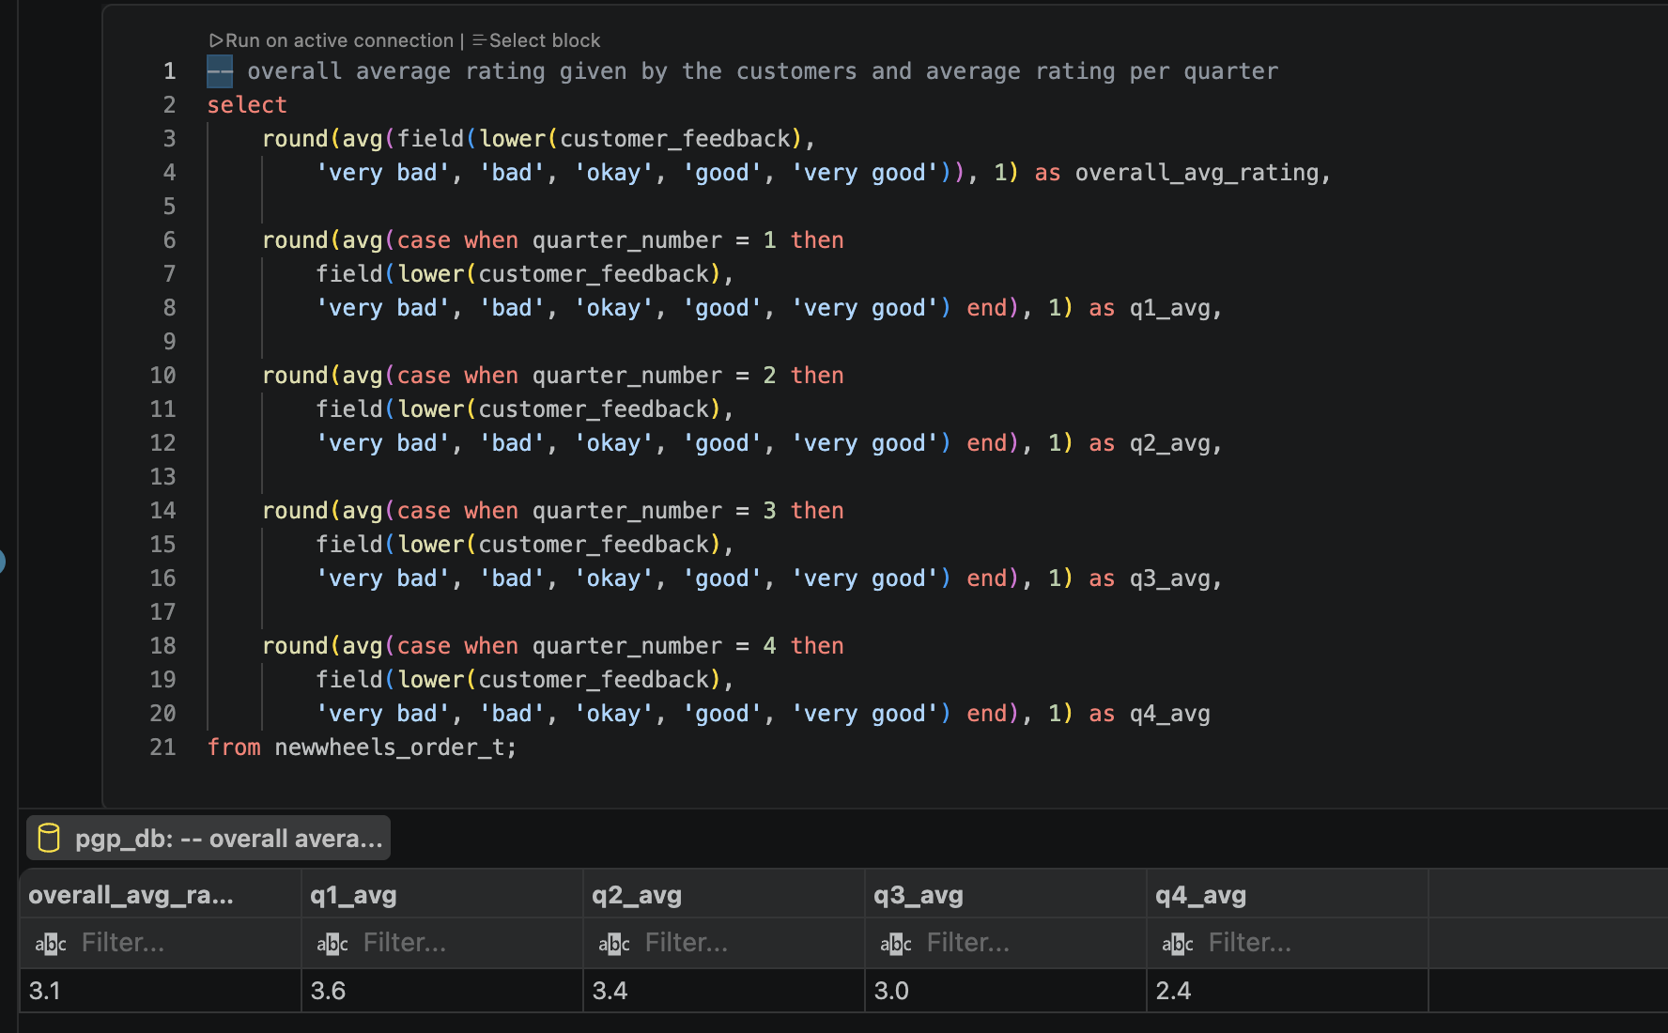
Observations and Insights:
- Overall customer rating is 3.1 out of 5.
- Average rating declined from 3.6 in Q1 to 3.4 in Q2.
- It fell further to 3.0 in Q3 and 2.4 in Q4.
- Customer satisfaction therefore deteriorated consistently during the year.
Insights: The sustained decline in ratings is a major warning sign. Q3 and particularly Q4 should be investigated for operational or service issues that negatively affected the customer experience.
Question 5: Find the percentage distribution of feedback from the customers. Are customers getting more dissatisfied over time?
Solution Query:
select
case
when quarter_number is null then 'Overall'
else concat('Q', quarter_number)
end as period,
round(100 * avg(lower(customer_feedback) = 'very bad'), 1) as pct_very_bad,
round(100 * avg(lower(customer_feedback) = 'bad'), 1) as pct_bad,
round(100 * avg(lower(customer_feedback) = 'okay'), 1) as pct_okay,
round(100 * avg(lower(customer_feedback) = 'good'), 1) as pct_good,
round(100 * avg(lower(customer_feedback) = 'very good'), 1) as pct_very_good
from newwheels_order_t
group by quarter_number with rollup
order by quarter_number is not null, quarter_number;
Output:
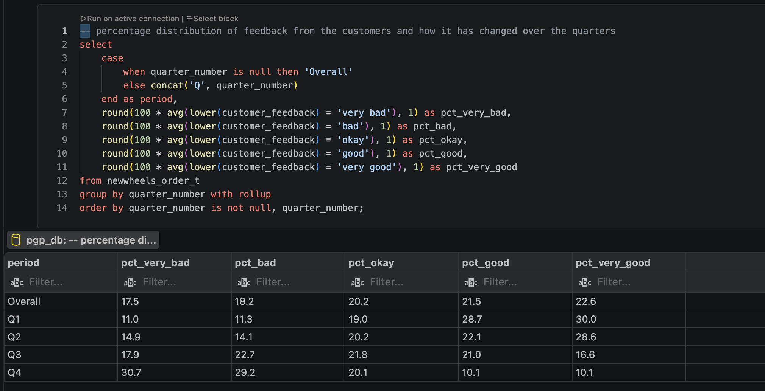
Observations and Insights:
- Overall, 22.6% of feedback is Very Good and 21.5% is Good.
- In Q1, Good + Very Good represented 58.7% of customer feedback.
- By Q4, Good + Very Good had fallen to only 20.2%.
- Conversely, Bad + Very Bad increased to 59.8% in Q4, compared with only 22.3% in Q1.
Insights: Customer sentiment changed substantially from positive to negative during the year. The deterioration is not simply a small movement in average rating; the entire feedback distribution shifted towards dissatisfaction.

Question 6: What is the trend of the number of orders by quarter?
Solution Query:
select
coalesce(concat('Q', quarter_number), 'Overall') as quarter,
count(distinct order_id) as total_orders
from newwheels_order_t
group by quarter_number with rollup
order by quarter_number is not null, quarter_number;

Output:
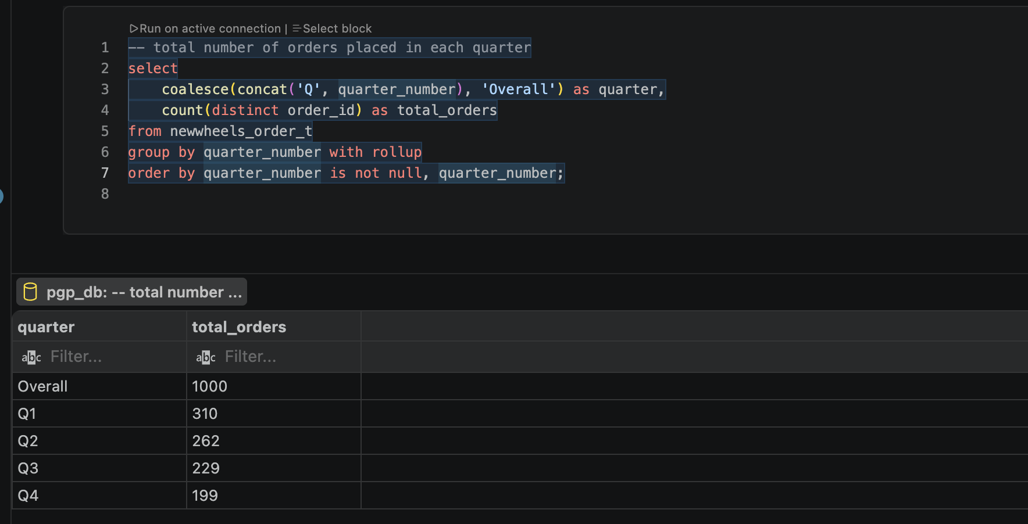
Observations and Insights:
- There were 1,000 orders overall.
- Orders declined from 310 in Q1 to 262 in Q2.
- Orders continued falling to 229 in Q3 and 199 in Q4.
- Q4 order volume was approximately 35.8% lower than Q1.
Insights: Order volume declined in every successive quarter. This shows that the business experienced a sustained reduction in sales activity rather than a temporary one-quarter decline.

Question 7: Calculate the net revenue generated by the company. What is the quarter-over-quarter % change in net revenue?
Solution Query:
with quarterly as (
select
quarter_number,
sum(quantity * vehicle_price * (1 - discount / 100.0)) as net_revenue,
lag(sum(quantity * vehicle_price * (1 - discount / 100.0)))
over (order by quarter_number) as previous_revenue
from newwheels_order_t
group by quarter_number
)
select
'Overall' as period,
round(sum(quantity * vehicle_price * (1 - discount / 100.0)), 2) as net_revenue,
null as qoq_pct_change
from newwheels_order_t
union all
select
concat('Q', quarter_number),
round(net_revenue, 2),
round((net_revenue - previous_revenue) / previous_revenue * 100, 1)
from quarterly;
Output:
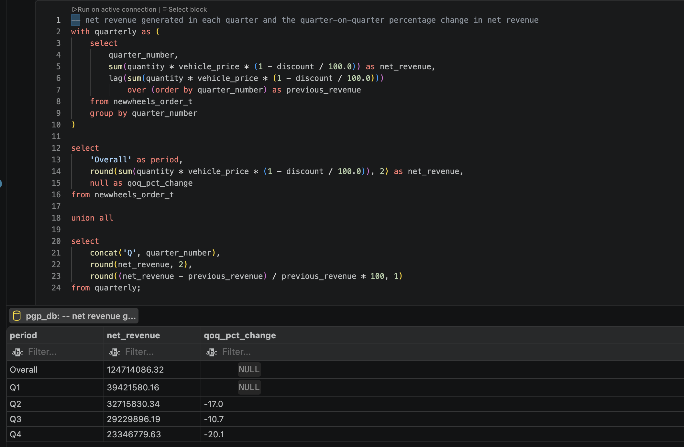
Observations and Insights:
- Total net revenue was approximately $124.71 million.
- Revenue fell from $39.42M in Q1 to $32.72M in Q2, a 17.0% decline.
- Q3 revenue fell a further 10.7% to $29.23M.
- Q4 recorded the largest QoQ decline of 20.1%, ending at $23.35M.
Insights: Revenue declined in every quarter, with the deterioration accelerating again in Q4. The combination of falling revenue and customer satisfaction indicates a broader business performance issue rather than only a pricing problem.

Question 8: What is the trend of net revenue and orders by quarters?
Solution Query:
select
concat('Q', quarter_number) as quarter,
round(sum(quantity * vehicle_price * (1 - discount / 100.0)),2 ) as net_revenue,
count(distinct order_id) as total_orders
from newwheels_order_t
group by quarter_number
order by quarter_number;

Output:
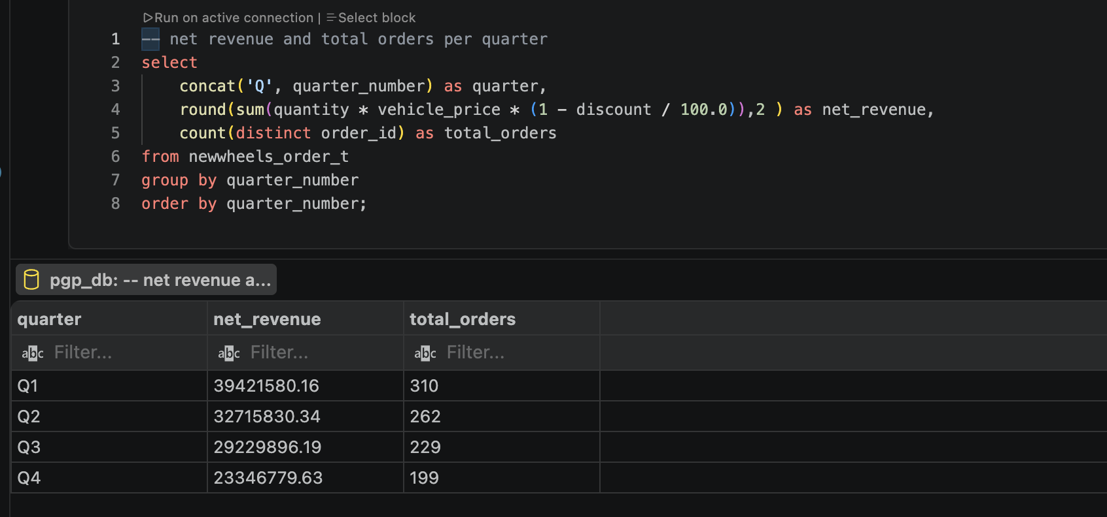
Observations and Insights:
- Q1 had the highest performance with 310 orders and $39.42M revenue.
- By Q4, performance had fallen to 199 orders and $23.35M revenue.
- Both orders and net revenue decline consistently from Q1 through Q4.
- The similar direction of both measures suggests falling order volume is an important contributor to the revenue decline.
Insights: Revenue performance closely follows order volume. The company should therefore focus not only on revenue per transaction but also on identifying why fewer customers are placing orders as the year progresses.

Question 9: What is the average discount offered for different types of credit cards?
Solution Query:
select
c.credit_card_type,
round(avg(o.discount), 2) as avg_discount
from newwheels_order_t o
join newwheels_customer_t c
on o.customer_id = c.customer_id
group by c.credit_card_type
order by avg_discount desc;

Output:
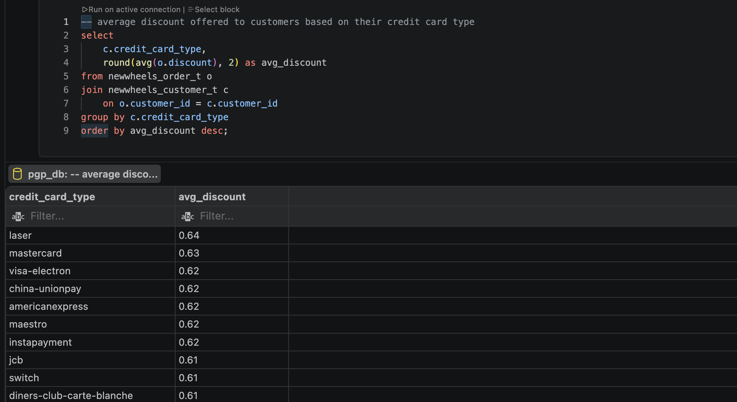

Observations and Insights:
- Laser customers received the highest average discount at approximately 0.64%.
- Mastercard follows at approximately 0.63%.
- Maestro, Visa Electron and several other card types average around 0.62%.
- The difference between the highest and lowest card categories is relatively small.
Insights: Credit-card type does not appear to create substantial differences in discount levels. Therefore, the significant decline in revenue is unlikely to be explained primarily by variations in discounts across card types.

Question 10: What is the average time taken to ship the placed orders for each quarter?
Solution Query:
select
coalesce(concat('Q', quarter_number), 'Overall') as quarter,
round(avg(datediff(ship_date, order_date)), 1) as avg_shipping_days
from newwheels_order_t
group by quarter_number with rollup
order by quarter_number is not null, quarter_number;

Output:
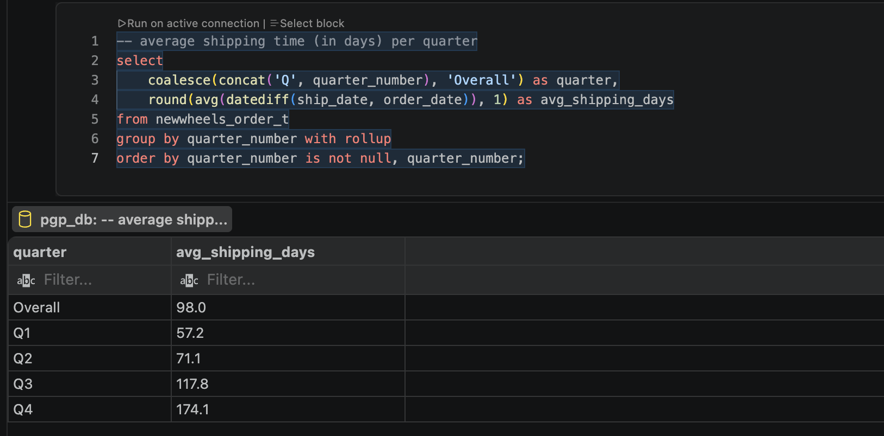
Observations and Insights:
- Overall average shipping time was approximately 98.0 days.
- Shipping time increased from 57.2 days in Q1 to 71.1 days in Q2.
- It rose sharply to 117.8 days in Q3.
- Q4 had an average shipping time of 174.1 days, more than three times the Q1 level.
Insights: Shipping performance is the strongest operational concern in the analysis. The sharp increase in shipping time occurs alongside declining ratings and rising negative feedback. This does not prove causation, but it strongly suggests that shipping delays should be investigated as a potential driver of customer dissatisfaction.

Business Metrics Overview
Total Revenue | Total Orders | Total Customers | Average Rating
$124,714,086.32 | 1000 | 994 | 3.1
Last Quarter Revenue | Last quarter Orders | Average Days to Ship | % Good Feedback
$23,346,779.63 | 199 | 98.0 days | 44.1%

Business Recommendations

Overall Insights
- Across the ten questions, three trends stand out: orders fell from 310 to 199, revenue fell from $39.42M to $23.35M, and average customer ratings fell from 3.6 to 2.4 between Q1 and Q4. At the same time, shipping time increased from 57.2 to 174.1 days.
- Taken together, the results point to a deteriorating customer and operational experience.

Business Recommendations
Based on the analysis, the business should prioritise reversing the simultaneous decline in orders, revenue, customer satisfaction, and shipping performance.
- Urgently improve shipping performance: Average shipping time increased from 57.2 days in Q1 to 174.1 days in Q4. Review shipper performance, fulfilment bottlenecks and delivery processes, and introduce shipping-time SLAs and quarterly performance monitoring.
- Investigate declining customer satisfaction: Average ratings dropped from 3.6 to 2.4, while negative (Bad + Very Bad) feedback reached 59.8% in Q4. Analyse feedback alongside shipping time, shipper, vehicle maker and state to identify the main drivers of dissatisfaction.
- Reverse the decline in sales: Orders fell from 310 in Q1 to 199 in Q4, while revenue declined from $39.42M to $23.35M. Target customer retention and re-engagement campaigns, particularly for customers who previously purchased but did not return.
- Use regional preferences for inventory planning: Vehicle-maker preferences differ across states. Stock and marketing campaigns should therefore reflect state-level demand rather than using a uniform national product strategy.
- Prioritise high-demand vehicle makers: Chevrolet, Ford and Toyota are among the most preferred brands. Ensure adequate availability of popular makers while monitoring whether demand changes by state.
- Review discount effectiveness: Differences in average discounts across credit-card types are relatively small. Rather than increasing discounts broadly, assess whether discounts generate additional orders or revenue and target incentives where they produce measurable returns.
- Introduce a quarterly performance dashboard: Track revenue, orders, customers, average rating, positive feedback %, shipping days and QoQ growth together. Set thresholds for significant deterioration so management can intervene before trends reach the scale observed in Q4.
Priority: Shipping and customer experience should be investigated first. The data shows shipping times worsening at the same time as ratings, feedback, orders and revenue deteriorate. This is an important relationship to investigate, although the available analysis does not establish that shipping delays caused the sales decline.

