

**Data Technician**

|  |
| --- |
|  |

|  |
| --- |
| Name: Annie Sadler Kamanya |
| Course Date: 3/01/2025 |
|  |

**Table of contents**

Day 1: Task 1 2

Day 2: Task 1 2

Day 2: Task 2 3

Day 2: Task 3 4

Day 3: Task 1 4

Day 3: Task 2 5

Dataset: 5

Step 1: Create a Pivot Table 5

Step 2: Use the SWITCH Function 5

Submission: 6

Day 3: Task 3 6

Day 4: Task 1 7

Course Notes 9

Additional Information 10

# Day 1: Task 1

Please complete the below boxes on commons laws and regulations that must be followed when working with customers data, use the below bulleted list to support your answers.

* What is it
* Why is it important
* Provide a real-world example of how you can follow it
* How does it impact working with data
* What could happen if you breached it

|  |  |
| --- | --- |
| Data Protection Act | **Data Protection Act:** is a legislation that aims to safeguard all information held about an individual person classified as personal and or sensitive. This may include name, address, financial details as well as religion- sensitive. The act ensures a person’s data is lawfully obtained with consent, stored fairly, transparent, and lawfully processed.  Data should be used for specific purposes and processed as intended.   * It's important   **Protects Personal Information**: - prevents misused, exploited, or mishandling of individual information.  **Ensures Privacy**: regulating ensures that a person’s privacy is respected and maintained  **Prevents Fraud and Identity Theft:** measures put in place help prevent fraudulent activities, hacking, phishing, and identity theft  **Maintains Trust**: trust is maintained between customers and stakeholders, as they demonstrate a commitment to safeguarding personal information.  **Legal Compliance:** legal frameworks is adhered to by organization to avoid penalties associated with data breaches and non-compliance  **Supports Data Integrity and Availability**: it promotes the principles of confidentiality, integrity, and availability of data, ensuring that information is accurate, reliable, and accessible on request.   * Provide a real-world example of how you can follow it   **Scenario**:  As a marketing and sales representative officer, I contact customers on the phone and via online to provide services. I collect and processes customer data for transactions, advertising, marketing, and customer service roles as well as offer discounts.  In the first instance I would make contact to collect data.  **Data Collection**: when contact is made, reason for contact is explained and consent is obtained before collecting customers personal information and any other data required for intended use.  Only essential -personal data is obtained from customer -(e.g., name, address, payment information and email address) is collected to complete transactions and send receipts following transection.  **Data Storage:** All personal data is stored appropriately in line with company policy -encrypted database to protect an authorised access.  **Access Control:** Only authorized individual who have access to sensitive data and have access can log into the system to regulate, maintain and monitor any data access activities.  **Data Processing:** Data is processed only for the purposes for which it was intended and collected- for marketing fulfilment and customer support as discussed.  **Data Minimization**: sales representative to ensure that only the necessary amount of data is processed and retains for long as needed.  **Data Sharing:** Third-Party Agreements: If data is shared with third-party service providers such as delivery services, due to purchase of items, sales representative will ensure that these providers comply with data protection regulations through contractual agreements.  **Transparency:** As a sale and marketing representative, customers will be informed about any data sharing practices and the purposes behind them.  **Data Subject Rights**: Access and Rectification: Customers can request access to their personal data and request corrections if there are inaccuracies with what is recorded.  **Deletion:** Customers have the right to request the deletion of their data when it is no longer needed for the purposes it was intended.  **Data Breach Response:** Incident Response Plan: Sales/marketing representative has a plan in place to respond to data breaches, including notifying affected customers and relevant authorities within the required timeframe, should in case this happen.  **Mitigation Measures:** Steps are taken to mitigate the impact of any data breach and prevent future incidents.  Following this practice as a Sale/marketing representative ensures compliance in line with Data Protection Act is followed and customers' personal data is protected effectively. |
| GDPR | **General Data Protection Regulation (GDPR)** is a legal framework that sets guidelines for the collection and processing of personal information from individuals who live in and outside of the European Union (EU). It aims to give consumers control over their own personal data by holding companies responsible for the way information is handled and treated. |
| Freedom of Information Act | **Freedom of Information Act 2000** gives the public a right of access to information held by public authorities. It also obliges authorities to publish certain information about their activities. The act covers any recorded information held by a public authority in England, Wales and Northern Ireland, and by UK-wide public authorities based in Scotland. |
| Computer Misuse Act | **Computer Misuse Act 1990;** makes it illegal to gain unauthorised access to a computer or to make changes to files on a computer without permission of the owner. |

# Day 2: Task 1

Please research and complete the following tasks within the retail-sales_dataset.xlsx document, paste a print screen into the provided boxes below:

1. In the sheet ‘retail_sales_dataset’ add all available data between columns **A – H** into a ‘table’
2. Using the ‘filter’ function, filter ‘Age’ to ‘largest to smallest’
3. Using the ‘SUM’ function, show me the commission total in cell ‘**P10’**
4. Using the ‘AVERAGE’ function, show me the average commission in cell **‘P11’**

|  |  |
| --- | --- |
| Print screen 1 |  |
| Print screen 2 |  |
| Print screen 3 |  |
| Print screen 4 |  |

# Day 2: Task 2

Please research and complete the following tasks within the retail-sales_dataset.xlsx document, paste print screens into the provided box below:

The dataset below tracks the sales performance of different products in various counties in England. Please paste the dataset into a blank Excel workbook. Your task is to:

* **Create a Pivot Table** to summarise the data by county and product.
* **Use the SWITCH function** to categorise products based on their sales volume.

***Dataset:***

|  |  |  |
| --- | --- | --- |
| **County** | **Product** | **Sales Volume** |
| Yorkshire | Laptops | 500 |
| Yorkshire | Smartphones | 200 |
| Cornwall | Laptops | 700 |
| Cornwall | Printers | 400 |
| Lancashire | Smartphones | 150 |
| Lancashire | Laptops | 600 |
| Essex | Printers | 800 |
| Essex | Smartphones | 300 |
| Durham | Laptops | 250 |
| Durham | Printers | 300 |
| Greater Manchester | Smartphones | 600 |
| Greater Manchester | Laptops | 400 |

***Step 1: Create a Pivot Table***

* Select the dataset (columns A to C).
* Insert a Pivot Table to summarise the data by **County** in the rows and **Products** in the columns. Use **Sales Volume** as the value to be summarised.

***Step 2: Use the SWITCH Function***

In a new column next to your data, use the SWITCH function to categorise products based on **Sales Volume** as follows:

* + For sales greater than 600: **"High"**
  + For sales between 300 and 600: **"Medium"**
  + For sales less than 300: **"Low"**

**SWITCH Function Example**:

=SWITCH(TRUE, C2 > 600, "High", C2 >= 300, "Medium", "Low")

* Apply this formula to each row, and check if the products are categorised correctly.

***Submission:***

* A completed Pivot Table summarising sales by county and product.
* A new column in the dataset categorising products by sales volume using the SWITCH function.
  + Please paste your completed work below

|  |  |
| --- | --- |
| Print screen 1 |  |

# Day 2: Task 3

Using the skills developed today, have some fun with the data set you have imported. Paste your work below and enjoy!

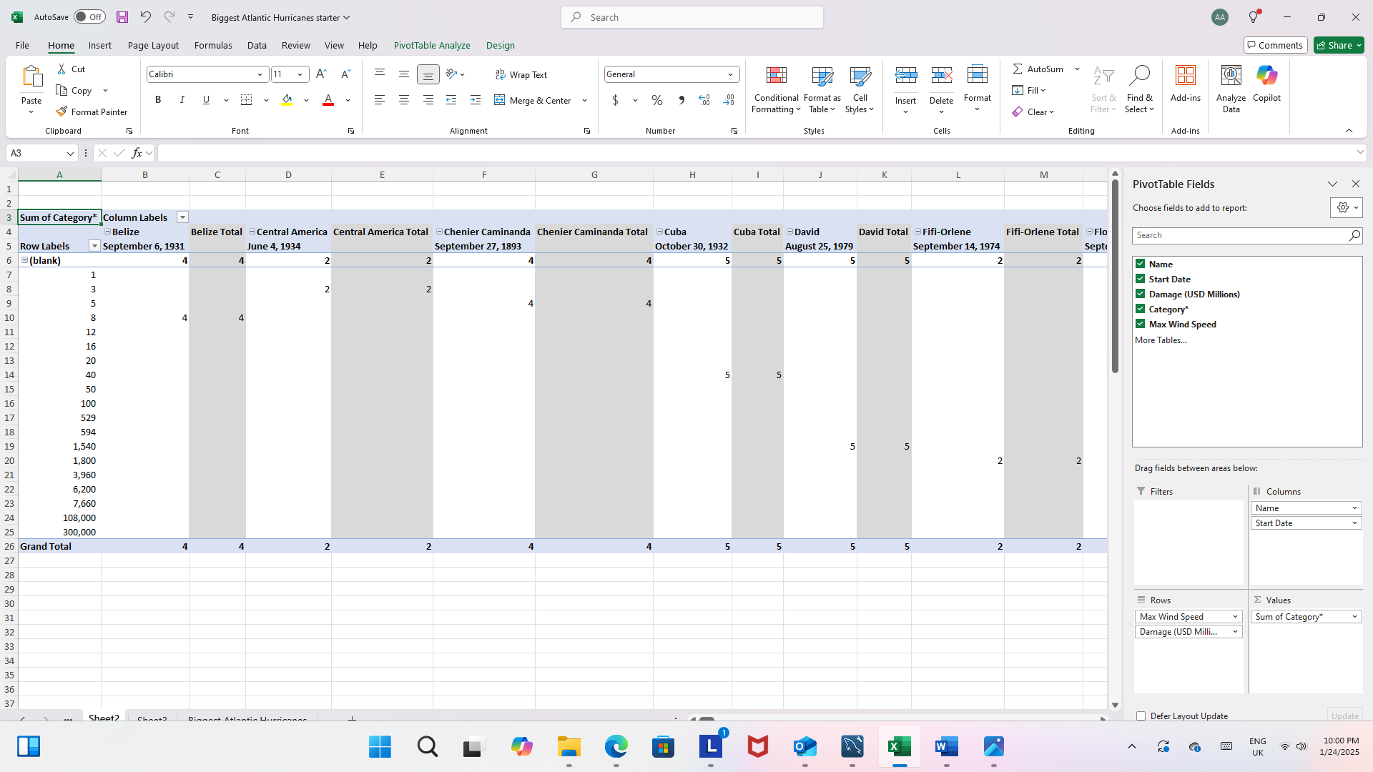

|  |  |
| --- | --- |
| Print screen 1 |  |

# Day 3: Task 1

Please download the dataset ‘Day_3_Task_1_Bike_Sales_Pivot_Lab.xlsx’ from [here](https://justit831-my.sharepoint.com/:x:/g/personal/danpe_justit_co_uk/Eb73L6LixCJHtafDJ4AOh-ABR9CVF0n9sdEgB4foSh261g?e=jh493A).

The lab instructions can be found [here](https://justit831-my.sharepoint.com/:b:/g/personal/danpe_justit_co_uk/EVySAtWQiEVDmrtCufrqTgwBuLVxX6mEKYqEAe0Mgl6b9Q?e=i05yOa). Do not worry if you do not complete the lab, just working with data and playing with the pivot table will be good experience.

Please paste your final pivot table below and complete the reflection questions:

|  |  |
| --- | --- |
| Print screen 1 |  |
| In which markets does Germany have customers? | Age group =Adults(35-64) |
| What country has sales in all markets? | Australia  United Kingdom |
| What are the most profitable markets by country, age group, and gender? | Australia  United States  France |
| Any other findings? | United states has 3 different columns of sales, and columu5 and column8 has the lowest grand sales. United Kingdom also has 2 different columns of sales across different fields. |

# Day 3: Task 2

The dataset below tracks the sales performance of different products in various counties in England. Please paste the dataset into a blank Excel workbook. Your task is to:

* **Create a Pivot Table** to summarise the data by county and product.
* **Use the SWITCH function** to categorise products based on their sales volume.

#### **Dataset:**

|  |  |  |
| --- | --- | --- |
| **County** | **Product** | **Sales Volume** |
| Yorkshire | Laptops | 500 |
| Yorkshire | Smartphones | 200 |
| Cornwall | Laptops | 700 |
| Cornwall | Printers | 400 |
| Lancashire | Smartphones | 150 |
| Lancashire | Laptops | 600 |
| Essex | Printers | 800 |
| Essex | Smartphones | 300 |
| Durham | Laptops | 250 |
| Durham | Printers | 300 |
| Greater Manchester | Smartphones | 600 |
| Greater Manchester | Laptops | 400 |

#### **Step 1: Create a Pivot Table**

* Select the dataset (columns A to C).
* Insert a Pivot Table to summarise the data by **County** in the rows and **Products** in the columns. Use **Sales Volume** as the value to be summarised.

#### **Step 2: Use the SWITCH Function**

In a new column next to your data, use the SWITCH function to categorise products based on **Sales Volume** as follows:

* + For sales greater than 600: **"High"**
  + For sales between 300 and 600: **"Medium"**
  + For sales less than 300: **"Low"**

**SWITCH Function Example**:

=SWITCH(TRUE, C2 > 600, "High", C2 >= 300, "Medium", "Low")

* Apply this formula to each row, and check if the products are categorised correctly.

#### **Submission:**

* A completed Pivot Table summarising sales by county and product.
* A new column in the dataset categorising products by sales volume using the SWITCH function.
  + Please paste your completed work below

|  |  |
| --- | --- |
| Print screen 1 |  |

# Day 3: Task 3

Please download the dataset ‘Day_3_Task_3_Bike_Sales_Visualisations_Lab.xlsx’ from [here](https://justit831-my.sharepoint.com/:x:/g/personal/danpe_justit_co_uk/ESeJLtyZhYxIpZXluVywvvkBxgx2EtpPUzmxLCzQBGTKNQ?e=naSu4B).

The lab instructions can be found [here.](https://justit831-my.sharepoint.com/:b:/g/personal/danpe_justit_co_uk/Ec1IWsNPl_ZMuaSbNcaLyVcByy3JcZaQgoG1FeFwO9neRQ?e=6lsJG1) Do not worry if you do not complete the lab, just working with data and playing with the charts will be good experience.

Please paste your results below:

|  |  |
| --- | --- |
| Print screen 1 |  |

|  |
| --- |
| **Course Notes** |

It is recommended to take notes from the course, use the space below to do so, or use the revision guide shared with the class:

|  |
| --- |
| **Pivots tables**: are used to summaries, analyses, explore data insights of large dataset.  It allows data to be aggregate eg. Summing/averaging sales from different category of products.  **Slicers** acts as filters to show specific data on pivot tables when plotted.  It provides an interactive way to filter data as well as used to control how data is presented in pivot tables.  **Switch function**  The Switch function evaluate one value (called the expression) against a list of values and returns the result corresponding to the first matching value).  -if no match, default value is returned.  Switch evaluates multiple conditions and returns a result based on the first match.  Below is example of correct **syntax for switch function**  **=switch(expression, value1, result1, [default]).**  **Visualization**  Is the graphical representation of data to highlight patterns, trends and insights.  It helps to quickly understand complex data through intuitive visual such as charts and graphs  Using visualization helps in the simplification of data analysis. It enhances decision making process as well as communicates findings effectively  **Visualization types**   * Column/Bar charts- help to compare data across categories. * Line charts – show trends overtime * Pie chart Displays proportions of a whole * Scatter Plots- shows relationships between variables      * Other few visuals include      * Sparklines, conditional formatting and Histograms |

|  |
| --- |
| **Additional Information** |

We have included a range of additional links to further resources and information that you may find useful, these can be found within your revision guide.

**END OF WORKBOOK**

**Please check through your work thoroughly before submitting and update the table of contents if required.**

**Please send your completed work booklet to your trainer by submitting in MS Teams Assignment page.**