natural.R

Annie de Lima

2021-01-16

library(colorspace)  
library(colordistance)  
library(scatterplot3d)  
  
##primeira metade das amostras 1-5##  
sample1natural=structure(list(Lstar = c(67.17, 72.75, 71.99, 77.37, 61.02),   
 Astar = c(5.76, 2.22, 2.09, 4.19, 8.26),  
 Bstar = c(17.9, 14.92, 15.65, 19.1, 18.25)), .Names = c("Lstar",  
 "Astar", "Bstar"), row.names = c(NA, 5L), class = "data.frame")  
head(sample1natural)

## Lstar Astar Bstar  
## 1 67.17 5.76 17.90  
## 2 72.75 2.22 14.92  
## 3 71.99 2.09 15.65  
## 4 77.37 4.19 19.10  
## 5 61.02 8.26 18.25

LABdatanatural<- with(sample1natural,LAB(Lstar,Astar,Bstar))  
LABdatanatural[1:5,]

## L A B  
## [1,] 67.17 5.76 17.90  
## [2,] 72.75 2.22 14.92  
## [3,] 71.99 2.09 15.65  
## [4,] 77.37 4.19 19.10  
## [5,] 61.02 8.26 18.25

hex(LABdatanatural)

## [1] "#BA9F84" "#C2B097" "#C0AE94" "#D4BB9C" "#AD8D74"

scatterplot3d(sample1natural, color = hex(LABdatanatural), main = "Colorimetry",sub = "Natural 1-5", xlab="L", ylab="a", zlab="b",   
 angle = 50, xlim = (60:80), ylim = (2:9), zlim = (14:26), type = "h", pch = 20, box = FALSE)

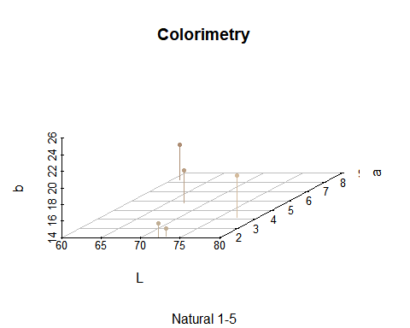

##Segunda metade das amostras 6-10##  
sample2natural=structure(list(Lstar = c(64.27, 73.61, 72.14, 65.62, 65.15),   
 Astar = c(5.24, 2.75, 6.18, 5.57, 8.63),  
 Bstar = c(17.43, 14.28, 17.73, 14.63, 24.65)), .Names = c("Lstar",  
 "Astar", "Bstar"), row.names = c(NA, 5L), class = "data.frame")  
head(sample2natural)

## Lstar Astar Bstar  
## 1 64.27 5.24 17.43  
## 2 73.61 2.75 14.28  
## 3 72.14 6.18 17.73  
## 4 65.62 5.57 14.63  
## 5 65.15 8.63 24.65

LABdatanatural<- with(sample2natural,LAB(Lstar,Astar,Bstar))  
LABdatanatural[1:5,]

## L A B  
## [1,] 64.27 5.24 17.43  
## [2,] 73.61 2.75 14.28  
## [3,] 72.14 6.18 17.73  
## [4,] 65.62 5.57 14.63  
## [5,] 65.15 8.63 24.65

hex(LABdatanatural)

## [1] "#B1987D" "#C4B29B" "#C8AC91" "#B39B86" "#BC9773"

scatterplot3d(sample2natural, color = hex(LABdatanatural), main = "Colorimetry",sub = "Natural 6-10", xlab="L", ylab="a", zlab="b",   
 angle = 50, xlim = (60:80), ylim = (2:9), zlim = (14:26), type = "h", pch = 20, box = FALSE)

