verniz.R

Annie de Lima

2021-01-16

library(colorspace)  
library(colordistance)  
library(scatterplot3d)  
  
##primeira metade das amostras 1-5##  
sample1verniz=structure(list(Lstar = c(59.86, 63.08, 60.63, 71.04, 45.18),   
 Astar = c(7.69, 3.65, 4.38, 5.26, 10.30),  
 Bstar = c(22.66, 17.48, 22.78, 24.00, 23.49)), .Names = c("Lstar",  
 "Astar", "Bstar"), row.names = c(NA, 5L), class = "data.frame")  
head(sample1verniz)

## Lstar Astar Bstar  
## 1 59.86 7.69 22.66  
## 2 63.08 3.65 17.48  
## 3 60.63 4.38 22.78  
## 4 71.04 5.26 24.00  
## 5 45.18 10.30 23.49

LABdataverniz<- with(sample1verniz,LAB(Lstar,Astar,Bstar))  
LABdataverniz[1:5,]

## L A B  
## [1,] 59.86 7.69 22.66  
## [2,] 63.08 3.65 17.48  
## [3,] 60.63 4.38 22.78  
## [4,] 71.04 5.26 24.00  
## [5,] 45.18 10.30 23.49

hex(LABdataverniz)

## [1] "#AB8A69" "#AB957A" "#A88E6A" "#C7A983" "#876444"

scatterplot3d(sample1verniz, color = hex(LABdataverniz), main = "Colorimetry",sub = "Verniz 1-5", xlab="L", ylab="a", zlab="b",   
 angle = 50, xlim = (45:80), ylim = (2:12), zlim = (14:28), type = "h", pch = 20, box = FALSE)

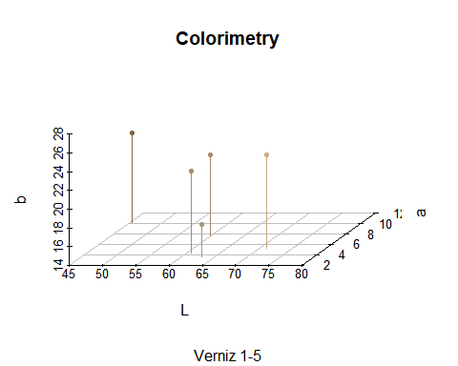

##Segunda metade das amostras 6-10##  
sample2verniz=structure(list(Lstar = c(54.68, 60.48, 66.97, 64.27, 55.71),   
 Astar = c(7.15, 5.86, 7.35, 4.68, 6.84),  
 Bstar = c(23.99, 22.15, 22.14, 18.83, 26.13)), .Names = c("Lstar",  
 "Astar", "Bstar"), row.names = c(NA, 5L), class = "data.frame")  
head(sample2verniz)

## Lstar Astar Bstar  
## 1 54.68 7.15 23.99  
## 2 60.48 5.86 22.15  
## 3 66.97 7.35 22.14  
## 4 64.27 4.68 18.83  
## 5 55.71 6.84 26.13

LABdataverniz<- with(sample2verniz,LAB(Lstar,Astar,Bstar))  
LABdataverniz[1:5,]

## L A B  
## [1,] 54.68 7.15 23.99  
## [2,] 60.48 5.86 22.15  
## [3,] 66.97 7.35 22.14  
## [4,] 64.27 4.68 18.83  
## [5,] 55.71 6.84 26.13

hex(LABdataverniz)

## [1] "#9D7D5A" "#AA8D6B" "#BE9D7C" "#B1987B" "#A08058"

scatterplot3d(sample2verniz, color = hex(LABdataverniz), main = "Colorimetry",sub = "Verniz 6-10", xlab="L", ylab="a", zlab="b",   
 angle = 50, xlim = (45:80), ylim = (2:12), zlim = (14:28), type = "h", pch = 20, box = FALSE)

