Embedded Systems Lab Programs
Exp No: 3

Stepper Motor using AT89C51 using Proteus

Program:
ORG 0000H

UP: MOV P2,#09H
ACALL DELAY
MOV P2,#0CH
ACALL DELAY
MOV P2,#06H
ACALL DELAY
MOV P2,#03H
ACALL DELAY
SJMP UP

DELAY: MOV R4,#18
H1: MOV R3,#255
H2: DJNZ R3,H2
DJNZ R4,H1
RET

END

Output:
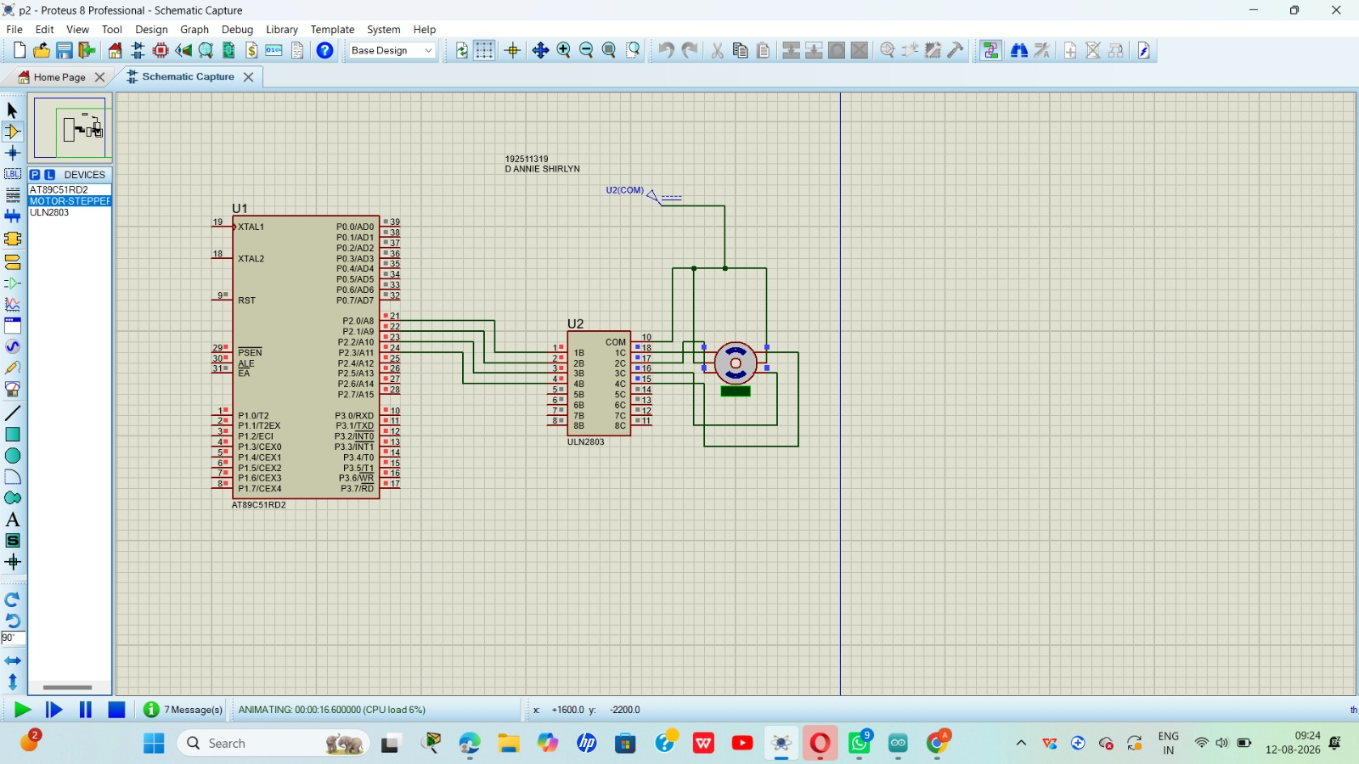

Exp No: 4

7 Segment Display using AT89C51 using Proteus

Program:
ORG 000H

UP: MOV P2,#0C0H
ACALL DELAY
MOV P2,#0F9H
ACALL DELAY
MOV P2,#0A4H
ACALL DELAY
MOV P2,#0B0H
ACALL DELAY
MOV P2,#99H
ACALL DELAY
MOV P2,#92H
ACALL DELAY
MOV P2,#82H
ACALL DELAY
MOV P2,#0F8H
ACALL DELAY
MOV P2,#80H
ACALL DELAY
MOV P2,#90H
ACALL DELAY

DELAY: MOV R5,#10
H1: MOV R4,#180
H2: MOV R3,#255
H3: DJNZ R3,H3
DJNZ R4,H2
DJNZ R5,H1
RET

END

Output:
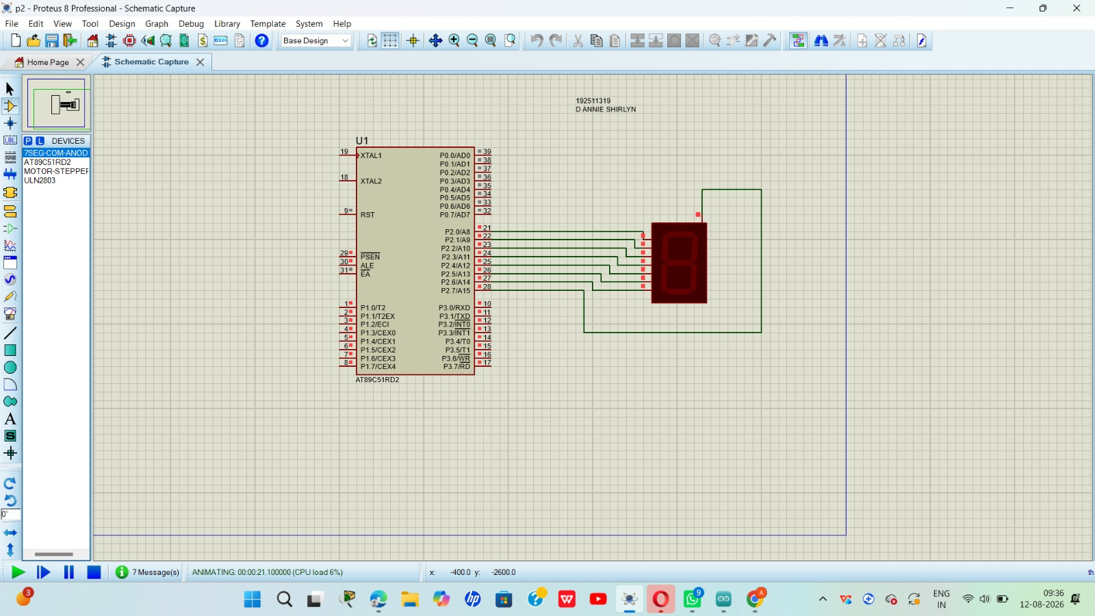

Exp No: 9

Arduino Based Manual Electronic Counter using Proteus

Program:
int x0,x1,x2,x3,x4,x5,x6,x7,x8,x9;
int delay_time = 200;

void setup() {
// configure pin2 as an input and enable the internal pull-up resistor
pinMode(12, INPUT_PULLUP);
pinMode(1, OUTPUT);
pinMode(2, OUTPUT);
pinMode(3, OUTPUT);
pinMode(4, OUTPUT);
pinMode(5, OUTPUT);
pinMode(6, OUTPUT);
pinMode(7, OUTPUT);
}

void loop() {
// read the pushbutton value into a variable
int sensorVal = digitalRead(12);

if (sensorVal == LOW) {
x0 = true;
}

while (x0) {
zero();
sensorVal = digitalRead(12);
if (sensorVal == LOW) {
x1 = true;
x0 = false;
}
}

while (x1) {
one();
sensorVal = digitalRead(12);
if (sensorVal == LOW) {
x2 = true;
x1 = false;
}
}
}
Note: the source file's code ends here — the remaining while-loop blocks (for x2 through x9) and closing braces were not present in the original document and may need to be completed.

Output:
