Kibana

root@ip-10-10-52-30:/home/tools/kibana#

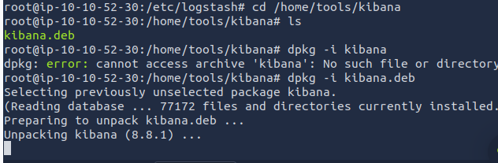

Kibana persistence

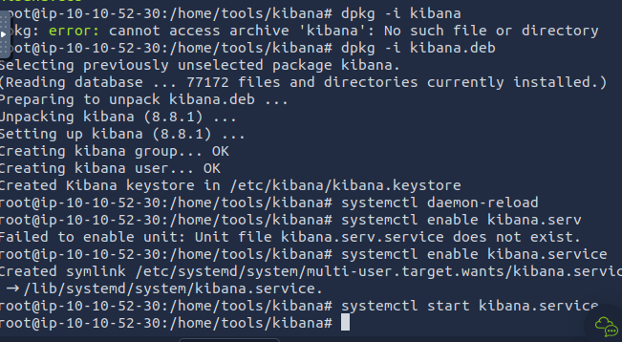

Checking status

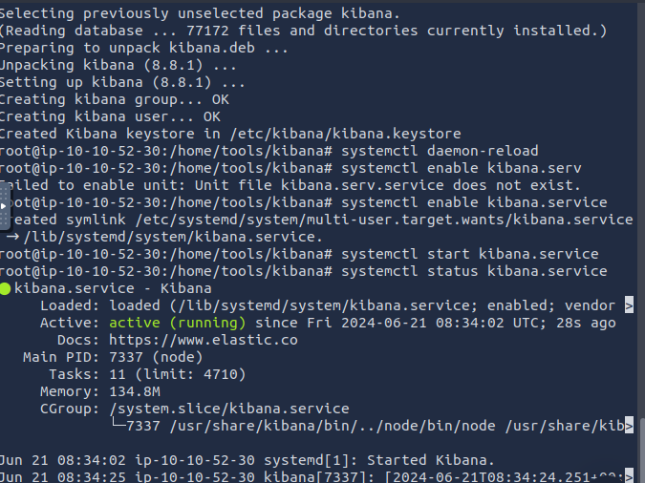

Make changes in kibana.yml

