Unicoder

Sigma ioc follian rule to elastalert alert

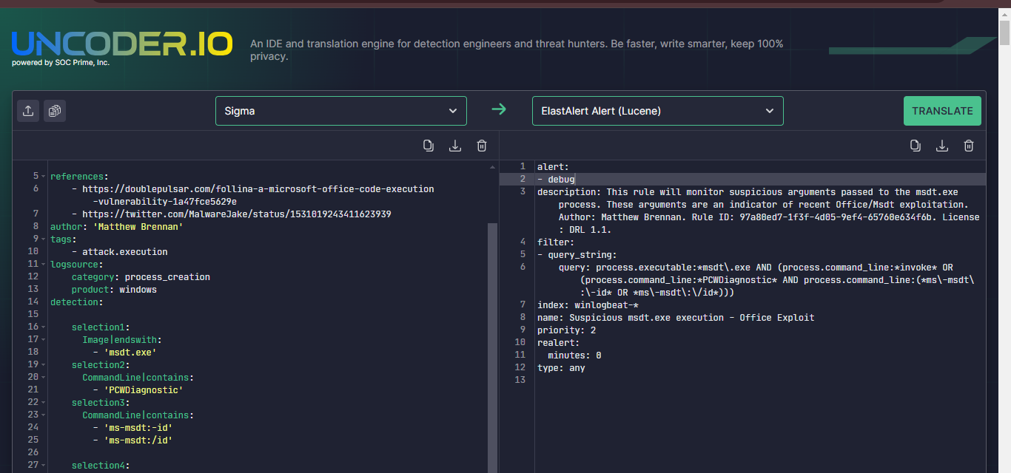

Sigma to elastic stack query

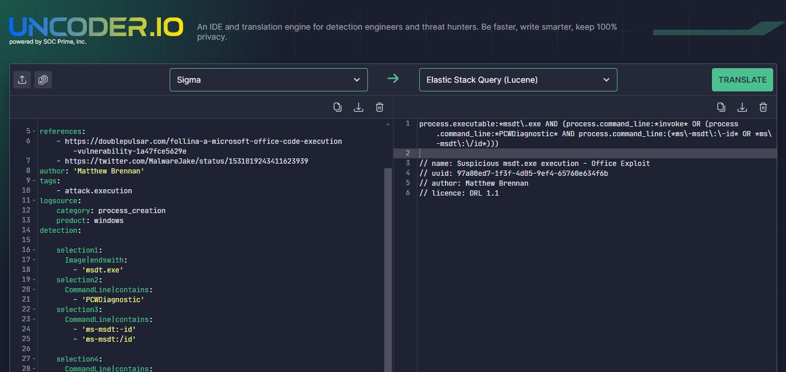

Log4j sigma alert to slpunk alert spl

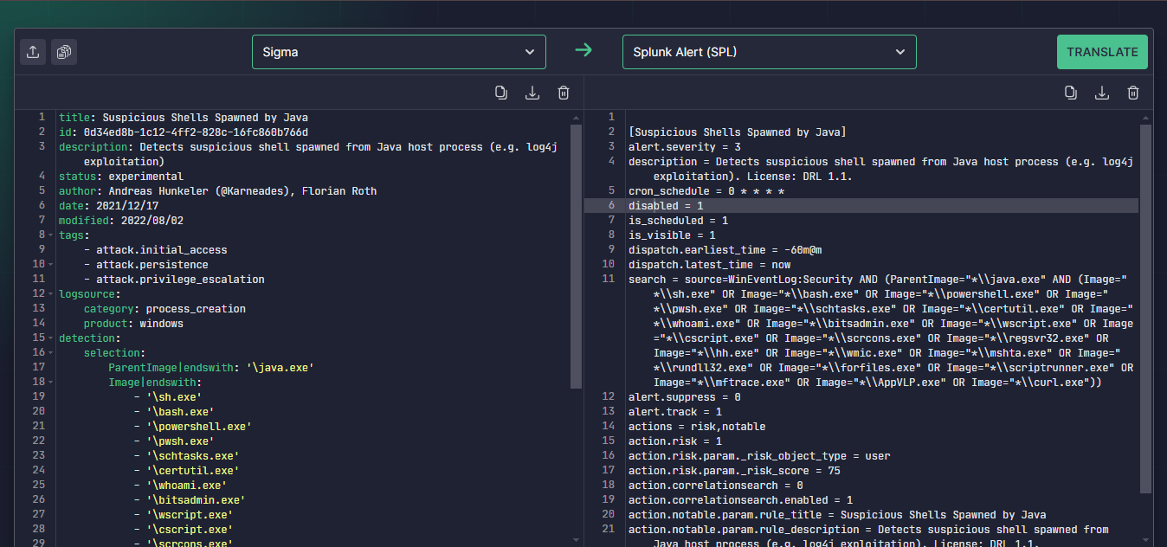

Sigma rule to splunk query spl

