# Annie Titus

## 12/13/2020

IST 659 Tues 8-9:30PM

Photo Organization Database (POD)

IST659

# Project Summary

Have you ever gotten the notifications on your icloud that said “Storage Almost Full” or “Not Enough Storage available for back-up.” I get these notification pop ups daily on my cloud or on my phone, and when I look to see what is taking up my storage space, it’s always my photos. I propose the implementation of a photo organization database (POD), to help streamline my photographs. With POD, I hope to better organize my photos to reduce photo redundancy, have easier accessibility, and identify potential areas of artistic interest in my photography. In phase 1 of this project, I will be outlining the following key items: Stakeholders (present and future), Business Rules, Glossary of terms, Data questions that I hope to answer as a result of this project, and the creation of both the conceptual and logical model. Once phase 1 has been reviewed and approved by stakeholders, we will implement the design of the logical model into a SQL database.

# Stakeholders

The stakeholders in this project include myself (photographer), and potential business partners who has mentioned they would like to see a portfolio of my photos for future collaborations. As the photographer, I will be able to track my photos through specific photo features identified in the database, giving me faster efficiency. POD will also allow for higher business acumen with potential artist collaborations who will be able to view and compare my photo type to theirs more easily and readily, increasing my marketability as a photographer.

# Business Rules

* A photograph can have one or more person in it
* A photograph can only display one location area
* A photograph contains photo details such as date and time of when photo is taken, and photo pixels
* A person be identified(tag) in the photo by first and last name
* A caption is optional to describe the photo location
* An occasion description is optional to describe the photo
* A photo type must be unique to a given photo
* A photo Aesthetics must be unique to a given photo
* A photo’s pixel can determine a photo’s print size

# Glossary

A **photo** is an image taken by the photographer through the use of a camera  
A **location** is the place the photo was taken and should contain the city and state

A **photo type** describes the occasion in which the photo was taken. Photo Types are: portrait, fashion, sports, editorial, architectural, landscape, and event photography

A **photo aesthetics** in this database is narrowed to if a photo is in color or monochrome (black and white)

A **photo pixel(or photo resolution)** is the picture element of a photo. The higher the pixel determines the photo’s printability and size

# Data Questions

* Is there an area of artistic interest (ie. Photo type) that stands out within the photo database?
* Who had the most photos taken?
* Are there any visible trends or patterns on when or where the photos are taken to determine the photographer’s preference?
* When is the most photos taken? Is there a ‘busy’ month/season?

# Conceptual Model

Logical Model

----Physical Database Design---

SQL Code(Table Creation)

--Create POD Database Tables

DROP TABLE PhotoAesthetics

--Creating PhotoAesthetics Table

CREATE TABLE PhotoAesthetics(

PhotoAestheticsID int identity not null,

PhotoAesthetics varchar (12)

--Constraints on the PhotoAesthetics Table

,CONSTRAINT PK_PhotoAesthetics Primary Key (PhotoAestheticsID)

)

--End creating PhotoAesthetics Table

DROP TABLE PhotoType

--Creating PhotoType Table

CREATE TABLE PhotoType(

--Column for the PhotoType table

PhotoTypeID int identity not null,

PhotoType varchar (50) not null

--Constraints on the PhotoType Table

CONSTRAINT PK_PhotoType Primary Key (PhotoTypeID)

)

--End creating PhotoType Table

DROP TABLE Location

--Creating the Location Table

CREATE TABLE Location(

--Columns for the Location table

LocationID Int identity not null,

City varchar(20) not null,

State varchar (2) not null,

LocationDescription varchar (30),

--Constraints on the Location Table

CONSTRAINT PK_Location Primary Key (LocationID)

)

--End creating the Location Table

--Creating the People Table

CREATE Table People(

--Columns for the People Table

IDNumber int identity not null,

FirstName varchar(30) not null,

LastName varchar (30) not null,

--Constraints on the People Table

CONSTRAINT PK_People Primary Key (IDNumber)

)

--End creating the People Table

DROP TABLE Photo

--Creating the Photo Table

CREATE TABLE Photo(

--Columns for the Photo Table

PhotoID int identity not null,

PhotoDate datetime not null,

PhotoTimeTaken datetime not null,

PeopleCount int not null,

PhotoPixel int not null,

PhotoDescription varchar(30),

IDNumber int not null,

PhotoAestheticsID int not null,

PhotoTypeID int not null,

LocationID int not null,

--Constraints on the Photo Table

CONSTRAINT PK_Photo Primary Key (PhotoID),

CONSTRAINT FK_1_Photo FOREIGN KEY (IDNumber) REFERENCES People(IDNumber),

CONSTRAINT FK_2_Photo FOREIGN KEY (PhotoAestheticsID) REFERENCES PhotoAesthetics(PhotoAestheticsID),

CONSTRAINT FK_3_Photo FOREIGN KEY (PhotoTypeID) REFERENCES PhotoType(PhotoTypeID),

CONSTRAINT FK_4_Photo FOREIGN KEY (LocationID) REFERENCES Location(LocationID)

)

--End Creating the Photo Table

DROP TABLE PhotoPeopleList

--Creating the PhotoPeopleList Table

CREATE Table PhotoPeopleList(

--Columns for the PhotoPeopleList

PhotoPeopleListID int identity not null,

PhotoID int not null,

IDNumber int not null,

--Constraints on the PhotoPeopleList Table

CONSTRAINT PK_PhotoPeopleList Primary Key (PhotoPeopleListID),

CONSTRAINT FK_1_PhotoPeopleList FOREIGN KEY (PhotoID) REFERENCES Photo(PhotoID),

CONSTRAINT FK_2_PhotoPeopleList FOREIGN KEY (IDNumber) REFERENCES People(IDNumber)

)

--End Creating the PhotoPeopleList Table

SQL Code(Inserting Data)

--Viewing PhotoAesthetics Table

SELECT * FROM PhotoAesthetics

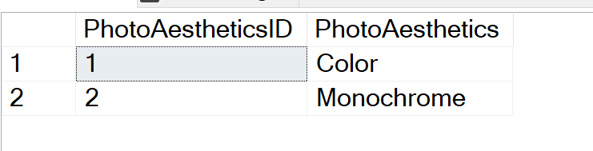

--Insert Data into PhotoAesthetics

INSERT INTO PhotoAesthetics(PhotoAesthetics)

VALUES ('Color'), ('Monochrome')

--Insert Date into PhotoType

INSERT INTO PhotoType (PhotoType)

VALUES ('Portrait Photography'), ('Fashion Photography '), ('Sports Photography'), ('Editorial Photography'), ('Architectural Photography'), ('Landscape Photography'), ('Event Photography')

SELECT * FROM PhotoType

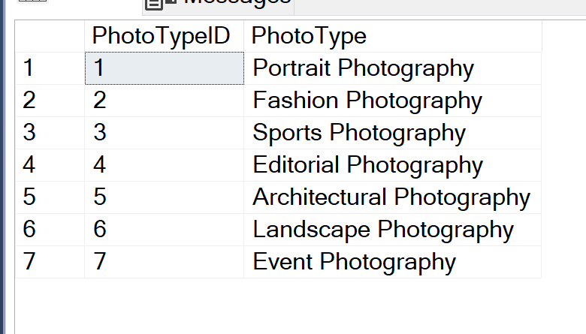

--Taking a look into Location

SELECT * FROM Location

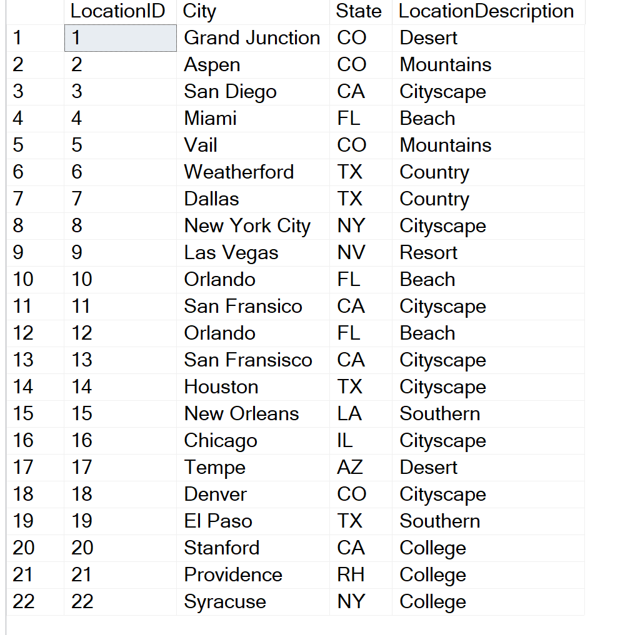

--Insert Data into Location

INSERT INTO Location(City, State, LocationDescription)

Values ('Grand Junction', 'CO', 'Desert'), ('Aspen', 'CO', 'Mountains'), ('San Diego', 'CA', 'Cityscape'),

('Miami', 'FL', 'Beach'), ('Vail', 'CO', 'Mountains'), ('Weatherford', 'TX', 'Country'),

('Dallas', 'TX', 'Country'), ('New York City', 'NY', 'Cityscape'),

('Las Vegas', 'NV', 'Resort'), ('Orlando', 'FL', 'Beach'), ('San Fransico', 'CA', 'Cityscape'),

('Orlando', 'FL', 'Beach'), ('San Fransisco', 'CA', 'Cityscape'), ('Houston', 'TX', 'Cityscape'),

('New Orleans', 'LA', 'Southern'), ('Chicago', 'IL', 'Cityscape'), ('Tempe', 'AZ', 'Desert'),

('Denver', 'CO', 'Cityscape'), ('El Paso', 'TX', 'Southern'), ('Stanford', 'CA', 'College'),

('Providence', 'RH', 'College'), ('Syracuse', 'NY', 'College')

--Taking a look at People Table

SELECT * FROM People

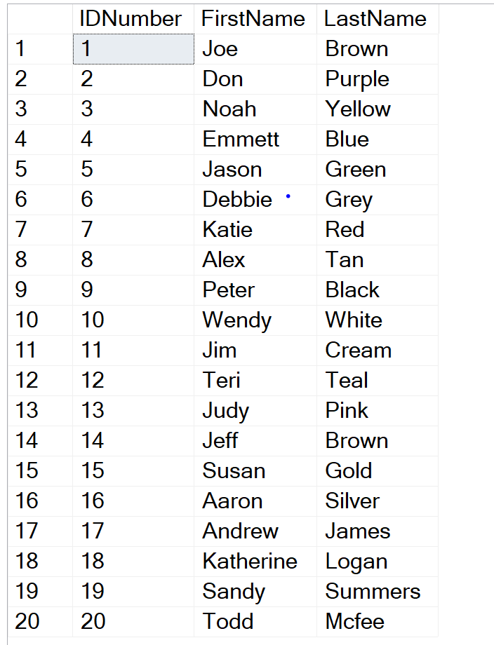

--Insert Data into People

INSERT INTO People (FirstName, LastName)

VALUES ('Joe', 'Brown'), ('Don', 'Purple'), ('Noah', 'Yellow'), ('Emmett', 'Blue'), ('Jason', 'Green'),

('Debbie', 'Grey'), ('Katie', 'Red'), ('Alex', 'Tan'), ('Peter', 'Black'), ('Wendy', 'White'), ('Jim', 'Cream'),

('Teri', 'Teal'), ('Judy', 'Pink'), ('Jeff', 'Brown'), ('Susan', 'Gold'), ('Aaron', 'Silver'), ('Andrew', 'James'),

('Katherine', 'Logan'), ('Sandy', 'Summers'), ('Todd', 'Mcfee')

--Taking a look into Photo Table

--Taking a look into Photo Table

SELECT * FROM Photo

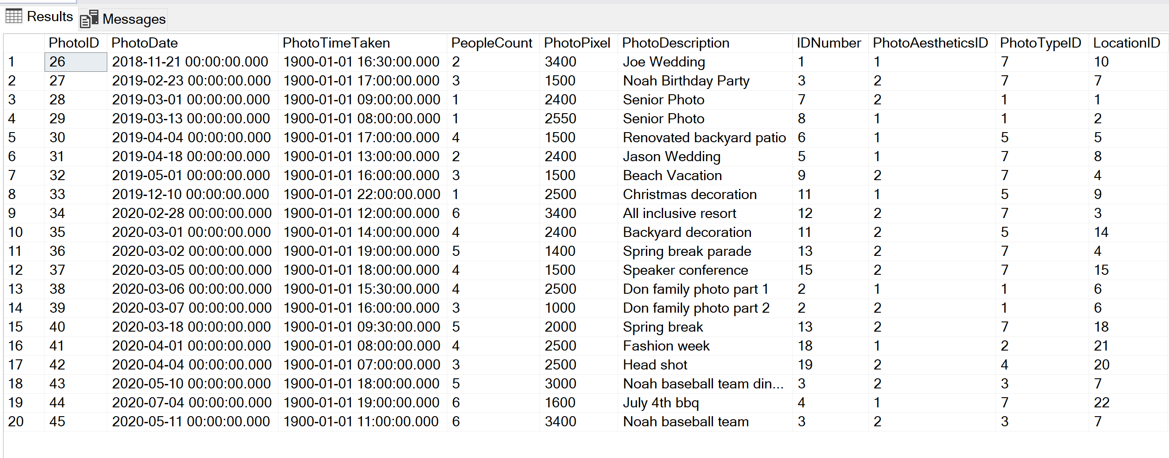

INSERT INTO Photo(PhotoDate, PhotoTimeTaken, PeopleCount, PhotoPixel, PhotoDescription, IDNumber, PhotoAestheticsID, PhotoTypeID, LocationID)

VALUES ('11/21/2018', '4:30PM', '2', '3400', 'Joe Wedding', (SELECT TOP 1 IDNumber FROM People WHERE FirstName = 'Joe'),

(SELECT TOP 1 PhotoAestheticsID FROM PhotoAesthetics WHERE PhotoAesthetics= 'Color'),

(SELECT TOP 1 PhotoTypeID FROM PhotoType WHERE PhotoType = 'Event Photography'),

(SELECT TOP 1 LocationID FROM Location WHERE City = 'Orlando'))

,('2/23/2019', '5PM','3', '1500', 'Noah Birthday Party', (SELECT TOP 1 IDNumber FROM People WHERE FirstName = 'Noah'),

(SELECT TOP 1 PhotoAestheticsID FROM PhotoAesthetics WHERE PhotoAesthetics = 'MonoChrome'),

(SELECT TOP 1 PhotoTypeID FROM PhotoType WHERE PhotoType = 'Event Photography'),

(SELECT TOP 1 LocationID FROM Location WHERE City = 'Dallas'))

,('3/1/2019', '9AM', '1', '2400', 'Senior Photo', (SELECT TOP 1 IDNumber FROM People WHERE FirstName = 'Katie'),

(SELECT TOP 1 PhotoAestheticsID FROM PhotoAesthetics WHERE PhotoAesthetics= 'MonoChrome'),

(SELECT TOP 1 PhotoTypeID FROM PhotoType WHERE PhotoType = 'Portrait Photography'),

(SELECT TOP 1 LocationID FROM Location WHERE City = 'Grand Junction'))

,('3/13/2019', '8AM', '1', '2550', 'Senior Photo', (SELECT TOP 1 IDNumber FROM People WHERE FirstName = 'Alex'),

(SELECT TOP 1 PhotoAestheticsID FROM PhotoAesthetics WHERE PhotoAesthetics = 'Color'),

(SELECT TOP 1 PhotoTypeID FROM PhotoType WHERE PhotoType = 'Portrait Photography'),

(SELECT TOP 1 LocationID FROM Location WHERE City = 'Aspen'))

,('4/4/2019', '5PM', '4', '1500', 'Renovated backyard patio', (SELECT TOP 1 IDNumber FROM People WHERE FirstName = 'Debbie'),

(SELECT TOP 1 PhotoAestheticsID FROM PhotoAesthetics WHERE PhotoAesthetics = 'Color'),

(SELECT TOP 1 PhotoTypeID FROM PhotoType WHERE PhotoType = 'Architectural Photography'),

(SELECT TOP 1 LocationID FROM Location WHERE City = 'Vail'))

,('4/18/2019', '1PM', '2', '2400', 'Jason Wedding', (SELECT TOP 1 IDNumber FROM People WHERE FirstName = 'Jason'),

(SELECT TOP 1 PhotoAestheticsID FROM PhotoAesthetics WHERE PhotoAesthetics = 'Color'),

(SELECT TOP 1 PhotoTypeID FROM PhotoType WHERE PhotoType = 'Event Photography'),

(SELECT TOP 1 LocationID FROm Location WHERE City = 'New York City'))

,('5/1/2019', '4PM', '3', '1500', 'Beach Vacation', (SELECT TOP 1 IDNumber FROM People WHERE FirstName = 'Peter'),

(SELECT TOP 1 PhotoAestheticsID FROM PhotoAesthetics WHERE PhotoAesthetics = 'Monochrome'),

(SELECT TOP 1 PhotoTypeID FROM PhotoType WHERE PhotoType = 'Event Photography'),

(SELECT TOP 1 LocationID FROm Location WHERE City = 'Miami'))

,('12/10/2019', '10PM', '1', '2500', 'Christmas decoration', (SELECT TOP 1 IDNumber FROM People WHERE FirstName = 'Jim'),

(SELECT TOP 1 PhotoAestheticsID FROM PhotoAesthetics WHERE PhotoAesthetics = 'Color'),

(SELECT TOP 1 PhotoTypeID FROM PhotoType WHERE PhotoType = 'Architectural Photography'),

(SELECT TOP 1 LocationID FROm Location WHERE City = 'Las Vegas'))

,('2/28/2020', '12PM', '6', '3400', 'All inclusive resort', (SELECT TOP 1 IDNumber FROM People WHERE FirstName = 'Teri'),

(SELECT TOP 1 PhotoAestheticsID FROM PhotoAesthetics WHERE PhotoAesthetics = 'Monochrome'),

(SELECT TOP 1 PhotoTypeID FROM PhotoType WHERE PhotoType = 'Event Photography'),

(SELECT TOP 1 LocationID FROm Location WHERE City = 'San Diego'))

,('3/1/2020', '2PM', '4', '2400', 'Backyard decoration', (SELECT TOP 1 IDNumber FROM People WHERE FirstName = 'Jim'),

(SELECT TOP 1 PhotoAestheticsID FROM PhotoAesthetics WHERE PhotoAesthetics = 'Monochrome'),

(SELECT TOP 1 PhotoTypeID FROM PhotoType WHERE PhotoType = 'Architectural Photography'),

(SELECT TOP 1 LocationID FROm Location WHERE City = 'Houston'))

,('3/2/2020', '7PM', '5', '1400', 'Spring break parade', (SELECT TOP 1 IDNumber FROM People WHERE FirstName = 'Judy'),

(SELECT TOP 1 PhotoAestheticsID FROM PhotoAesthetics WHERE PhotoAesthetics = 'Monochrome'),

(SELECT TOP 1 PhotoTypeID FROM PhotoType WHERE PhotoType = 'Event Photography'),

(SELECT TOP 1 LocationID FROm Location WHERE City = 'Miami'))

,('3/5/2020', '6PM', '4', '1500', 'Speaker conference', (SELECT TOP 1 IDNumber FROM People WHERE FirstName = 'Susan'),

(SELECT TOP 1 PhotoAestheticsID FROM PhotoAesthetics WHERE PhotoAesthetics = 'Monochrome'),

(SELECT TOP 1 PhotoTypeID FROM PhotoType WHERE PhotoType = 'Event Photography'),

(SELECT TOP 1 LocationID FROm Location WHERE City = 'New Orleans'))

,('3/6/2020', '3:30PM', '4', '2500', 'Don family photo part 1', (SELECT TOP 1 IDNumber FROM People WHERE FirstName = 'Don'),

(SELECT TOP 1 PhotoAestheticsID FROM PhotoAesthetics WHERE PhotoAesthetics = 'Color'),

(SELECT TOP 1 PhotoTypeID FROM PhotoType WHERE PhotoType = 'Portrait Photography'),

(SELECT TOP 1 LocationID FROm Location WHERE City = 'Weatherford'))

,('3/7/2020', '4PM', '3', '1000', 'Don family photo part 2', (SELECT TOP 1 IDNumber FROM People WHERE FirstName = 'Don'),

(SELECT TOP 1 PhotoAestheticsID FROM PhotoAesthetics WHERE PhotoAesthetics = 'Monochrome'),

(SELECT TOP 1 PhotoTypeID FROM PhotoType WHERE PhotoType = 'Portrait Photography'),

(SELECT TOP 1 LocationID FROm Location WHERE City = 'Weatherford'))

,('3/18/2020', '9:30AM', '5','2000', 'Spring break', (SELECT TOP 1 IDNumber FROM People WHERE FirstName = 'Judy'),

(SELECT TOP 1 PhotoAestheticsID FROM PhotoAesthetics WHERE PhotoAesthetics = 'Monochrome'),

(SELECT TOP 1 PhotoTypeID FROM PhotoType WHERE PhotoType = 'Event Photography'),

(SELECT TOP 1 LocationID FROm Location WHERE City = 'Denver'))

,('4/1/2020', '8AM', '4', '2500', 'Fashion week', (SELECT TOP 1 IDNumber FROM People WHERE FirstName = 'Katherine'),

(SELECT TOP 1 PhotoAestheticsID FROM PhotoAesthetics WHERE PhotoAesthetics = 'Color'),

(SELECT TOP 1 PhotoTypeID FROM PhotoType WHERE PhotoType = 'Fashion Photography'),

(SELECT TOP 1 LocationID FROm Location WHERE City = 'Providence'))

,('4/4/2020', '7AM', '3', '2500', 'Head shot', (SELECT TOP 1 IDNumber FROM People WHERE FirstName = 'Sandy'),

(SELECT TOP 1 PhotoAestheticsID FROM PhotoAesthetics WHERE PhotoAesthetics = 'Monochrome'),

(SELECT TOP 1 PhotoTypeID FROM PhotoType WHERE PhotoType = 'Editorial Photography'),

(SELECT TOP 1 LocationID FROm Location WHERE City = 'Stanford'))

,('5/10/2020', '6PM', '5', '3000', 'Noah baseball team dinner', (SELECT TOP 1 IDNumber FROM People WHERE FirstName = 'Noah'),

(SELECT TOP 1 PhotoAestheticsID FROM PhotoAesthetics WHERE PhotoAesthetics = 'Monochrome'),

(SELECT TOP 1 PhotoTypeID FROM PhotoType WHERE PhotoType = 'Sports Photography'),

(SELECT TOP 1 LocationID FROm Location WHERE City = 'Dallas'))

,('7/4/2020', '7PM', '6', '1600', 'July 4th bbq', (SELECT TOP 1 IDNumber FROM People WHERE FirstName = 'Emmett'),

(SELECT TOP 1 PhotoAestheticsID FROM PhotoAesthetics WHERE PhotoAesthetics = 'Color'),

(SELECT TOP 1 PhotoTypeID FROM PhotoType WHERE PhotoType = 'Event Photography'),

(SELECT TOP 1 LocationID FROm Location WHERE City = 'Syracuse'))

,('5/11/2020', '11AM', '6', '3400', 'Noah baseball team', (SELECT TOP 1 IDNumber FROM People WHERE FirstName = 'Noah'),

(SELECT TOP 1 PhotoAestheticsID FROM PhotoAesthetics WHERE PhotoAesthetics = 'Monochrome'),

(SELECT TOP 1 PhotoTypeID FROM PhotoType WHERE PhotoType = 'Sports Photography'),

(SELECT TOP 1 LocationID FROm Location WHERE City = 'Dallas'))

--Insert Data into PhotoPeopleList of all people have taken pictures

INSERT INTO PhotoPeopleList(PhotoID, IDNumber)

VALUES ((SELECT PhotoID FROM Photo WHERE PhotoDate = '11/21/2018'), (SELECT IDNumber FROM People WHERE FirstName ='JOE'))

,((SELECT PhotoID FROM Photo WHERE PhotoDate = '2/23/2019'), (SELECT IDNumber FROM People WHERE FirstName ='Noah'))

,((SELECT PhotoID FROM Photo WHERE PhotoDate = '3/1/2019'), (SELECT IDNumber FROM People WHERE FirstName ='Katie'))

,((SELECT PhotoID FROM Photo WHERE PhotoDate = '3/13/2019'), (SELECT IDNumber FROM People WHERE FirstName ='Alex'))

,((SELECT PhotoID FROM Photo WHERE PhotoDate = '4/4/2019'), (SELECT IDNumber FROM People WHERE FirstName ='Debbie'))

,((SELECT PhotoID FROM Photo WHERE PhotoDate = '4/18/2019'), (SELECT IDNumber FROM People WHERE FirstName ='Jason'))

,((SELECT PhotoID FROM Photo WHERE PhotoDate = '5/1/2019'), (SELECT IDNumber FROM People WHERE FirstName ='Peter'))

,((SELECT PhotoID FROM Photo WHERE PhotoDate = '12/10/2019'), (SELECT IDNumber FROM People WHERE FirstName ='Jim'))

,((SELECT PhotoID FROM Photo WHERE PhotoDate = '2/28/2020'), (SELECT IDNumber FROM People WHERE FirstName ='Teri'))

,((SELECT PhotoID FROM Photo WHERE PhotoDate = '3/1/2020'), (SELECT IDNumber FROM People WHERE FirstName ='Jim'))

,((SELECT PhotoID FROM Photo WHERE PhotoDate = '3/2/2020'), (SELECT IDNumber FROM People WHERE FirstName ='Judy'))

,((SELECT PhotoID FROM Photo WHERE PhotoDate = '3/5/2020'), (SELECT IDNumber FROM People WHERE FirstName ='Susan'))

,((SELECT PhotoID FROM Photo WHERE PhotoDate = '3/6/2020'), (SELECT IDNumber FROM People WHERE FirstName ='Don'))

,((SELECT PhotoID FROM Photo WHERE PhotoDate = '3/7/2020'), (SELECT IDNumber FROM People WHERE FirstName ='Don'))

,((SELECT PhotoID FROM Photo WHERE PhotoDate = '3/18/2020'), (SELECT IDNumber FROM People WHERE FirstName ='Judy'))

,((SELECT PhotoID FROM Photo WHERE PhotoDate = '4/1/2020'), (SELECT IDNumber FROM People WHERE FirstName ='Katherine'))

,((SELECT PhotoID FROM Photo WHERE PhotoDate = '4/4/2020'), (SELECT IDNumber FROM People WHERE FirstName ='Sandy'))

,((SELECT PhotoID FROM Photo WHERE PhotoDate = '5/10/2020'), (SELECT IDNumber FROM People WHERE FirstName ='Noah'))

,((SELECT PhotoID FROM Photo WHERE PhotoDate = '7/4/2020'), (SELECT IDNumber FROM People WHERE FirstName ='Emmett'))

,((SELECT PhotoID FROM Photo WHERE PhotoDate = '5/11/2020'), (SELECT IDNumber FROM People WHERE FirstName ='Noah'))

SELECT * FROM PhotoPeopleList

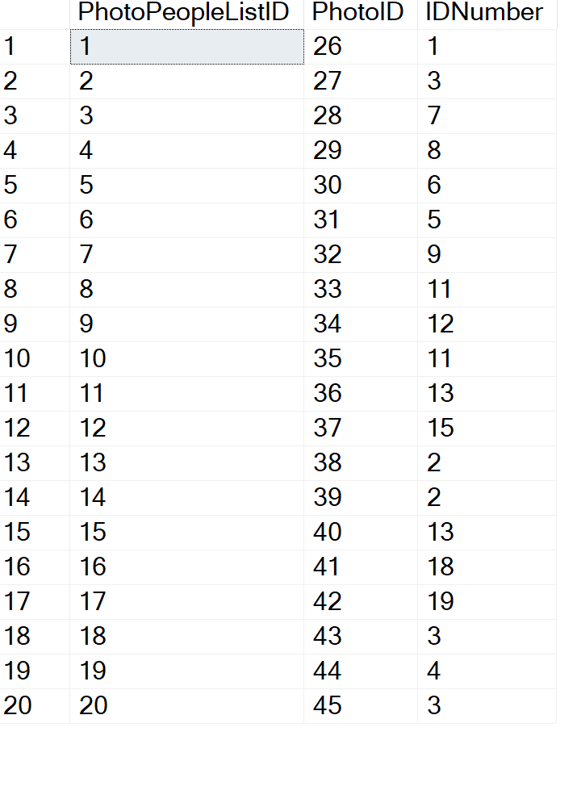

SQL Code(Creating Views)

--Create View of PhotoCount by People

GO

CREATE VIEW PeoplePhotoCount

AS

SELECT

People.FirstName as FirstName,

People.LastName as LastName,

count(Photo.IDNumber) as PhotoCount

FROM Photo

JOIN People on Photo.IDNumber = People.IDNumber

GROUP BY People.FirstName, People.LastName, Photo.IDNumber

GO

Select * FROM PeoplePhotoCount

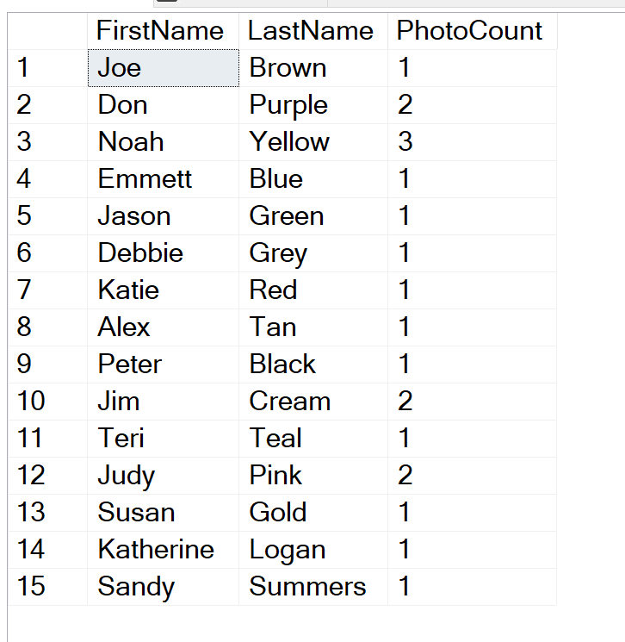

--Create View of PhotoTable but with actual information for IDnumber, PhotoAesthetics, Phototype and location

GO

CREATE VIEW PhotoTableView

AS

SELECT

Photo.PhotoID as PhotoID,

Photo.PhotoDate as PhotoDate,

Photo.PhotoTimeTaken as PhotoTimeTaken,

Photo.PeopleCount as Number_Of_People_in_Photo,

Photo.PhotoPixel as PhotoPixel,

People.FirstName as FirstName,

People.LastName as LastName,

PhotoAesthetics.PhotoAesthetics as PhotoAesthetics,

PhotoType.PhotoType as PhotoType,

Location.City as City,

Location.State as State

FROM Location INNER JOIN

Photo ON dbo.Location.LocationID = Photo.LocationID INNER JOIN

People ON Photo.IDNumber = People.IDNumber INNER JOIN

PhotoAesthetics ON Photo.PhotoAestheticsID = PhotoAesthetics.PhotoAestheticsID INNER JOIN

PhotoType ON Photo.PhotoTypeID = PhotoType.PhotoTypeID

GROUP BY Photo.PhotoID,

Photo.PhotoDate,

Photo.PhotoTimeTaken,

Photo.PeopleCount,

Photo.PhotoPixel,

People.FirstName,

People.LastName,

PhotoAesthetics.PhotoAesthetics,

PhotoType.PhotoType,

Location.City,

Location.State

GO

Select * FROM PhotoTableView

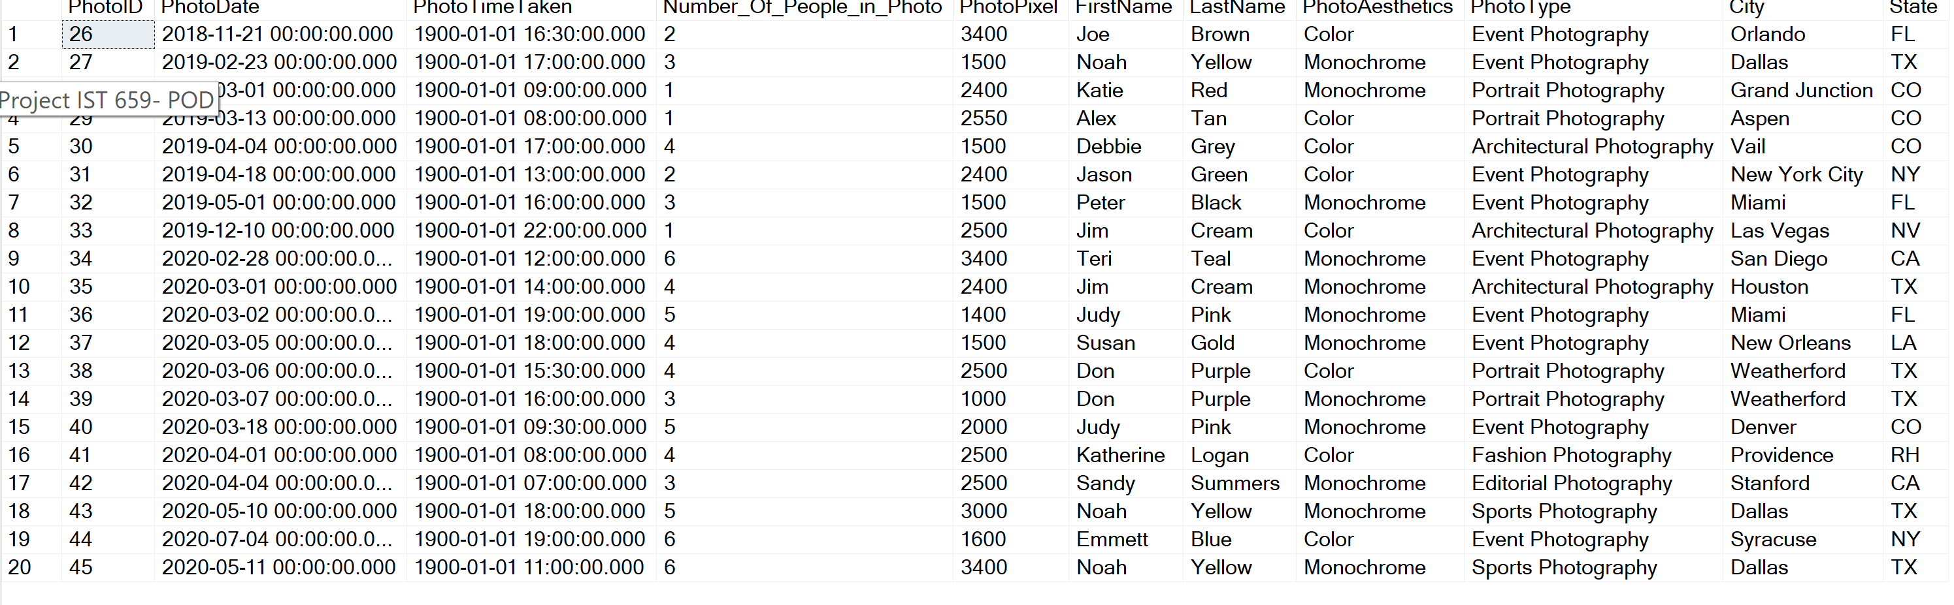

--Creating view to get total count of PhotoAesthetics

GO

CREATE VIEW PhotoAestheticCount

AS

SELECT

PhotoAesthetics.PhotoAesthetics as PhotoAesthetics,

count(photo.PhotoAestheticsID) as TotalAesthetics,

count(Photo.IDNumber) as PhotoCount

FROM Photo INNER JOIN

PhotoAesthetics ON Photo.PhotoAestheticsID = PhotoAesthetics.PhotoAestheticsID

INNER JOIN PhotoType ON Photo.PhotoTypeID = PhotoType.PhotoTypeID

GROUP BY PhotoAesthetics.PhotoAesthetics, Photo.PhotoAestheticsID

GO

SELECT * FROM PhotoAestheticCount

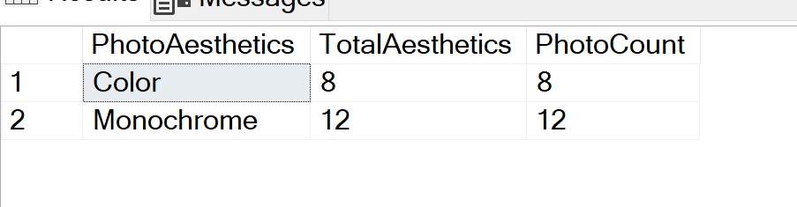

--Creating view to get total count of PhotoType

GO

CREATE VIEW SumofPhotoType

AS

SELECT

PhotoType.PhotoType as PhotoType,

count(photo.PhotoTypeID) as TotalPhotoType,

count(Photo.IDNumber) as PhotoCount

FROM Photo INNER JOIN

PhotoType ON Photo.PhotoTypeID = PhotoType.PhotoTypeID

GROUP BY PhotoType.PhotoType, Photo.PhotoTypeID

GO

Select * FROM SumofPhotoType

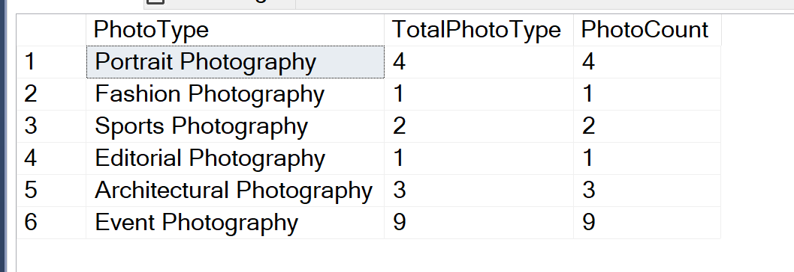

**DATA QUESTIONS**

* Is there an area of artistic interest (ie. Photo type) that stands out within the photo database?

***Response:***

***Event Photography was the most popular form of photo type taken, at 9 photos total***

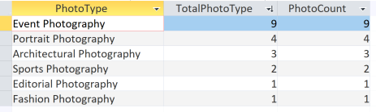

* Who has had the most photos taken?

***Response:***

***Noah Yellow had the most photos taken, at a total of 3 photos***



* Are there any visible trends or patterns on when or where the photos are taken to determine the photographer’s preference?

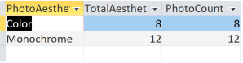 

***Response:***

***Monochrome as the PhotoAesthetic, and Event Photography as the PhotoType were the most popular, showing a visible interest in the photographer’s preference to shoot events in black and white color.***

* When is the most photos taken? Is there a ‘busy’ month/season?

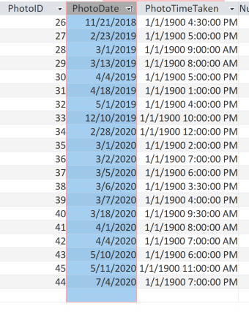

***Response:***

***Most photos were taken in the months of March (8) and April (4) which could signal that those months are busier times for the photographer.***

**Reflection**

There have been several ‘revelation’ moments during the course of working on this project.

First, having a good conceptual and logical model is key to developing the tables and relationships. I referenced several times back to my logical model during the table creation. I had to change my table because I realized that initially labeling an attribute as Unique didn’t make sense when I was inserting the data.

Second, SQL syntax is very important and understanding how and why to code using the different syntax will save a lot of time and frustration. Attention to detail of the code prior to execution is important, otherwise DELETE, ALTER, DROP will be favorite SQL commands.

And lastly, there’s a difference between ‘getting it’ with the homework assignments and doing it on your own with a unique project. Several times I reference back to past asynchronous videos and homework assignments to refresh what I learned a few week ago.

# **Summary**

As a previous professor once told me, frustration is a powerful source of learning and if I can push through to the ‘other side’, I can and will ultimately learn a greater deal and get around that source of frustration.

This is my first time coding using SQL and there were several time, where I was frustrated and had to step away. Ultimately, I would come back and play around with the code and it would work, those times were truly ‘light bulb’ moments where I have a better understanding of the initial error and the resolution. I do think more SQL practice will help, because during the course and this project, I have seen and learned different methods of coding and recognized there is not one way to get information. This class and project open the gateway to exploring the different functions of SQL which I can see will be extremely useful in my path as a data scientist.