**Assignment -1**

1) Download tableau desktop & Mysql in your PC or laptop

2) Create a new schema in your Mysql workbench and upload your data

3) Connect your Mysql and Tableau

4) Create the below 5 charts/plots

● Bar chart

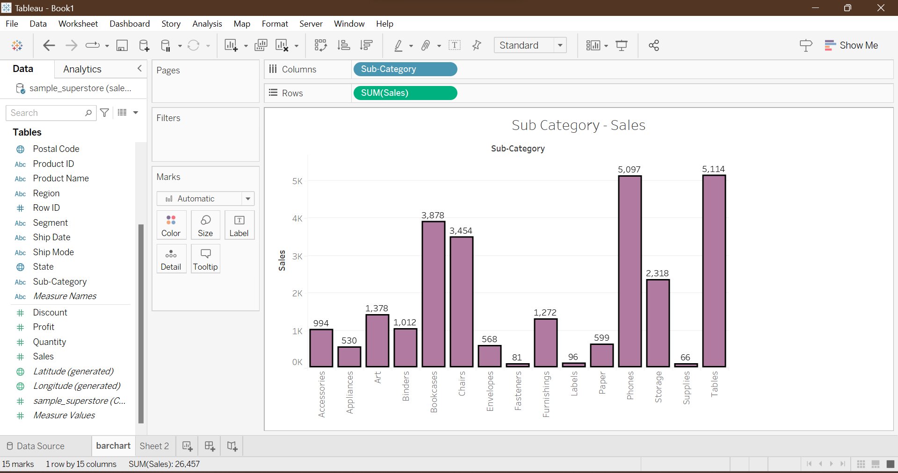

● Tree map

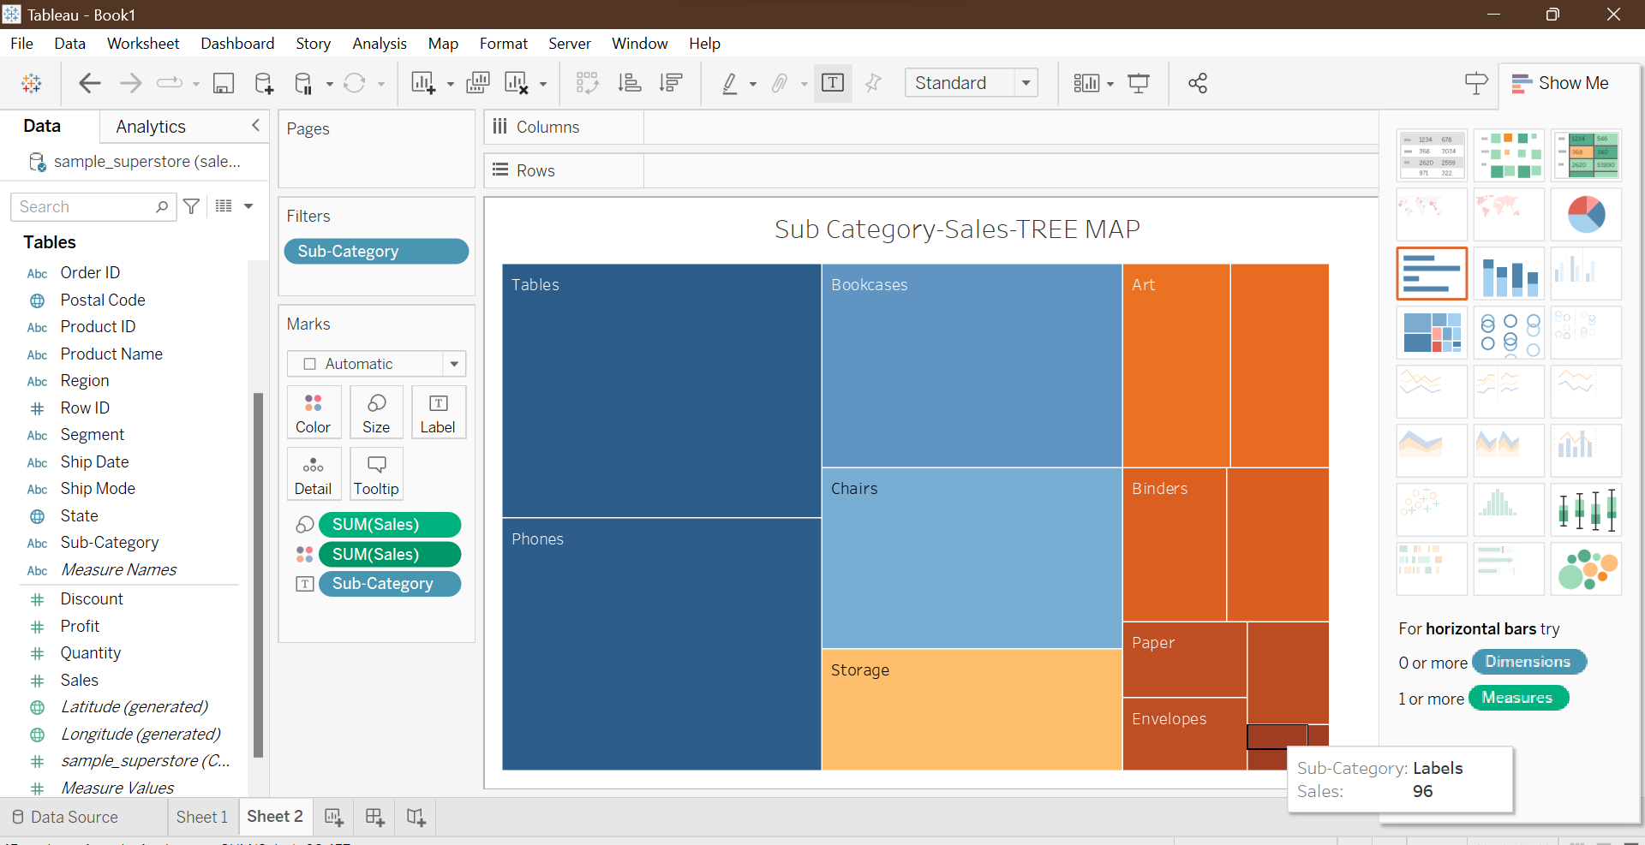

● Heatmap

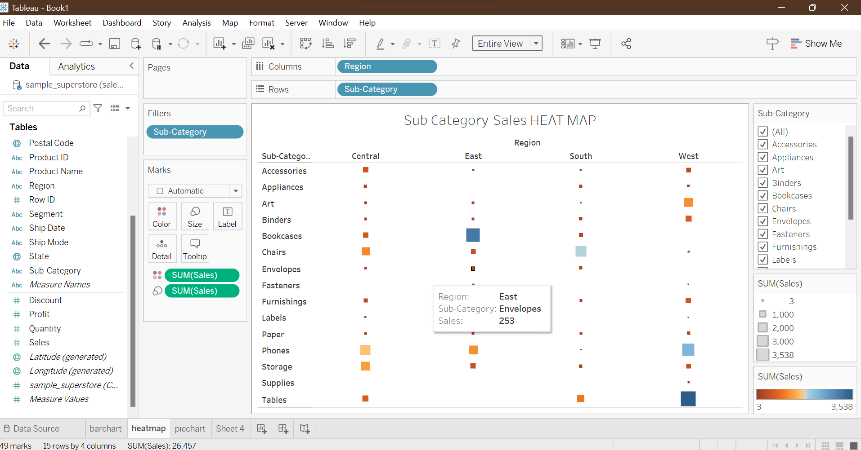

● Pie chart

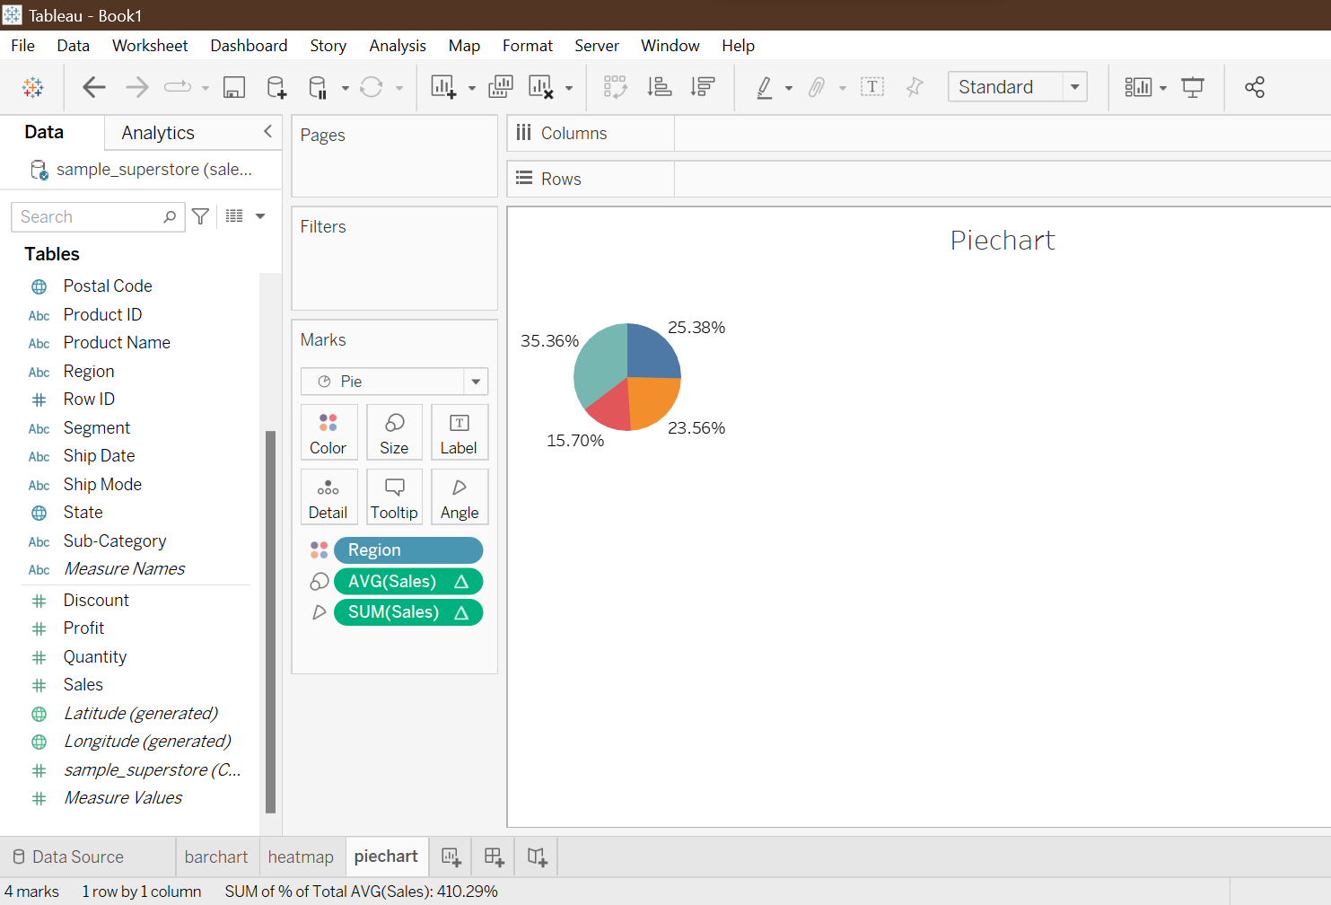

● Horizontal bar chart

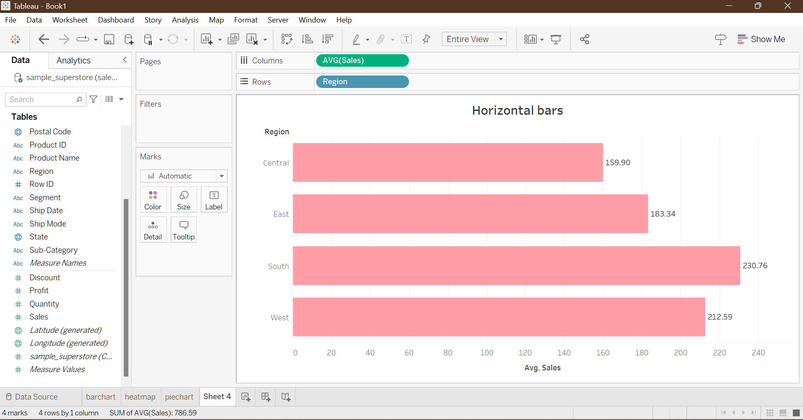

You can use superstore dataset