Databases Laboratory Work #2

Creating and Maintaining a Database

Prerequisites: Computer, SQL Server Management Studio

Objectives: Learning how to efficiently organize and maintain a database, by being acquainted with the size of different files, how to create the right maintenance plans for databases etc.

Tasks:
- Read Chapter 2 from the SQL Server Lab Book;
- Answer the questions at the end of the chapter;
- Implement the learned skills by executing the tasks at the end of the chapter.
1. Create a database that is physically located in the MyDocuments\Data folder, setting a file growth of 16 MB for the primary file, with the growth limit of 128 MB, and a growth of 64 MB with the maximal growth of 1024 MB for the log file. For secondary files, define a new default Filegroup, setting a growth of 64 MB with the limit of 1024 MB for these files.
2. Create a database, where the log file is physically located in the MyDocuments\Log folder. The name of the log file in the operating system environment must differ from the logically defined name in the physical scheme. The database must compatible with the MS SQL Server 2017 system and it should be accessible to only one user at a time.

3. Create a maintenance plan for the database created for the first task. The unused files space must be freed when it reaches 2000 Mb. This space must be returned to the operating system. The task should be executed every Friday, at 12 A.M. The maintenance plan’s execution report must be saved in the Documents\SQL_event_logs folder. Initialize the plan. After the execution, check the results in the log file.

4. Create a maintenance plan for the database built in the second step. Name the plan “Index Rebuilding”. In this plan, the system must perform the reconstruction of the indexes of the schemes in the main tables from this database (excluding views). The free space on the page must be 10%. The sorting of the indexes must be performed within the tempdb file. After the reconstruction, complete statistics about the reconstructed indexes must be collected. The third task of the maintenance plan is to clear the Backup-Restore history performed on the SQL Server older than 6 weeks. The plan must be executed on every first Sunday of the month. Create the MyDocmunents\SQL_reports file and store the execution report in it. The maintenance process should be carried out in the extended log mode. After execution, check the results in the generated file from the log folder.

Implementation

1. After creating DB1, I set the required growth parameters to it.

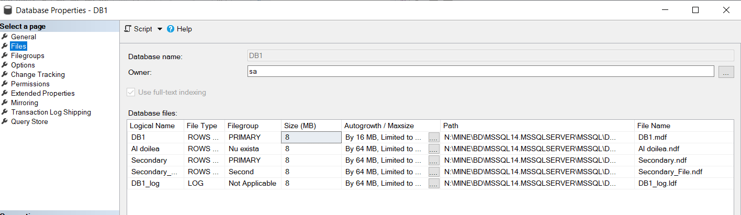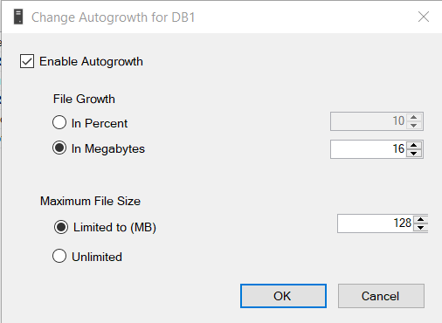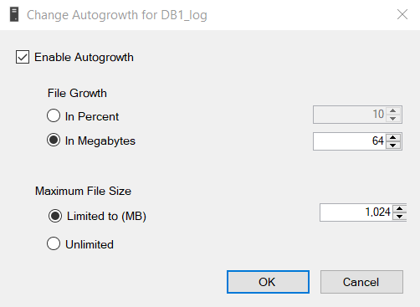

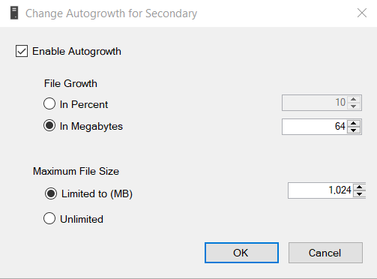

2. After creating the second database – DB2, I have also set the outlined properties for its growth plan.

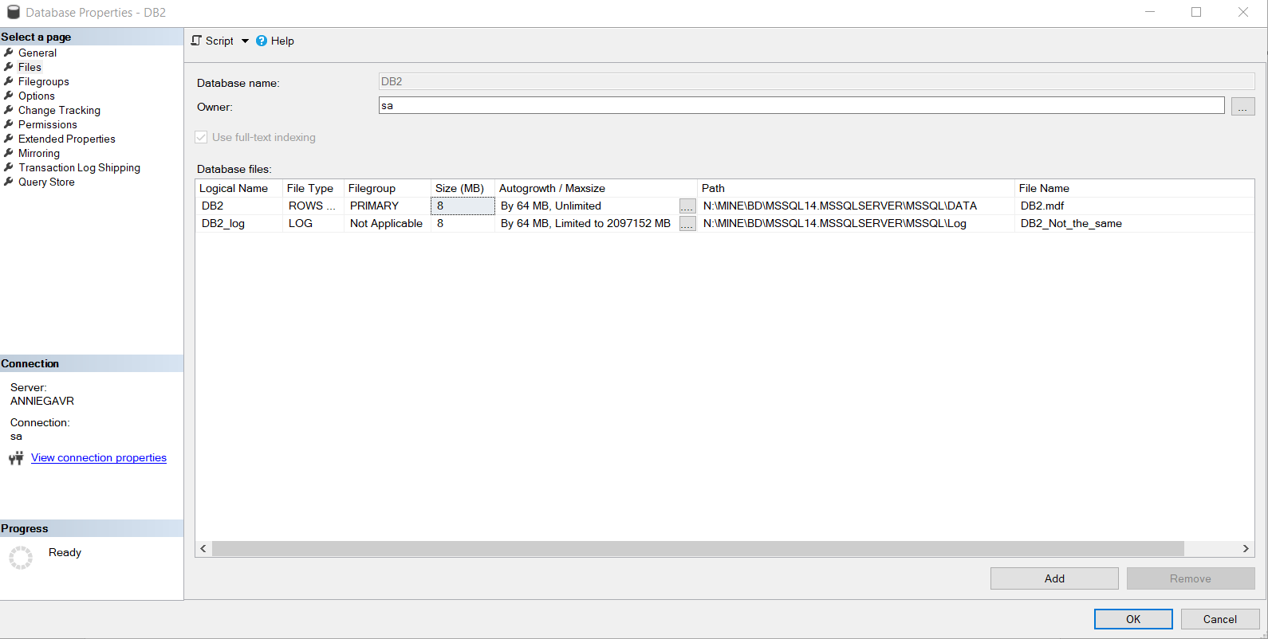

3. After this, I have followed the instructions in order to create the maintenance plan for the 1st database (DB1):

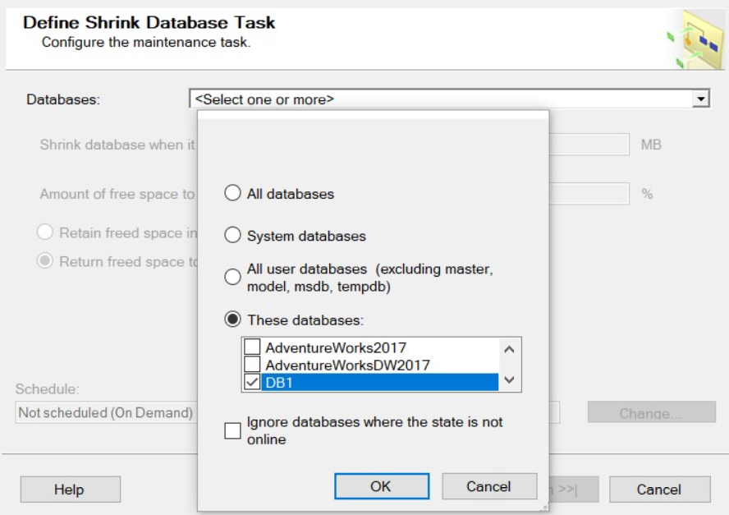
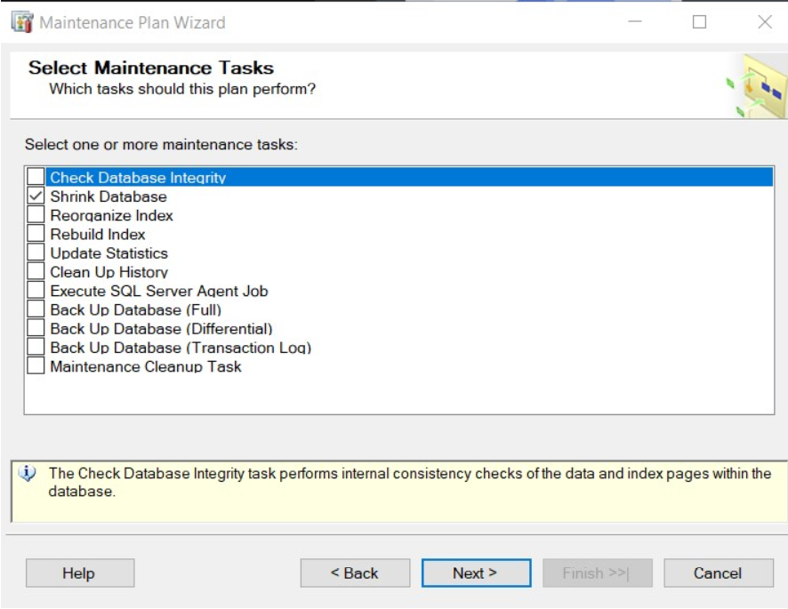
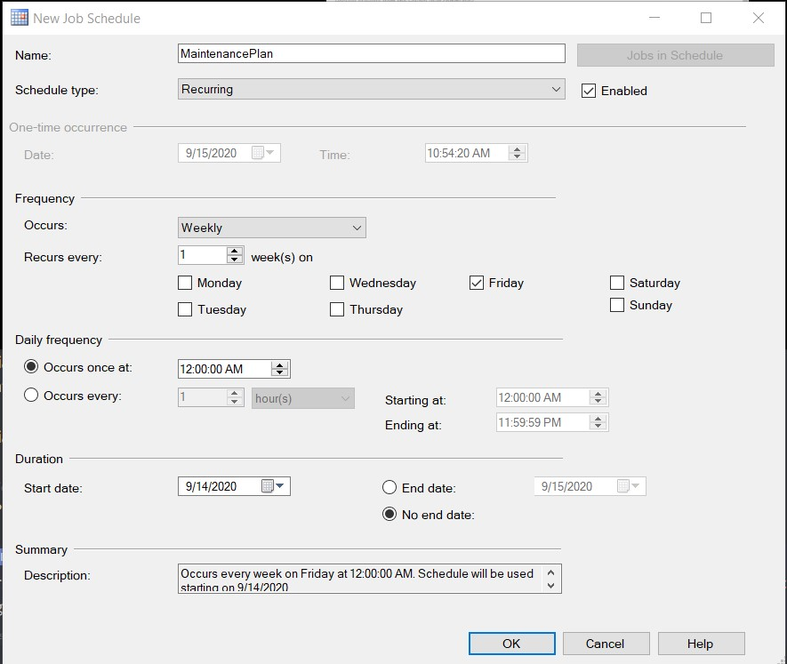
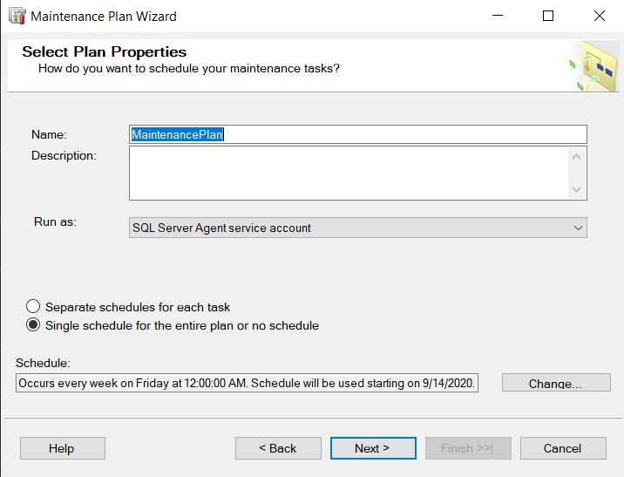

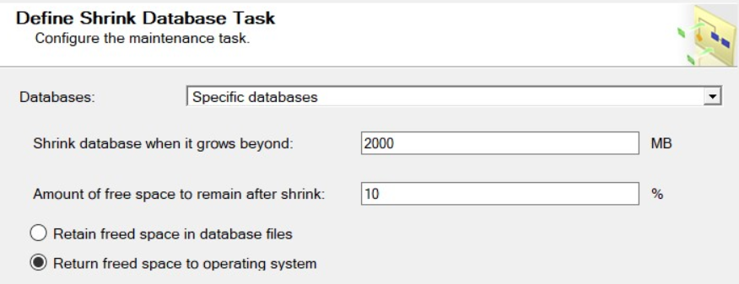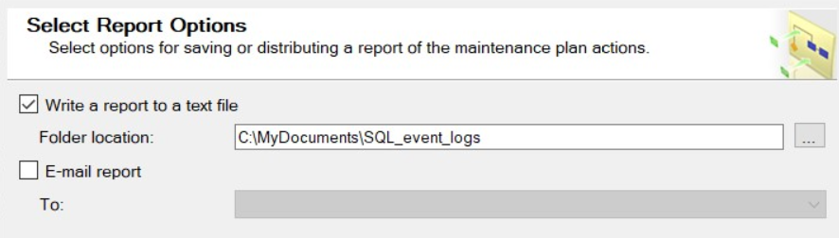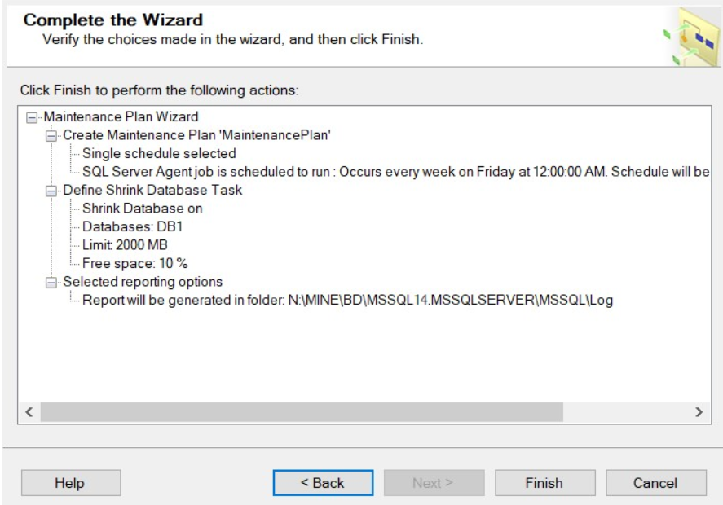

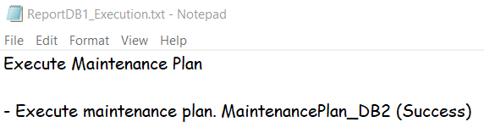

4. The last step was to follow the instruction outlined for the building of the maintenance plan for the 2nd database (DB2):

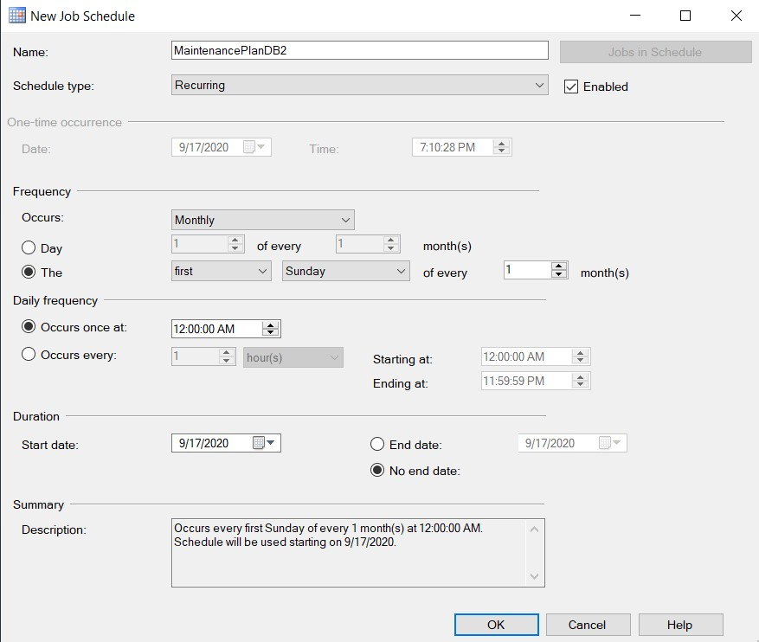

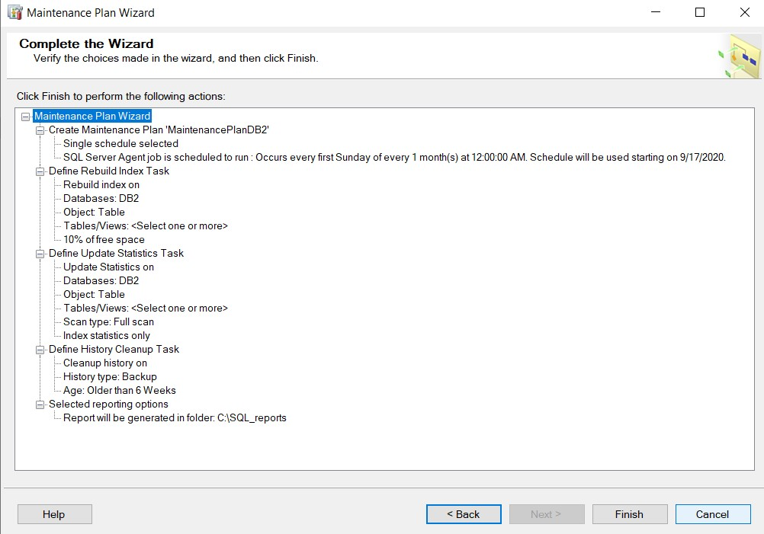

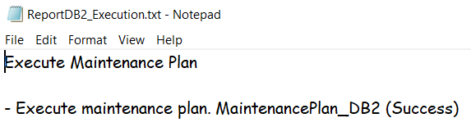

Conclusion

The fact that SQL Server can automatically manage our database files saves a lot of time for the users. The Maintenance Plan Wizard is another useful tool I have discovered. Some executions may need man’s supervising, but most of the process can be trusted to be automatically done by the SQL Server tools.

