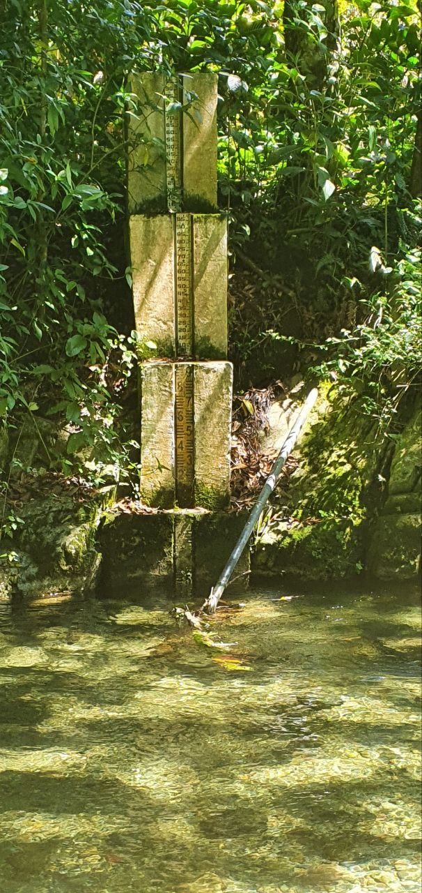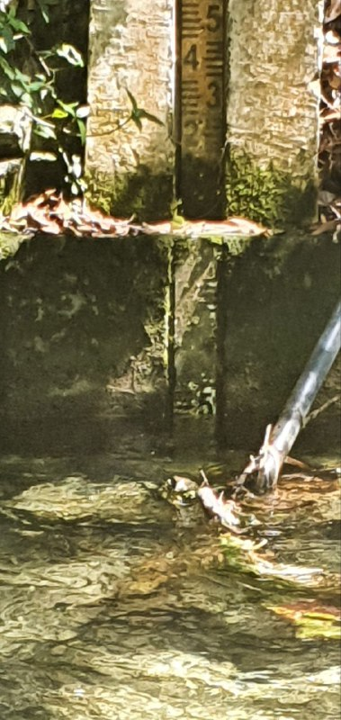

**Los Guanos**,

already existing gauge. Maintenance (Security) through office of Natural Park. Internet would be possible with extra work. Expected variation of Waterlevel multiple 10cm up to 1.5-2m.

**Ubication:** 19.066947082341944, -70.86372423755735

**Catchment describtion:** “healthy catchment”, nearly all the area is protected area and has high cobertura. As well regularly measured good water quality.

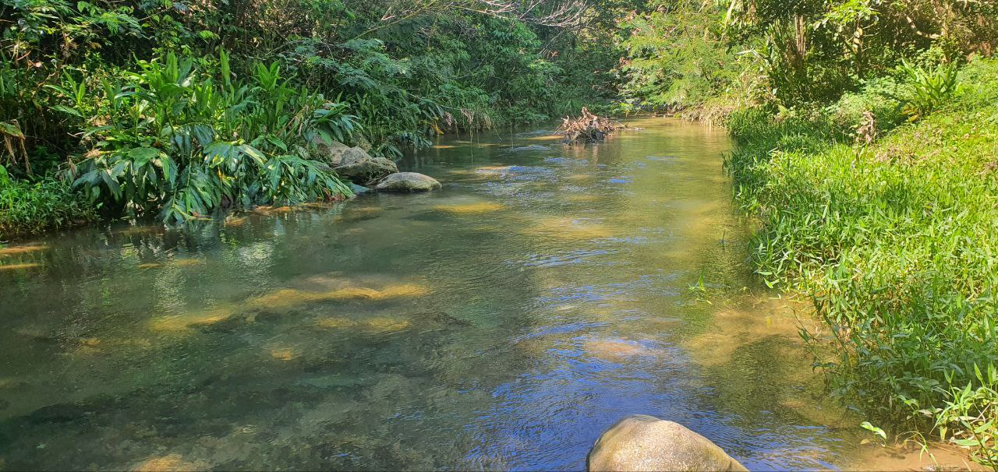

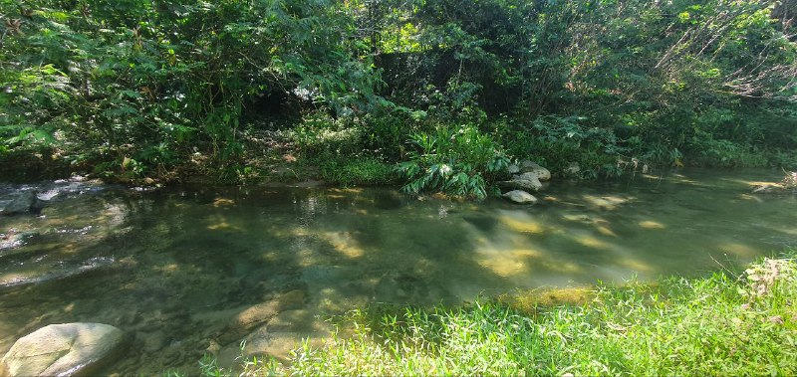

**Los Dajaos,**

Water Gauge so far not existent. Security could be obtained by nearby Family/House (Emanuel knows who, lives in Jarabacoa). No electricity, no Internet. Expected variation of Waterlevel: few cm up to 50-70cm. Stream flows in a little constricted riverbed. Relatively large floodplain area.

**Ubication:** 19.076998917916917, -70.7683222429482

**Catchment information:** “damaged catchment”, high percentage in Agriculture- already existing measures of PlanYaque.