**Differences, advantages, disadvantages between**

**Scrum and Kanban frameworks**

|  |  |
| --- | --- |
| **SCRUM** | **Kanban** |
| **Differences** | |
| Scrum is based on planning (Pre-planning, daily scrum, sprint, sprint review, retrospective review) | Kanban is open to making changes, things can change frequently. |
| Time of sprints (iterations) is definite value (usually 2-4 weeks) | Kanban focuses on planning a different duration for individual iteration. Kanban recommends graphs to get an overview of team’s progress over time. |
| Estimation has a very important role in Scrum | Kanban has no mandatory requirements for estimation. |
| Scrum is about the sprint goals and forecasts. | Kanban relies on time-boxing and forecasts. |
| Teams are required to commit a specific amount of work. | Commitment not necessary it is optional for teams. |
| Cross-functional team is required | Specialized team is required |
| It is not possible to add items to ongoing iterations. | New items can easily add if the additional capacity is available. |
| A sprint backlog is owned by only by a single team. | Multiple teams can share Kanban board. |
| Scrum software development method focuses on the backlog. | Kanban method entirely focuses on process dashboard. |
| Every team member has a specific role ([Scrum master](https://www.guru99.com/scrum-master-training.html), product owner, developers) | There are no pre-defined roles for a team. However, there may still be a Project Manager; the team is encouraged to collaborate and works together. |
| Measures production using velocity through sprints. | Measures production using iteration time or the exact time it takes to complete one full piece of a project. |
| It is an ideal method for projects with widely-varying priorities. | Best suitable for teams with stable priorities. |
| In Scrum, the entire team focuses on to collaborate and complete the task to provide quality development work. | Teams work to achieve goals and reduce the time to complete the entire process. Thus, reduction in the time cycle is biggest indicators of success here. |
| The total work is done in  Sprints. | The entire project is performed on the movement of single-threaded work item flows. |
| Scrum master acts as a problem solver. | Kanban encourages every team member is a leader and sharing responsibility amongst them all. |

**Advantages**

**SCRUM**

Scrum helps firms to save time and money. Project are coded and tested during the sprint review.

Achieve stable and consistent communication of performance at all levels.

It is easier to adapt to the constant changes because of the short sprints and regular feedback. It is easier to deliver a quality product at a scheduled time.

The total cost of the project is minimal which may lead to quicker and cheaper result.

The project plan will never disturb even if a team member leaves the team.

It is an ideal method for projects with widely-varying priorities

Large projects can easily divided into easily manageable sprints.

**KANBAN**

Kanban method focus on continuous improvement, productivity, and efficiency.

It is designed for a regular, steady output

Best suitable for teams with stable priorities.

Team members are more likely to accomplish their goals much easier because of visual nature of Kanban boards.

New items can easily add if the additional capacity is available.

**Disadvantages:**

**Scrum**

This methodology requires experienced team members only. So, If the team consists of people who are not an expert, the project cannot be completed in time.

Daily meetings sometimes frustrate team members.

It is not possible to add items to ongoing iterations.

**Kanban**

Major changes in customer demand can make Kanban fail.

If a task is not correctly estimated, the total project cost will never be accurate. In such cases, the task can be spread over several sprints.

No specific timeframes are allocated with each phase, so team members never get the idea how much time they can take in every phase.

If any of the team members exit during development, it can hurt the project development Outdated Kanban board can lead to issues in the development process.

Only works well with small teams so not suitable large size team

**User Story Mapping and Acceptance Criteria**

**On-line BOOK Store**

**1 release = 1sprint**

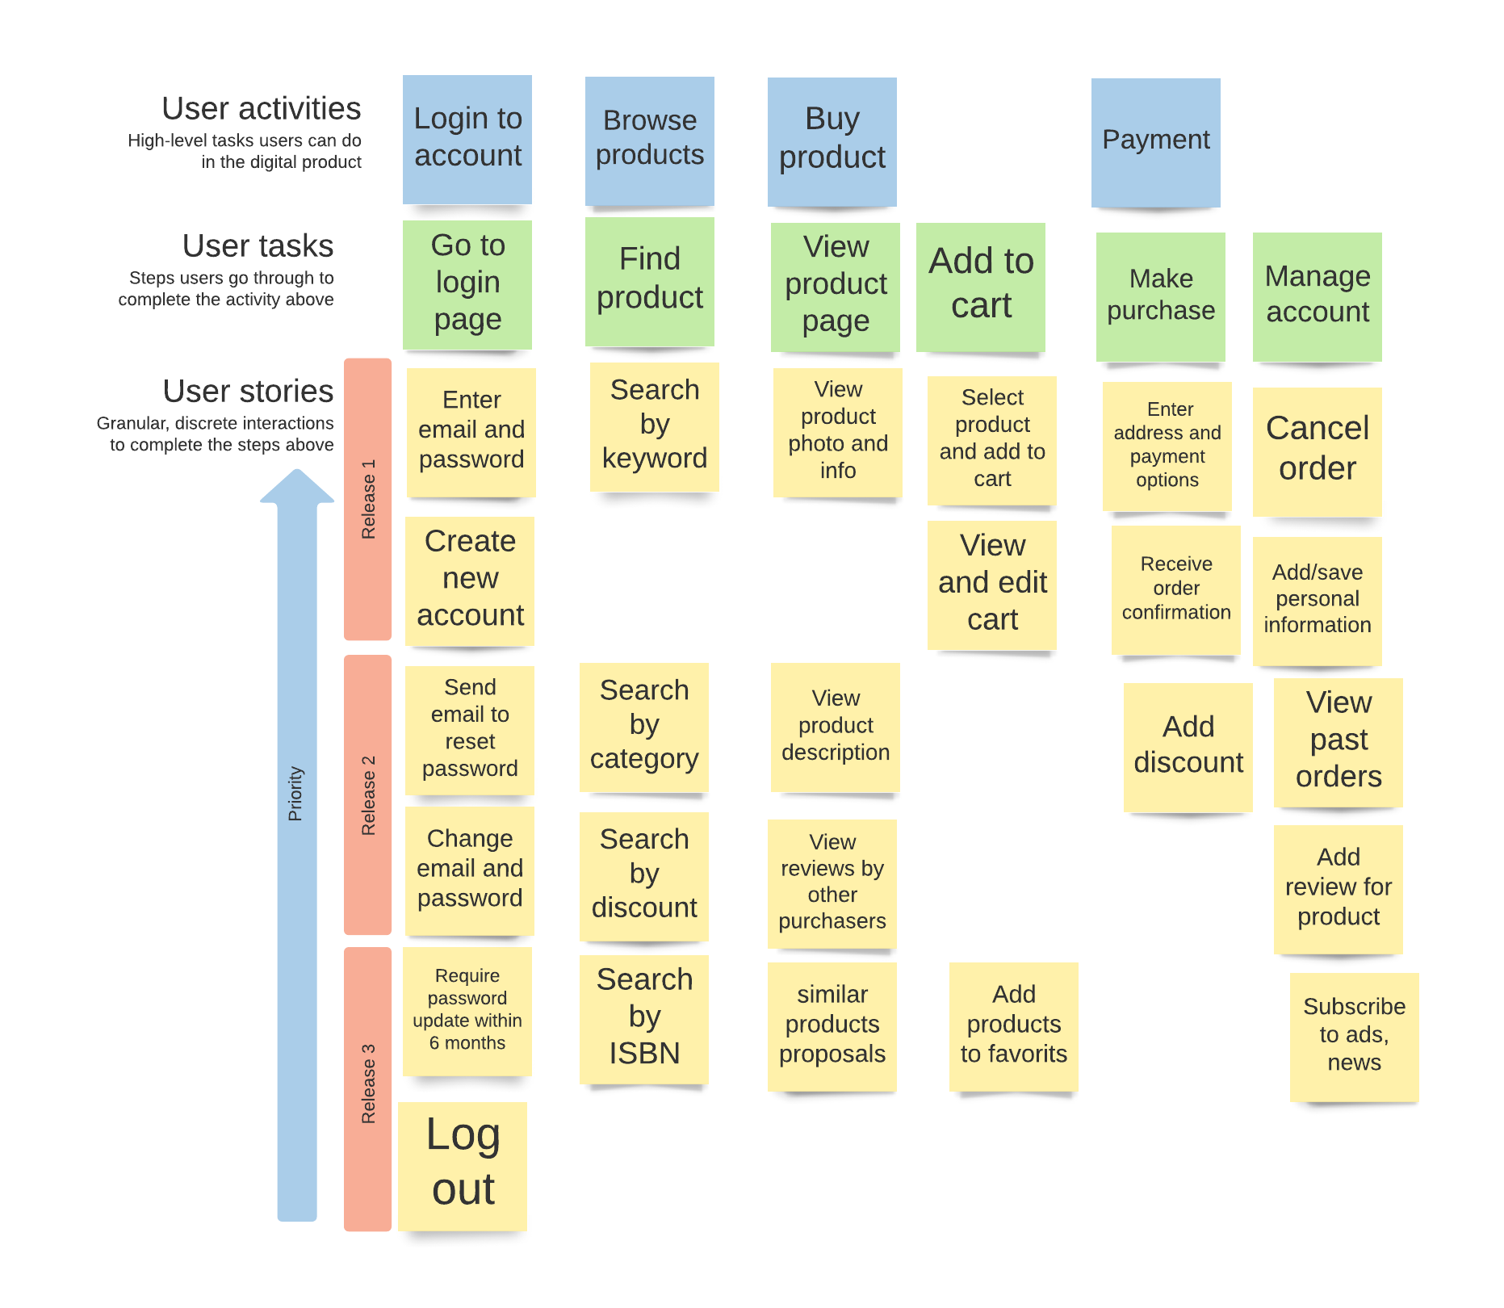

**User stories with value statement:**

|  |  |  |
| --- | --- | --- |
| # | Title | Value Statement |
| **RELEASE 1 = 1 sprint** | | |
| **1.1** | **Enter email and password for login** | As a user, I want to log in using my email and password so that I can start using the application and buy goods |
| **1.2** | **Create new account** | As a user, I want to create new account so that I can start using the application and buy goods |
| **1.3** | **Search item by keyword** | As a user, I want to find item by keywords so that I can to quickly find what I’m looking for |
| **1.4** | **View item photo and short info** | As a user, I want to view product photo and short information so that I can make decision about purchasing |
| **1.5** | **Select product and add to cart** | As a user, I want to select and add item to cart so that I can purchase chosen items |
| **1.6** | **View and edit cart** | As a user, I want to view and edit items in cart so that I can verify that items and quantity before purchasing |
| **1.7** | **Enter address and payment options** | As a user, I want to enter address and choose pay options so that I can complete my order and pay for selected items |
| **1.8** | **Receive order confirmation** | As a user, I receive the order confirmation so that I want to be sure that I will receive my order |
| **1.9** | **Cancel order** | As a user, I want to cancel my order in definite period so that I can refuse an order and return money |
| **1.10** | **Add/save personal information** | As a user, I manage my account so that it presents my current information |
|  |  | **RELEASE 2 =1 sprint** |
| **2.1** | **Send email to reset password** | As a user, I want to send email to reset my password so that it I can restore access to my account |
| **2.2** | **Change email and password** | As a user, I want to change email and password so that it I can to keep my account in security |
| **2.3** | **Search item by category** | As a user, I want to find item by category so that I should select items from given category |
| **2.4** | **Search by discount** | As a user, I want to find item by discount so that I can select items with suitable price |
| **2.5** | **View product description** | As a user, I want to view product description so that I can make decision about purchasing if I doubt |
| **2.6** | **View reviews by other purchases** | As a user, I want to view reviews by other purchases so that I can make decision about purchasing if I doubt |
| **2.7** | **Add discount** | As a user, I want to add discount to my order so that I can pay less for my purchasing |
| **2.8** | **View past orders** | As a user, I want to view past orders so that I can make order based on my experience |
| **2.9** | **Add review for product** | As a user, I add review so that I inform other purchaser and seller about my opinion |
| **RELIASE 3 =1 sprint** | | |
| **3.1** | **Require password update within 6 month** | As a user, I should change my account so that I keep my account in security |
| **3.2** | **Log out** | As a user, I want to log out of my account so that I keep my account in security |
| **3.3** | **Search by ISBN** | As a user, I want to find item by ISBN so that I can find item with strictly defined characteristics |
| **3.4.** | **Similar products proposals** | As a user, I want to see similar products proposals so that I have a greater range of products for decision |
| **3.5** | **Add products to favorites** | As a user, I want to add products to favorites in case when item is absent or I don’t want to buy now, so that I can save favorites items for future purchasing |
| **3.6.** | **Subscribe to ads, news** | As a user, I manage subscriptions, ads, news so that I receive information about my account and purchases |

**User stories with Acceptance Criteria**

|  |  |
| --- | --- |
| Title: | * 1. **Enter email and password for login** |
| Value Statement: | As a user, I want to log in using my email and password so that I can start using the application and buy goods |
| Acceptance Criteria: | **Acceptance Criteria:**  Given that the user navigates to the login page When the user enters a valid email and password Then the user successfully login to application |
| Definition of Done: | Unit tests passed  Acceptance criteria met  Cod reviewed  Function Tests passed  Non-functional requirements met  Product Owner accepts User Story |
| Owner: | Owner |
| Iteration: | 1 iteration |
| Estimate: | 3 point |

|  |  |
| --- | --- |
| Title: | * 1. **Create new account** |
| Value Statement: | As a user, I want to create new account so that I can start using the application and buy goods |
| Acceptance Criteria: | **a) Acceptance Criteria 1:** User gets the link Given that he user navigates to the login page When the user selects “Create new account” AND enters email and personal information Then the system sends link to entered email  b) **Acceptance Criteria 2:** User can access the link Given that the user receives link via email When the user navigates thought the link in email Then New account is created |
| Definition of Done: | Unit tests passed  Acceptance criteria met  Cod reviewed  Function Tests passed  Non-functional requirements met  Product Owner accepts User Story |
| Owner: | Owner |
| Iteration: | 1 iteration |
| Estimate: | 5 point |

|  |  |
| --- | --- |
| Title: | * 1. **Search item by keyword** |
| Value Statement: | As a user, I want to find item by keywords so that I can quickly find what I’m looking for |
| Acceptance Criteria: | **Acceptance Criteria:**  Given that the user goes to search by keyword  When the user enters keyword of item description  Then the application displays all items with keyword in description |
| Definition of Done: | Unit tests passed  Acceptance criteria met  Cod reviewed  Function Tests passed  Non-functional requirements met  Product Owner accepts User Story |
| Owner: | Owner |
| Iteration: | 1 iteration |
| Estimate: | 5 point |

|  |  |
| --- | --- |
| Title: | * 1. **View item photo and short info** |
| Value Statement: | As a user, I want to view product photo and short information so that I can make decision about purchasing |
| Acceptance Criteria: | **Acceptance Criteria 1:**  Given that the user selects item  When the user clicks on item  Then the item photo and short information are displayed |
| Definition of Done: | Unit tests passed  Acceptance criteria met  Cod reviewed  Function Tests passed  Non-functional requirements met  Product Owner accepts User Story |
| Owner: | Owner |
| Iteration: | 1 iteration |
| Estimate: | 3 point |

|  |  |
| --- | --- |
| Title: | **2.3. Search item by category** |
| Value Statement: | As a user, I want to find item by category so that I should select items from given category |
| Acceptance Criteria: | **Acceptance Criteria:**  Given that the user goes to category section  When the user select category of items  Then the application displays all items from selected category |
| Definition of Done: | Unit tests passed  Acceptance criteria met  Cod reviewed  Function Tests passed  Non-functional requirements met  Product Owner accepts User Story |
| Owner: | Owner |
| Iteration: | 2 iteration |
| Estimate: | 3 point |

|  |  |
| --- | --- |
| Title: | **2.5. View product description** |
| Value Statement: | As a user, I want to view product description so that I can make decision about purchasing if I doubt |
| Acceptance Criteria: | **Acceptance Criteria:**  Given that the user views product page  When the user clicks on description  Then the description is displayed |
| Definition of Done: | Unit tests passed  Acceptance criteria met  Cod reviewed  Function Tests passed  Non-functional requirements met  Product Owner accepts User Story |
| Owner: | Owner |
| Iteration: | 2 iteration |
| Estimate: | 1 point |

|  |  |
| --- | --- |
| Title: | **2.6. View reviews by other purchases** |
| Value Statement: | As a user, I want to view reviews by other purchases so that I can make decision about purchasing if I doubt |
| Acceptance Criteria: | **Acceptance Criteria:**  Given that the user view product page  When the user clicks on reviews  Then the reviews are displayed |
| Definition of Done: |  |
| Owner: | Owner |
| Iteration: | 2 iteration |
| Estimate: | 1 point |