

**GenC Internship Skilling**

**Program Guidelines 2025**

**India**

**Table of Contents**

1 Introduction 4

2 Scope of the document 4

3 Purpose 4

4 GenC Program Overview 4

5 Acronyms and Definitions 6

Acronyms 6

6 Guidelines 6

7 Skilling completion criteria for GenC Interns 7

7.1 Technical Competencies 7

7.1.1 Stage 1 7

7.1.2 Stage 2 and beyond (Advanced skilling stages) 7

7.1.2.1 RAG Definition 8

7.1.2.2 Skilling completion criteria from Stage 2 and attempt eligibility 9

7.1.2.3 Gating criteria Beyond Stage 2 9

7.1.3 Exceptions to evaluation components 9

7.1.3.1 EPS B.COM hiring selects 9

7.1.4 Note 10

8 Behavioral Competencies 10

8.1 Expectation post FTE onboarding 10

9 Attendance health Status 11

10 Internship Stipend 11

11 GenC Internship skilling program guidelines 11

11.1 Code of Ethics - Guiding Principles 13

11.1.1 Employee Relations matters 13

12 Attendance Health score Guidelines 13

12.1 AHS RAG 13

12.2 AHS Consequence 14

12.2.1 Internship leave policy 14

12.3 Integrity in Assessments 14

12.3.1 What constitutes Malpractice 14

12.4 Deployment guidelines 15

12.5 Communication protocols 15

12.5.1 GenC Program communication Escalation Matrix 15

12.5.2 Mail format 16

13 GenC Grievance cell 17

13.1 How does the grievance cell work? 17

13.2 Grievance Categories 17

14 Feedback communication to the GenC 17

15 Outliers/Exceptions 18

16 Appendix 19

16.1 Definitions 19

16.2 Gen Catalyst Professional Development program 20

# Introduction

The Generation Cognizant Program (GenC Program) caters to the Entry Level Training within Cognizant in India. stretches across the entire timeline of a campus hire's learning journey from the time he/she accepts the offer letter from the company - to the first year of his/her tenure in the organization. There is a robust learning strategy put in place across each of the stages:

* Pre-Onboarding (Early Engagement, Campus engagement, Internship, Certified skill development)
* GenC FTE training
* Year One Enablement
* Continuous Role Development

# Scope of the document

This document covers the **guidelines for GenC Internship** in Cognizant at India for On –Campus and Off-campus selects going through Cognizant GenC skilling program enablement via Classroom/Virtual / Hybrid *(Classroom & Virtual)* mode in the year 2025. These guidelines are applicable to all types of skilling programs (Skilling/Re-skilling pre & post onboarding to the skilling program)

The duration and exit criteria of the **GenC Internship** will be determined by the curriculum track to which the GenC is mapped as per the business demand. *(Refer Stage 2 for details)*

# Purpose

The purpose of this document is to define the approach towards Cognizant GenC Internship 2025 skilling completion from the HR GenC Program standpoint.

The GenC curriculum is designed to with the focus to enable GenC Intern candidates to incorporate the skills acquired, by developing real time projects/use cases as well as considerably improve their professional skills as they progress through the program.

# GenC Program Overview

The GenC (Generation Cognizant) Program assures skill capability in our fresh hires (GenCs) towards business readiness at Cognizant. This program spans the entire duration of GenCs learning journey from the time GenCs accept Cognizant offer, through the first-year completion as an FTE in the organization. There is a robust learning strategy put in place across four phases.

In the Cognizant GenC skilling program, the Intern candidates are provided with a learning path and their performance is assessed as per the milestones in the curriculum including meeting the gating criteria for the curriculum assigned, completion of learning/assessment's/Hands-on assignments as per the given schedule including adherence to the skilling program guidelines.

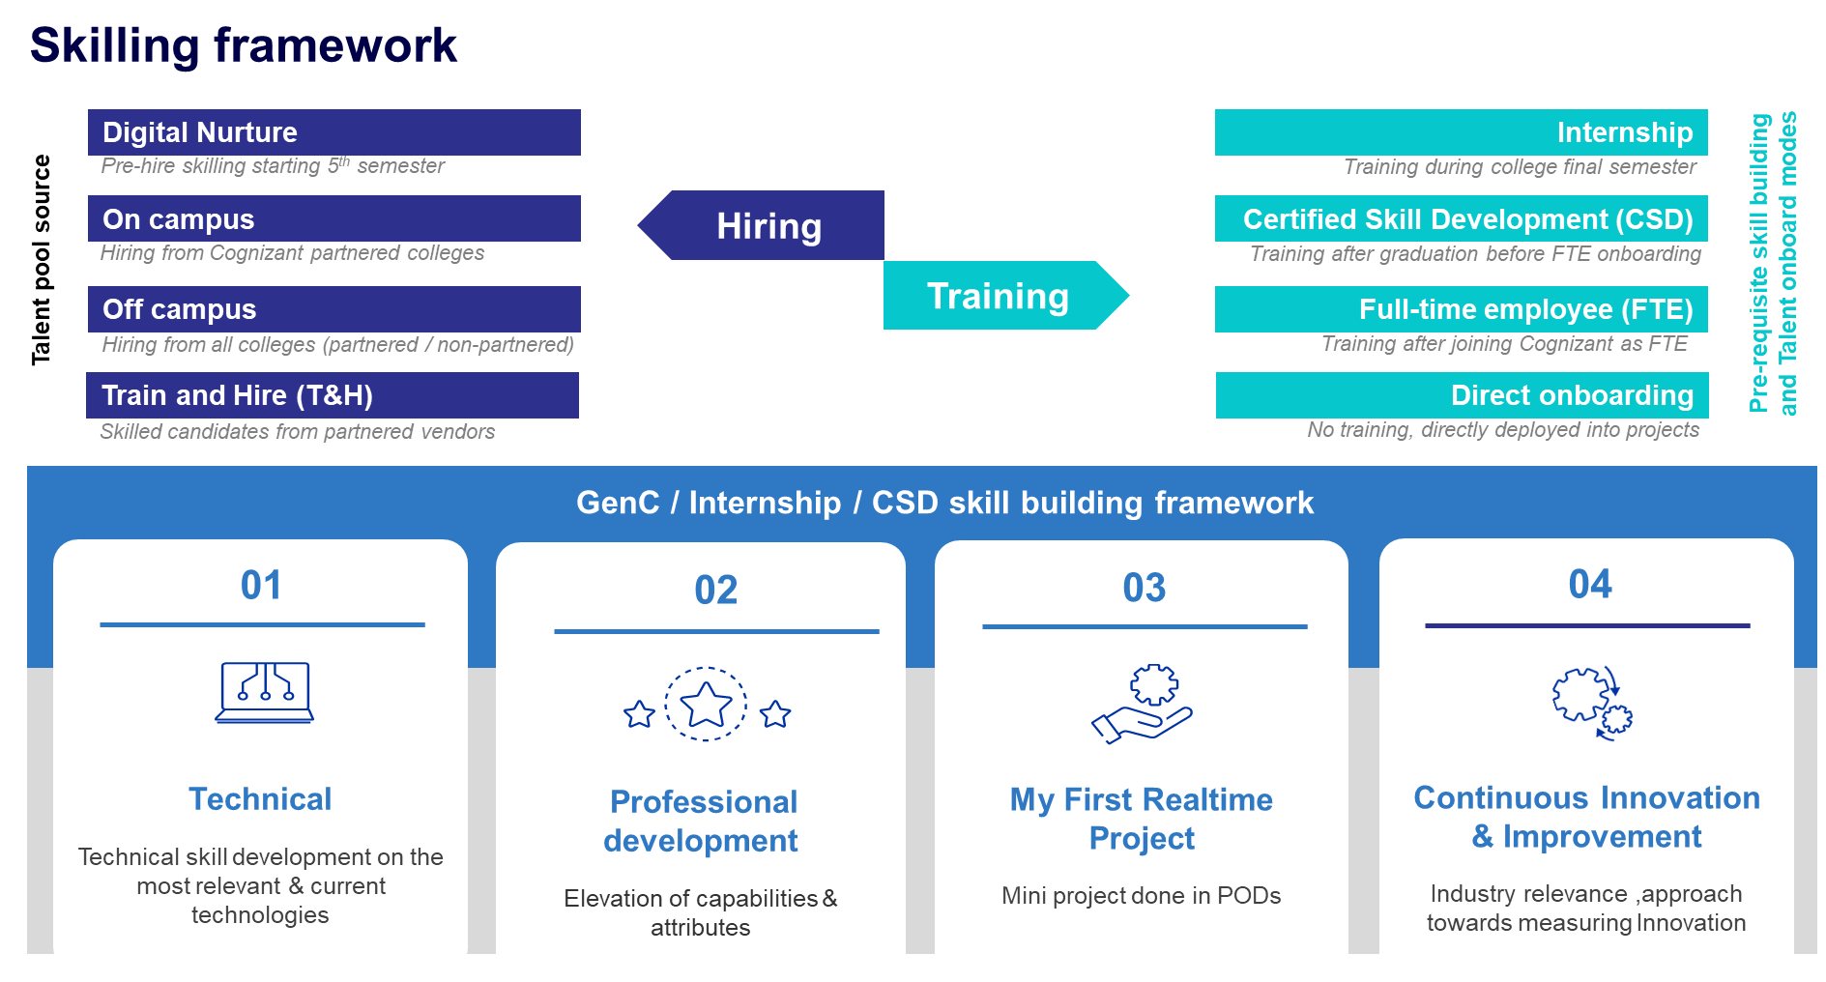

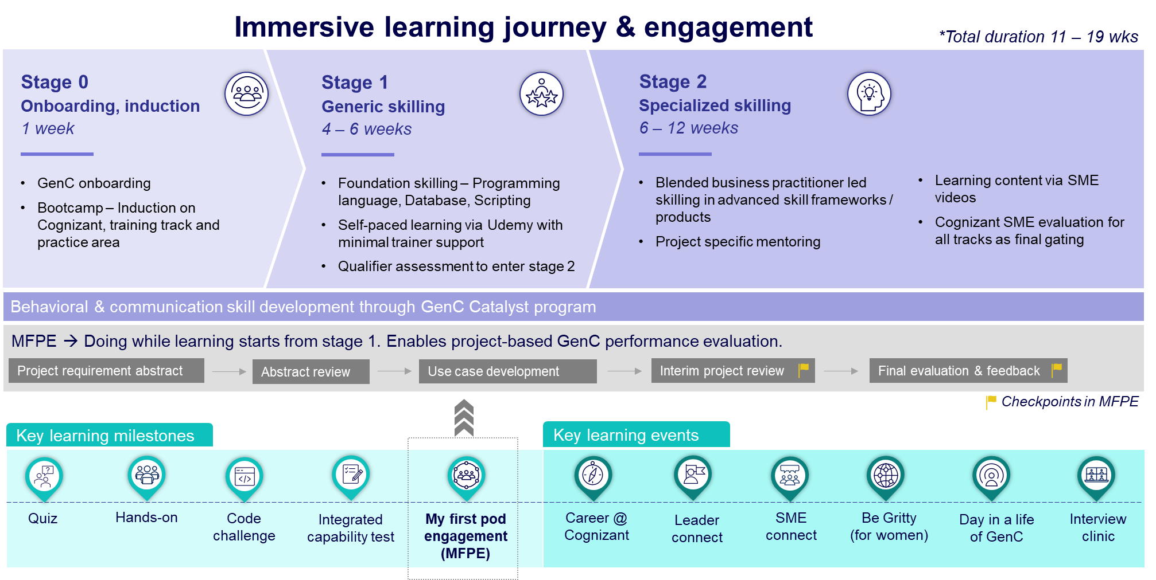

# Acronyms and Definitions

Few of the acronyms and / or its definitions provided here may not have been used in this document but has been provided for easy reference to their definitions.

## Acronyms

|  |  |
| --- | --- |
| Acronym | Description |
| GenC | Generation Cognizant |
| SL | Service Line |
| BU | Business Unit |
| FTE | Full Time Employee |
| PHS | Performance Health Status |
| AHS | Attendance Health Status |
| RAG | Red, Amber, Green |
| LOI | Letter of Intent |
| CEFR | Common European Framework |
|  |  |

# Guidelines

The overall performance of the GenC will be assessed across the evaluation/assessment modules and the eligibility criteria for successful completion of skilling program will include the GenC’s technical competency, behavioral competencies and adherence to policy aligned GenC Internship skilling program guidelines.

# Skilling completion criteria for GenC Interns

# Technical Competencies

Every GenC is mapped to a technical track based on the business demand and provided systematic training to develop their technical skills. Each technical track has a defined curriculum which is oriented to the GenCs at the beginning of the technical skilling phase. Towards successful completion of the skilling program, the GenC's are expected to demonstrate their comprehension and ability to implement the technical concepts as per the defined curriculum.

The details on the skilling completion criteria relating to technical skilling across fundamental & advanced levels are as explained below:

The **technical performance skilling and evaluation** will happen at two levels:

1. Stage 1 [Fundamentals]
2. Stage 2 and beyond as applicable [Advanced skilling stages]

### Stage 1

Stage 1 in the training curriculum of each track will be the qualifier stage to progress to the advanced skilling stages.

* The GenC Interns are expected to obtain >=70% score in the stage 1 assessment.
* 100% completion of hands-on exercises assigned in stage 1 curriculum is mandatory to be eligible for stage 1 assessment.
  + - * Catch-up instance will be provided to complete hands-on and attempt stage1 assessment.

|  |  |
| --- | --- |
| **Stage 1 passing criteria** | **GenC Type** |
| **Interns** |
| **>= 70% in stage 1 assessment** | Proceed with stage 2 learning |
| **< 70% in stage 1 assessment** | Proceed with stage 2 in parallel to stage 1 reattempt.  Pass stage1 assessment 2 before completion of Stage 2 final evaluation. |

Successful completion of Stage 1 is mandatory. depending on the SL track, trainees may be detained from taking the final evaluation if they fail Stage 1, which could result in not meeting the internship completion criteria.

### Stage 2 and beyond (Advanced skilling stages)

From Stage 2, the candidates' technical proficiency and their ability to implement the skills will be evaluated to determine their Performance Health Status (PHS) based on a one-to-one evaluation by a Subject Matter Expert (SME). The SME evaluation will be a single event covering both technical and project implementation aspects conducted at two checkpoints during the skilling phase: (i) Interim Evaluation (ii) Final evaluation.

1. The interim evaluation is conducted at a logical midpoint during the advanced skilling stages. A candidate's learning progress is assessed during the interim evaluation, and an interim PHS is provided along with feedback to assist them in achieving their final evaluation goals.
2. The final evaluation is conducted at the end of the technical skilling phase and the candidate is assessed on the entire set of skills he has learned in the curriculum. Final evaluation results are presented in Red/Amber/Green as Performance Health Status (PHS).

At the end of technical skilling phase, the GenC Intern candidates are expected to have a performance health status of 'Green' to be eligible for successful completion of the GenC skilling program.

If the PHS is Red/Amber after the final evaluation, candidate will be de-enrolled from the GenC skilling program and LOI will be revoked. The candidate will not be eligible for a FTE offer.

#### RAG Definition

|  |  |
| --- | --- |
| **Red** | Candidate is not able to answer the basic questions asked on particular skill. Candidate has implemented a few project requirements and unable to answer questions on the project clearly.  Candidate is not able to respond in complete sentences to the questions asked, struggles to find the words and unable to comprehend questions, poor attitude towards learning, |
| **Amber** | Candidate is able to answer basic questions and some of scenario-based questions without detailed explanation. Candidate has implemented few of project requirements and able to present, explain and answer basic questions on project. Candidate is able to respond in complete sentences to questions, using too many fillers, having good attitude and finds difficult to comprehend the questions. |
| **Green** | Candidate has good understanding on skill and able to answer most of the basic and scenario-based questions. Candidate has implemented most of the project requirements, able to present the requirement well and answer the questions related to project. Candidate speaks clearly with right attitude, maintains eye contacts, and speaks confidently and able to articulate his/her thoughts. |

#### Skilling completion criteria from Stage 2 and attempt eligibility



Evaluation components may be excluded, modified, or excluded based on SL discretion and GenC program head approval. *Refer section 7.1.3*

#### Gating criteria Beyond Stage 2

|  |  |  |  |
| --- | --- | --- | --- |
| GenC/Intern Training | Overall Evaluation Components | Pass Criteria | Evaluation Done by |
| **Performance Health Status - PHS**  *(Only from Stage 2)* | Interim Evaluation  (Project + Technical)  *(Refer curriculum details for SL specific evaluation components)* | Passing criteria & the eligible number of attempts are as given in 7.1.2.2 | BU SME |
| Final Evaluation  (Project + Technical)  *(Refer curriculum details for SL specific evaluation components)* |

### Exceptions to evaluation components

#### EPS B.COM hiring selects

B.Com selects for EPS track undergoing skilling will be evaluated only on the interim & Final evaluation.

forego qualifier and exit at Stage-1 level as all selects were hired by respective SL’s competency nominated panels.

However, as a process we follow for all hires that undergo skilling for specific deployment roles, there will be an evaluation process comprising interim and final. If the candidates do not clear the evaluation process as part of skilling, consequence should be applied as they will not be fit for the roles based on skilling performance outcomes.

### Note

* Evaluation would be scheduled through GenC Learn platform and evaluator will update RAG status and feedback in the platform.
* Evaluations to happen at an individual level in person and on video and mandatorily recorded. (*Even if the GenC Intern & the evaluator are in the same location)*
* 100% Completion of Hands on in Stage 2 is mandatory for interim / final evaluation eligibility.
* Eligible for “Successful completion” indicates that the GenC Intern candidate has met the performance threshold set at the checkpoint.
* **Re-attempt on** Final evaluation would be provided will be applicable for as per above rubrics.
  + *Trainee is not eligible for final evaluation re-attempt, if both Interim/Final evaluation (attempt 1) status is Red.*
* **Remedial Phase:** Additional **1 week** post the Tentative/Planned Graduation date is the permissible time, provided to any GenC to successfully complete all the pending components (backlog including project / technical evaluations). Consequence management activities start based on the Performance status at the end of this remedial phase leading to revocation of Internship offer
  + **If GenC Intern candidate underperforms at end of remedial phase**, he/she could be tagged to Alternate service line (with a lower profile role and compensation, as applicable) purely based on demand/availability in that service line.
  + **If GenC Intern candidate fails to get tagged to Alternate service line** within a timeline of 2 weeks post the end of remedial phase, GenC **Intern candidate** consequence towards failure in the assessment will be initiated as per organization policy
* There could be exception to deployment clause based on the demand & training outcomes, at the discretion of the ISL and GenC Program head approval.

# Behavioral Competencies

The behavioral assessment outcome for GenC Intern candidates are expected to be **>=B2 CEFR rating\*** level in language assessment to be eligible **for onboarding.**

GenC Intern candidates scoring < B2 CEFR in language assessment could be allowed to successfully complete the skilling program.

However, the candidates are encouraged to undertake self-enabled Professional development courses and demonstrate level progression to ensure prioritized onboarding.

*Progressive level movement refers to advancement shown by the associate in their CEFR scores from the time of GenC selection as explained below:*

|  |  |  |
| --- | --- | --- |
| **During selection** | **Preferred level movement for onboarding** | **Progressive level advancement demonstrated?** |
| A1 | > = A2 | Yes |
| A1 | A1 | No |
| A2 | > = B1 | Yes |
| A2 | < = A2 | No |
| B1 | > = B2 | Yes |
| B1 | < =B1 | No |

### Expectation post FTE onboarding

1. GenC Intern candidate with CEFR score below B2 in the language assessment are required to achieve B2 rating within one year of becoming a full-time employee (FTE) or show level progression.
2. They will partake in a self-directed Professional development training program lasting between six to nine months, after which they will be reassessed.
3. The assessment results will be a critical factor in the probation confirmation process.
4. CEFR level progression will be used to gauge the associate's language proficiency improvement.
5. Approval of the probation confirmation by the associate’s supervisor is contingent upon a satisfactory review of the language assessment outcomes.

# Attendance health Status

**Attendance Health Status (AHS)** of the GenC intern candidate must be in **Green** every month to be eligible for successful completion of Internship skilling program.

*Refer section* *8.2* *for AHS guidelines*

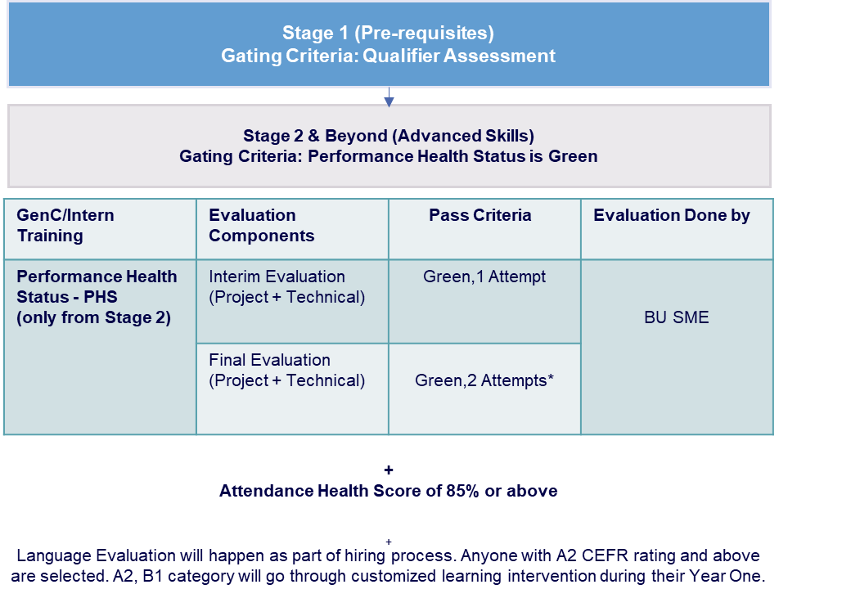

# Internship Stipend (not applicable for full time employees – ftes)

All the GenC Interns will receive a monthly stipend of INR.15,000 based on their attendance. The final month's stipend will be paid upon successful completion of the curriculum. Intern attendance and performance plays a crucial role in determining the stipend amount, highlighting the importance of active participation and engagement in the internship activities.

# GenC Internship skilling program guidelines

All GenCs Interns are expected to adhere to and uphold the Cognizant Code of Ethics (“Code”) to help ensure that everything they do at Cognizant is in accordance with our standards of integrity.

The guidelines are to support the GenC Intern candidates stay focused and on-track w.r.t successful completion of the training program.

* **Non-adherence of the below guidelines for more than 2 times** to any of the below will be considered as a breach leading to de-enrollment from Internship program and revocation of LOI
  + - Code of Ethics
    - Adherence to Attendance*
    - Integrity in assessments**
    - Dress code
    - Adherence to communication Protocols

**Note:**

* In case of a breach in any of the above stated, the GenC Intern candidate will be issued a warning by the respective coach.
* It is recommended that the associate responds to the warning mailer with an explanation.
* If any GenC Intern candidate is given more than 2 warnings, it will lead to immediate

de-enrollment from the GenC Internship skilling program and revocation of LOI.

* The GenC can also write to the ‘Grievance cell’: [GrievanceCoreTeam@cognizant.com](mailto:GrievanceCoreTeam@cognizant.com) regarding the breach as applicable. *Refer section 9 for details.*
* For details on Adherence to Attendance* - *Refer Section 8.2*
* For details on Integrity in assessments** - *Refer section 8.3*
* Non- Adherence to attendance * & Absence of Integrity in assessments** stringent disciplinary action as per organization policies resulting in de-enrollment from Internship program and revocation of LOI.Below are the details and links of the policies and guidelines which will govern the GenC Internship skilling program.

|  |  |  |
| --- | --- | --- |
| **Policy/Guidelines** | **Description** | **Link** |
| Code of ethics | The behavior and professionalism of each Associate are critical to creating a safe and harmonious work environment where everyone can thrive and be stewards of Cognizant’s reputation, impact, and success. | https://be.cognizant.com/documents/preview/406771/Core-Values-Code-of-Ethics  *Also refer section 8.1* |
| Integrity in assessments | Any learning and assessment are expected to be given by the GenCs in a very honest way. Plagiarism / copying / any malpractice has a zero tolerance | *Refer section 8.3* |
| Dress code | Our Dress code policy expects our employees to use their best judgment in deciding how they dress at work. | *Link to Orientation deck* |
| Communication protocols | All Cognizant associates are expected to comply with the organization’s Communications & social media Policy | [Cognizant 'Communications & Social Media' Policy](https://be.cognizant.com/documents/preview/552934/External-Communications-and-Social-Media-Policy) |
| **Acceptable use policy** | <https://be.cognizant.com/documents/preview/520827/Acceptable-Use-Policy> | |
| **Social media security guidance** | <https://be.cognizant.com/documents/preview/693393/Social-Media-Security-Guidance> | |
| **Social media security quick tips** | <https://be.cognizant.com/documents/preview/693392/Social-Media-Security-Quick-Tips> | |
| **Prevention of Sexual Harassment Policy - India** | [India Benefits - Policies (cognizant.com)](https://be.cognizant.com/sites/global-human-resources/india-benefits/SitePage/809934/india-policies-homepage)  - [Document Preview - Prevention of Sexual Harassment Policy - India (cognizant.com)](https://be.cognizant.com/documents/sppreview/95e90182-a4ef-4317-b2fa-089212fafe87)  In case of any SH related issues, kindly reach out directly to your location Prevention of Sexual Harassment Committee. Refer to the above policy link for email id of the location wise committee. | |

# Code of Ethics - Guiding Principles

Misconduct can be broadly defined as a behavior or a failure to act in line with the company’s values, standards, policies, procedures, or other documents regulating the employment relationship.

The list below provides examples of misconduct; however, this is only illustrative and not deemed to be an exhaustive list.

### Employee Relations matters

* Refusing to follow reasonable work instructions from a supervisor
* Habitual absenteeism and late reporting to work,
* unscheduled or unapproved leave impacting individual performance or teamwork.
* Negative language in the Work Environment
* Behaviors impacting productivity
* Inter-personal conflict
* Borrowing and lending money within peers
* Inappropriate leadership behavior

# Attendance Health score Guidelines

* All GenC Intern candidates are expected to be available for the training at a physical location for all the 5 days in a week.
* Attendance at the physical location must be at least 85% every month to continue in the GenC internship skilling program and successfully complete the program
* The Trutime hours logged should comply to Cognizant Working Hours guidelines
* 100% attendance is mandatory in all Instructor led sessions (ILT)
* The total number of hours for mandatory video-based sessions (both technical & behavioural sessions) will be considered for AHS calculation.
  + Intern candidate must be on video to have attendance for all VILT (Virtual Instructor Led Training) sessions.
    - Any breach of this evidenced in email with a concern raised by instructor/Coach/HR GenC will call for attendance not marked for the session and invite a warning resulting in consequence.

### AHS RAG

* The GenC Intern candidate attendance will be reported as AHS RAG
* GenC Intern candidate Intern candidate attendance reports will be generated every fortnight and the cumulative weekly AHS RAG status for **each month** must be in “Green”
* The AHS RAG status will be calculated and reported based on:
  + 1. Trutime hours
    2. Attendance in mandatory ILT/VILT sessions *(manual report of both technical & behavioural sessions)*

85% attendance in both the above parameters is mandated. AHS calculation matrix will be as below:

|  |  |  |
| --- | --- | --- |
| **Actual Trutime** | **Actual session hours reported** | **RAG** |
| >=85% | >=85% | Green |
| >=80% & <85% | >=85% | Amber |
| >=85% | >=80 & <85% | Amber |
| <85% | <85% | Red |

### AHS Consequence

|  |  |
| --- | --- |
| **Monthly AHS RAG** | **Consequence** |
| **Interns** |
| **Green** | Continue with the skilling program |
| **Amber** | De-enrolment from the skilling program. revoked LOI |
| **Red** |

### Internship leave policy

* Leaves are not permitted during GenC Internship skilling program.
* Attendance to be followed as per the AHS guidelines
* It is mandatory to be in-person or on video for VILT sessions (concern raised by facilitator will be a breach)
* Uninformed leaves of more than 3 days will lead to consequence
* Examination breaks not to exceed 5 working days (validated with college confirmed exam dates)
* 3 to 4 months in office is mandatory. If the trainees do not have 85% attendance in a month (both physical & virtual), it would lead to program de-enrolment in the 1st week of the subsequent month.
* Leave approvals to be taken in advance through their GenC HR coach – Validated medical leaves from Cognizant medical team only will be permitted
* Notify the GenC HR coach immediately for any Sick/Emergency leave – medical reports to be validated through Cognizant medical team
* All other leaves in any other reasons/categories would have an impact in the AHS attendance. Any uninformed leave(s) would lead to consequence as per AHS guidelines.
* Prior approved leaves aligned with college TPO would be required for the ‘Exam breaks’ (if required and applicable) and would be to the max of 5 days only.
* GenC Intern candidates are expected to have uninterrupted access to office mail and are always reachable on mobile phone numbers and MS Teams
* Attendance proxy both giving on behalf of others or availing the act would warrant serious consequence.
* Uninformed Leave >3 days will be moved to No-Show case and Internship abandonment will be initiated for GenC Intern candidates

# Integrity in Assessments

Any learning and assessment are expected to be given by the GenCs in a very honest way. Plagiarism / copying / any malpractice has a zero tolerance.

The type of disciplinary action(s) would be based on multiple factors attached to the incident and incidents with high severity may call for stringent disciplinary action as per organization policies.

### What constitutes Malpractice

|  |  |  |  |
| --- | --- | --- | --- |
| **S. No** | **Scenarios** | **S. No** | **Scenarios** |
| 1 | Trying to capture and leak questions and/or answers, in ANY mode – mobile pictures, screenshots, streaming etc., | 11 | False declaration of authenticity in relation to the submission of coursework to become eligible for a test. |
| 2 | Copying code or answers or helping to copy from ANY source | 12 | Wasting an attempt to just look at or capture questions |
| 3 | Informing any other parties about the details of the questions and answers, either before or after the assessment through any medium, including verbal or electronic. | 13 | Spurious complaints about system or infra related issues to explain failed attempt |
| 4 | Having someone else take the test for you or help you with the answers in any way or mode. | 14 | Any attempt to compromise the integrity of the exam through any electronic or non-electronic method |
| 5 | Running a parallel test session to gauge questions. | 15 | Trying to look in the other person’s desktop in the assessment hall |
| 6 | Attempt to take assessments in groups | 16 | Discussion in the assessment hall before starting the test/ while attempting or even after finishing your test |
| 7 | Using any electronic devices to capture exam related data or look for answers through any channels. | 17 | Trying to pass answers via rough sheet or any by any other source. |
| 8 | Fabrication of results or evidence | 18 | Using Bluetooth devices during the assessment |
| 9 | Stepping out of assessment hall more than once for drinking water or any other personal reasons. | 19 | Using nonverbal communication **facial expressions, gestures, paralinguistics (such as loudness or tone of voice), body language, eye gaze** |
| 10 | Carrying any additional paper, cheat sheet to the assessment hall |  |  |

# Deployment guidelines

During the internship period and on onboarding as full-time employee, trainees will be required to show:

* Flexibility to work out of any of our Cognizant Location(s), as per the training/ project requirements.
* Ready to work in any shift, as per the training/project requirement.
* Ready to work in the technology as per the final graduated skilling track.

* Employment agreement as full time employee shall be subject to and be effective only upon successful completion of the GenC program and background verification

# Communication protocols

### GenC Program communication Escalation Matrix

**“Whom shall I reach out to in case of any query”**

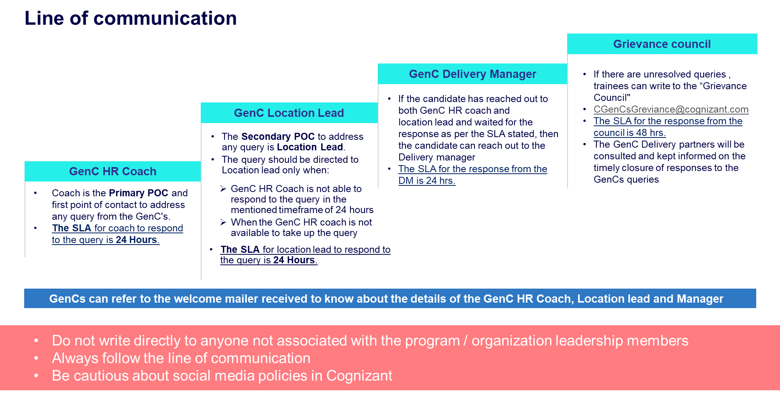

### Mail format

It is highly recommended that the GenC Intern candidates follow the below format while writing regarding their queries for faster resolution

**Mail Template**

|  |  |
| --- | --- |
| **Subject: <<Cohort Code>>_<<Candidate ID>> - brief of the issue/query** | |
| **Candidate ID** |  |
| **Name** |  |
| **DOJ** | DD-MM-YY |
| **SL** |  |
| **Cohort Code** |  |
| **Coach Name** |  |
| **Delivery Lead Name** |  |
| **Have you reached out to your coach and SL POC earlier?** | Yes/No/NA If no, reach out to your respective PoC. Please send this query to DL only if it is not addressed by both your Coach/Delivery Lead. |
| **Query not addressed by Leads/Coaches** | Explain in 2-3 lines. Attach email proof of the query which was not addressed by Coach/Lead within 48Hours |

# GenC Grievance cell

The objective of the grievance cell is to provide a good learning experience & working relationship for the GenC Intern candidates throughout their journey with the GenC skilling program.

The cell encourages the GenC Intern candidates to express their grievances / problems freely and frankly, without any fear of being victimized

The Grievance cell will focus on advising the candidates to show utmost restraint and patience whenever any occasion of issue/challenges to follow escalation matrix not write to cognizant leadership or write in public domain. Also, advise all GenC program POCs to be more approachable to the GenC Intern candidates and not be unresponsive to candidate’s concerns.

### How does the grievance cell work?

Raising a grievance is a 3 steps process wherein the GenC Intern candidates can log their grievance to the cell which will be tracked, monitored, and closed by the Grievance committee

1. 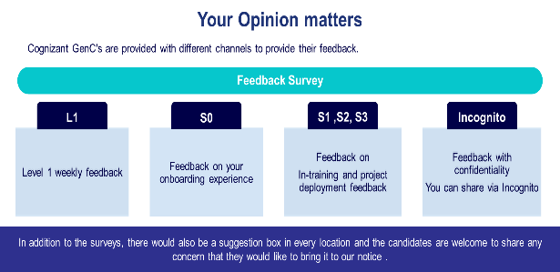Through Incognito survey which will be launched in a specified frequency/timeline during the skilling journey
2. Common mailbox for Grievance <mailto:CInternsGreviance@cognizant.com>[GrievanceCoreTeam@cognizant.com](mailto:GrievanceCoreTeam@cognizant.com) where the concerns can be emailed.
3. Suggestion drop box placed in all the physical location wherein the GenCs Intern candidates can drop a grievance note.

**Link to Incognito survey:** [**https://forms.office.com/r/SPwfQKcedY**](https://forms.office.com/r/SPwfQKcedY)

### Grievance Categories

|  |  |
| --- | --- |
| SME Evaluation failures in 1st, 2nd and both the attempts | **Warning given by the coaches on the guideline breach**   * Dress code guideline violation * Misconduct covering Behavioral, Values and Ethics etc. * Malpractice aligned to lack of learning agility * Communication breach * Training at physical location and AHS attendance |
| Stipend not received on time/Stipend amount is incorrect |
| Issues with company assets |
| Issues with company learning platform |
| Issues with Internal & external SMEs conduct |
| Issues related to BGV, onboarding process and offer letter |

# Feedback communication to the GenC

Performance status will be communicated to GenC Intern candidates at the appropriate checkpoints and will be available on the GenC learning platform dashboard.

The consequence-based feedback will be provided to the GenC Intern candidates based on the performance status at Checkpoint.

* **On Track for successful completion (Green)**
* **Improvement Recommended (Amber)**
* **Critical focus required on progress (Red)**

# Outliers/Exceptions

Any GenC NOT falling under ‘Successfully completed’ or ‘Alternate Service Line’ will not be applicable for the report card from Cognizant GenC skilling program.

# Appendix

# Definitions

| **Component** | **Description** | **Examples** |
| --- | --- | --- |
| Learning and Evaluation Components | The broad parameters that will be applicable for all types of enablement, based on which the evaluation and completion criteria would be determined. | Continuous Learning (Technical & Behavioral)  Hands-on exercises  Qualifier assessments  Interim Technical & Project Evaluation  Final Technical & Project Evaluation |
| Type of Curriculum | The learning path can follow any of the predefined structure as designed by Cognizant GenC skilling program.  Alternatively, based on the business demand, to meet the expectations of learning outcome, customizations would be applied the existing defined learning path [a joint venture between the Service Line (SL) and GenC program team]  A completely niche learning path could be designed by Business team [referred as Service Line (SL) Driven]. | **Standard Skill Tracks**  GenC program driven  **Business Defined Skill Tracks**  GenC program + SL driven  SL Driven |
| Minimum Score/ Expected Status | The score/status that the GenC should obtain to clear a particular Evaluation Component. The score/Status indicates a completion or a skill/technical score, as per the applicability, for the Evaluation Component. | All score-based Assessments – Evaluation score of 70% and above  PHS to successfully complete the training will be “Green” |
| Number of Attempts | Any GenC who has not obtained the pre-defined minimum percentage to clear the Evaluation components will be eligible for reattempt, as applicable. The number of reattempts would be as defined for respective evaluation components in the learning path. | 1 or 2, as prescribed for the Evaluation Components |
| Performance Health Status | Status determined based on the performance by GenC in the evaluation components, applicable for the learning path | Green/Amber /Red status  PHS to successfully complete the training will be “Green” |
| AHS  Attendance Health Status | Cumulative attendance Status of the GenC at physical location and virtual training. | Green/Amber /Red status  Time at Office – 10 hours across all India locations [9 hours for Kolkata and NCR]  TruTime Compliance = “Green” (min 9 hours/day)  Attendance in mandatory ILT/VILT sessions |

# Gen Catalyst Professional Development program

Language assessment level descriptions

The Common European Framework (CEFR) - The CEFR is an international standard for describing language ability. It marks an individual's language skills along a six-mark scale ranging from A1 (beginners) to C2 (advanced)

|  |  |  |
| --- | --- | --- |
| PROFICIENT USER | C2 | Can understand with ease virtually everything heard or read. Can summarize information from different spoken and written sources, can express themselves spontaneously, very fluently and precisely, and explain complex situations |
| C1 | Can express themselves fluently and spontaneously without much obvious searching for expressions. Can use language flexibly and effectively for social, academic, and professional explanation. Can produce clear, well-structured, detailed text on the questions asked clearly with no errors |
| INDEPENDENT USER | B2 | Can understand the main ideas of complex text on both concrete and abstract topics, including technical discussions in his/her field of specialization. Can interact with a degree of fluency and spontaneity Can explain the response to the questions asked with very minimal errors |
| B1 | Can understand the main points of clear standard input on familiar matters regularly encountered in work, school, leisure, etc. Can speak on topics that they are familiar with for e.g., can introduce themselves and answer questions where the response is simple and practiced. Can describe experiences and events, dreams, hopes & ambitions and briefly give reasons and explanations for opinions and plans. |
| BASIC User | A2 | Can understand sentences and frequently used expressions related to areas of most immediate relevance (e.g., very basic personal and family information, shopping, local geography, employment). Can communicate in simple and routine tasks requiring a simple and direct exchange of information on familiar and routine matters.  can respond in complete sentences on topics and questions familiar to him\her. Needs prompting or help in completing sentences to complex questions and responses |
| A1 | Can understand and use familiar everyday expressions and very basic phrases aimed at the satisfaction of needs of a concrete type. Can introduce themselves and others and can ask and answer questions about personal details such as where they live, people they know and things they own. Finds it difficult to respond in complete sentences. Often fumbles, pauses and searches for words to complete the response. Makes a lot of grammatical errors while speaking |

**GenC Internship Skilling 2025**

**Performance Declaration Form**

I ……………………………………………., undergoing skilling in the GenC Internship program via classroom/virtual mode will be obliged to abide by, acknowledge, and agree to the following:

“GenC Internship skilling completion guidelines 2025” applicable to all types of skilling programs

**Successful completion of the internship skilling program is mandatory for eligibility for FTE onboarding.**

**Flexibility regarding location, shift, role, and technology is required during training and project deployment.**

(Skilling/Re-skilling pre & post onboarding)

The GenC Internship skilling completion guidelines 2025 document outlines the guidelines and criteria for successful completion of the GenC Internship skilling program:

|  |  |
| --- | --- |
| **Performance Standards** | Performance indicators such as Performance Health Status (PHS - GREEN), Behavioral rating (CEFR > = B2), and Attendance Health Status (AHS – 85%) are mandatory for successful completion. If a GenC Intern candidate fails to meet the performance standards of the skilling program within the stipulated timeline, they will be de-enrolled from the program, and the Letter of Intent (LOI) will be revoked. |
| **Hands-On Completion** | 100% completion of hands-on exercises at each stage is mandatory for eligibility to progress to the next stage. |
| **Mandatory Assessments** | Clearing the Stage-1 assessment and final evaluation is mandatory for successful completion of training and eligibility for deployment to Business Units (BU) in skilling or re-skilling programs. |
| **Zero Tolerance for Malpractices** | Any form of malpractice will be dealt with zero tolerance, potentially leading to immediate de-enrollment from the program and revocation of the LOI. |
| **Attendance Requirement** | Interns must maintain minimum 85% attendance at the physical location every month to continue and successfully complete the program. |
| **Exceptions** | There could be exceptions to the applicability of evaluation components and deployment clauses based on demand and training outcomes, subject to ISL discretion and GenC program head approval. |
| **Reporting Discrepancies** | Any discrepancies or deviations observed in the defined process or procedure should be reported to the respective Learning point of contact immediately during the learning journey. |
| **Concerns post-unsuccessful completion** | Concerns raised after failing to meet the expected performance health indicators will not be considered as exceptions to the consequence management process. |

Candidate Name: Gokul S Candidate ID: 2393285

