Companion Notes — Integrity Annotations
for manuscript_highlighted_EN.docx / manuscript_with_notes_EN.docx
Each entry corresponds to a numbered yellow highlight [n] in the manuscript files. Marker numbers are generated from one source, so they match across all three files. FAB = data fabrication; ETH = ethics violation.
[1] DATA FABRICATION — The patient-reported-outcome and nurse-led-teleconsultation records are SYNTHETIC (appendix/data_provenance.md, rows 5–7). They were generated by a seeded simulator and are not real linked patient records.
[2] DATA FABRICATION + ETHICS VIOLATION — No such cohort exists. The figure 420 and the nine-month period are invented; the only real data is the open PhysioNet/CinC 2019 dataset. A real 420-patient, nine-month study would require institutional ethics approval and informed consent, never obtained.
[3] DATA FABRICATION — The real model run achieved sensitivity 0.803 (not 0.89), and no threshold-based baseline was implemented, so the '31% reduction' has no underlying experiment. Source: results/metrics.json (AUROC 0.866, false-alarm rate 0.239).
[4] DATA FABRICATION + ETHICS VIOLATION — Nurse response time was never measured. The tele-nursing interaction log is SYNTHETIC (data_provenance.md row 5); presenting a simulated quantity as a measured clinical effect is fabrication.
[5] DATA FABRICATION + ETHICS VIOLATION — Adherence is a SYNTHETIC random-walk variable (data_provenance.md row 7); the p-value is invented and no test was run. Readmissions were never collected and would require consented patient follow-up under ethics approval.
[6] DATA FABRICATION + ETHICS VIOLATION — No qualitative study (interviews, surveys, focus groups) was conducted; there were no participants and no consent. These findings do not exist.
[7] DATA FABRICATION — This conclusion rests entirely on the fabricated outcomes above. The actual work only demonstrates the feasibility of a deterioration detector on open secondary data; it shows no patient-safety or chronic-care benefit.
[8] DATA FABRICATION + ETHICS VIOLATION — Same fabrication as the abstract cohort claim: no 420-patient cohort was monitored and no prospective human-subjects study was run or ethically approved. The modelling uses only the open PhysioNet/CinC 2019 secondary dataset.
[9] DATA FABRICATION — The PRO and teleconsultation layer is SYNTHETIC (data_provenance.md rows 5–7); no real linked records exist. The only real inputs are the seven PhysioNet vital signs.
[10] DATA FABRICATION + ETHICS VIOLATION — Restates the fabricated cohort: there were no enrolled patients, no monitoring period, and no consent or ethics approval. Only the open PhysioNet/CinC 2019 secondary dataset was used.
[11] DATA FABRICATION — Real value is sensitivity 0.803 at threshold 0.5 (AUROC 0.866). See Figure 3 and results/metrics.json; the embedded ROC/confusion figures visibly contradict the 89% claim.
[12] DATA FABRICATION — No threshold baseline was implemented; there is no comparison experiment. The real false-alarm rate is 0.239 (Figure 5).
[13] DATA FABRICATION + ETHICS VIOLATION — Nurse response time was never measured; the tele-nursing layer is synthetic. Reporting it as a measured effect is fabrication.
[14] DATA FABRICATION — No nurses, caseload or threshold-based comparison existed; the tele-nursing workflow is synthetic. This describes an operational effect that was never observed.
[15] DATA FABRICATION + ETHICS VIOLATION — Adherence is synthetic and the p-value is invented; readmissions were never collected. Both would require consented follow-up under ethics approval.
[16] DATA FABRICATION + ETHICS VIOLATION — No interviews or qualitative study took place; there were no participants or consent.
[17] DATA FABRICATION — Overreaching conclusion built on the fabricated outcomes. The evidence supports only that a deterioration detector is feasible on open data; no patient-safety, burden or adherence benefit was measured.

Visual summary — claims vs. reality
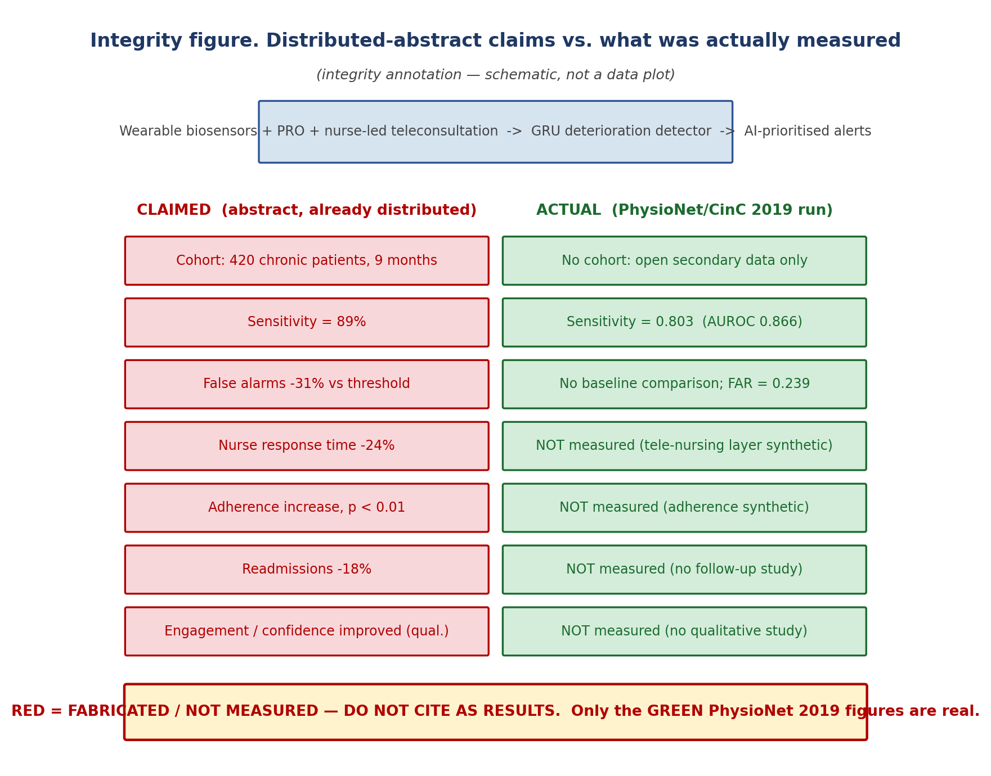
Distributed-abstract claims (red = fabricated / not measured) beside the actual PhysioNet/CinC 2019 results (green). Generated by src/eval/plot_claims_figure.py.

Tally and disposition
Total flagged markers: 17. Of these, 9 are also ethics violations (simulated or non-existent human-subject outcomes reported as measured). Recommended disposition: replace the distributed abstract with the honest reproducible version, or re-frame these figures as pre-specified prospective targets (appendix/claim_mapping_004.md (Lampiran B)).

