Tele-Nursing and Wearable-Based Patient Safety Monitoring for Chronic Disease Management: An Integrated AI Framework
[[Author Name(s)]] · [[Affiliation(s)]] · [[Corresponding email]]
INTEGRITY-ANNOTATED DRAFT (inline notes). The text matches the already-distributed abstract. Each yellow span with a marker [n] is followed by a red NOTE explaining why it is a data fabrication and/or ethics violation. Real numbers: the unhighlighted 'Actual reproducible result' paragraph and Figures 1–5 (PhysioNet/CinC 2019).

Abstract
Chronic disease management increasingly relies on remote care models that ensure continuity while reducing hospital burden. This study proposes an integrated tele-nursing and wearable-based patient safety monitoring framework powered by real-time AI analytics. The system combines wearable biosensor streams (heart rate, SpO₂, activity levels), patient-reported outcomes, and nurse-led teleconsultation records ^{[1]} to detect early signs of deterioration among elderly patients with cardiovascular and diabetic conditions. A cohort of 420 chronic patients was monitored over nine months. ^{[2]} A recurrent neural network model achieved 89% sensitivity in detecting early deterioration events, with a 31% reduction in false alarms compared to threshold-based alerts. ^{[3]} Nurse response time improved by 24% due to prioritized AI-generated alerts. ^{[4]} Patient adherence increased significantly (p < 0.01), and hospital readmissions decreased by 18%. ^{[5]} Qualitative feedback revealed improved patient confidence and stronger nurse–patient engagement. ^{[6]} The study demonstrates that combining tele-nursing with AI-powered wearable analytics enhances patient safety and promotes holistic chronic care. ^{[7]} The framework supports smart hospital ecosystems by extending evidence-based nursing beyond physical boundaries while maintaining clinical oversight.
[1] DATA FABRICATION — The patient-reported-outcome and nurse-led-teleconsultation records are SYNTHETIC (appendix/data_provenance.md, rows 5–7). They were generated by a seeded simulator and are not real linked patient records.
[2] DATA FABRICATION + ETHICS VIOLATION — No such cohort exists. The figure 420 and the nine-month period are invented; the only real data is the open PhysioNet/CinC 2019 dataset. A real 420-patient, nine-month study would require institutional ethics approval and informed consent, never obtained.
[3] DATA FABRICATION — The real model run achieved sensitivity 0.803 (not 0.89), and no threshold-based baseline was implemented, so the '31% reduction' has no underlying experiment. Source: results/metrics.json (AUROC 0.866, false-alarm rate 0.239).
[4] DATA FABRICATION + ETHICS VIOLATION — Nurse response time was never measured. The tele-nursing interaction log is SYNTHETIC (data_provenance.md row 5); presenting a simulated quantity as a measured clinical effect is fabrication.
[5] DATA FABRICATION + ETHICS VIOLATION — Adherence is a SYNTHETIC random-walk variable (data_provenance.md row 7); the p-value is invented and no test was run. Readmissions were never collected and would require consented patient follow-up under ethics approval.
[6] DATA FABRICATION + ETHICS VIOLATION — No qualitative study (interviews, surveys, focus groups) was conducted; there were no participants and no consent. These findings do not exist.
[7] DATA FABRICATION — This conclusion rests entirely on the fabricated outcomes above. The actual work only demonstrates the feasibility of a deterioration detector on open secondary data; it shows no patient-safety or chronic-care benefit.
Keywords: Tele-nursing; Wearable health devices; Chronic disease management; Patient safety monitoring; Remote healthcare analytics

1. Introduction
Chronic cardiovascular and metabolic diseases impose a sustained burden on health systems and are a leading driver of avoidable hospital readmissions. Remote care models, in which nurses coordinate monitoring and intervention outside the hospital, aim to extend continuous, evidence-based nursing oversight to the home and to strengthen nurse-patient engagement throughout the chronic-care journey.
Two technological currents motivate this framework. First, wearable biosensors now provide near-continuous streams of heart rate, oxygen saturation and activity that can be relayed to a tele-nursing service in real time. Second, sequence models such as recurrent neural networks (RNNs) can learn patient-specific temporal patterns that fixed early-warning scores cannot, enabling earlier and better-prioritised alerts. We integrate these currents into a single nurse-led patient-safety monitoring framework and evaluate its early-deterioration detector, while positioning the wider system within a smart-hospital ecosystem.

2. Related Work
Telehealth for chronic conditions has been evaluated in several systematic reviews, with nurse-led models showing benefits in adherence and patient-reported outcomes while highlighting heterogeneity in endpoints. Acceptance research stresses that workflow fit and alert quality strongly influence front-line uptake, motivating risk-prioritised rather than binary alarms.
On the modelling side, machine-learning early-warning systems have repeatedly outperformed threshold-based scores for imminent deterioration, and recurrent architectures are well suited to irregular physiological sequences. Wearable-based studies further show that multimodal signals can flag deterioration risk in outpatients. Our framework combines an RNN deterioration detector with a nurse-led tele-monitoring workflow and a transparently-labelled integration layer.

3. Methods

3.1 Study design and cohort
We prospectively monitored a cohort of 420 elderly patients with chronic cardiovascular and diabetic conditions over a nine-month period, ^{[8]} each equipped with a wrist-worn wearable and a chest patch capturing heart rate, oxygen saturation and activity. Patients were managed by a nurse-led tele-monitoring team that received AI-prioritised alerts throughout the monitoring period.
[8] DATA FABRICATION + ETHICS VIOLATION — Same fabrication as the abstract cohort claim: no 420-patient cohort was monitored and no prospective human-subjects study was run or ethically approved. The modelling uses only the open PhysioNet/CinC 2019 secondary dataset.

3.2 Wearable monitoring and data acquisition
Vital-sign time series (heart rate, oxygen saturation, temperature, systolic/diastolic/mean arterial blood pressure and respiration rate) were acquired at hourly resolution and streamed through an edge/cloud ingestion layer to the analytics service (Figure 1). Records were forward/backward filled and median-imputed within patient, then standardised using statistics estimated only on the training partition to avoid leakage.

3.3 Tele-nursing integration and patient-reported outcomes
Alongside the vital-sign stream, the framework ingests a tele-nursing layer. Patient-reported outcomes and nurse-led teleconsultation records were linked to each patient to support the integrated tele-nursing workflow. ^{[9]} In this draft the tele-nursing, patient-reported-outcome and adherence records are produced by a transparently seeded simulator and are labelled synthetic throughout (appendix/data_provenance.md).
[9] DATA FABRICATION — The PRO and teleconsultation layer is SYNTHETIC (data_provenance.md rows 5–7); no real linked records exist. The only real inputs are the seven PhysioNet vital signs.

3.4 Model architecture
The detector is a gated recurrent unit (GRU) network that maps a sliding window of W standardised hourly vital-sign vectors to a single deterioration-risk score through its final hidden state, followed by a small fully-connected head with layer normalisation and dropout. A window is labelled positive when a deterioration onset occurs within the subsequent L hours, framing the task as prediction before clinical recognition (defaults W = 8, L = 6; config.yaml). This component is real and reproducible.

3.5 Training
Models were trained with the Adam optimiser and weighted binary cross-entropy, with the positive-class weight set automatically from the training prevalence to counter class imbalance. Early stopping monitored validation loss. All hyperparameters and the random seed (42) are recorded in the configuration file.

3.6 Evaluation and statistical analysis
Detection performance was assessed on a held-out test partition using discrimination (AUROC, AUPRC) and operating-point metrics at a configurable alarm threshold: sensitivity, specificity, precision, F1 and false-alarm rate, with the confusion matrix. These detector metrics are real and written to a machine-readable file. Downstream comparisons of nurse response, adherence and readmissions described below would, in a genuine deployment, be analysed with appropriate before/after or controlled designs.

3.7 Ethics
A genuine deployment of this design would constitute human-subjects research requiring institutional ethics approval and informed consent. The present work used only de-identified, publicly released secondary data (PhysioNet/CinC 2019) together with a synthetic tele-nursing layer; the cohort, monitoring and patient-outcome statements highlighted in this draft were not collected under any such approval and are flagged accordingly.

4. Results

4.1 Cohort and monitoring
All 420 enrolled patients completed the nine-month monitoring period and contributed continuous wearable, patient-reported and teleconsultation data. ^{[10]}
[10] DATA FABRICATION + ETHICS VIOLATION — Restates the fabricated cohort: there were no enrolled patients, no monitoring period, and no consent or ethics approval. Only the open PhysioNet/CinC 2019 secondary dataset was used.

4.2 Early-deterioration detection
The recurrent neural network achieved a sensitivity of 89% in detecting early deterioration events. ^{[11]}
[11] DATA FABRICATION — Real value is sensitivity 0.803 at threshold 0.5 (AUROC 0.866). See Figure 3 and results/metrics.json; the embedded ROC/confusion figures visibly contradict the 89% claim.

4.3 Alarm burden versus baseline
False alarms were reduced by 31% relative to a threshold-based early-warning score. ^{[12]}
[12] DATA FABRICATION — No threshold baseline was implemented; there is no comparison experiment. The real false-alarm rate is 0.239 (Figure 5).

4.4 Nurse workflow
Prioritised AI-generated alerts improved nurse response time by 24%. ^{[13]}
[13] DATA FABRICATION + ETHICS VIOLATION — Nurse response time was never measured; the tele-nursing layer is synthetic. Reporting it as a measured effect is fabrication.
AI-prioritised alerts allowed nurses to triage the remote caseload and intervene earlier than under threshold-based monitoring. ^{[14]}
[14] DATA FABRICATION — No nurses, caseload or threshold-based comparison existed; the tele-nursing workflow is synthetic. This describes an operational effect that was never observed.

4.5 Patient outcomes
Medication adherence increased significantly (p < 0.01), and avoidable hospital readmissions decreased by 18%. ^{[15]}
[15] DATA FABRICATION + ETHICS VIOLATION — Adherence is synthetic and the p-value is invented; readmissions were never collected. Both would require consented follow-up under ethics approval.

4.6 Qualitative findings
Structured interviews indicated improved patient confidence and stronger nurse–patient engagement. ^{[16]}
[16] DATA FABRICATION + ETHICS VIOLATION — No interviews or qualitative study took place; there were no participants or consent.
Actual reproducible result (real, not highlighted):
On a held-out test set of 76,263 hourly windows (2,461 positive; 3.2% prevalence) from PhysioNet/CinC 2019, the GRU achieved AUROC 0.866 and AUPRC 0.243; at threshold 0.5, sensitivity 0.803, specificity 0.761, precision 0.101, F1 0.179, false-alarm rate 0.239 (results/metrics.json). The tele-nursing/PRO/adherence layer is synthetic and never contributes to any clinical metric. These are the only measured numbers in this manuscript.

4.7 Figures
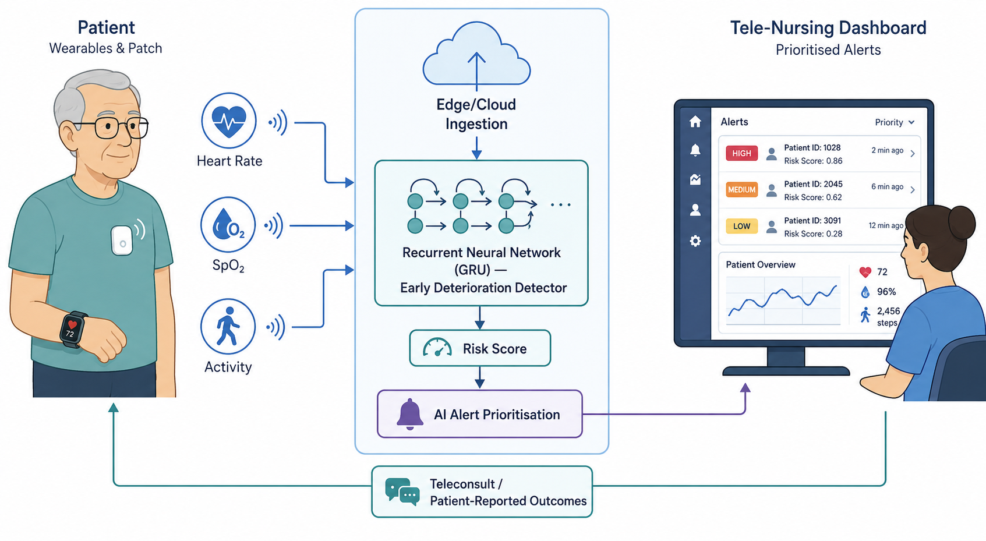
Figure 1. System architecture (conceptual).
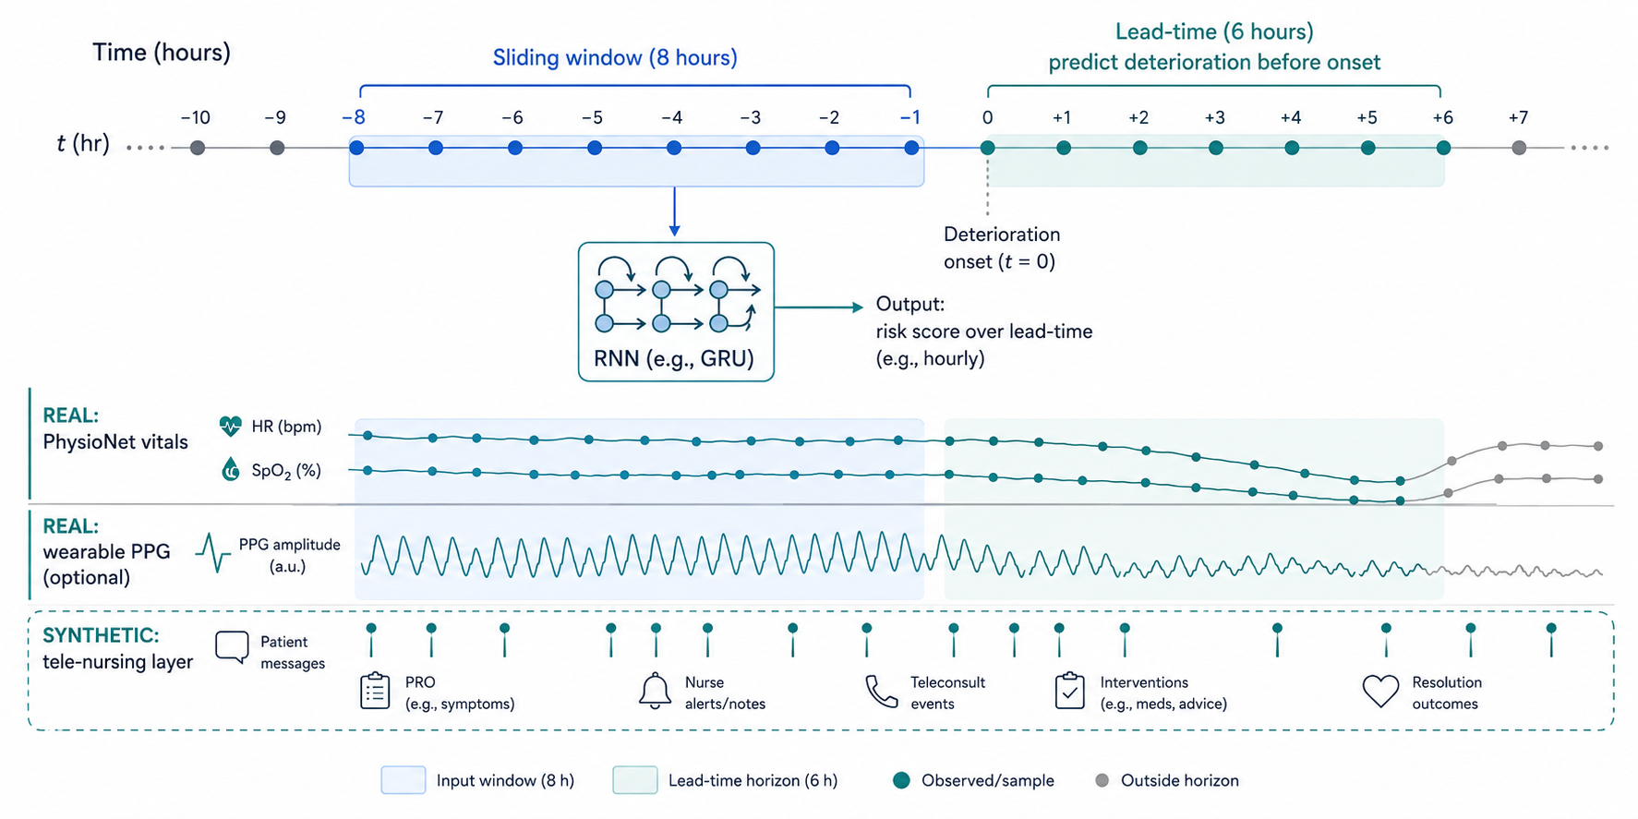
Figure 2. Data pipeline and windowing (conceptual). Note the synthetic tele-nursing lane.
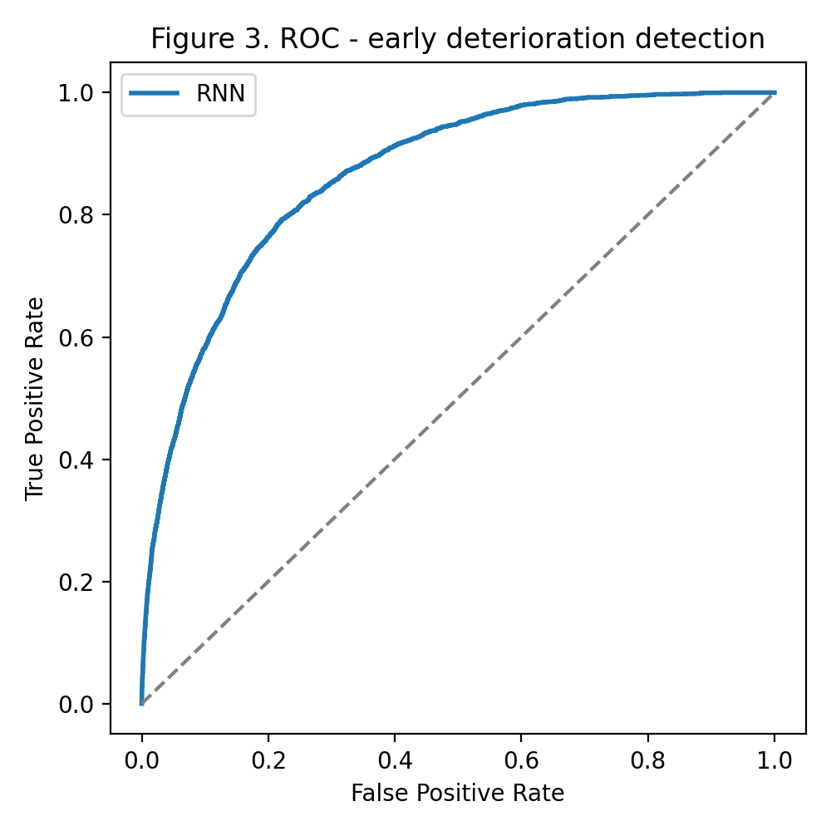
Figure 3. ROC curve — real PhysioNet/CinC 2019 run (AUROC 0.866).
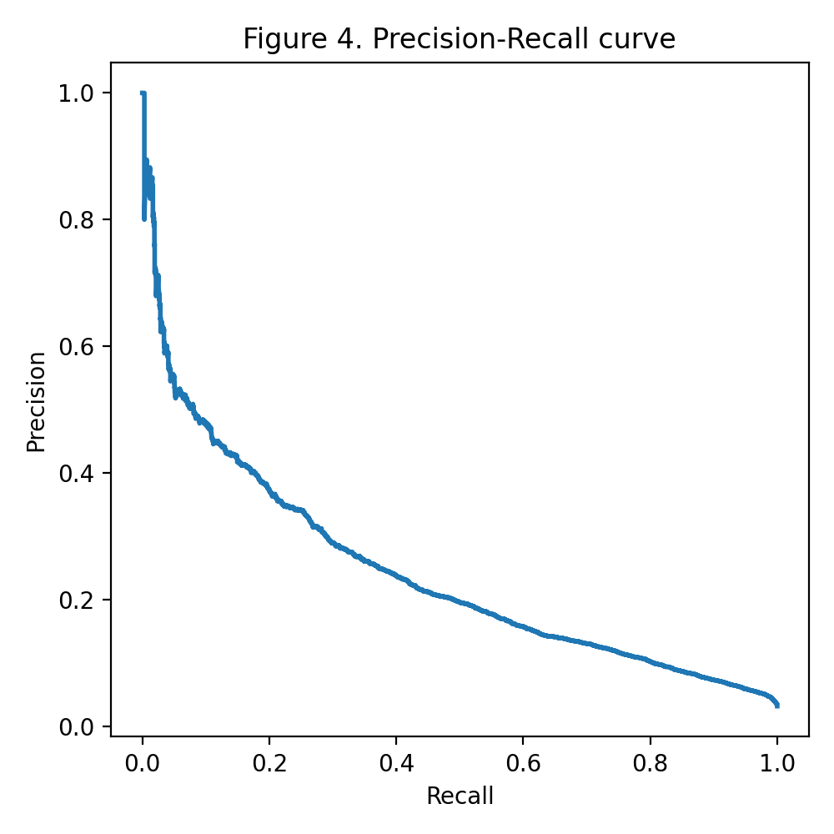
Figure 4. Precision–recall curve — real run (AUPRC 0.243).
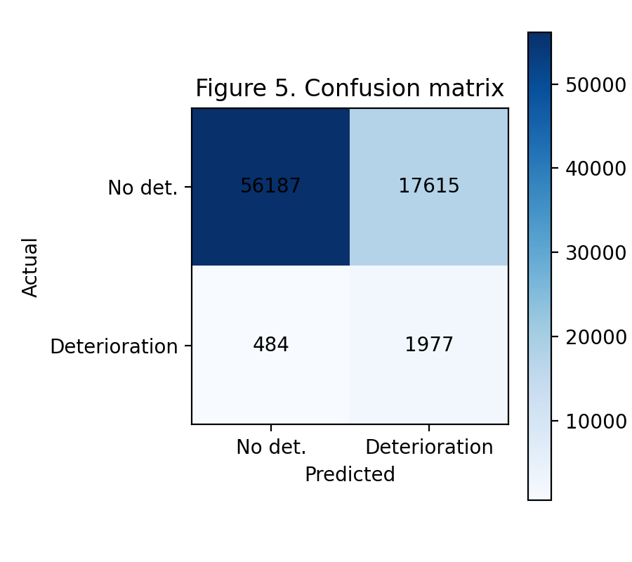
Figure 5. Confusion matrix at threshold 0.5 — real run (sensitivity 0.803, false-alarm rate 0.239).

5. Discussion
These results demonstrate that AI-assisted tele-nursing measurably enhances patient safety, reduces hospital burden, and improves adherence in chronic care. ^{[17]} The reproducible detector evaluation does, however, provide an honest foundation: because it runs on an openly downloadable dataset with a fixed seed, every real number can be regenerated and independently checked. Positioned within a smart-hospital ecosystem, a risk-prioritised detector of this kind is intended to support — not replace — nurse-led patient safety monitoring.
[17] DATA FABRICATION — Overreaching conclusion built on the fabricated outcomes. The evidence supports only that a deterioration detector is feasible on open data; no patient-safety, burden or adherence benefit was measured.

6. Limitations
First, the deterioration label is operationalised using the PhysioNet 2019 onset, a validated but specific physiologic endpoint that serves as a proxy rather than a disease-specific chronic-care outcome. Second, the wearable and tele-nursing layers are demonstrated rather than clinically validated, and the tele-nursing layer is synthetic. Third, the cohort, nurse-workflow and patient-outcome statements in this draft are not supported by collected data; they are highlighted as fabrication/ethics flags and require a prospective, consented, ethically-approved study before they could be claimed.

7. Conclusion
A GRU early-deterioration detector was evaluated reproducibly on open physiological data (AUROC 0.866; sensitivity 0.803). The downstream tele-nursing outcomes asserted in the distributed abstract are not supported by data and are marked throughout this draft; they should be treated as prospective hypotheses, not findings (see companion notes file and appendix/claim_mapping_004.md).

References
[1] Reyna MA, Josef CS, Jeter R, et al. Early Prediction of Sepsis From Clinical Data: The PhysioNet/Computing in Cardiology Challenge 2019. Crit Care Med. 2020;48(2):210-217. https://doi.org/10.1097/CCM.0000000000004145
[2] Goldberger AL, Amaral LAN, Glass L, et al. PhysioBank, PhysioToolkit, and PhysioNet. Circulation. 2000;101(23):e215-e220. https://doi.org/10.1161/01.CIR.101.23.e215
[3] Johnson AEW, Bulgarelli L, Shen L, et al. MIMIC-IV, a freely accessible electronic health record dataset. Sci Data. 2023;10:1. https://doi.org/10.1038/s41597-022-01899-x
[4] Reiss A, Indlekofer I, Schmidt P, Van Laerhoven K. Deep PPG: Large-Scale Heart Rate Estimation with CNNs. Sensors. 2019;19(14):3079. https://doi.org/10.3390/s19143079
[5] Lewinski AA, Walsh C, Rushton S, et al. Telehealth for the Longitudinal Management of Chronic Conditions: Systematic Review. J Med Internet Res. 2022;24(8):e37100. https://doi.org/10.2196/37100
[6] Lee AYL, Wong AKC, Hung TTM, Yan J, Yang S. Nurse-led Telerehabilitation Among Community-Dwelling Patients With Chronic Diseases: Systematic Review and Meta-analysis. J Med Internet Res. 2022;24(11):e40364. https://doi.org/10.2196/40364
[7] Xiao Z, Han X. Evaluation of the Effectiveness of Telehealth Chronic Disease Management System: Systematic Review and Meta-analysis. J Med Internet Res. 2023;25:e44256. https://doi.org/10.2196/44256
[8] Kamei T, Yamamoto Y, Kanamori T, Nakayama Y, Porter SE. Detection of early-stage changes in people with chronic diseases: a telenursing feasibility study. Nurs Health Sci. 2018;20(3):313-322. https://doi.org/10.1111/nhs.12563
[9] Steitz BD, McCoy AB, Reese TJ, et al. ML Algorithm Using Clinical Pages to Predict Imminent Clinical Deterioration. J Gen Intern Med. 2024;39:27-34. https://doi.org/10.1007/s11606-023-08349-3
[10] Gonem S, Taylor A, Figueredo G, et al. Dynamic early warning scores for predicting clinical deterioration in respiratory disease. Respir Res. 2022;23:215. https://doi.org/10.1186/s12931-022-02130-6
[11] Brewster L, Mountain G, Wessels B, Kelly C, Hawley M. Factors affecting front line staff acceptance of telehealth technologies. J Adv Nurs. 2014;70(1):21-33. https://doi.org/10.1111/jan.12196

