Neural network extract identifying features from data, lacking pre-programmed understanding. Network components include neurons, connections, weights, biases, propagation functions, and a learning rule. Neurons receive inputs, governed by thresholds and activation functions

These include:

1. The neural network is simulated by a new environment.
2. Then the free parameters of the neural network are changed as a result of this simulation.
3. The neural network then responds in a new way to the environment because of the changes in its free parameters

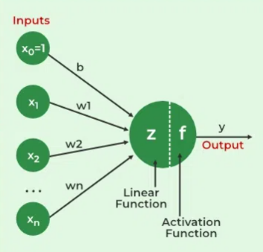

**How does Neural Networks work?**

Let’s understand with an example of how a neural network works:

Consider a neural network for email classification. The input layer takes features like email content, sender information, and subject. These inputs, multiplied by adjusted weights, pass through hidden layers. The network, through training, learns to recognize patterns indicating whether an email is spam or not. The output layer, with a binary activation function, predicts whether the email is spam (1) or not (0). As the network iteratively refines its weights through backpropagation, it becomes adept at distinguishing between spam and legitimate emails, showcasing the practicality of neural networks in real-world applications like email filtering.

### Working of a Neural Network

Neural networks are complex systems that mimic some features of the functioning of the human brain. It is composed of an input layer, one or more hidden layers, and an output layer made up of layers of artificial neurons that are coupled. The two stages of the basic process are called backpropagation and [forward propagation](https://www.geeksforgeeks.org/deep-neural-net-with-forward-and-back-propagation-from-scratch-python/)

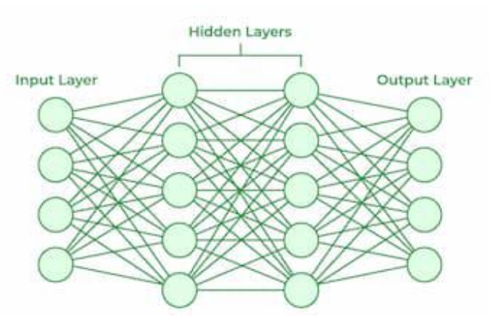Forward Propagation

* **Input Layer:**Each feature in the input layer is represented by a node on the network, which receives input data.
* **Weights and Connections:** The weight of each neuronal connection indicates how strong the connection is. Throughout training, these weights are changed.
* **Hidden Layers:** Each hidden layer neuron processes inputs by multiplying them by weights, adding them up, and then passing them through an activation function. By doing this, non-linearity is introduced, enabling the network to recognize intricate patterns.
* **Output:** The final result is produced by repeating the process until the output layer is reached.

#### Backpropagation

* **Loss Calculation:** The network’s output is evaluated against the real goal values, and a loss function is used to compute the difference. For a regression problem, the [Mean Squared Error](https://www.geeksforgeeks.org/python-mean-squared-error/) (MSE) is commonly used as the cost function.  
  **Loss Function:**
* **Gradient Descent:**Gradient descent is then used by the network to reduce the loss. To lower the inaccuracy, weights are changed based on the derivative of the loss with respect to each weight.
* **Adjusting weights:** The weights are adjusted at each connection by applying this iterative process, or [backpropagation](https://www.geeksforgeeks.org/backpropagation-in-data-mining/), backward across the network.
* **Training:**During training with different data samples, the entire process of forward propagation, loss calculation, and backpropagation is done iteratively, enabling the network to adapt and learn patterns from the data.
* **Actvation Functions:** Model non-linearity is introduced by activation functions like the [rectified linear unit](https://www.geeksforgeeks.org/activation-functions-neural-networks/) (ReLU) or [sigmoid](https://www.geeksforgeeks.org/derivative-of-the-sigmoid-function/). Their decision on whether to “fire” a neuron is based on the whole weighted input.

**Types of Neural Networks**

* **Feedforward Networks:** A [feedforward neural network](https://www.geeksforgeeks.org/difference-between-feed-forward-neural-networks-and-recurrent-neural-networks/) is a simple artificial neural network architecture in which data moves from input to output in a single direction. It has input, hidden, and output layers; feedback loops are absent. Its straightforward architecture makes it appropriate for a number of applications, such as regression and pattern recognition.
* **Multilayer Perceptron (MLP):** [MLP](https://www.geeksforgeeks.org/difference-between-multilayer-perceptron-and-linear-regression/) is a type of feedforward neural network with three or more layers, including an input layer, one or more hidden layers, and an output layer. It uses nonlinear activation functions.
* **Convolutional Neural Network (CNN):** A [Convolutional Neural Network](https://www.geeksforgeeks.org/introduction-convolution-neural-network/)(CNN) is a specialized artificial neural network designed for image processing. It employs convolutional layers to automatically learn hierarchical features from input images, enabling effective image recognition and classification. CNNs have revolutionized computer vision and are pivotal in tasks like object detection and image analysis.
* **Recurrent Neural Network (RNN):**An artificial neural network type intended for sequential data processing is called a [Recurrent Neural Network](https://www.geeksforgeeks.org/introduction-to-recurrent-neural-network/)(RNN). It is appropriate for applications where contextual dependencies are critical, such as time series prediction and natural language processing, since it makes use of feedback loops, which enable information to survive within the network.
* **Long Short-Term Memory (LSTM):**[LSTM](https://www.geeksforgeeks.org/long-short-term-memory-networks-explanation/) is a type of RNN that is designed to overcome the vanishing gradient problem in training RNNs. It uses memory cells and gates to selectively read, write, and erase information.