A Version Control System (VCS) is a software tool that helps manage changes to source code over time. It tracks modifications to files, allowing multiple individuals to collaborate on a project simultaneously without overwriting each other's work. It maintains a history of changes, facilitating the ability to revert to earlier versions if needed.

**SETUP**

Configuring user information used across all local repositories

git config --global user.name “[firstname lastname]” set a name that is identifiable for credit when review version history

git config --global user.email “[valid-email]” set an email address that will be associated with each history marker

git config --global color.ui auto set automatic command line coloring for Git for easy reviewing

**SETUP & INIT**

Configuring user information, initializing and cloning repositories

git init initialize an existing directory as a Git repository

git clone [url] retrieve an entire repository from a hosted location via URL

**STAGE & SNAPSHOT**

Working with snapshots and the Git staging area

git status show modified files in working directory, staged for your next commit

git add [file] add a file as it looks now to your next commit (stage)

git reset [file] unstage a file while retaining the changes in working directory

git diff diff of what is changed but not staged

git diff --staged diff of what is staged but not yet commited

git commit -m “[descriptive message]” commit your staged content as a new commit snapshot

**BRANCH & MERGE**

Isolating work in branches, changing context, and integrating changes git branch list your branches. a * will appear next to the currently active branch git branch [branch-name] create a new branch at the current commit git checkout switch to another branch and check it out into your working directory git merge [branch] merge the specified branch’s history into the current one git log show all commits in the current branch’s history.

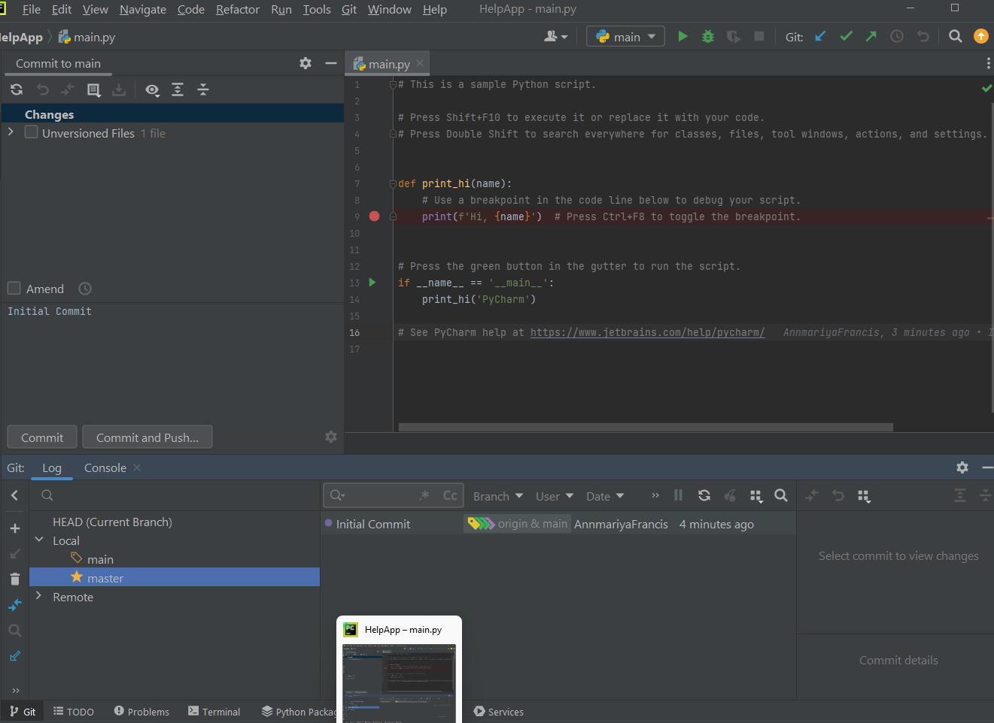

Local project is imported to git Repository using ‘Push’ command.

