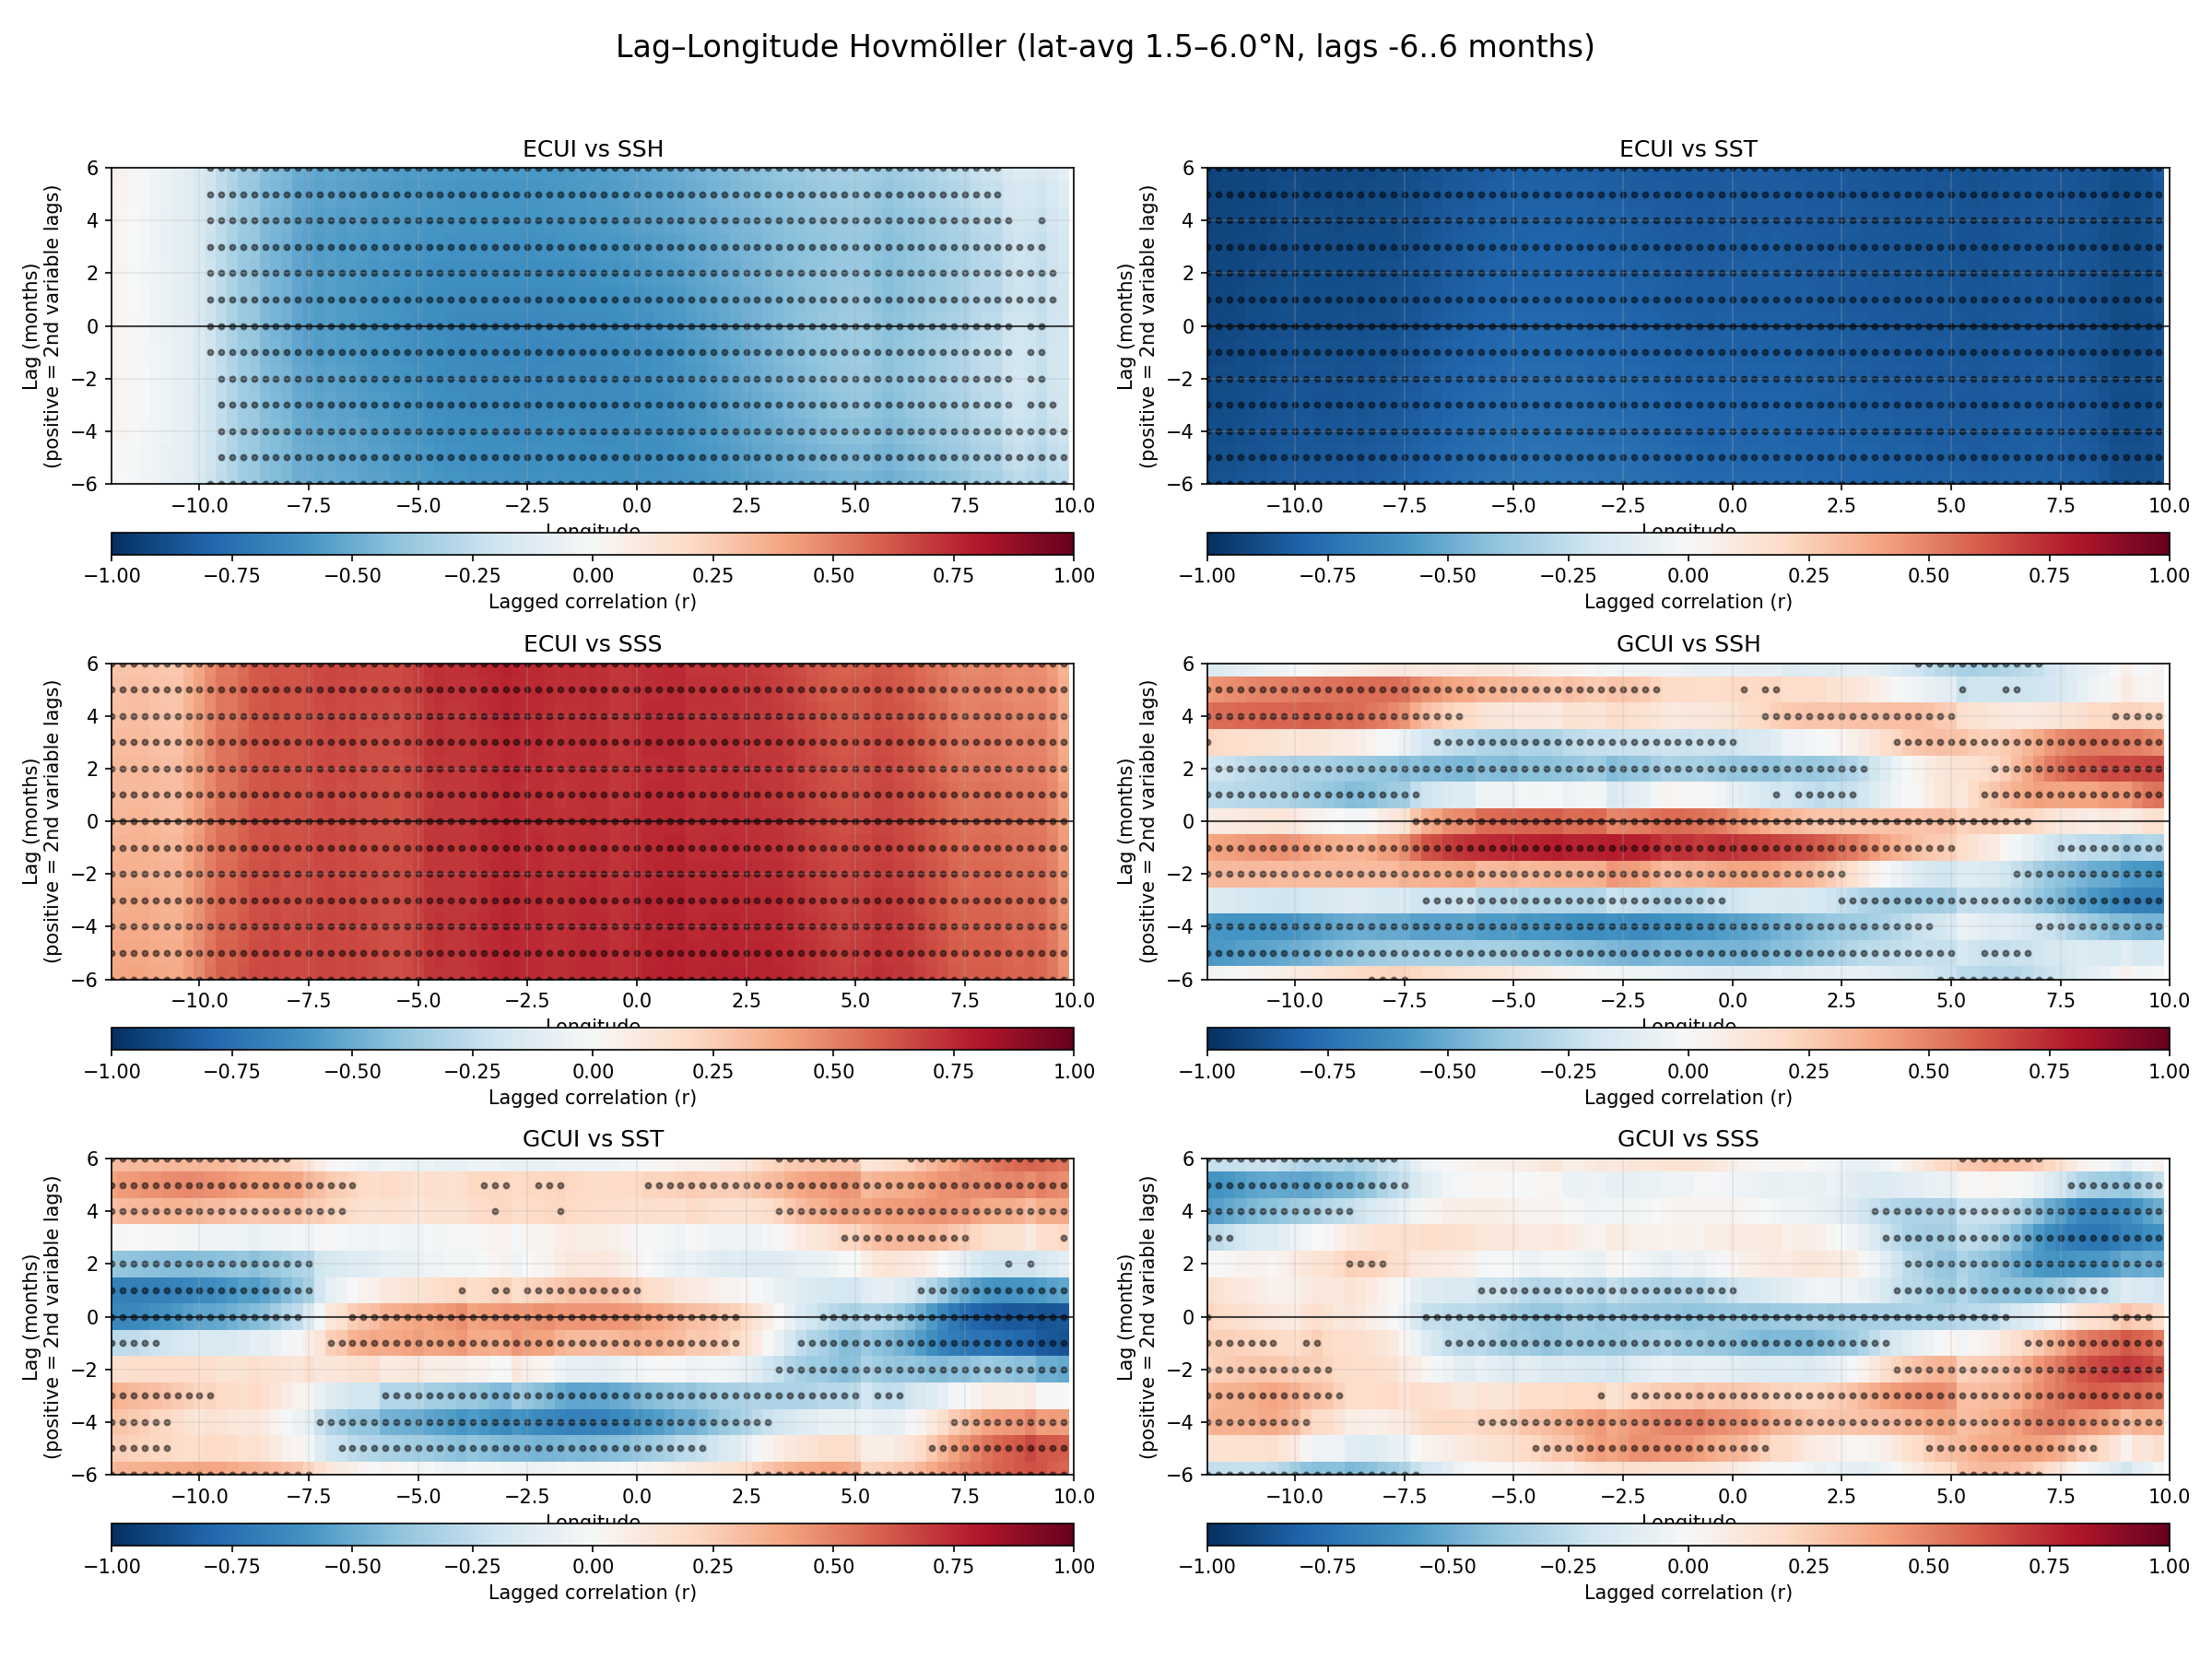

(a) ECUI vs SSH
The field is consistently negative (blue) along the entire coast and across nearly all lags, indicating a strong, inverse relationship between upwelling intensity and sea level.
When upwelling intensifies (ECUI ↑), surface waters diverge and SSH decreases (lower sea level).
The lack of a pronounced lag structure suggests that SSH responds almost instantaneously to changes in local wind-driven Ekman dynamics.
This pattern confirms that Ekman-driven upwelling lowers the sea surface height by enhancing coastal divergence.

(b) ECUI vs SST
This panel shows uniformly strong negative correlations (dark blue), again without notable lag dependence.
This reflects the immediate cooling of surface waters during upwelling events: intensified upwelling brings colder subsurface water to the surface, reducing SST almost synchronously.
The high magnitude (r ≈ −0.8 to −1.0) underscores how SST is an excellent proxy for local upwelling strength in the eastern tropical Atlantic.

(c) ECUI vs SSS
The correlation is positive (red) and spatially coherent along the coast.
As upwelling intensifies (ECUI ↑), salinity increases (SSS ↑) — consistent with the upward entrainment of saltier subsurface water.
The absence of a strong lag pattern implies that SSS adjusts rapidly to vertical mixing and advection associated with upwelling.
Together, (a)–(c) show that Ekman-driven upwelling modifies SSH, SST, and SSS almost simultaneously, confirming a local, wind-forced mechanism.

(d) GCUI vs SSH
This panel is more complex, exhibiting alternating red and blue horizontal bands with a roughly 2–3 month periodicity.
These oscillations suggest a phase-shifted relationship between the Guinea Current and sea level:
- Near zero lag to +2 months, positive correlations (red) indicate that stronger eastward flow (GCUI ↑) coincides with or slightly precedes higher SSH.
- At negative lags, the relationship reverses (blue), implying a delayed current response to preceding sea-level anomalies.
Such alternating bands are typical signatures of coastal-trapped Kelvin waves or seasonal current reversals propagating along the coast, with the current and SSH leading or lagging each other by a few months.
This points to dynamical coupling between the Guinea Current and the regional sea-level field.

(e) GCUI vs SST
Here, red–blue alternations also appear, though less regular.
Periods of stronger current correspond to warming or cooling episodes that evolve with time lag along the coast.
This reflects the Guinea Current’s role in advective heat transport: changes in current strength redistribute warm surface waters, leading to SST adjustments a few months later.

(f) GCUI vs SSS
The correlation alternates weakly between positive and negative phases.
This likely reflects the combined influence of horizontal advection of fresh coastal water and vertical mixing driven by the current.
Although less coherent, these correlations again indicate that SSS variations are partially governed by changes in the Guinea Current’s intensity and its delayed response to coastal wave dynamics.

🔎 Overall significance
- Ekman upwelling (ECUI) impacts SSH, SST, and SSS almost instantaneously, confirming a local, wind-driven response.
- Guinea Current variability (GCUI) shows time-lagged, oscillatory correlations with SSH, SST, and SSS, revealing remote forcing and propagating signals consistent with Kelvin-wave–driven seasonal adjustments along the Gulf of Guinea.
- These lagged patterns suggest a hierarchy of timescales:
  - Local wind forcing → near-zero-lag Ekman response (SSH, SST, SSS).
  - Large-scale ocean dynamics → 1–3 month lag between current and sea-level anomalies.
- ✍️ Example paragraph for your report
- Lag–longitude correlation analyses (Figure X) reveal contrasting temporal responses between Ekman-driven and geostrophic components of the coastal upwelling system. The Ekman Coastal Upwelling Index (ECUI) exhibits strong, nearly instantaneous correlations with sea surface height (SSH), sea surface temperature (SST), and salinity (SSS), confirming that wind-driven upwelling rapidly lowers sea level, cools surface waters, and increases salinity through vertical entrainment. In contrast, the Guinea Current Upwelling Index (GCUI) shows oscillatory correlations with SSH and SST over lags of ±2–4 months, indicating the influence of propagating coastal-trapped waves and seasonal current reversals. These results highlight the dual nature of Gulf of Guinea upwelling: a fast, local Ekman response and a slower, wave-modulated adjustment of the regional circulation.

