Assignment

1. Create a blog or website using Blogspot and WordPress. Customize the theme design and post new article with 500 words.

<https://foodiegrasp1234.blogspot.com/2023/10/foodiegrasp.html>

1. Create a New Facebook Business Page and post one social

media poster for your brand.

<https://www.facebook.com/profile.php?id=61550016305689&mibextid=ZbWKwL>

1. Create and design a social media advertisement poster using Canva.

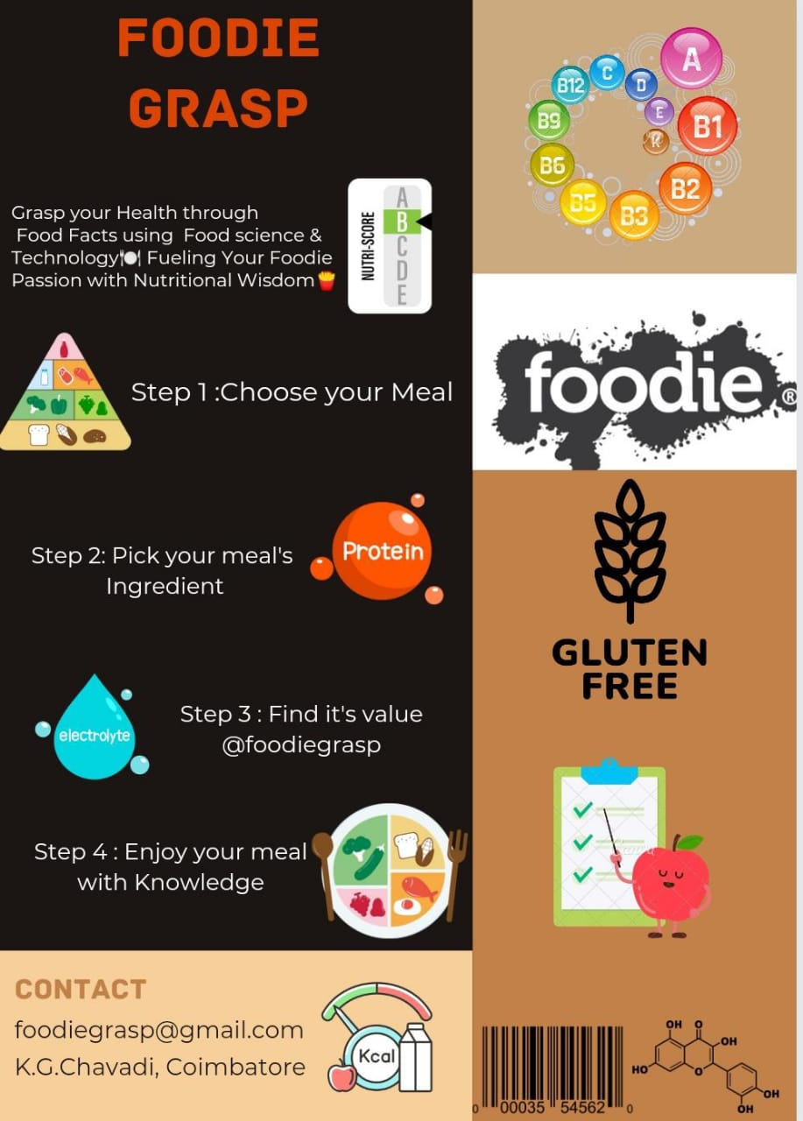

<https://m.facebook.com/story.php?story_fbid=pfbid02f533BW5eyDy2uLyRWjKhv1FMpCGLHBfDEsQZNsJ1JJ8hHpAQkZATwUq4WZV4a9hql&id=61550016305689&mibextid=Nif5oz>

1. Create email newsletter design using MailChimp or canva tool.

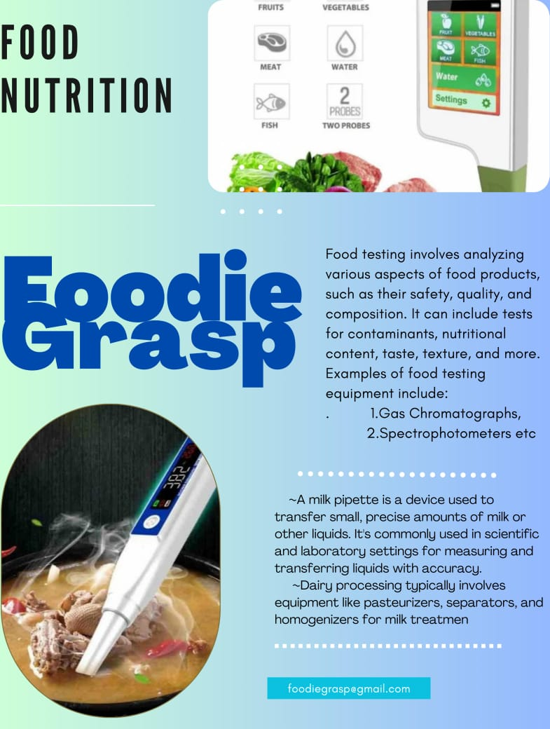

<https://m.facebook.com/story.php?story_fbid=pfbid031PjuntwCs9DYmcZMYcLUBYnwTD4mkDt5b2WKA9qx7Mb8UnUwTDBn44hZ69QyV5Nxl&id=61550016305689&mibextid=Nif5oz>