EXPERIMENT 4
Create a table named student and populate the table as shown in the table. The table contains the marks of 10 students for 3 subjects(Physics, Chemistry, Mathematics).The total marks for physics and chemistry is 25.while for mathematics it is 50.The pass mark for physics and chemistry is 12 and for mathematics it is 25. A student is awarded a ‘Pass’ if he has passed all the subjects.
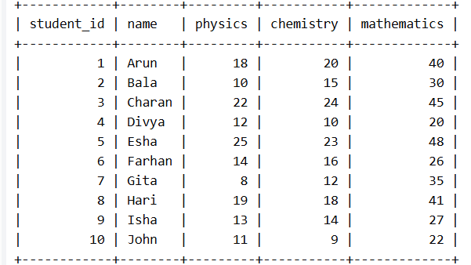
1.Find the class average for the subject ‘Physics’
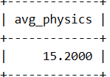
2.Find the highest marks for mathematics (To be displayed as highest_marks_maths).
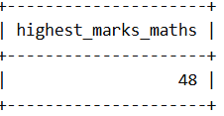
3. Find the lowest marks for chemistry(To be displayed as lowest_mark_chemistry)
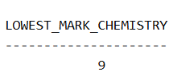
4. Find the total number of students who have got a ‘pass’ in physics.
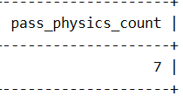
5. Generate the list of students who have passed in all the subjects
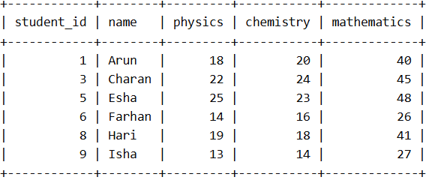
6. Generate a rank list for the class. Indicate Pass/Fail. Ranking based on total marks obtained by the students.
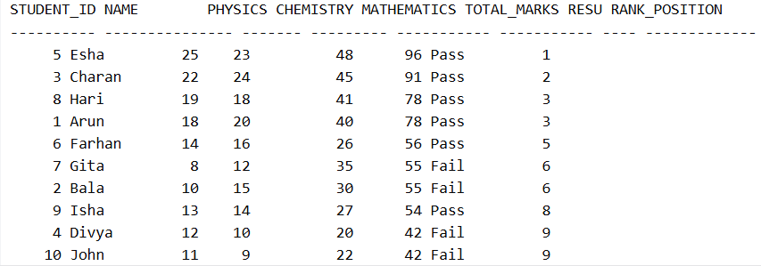

7. Find pass percentage of the class for mathematics
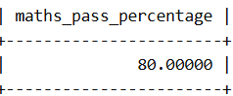
8. Find the overall pass percentage for all classes.
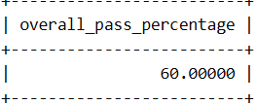
9. Find the class average
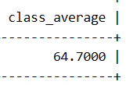
10. Find the total number of students who have got a Pass.
