**Q1)** Create & compress the file with bzip2.

1. To install the bzip2 file in the linux we need to perform below command:

**$ sudo apt install bzip2**

Imp:

* By default, **bzip2** deletes the input files during compression or decompression, to keep the input files, use the **-k** or **--keep** option.
* In addition, the **-f** or **--force** flag will force **bzip2** to overwrite an existing output file.

**Q2)** What should be the argument to be given to unzip that file.

1. To unzip a **.bz2** file, make use of the **-d** or **--decompress** option like so:

**$ bzip2 -d filename.bz2**

Imp: The file must end with a **.bz2** extension for the command above to work.

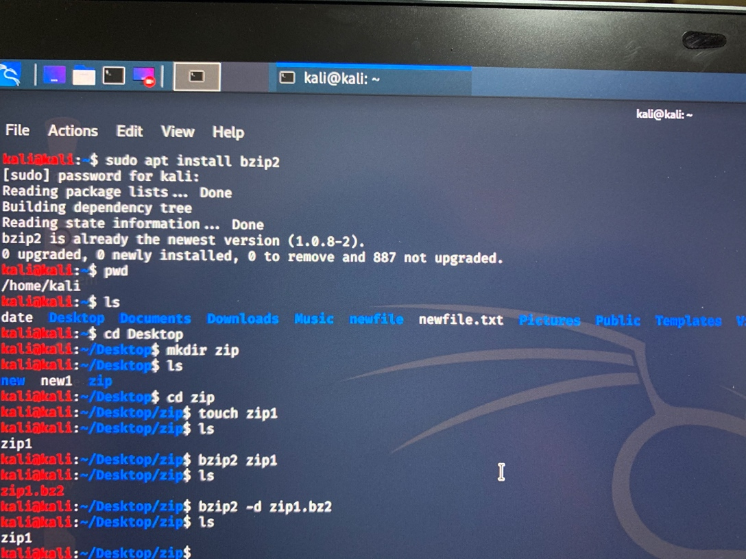

**Q3)** Read a file & show the data on terminal using file input & output redirection.

1. Read a file & show the data on terminal using file input and output redirection:

* For output redirection, I have attach date and calendar together as shown below:

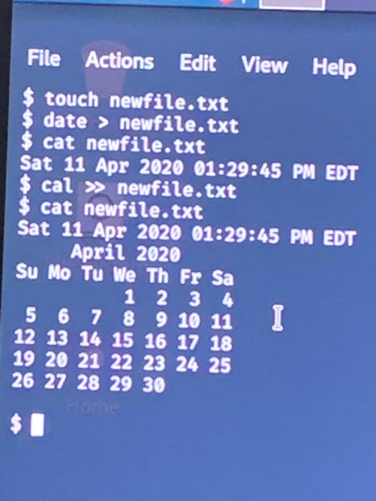

* For input redirection, We can use the below command:

**Mail -s “subject”** [**xyz@mail.com**](mailto:xyz@mail.com) **< File name**

**Q4)** How to change the shell of user to “/bin/sh” at the time of adding the user.

1. The default shell property can be added when creating a new user by the bellow command:

**Sudo useradd -s /bin/sh new_user**

