An Industry Internship Project Report On
Bank Account Management System
Work Carried At
Weblabz
NIT Faridabad (HR)
Submitted to
MAHARSHI DAYANAND UNIVERSITY, ROHTAK
MASTER OF COMPUTER APPLICATIONS
Semester:-IInd

Submitted by
Annu
University Roll No:

Under the Guidance Of:

External Guide: | Internal Guide:
Mr. Kailash Pandey | Mr. Rashmeen Kaur
Senior Software Developer | Asst.(professor)


INSTITUTE OF MANAGEMENT & TECHNOLOGY
(An NBA AICTE Accredited Institute)
(Approved by AICTE & Affiliated to MD University, Rohtak)
Tigaon Road, Near Sai Dham, Faridabad
DECLARATION

I hereby certify that the work which is being presented in this Industry Internship project report
entitled “Bank Account Management System” for the award of the degree of Master of
Computer Applications (MCA), submitted in the Department of Computer Science and
Applications of Institute Of Management & Technology, Faridabad, is an authentic record
of my work carried out during my project training, under the supervision & guidance of
Mr. Kailash Pandey (Senior Software Developer).

I have not submitted the matter embodied in this project for the award of any other degree or diploma.

Date-
Place: Faridabad Annu

CERTIFICATE OF COMPANY



ACKNOWLEDGEMENT

Submission of this project report gives me an opportunity to convey my gratitude to all those who have helped me to reach a stage where I have immense confidence to launch my career in the competitive world of information Technology

I take this opportunity to express my deep and sincere gratitude to Weblabz Who have been kind enough to spare his valuable time.

I would like to thank Mr. Kailash Pandey (Senior Software Developer),for their timely guidance and invaluable and regular focus on my work successful culmination of this project.

It would not have been possible to see through the undertaken projects without the guidance of Ms. Urvija Raina, Dean of Department of Computer Science and other staff members of the Department. It was purely on the basis of their experience and knowledge that I was able to clear all the theoretical and technical hurdles during the development phases of this work.

I would like to thank Ms. Rashmeen Kaur (Internal guide) for her help and cooperation and for remaining interactive with me during the reviews of my projects for the various designs and performance issues.

I would also like to thank my friends and fellow trainees for their support and cooperation for completion of this project.

Annu

TABLE OF CONTENTS
- PREFACE………………………………………………………………1
- COMPANY PROFILE…………………………………………………2
- HARDWARE AND SOFTWARE REQUIREMENTS………………3-6
  - HARDWARE ENVIRONMENT……………………………………….3.1
  - SOFTWARE ENVIRONMENT………………………………………..3.2
  - SOFTWARE SPECIFICATION………………………………………..3.3
- SOFTWARE TOOLS…………………………………….…………….7-9
  - FRONT END…………………..………………………………………..7.1
  - BACK END……………………………………………………………..7.2
- PROJECT OBJECTIVE………………………………………………..8
- PROJECT INTRODUCTION…………………………………………..9
(SOFTWARE DEVELOPMENT LIFE CYCLE)
- REQUIREMENT SPECIFICATIONS…………………………………10-11
- FEASIBILITY STUDY………………………………………………….12-13
- SYSTEM ANALYSIS……………………………………………………14-15
- METHODOLOGY AND MODEL………………….…………………..16-17
- SYSTEM DESIGN……………………………………………………….18-19
- MODULES………………………………………………………………..20
- E-R DIAGRAM…………………………………………………………....21
- DATA FLOW DIAGRAM………………………………………………..22-23
- DATA BASE DESIGN…………………………………………………….24-25
- SCREENSHOTS………………………………………………………...…26-27
- CODING……………………………………………………………………28-41
- TESTING…………………………………………………………………...42
- IMPLEMENTATION……………………………………………………...43-45
- MAINTENANCE………………...…………………..……………………..46-48
- LIMITATIONS……………………………………………………………..49
- FUTURE SCOPE……………………………………………………………50
- CONCLUSION…………………..………………………………………….51
- BIBLIOGRAPHY…………………………………………………………..52
- REFERENCES……………………………………………………………...53

1.PREFACE

In today's fast-paced world, banking has evolved from traditional brick-and-mortar branches to digital platforms that offer convenience, accessibility, and security to customers. The advent of online banking, mobile applications, and electronic transactions has transformed the way individuals manage their finances and interact with financial institutions.

This document serves as the preface to our comprehensive Bank Account System, a robust software solution designed to meet the diverse needs of modern banking operations. Developed with a focus on usability, reliability, and security, our Bank Account System aims to streamline banking processes, enhance customer experience, and optimize operational efficiency for financial institutions of all sizes.

This system aims to automate and streamline the core banking operations including account management, transaction processing, loan management, and customer relationship management. By replacing manual processes with digital solutions, the system enhances accuracy, reduces operational costs, and improves customer service.

We hope this project serves as a foundation for further enhancements and encourages innovation in the financial technology sector. We would like to express our sincere gratitude to our mentors, peers, and all those who have supported us throughout the development of this system.

2.COMPANY PROFILE



2.1 Overview
Weblabz is a tech-driven educational company dedicated to bridging the gap between theoretical learning and industry-oriented practical skills. Through hands-on internships, real- time projects, and expert-led training, we aim to shape future-ready tech professionals.

Mission
    - Deliver affordable and accessible technical education.

    - Provide real-world project experience to enhance employability.

    - Foster innovation through practical exposure and mentorship.

Vision
    - Be recognized as a leading platform for project-based learning.
    - Expand offerings to include globally recognized certification programs.
    - Build a tech-savvy community of learners and innovators.

Team Structure
    - Software Developers
    - Web Developers
    - UI/UX Designers
    - Project Mentors Technical Trainers

3.HARDWARE AND SOFTWARE REQUIREMENTS
  - Hardware Environment

3.1.1 RAM:
At least 512 MB
3.1.2 Processor:
Minimum Pentium 2 266 MHz processor
    - Hard disk:
20 GB
    - Monitor:
14 inch
3.1.5 Mouse:
Button scroll
    - CD Drive:

    - Keyboard:
- ys
    - Printer:
Laser/ Ink JET

3.2 Software Environment

3.2.1 Operating System:
Linux-based server operating system (e.g., Ubuntu Server).
3.2.2 Database Management:
Database system for data storage (e.g., PostgreSQL).
3.2.3 Programming Language:
Java for backend development.
3.2.4 Web Framework:
Spring Boot for building the web application.
3.2.5 Front-end Framework:
HTML, CSS, and Vaadin for the user interface.
3.2.6 Numerical Models:
Integration of established weather models (e.g., GFS, ECMWF)

3.3Software Specification

    - Operating System:
Windows 2000/XP/vista/2007/2008/7/8/10
    - Languages:
JavaScript, HTML, CSS, Java
    - Front End:
HTML, CSS, Vaadin
    - Tools:
Intelli J(IDE)
    - Backend:
Java, Spring Boot
    - Deployment:
Local Server

4. SOFTWARE TOOLS
4.1Front End

    - Web Development Framework

i) HTML (HyperText Markup Language):
HTML forms the structure of your web pages. You'll use it to create the layout and define the different components of your weather forecasting application, such as headers, navigation menus, data display areas, and interactive elements.

ii) CSS (Cascading Style Sheets):
CSS is used to style the HTML elements, giving your weather forecasting application its visual appearance. With CSS, you can control the colors, fonts, spacing, layout, and overall design of your application.
CSS frameworks like Bootstrap or MaterializeCSS can help you quickly style your application with pre-designed components and responsive layouts.

4.1.2 UI Component Libraries

i) Material-UI: A popular React UI framework that provides pre-designed components following Google's Material Design principles. It offers ready-to-use components for building responsive and visually consistent user interfaces.
ii) Ant Design: A design system and React UI library that offers a wide range of components, including layout, navigation, and form elements. It can help streamline the development of frontend interfaces for weather forecasting applications.

4.2 Back End

1. Java Programming Language:
  - Java is a popular, versatile, and widely adopted programming language known for its stability, performance, and strong ecosystem.
  - You can use Java to implement the core logic of your weather forecasting system, including data processing, analysis, and prediction algorithms.
  - Java's extensive standard library and third-party libraries provide support for tasks such as handling dates and times, working with APIs, and performing mathematical computations.

2. Spring Boot Framework:
- Spring Boot is a powerful framework for building Java-based web applications and microservices. It simplifies the development process by providing out-of-the-box solutions for common tasks and configurations.
- With Spring Boot, you can quickly set up a production-ready backend for your weather forecasting application, including features such as dependency injection, configuration management, logging, and security

- Spring Boot's built-in support for RESTful web services makes it easy to expose APIs for accessing weather data and forecasts from your frontend application.
- You can leverage Spring Boot's integration with Spring Data to interact with databases and Spring Security for implementing authentication and authorization mechanisms to protect your application.

PROJECT OBJECTIVE

1. Efficient Account Management:
Develop a system that allows users to create, update, and manage their bank accounts efficiently.

2. Transaction Processing:
Enable users to perform various types of transactions such as deposits, withdrawals, transfers, and payments seamlessly and securely.

3. Security and Compliance:
Implement robust security measures to protect sensitive financial data and ensure compliance with industry regulations and standards (e.g., GDPR, PCI-DSS).

4. User Authentication and Authorization:
Provide secure authentication mechanisms to verify user identities and enforce access controls based on roles and permissions.

5. User-Friendly Interface:
Design an intuitive and user-friendly interface that allows customers to navigate the system easily and perform transactions with minimal effort.

6. Real-Time Account Access:
Offer real-time access to account balances, transaction histories, and other account-related information to provide customers with up-to-date financial insights.

7. Customer Service and Support:
Incorporate features for customer support, including helpdesk functionality, FAQs, and online chat support, to assist users with inquiries and issues promptly.

8. Reporting and Analytics:
Enable bank administrators to generate comprehensive reports, analyze transaction data, and gain insights into customer behavior and market trends for strategic decision-making.

9. Integration with Banking Infrastructure:
Integrate the system with existing banking infrastructure, including core banking systems, payment gateways, and third-party services, to ensure interoperability and data consistency.

10. Scalability and Flexibility:
Build a scalable and flexible system architecture that can accommodate growth in the number of users, transactions, and functionalities over time.

11. Mobile Banking:
Develop mobile banking applications that enable users to access banking services on their smartphones or tablets, offering convenience and accessibility.

6.PROJECT INTRODUCTION

In an era characterized by digital transformation and technological innovation, the banking sector continues to evolve rapidly to meet the changing needs and expectations of customers. With the advent of online banking, mobile applications, and electronic transactions, financial institutions are embracing technology to offer seamless, convenient, and secure banking services to their customers.

Our Bank Account Management System represents a state-of-the-art software solution designed to revolutionize the way individuals manage their finances and interact with their banks. Developed with a focus on usability, reliability, and security, our system empowers both customers and bank administrators with powerful tools and features to streamline banking operations and enhance the overall banking experience.

The primary objectives of our Bank Account Management System are as follows:

1. Efficient Account Management:
Provide users with intuitive tools to create, update, and manage their bank accounts easily and efficiently.

2. Transaction Processing:
Enable users to perform various types of transactions, including deposits, withdrawals, transfers, and payments, seamlessly and securely.

3. Security and Compliance:
Implement robust security measures to safeguard sensitive financial data and ensure compliance with industry regulations and standards.

4. User Authentication and Authorization:
Enhance security with secure authentication mechanisms and enforce access controls based on roles and permissions.

5. User-Friendly Interface:
Design an intuitive and user-friendly interface that enables customers to navigate the system effortlessly and perform transactions with minimal effort.

6. Real-Time Account Access:
Offer real-time access to account balances, transaction histories, and other account-related information to provide customers with up-to-date financial insights.

7. Customer Service and Support:
Incorporate features for customer support, including helpdesk functionality, FAQs, and online chat support, to assist users with inquiries and issues promptly.

8. Reporting and Analytics:
Enable bank administrators to generate comprehensive reports, analyze transaction data, and gain insights into customer behavior and market trends for strategic decision-making.

7. REQUIREMENT SPECIFICATION

1. Introduction

The Hospital Management System (HMS) is a comprehensive software solution designed to streamline administrative, operational, and clinical processes within a healthcare facility. The system aims to improve efficiency, enhance patient care quality, and optimize resource utilization by automating key tasks and facilitating seamless communication and collaboration among healthcare professionals.

2. Functional Requirements

2.1 Patient Management

- The system shall allow registration of new patients, capturing demographic information, contact details, and medical history.
- It shall provide functionality for updating and maintaining patient records, including adding new information, editing existing data, and archiving inactive records.
- The system shall support patient search and retrieval based on various criteria such as name, patient ID, date of birth, and medical record number.

2.2 Appointment Scheduling

- The system shall enable healthcare providers to schedule appointments for patients, specifying the date, time, and location of the appointment.
- It shall allow patients to request appointments through online portals or mobile applications, with real-time availability checks and confirmation notifications.
- The system shall send reminders to patients regarding upcoming appointments via SMS, email, or in-app notifications.

2.3 Medical Records Management

- The system shall facilitate the creation, storage, and retrieval of electronic medical records (EMRs) for patients, including medical history, diagnoses, treatments, medications, and laboratory results.
- It shall support secure access controls to ensure that only authorized healthcare professionals can view and update patient records.
- The system shall enable healthcare providers to generate medical reports, summaries, and discharge summaries for patients, incorporating relevant clinical information and documentation.

2.4 Billing and Payment Processing

- The system shall generate bills and invoices for services rendered to patients, including consultations, treatments, medications, and procedures.
- It shall support multiple payment methods, including cash, credit/debit cards, insurance claims, and online payments.
- The system shall integrate with billing and accounting systems to track payments, process refunds, and reconcile financial transactions.

2.5 Inventory Management

- The system shall manage inventory levels of medical supplies, medications, and equipment, tracking stock levels, expiration dates, and usage patterns.
- It shall automate inventory replenishment processes, generating purchase orders, and alerts for low stock items.
- The system shall support barcode scanning and RFID technology for efficient inventory tracking and management.

3. Non-Functional Requirements

3.1 Security

- The system shall implement robust security measures to protect patient data, including encryption, access controls, and audit trails.
- It shall comply with relevant healthcare regulations and standards such as HIPAA, GDPR, and HITECH Act.
- The system shall undergo regular security audits and penetration testing to identify and mitigate potential vulnerabilities.

3.2 Performance

- The system shall be scalable to accommodate increasing data volumes, user loads, and transaction throughput.
- It shall have fast response times and minimal downtime to ensure uninterrupted access to critical patient information and services.
- The system shall support concurrent access by multiple users without degradation in performance.

3.3 Usability

- The system shall have an intuitive user interface with clear navigation, consistent layout, and contextual help options.

- It shall be accessible from various devices and platforms, including desktop computers, laptops, tablets, and smartphones.
- The system shall provide training and support materials for users to learn and utilize the system effectively.

4. System Architecture

- The system shall be web-based, built using modern technologies such as HTML5, CSS3, JavaScript, and responsive design frameworks.
- It shall follow a modular architecture with separate components for frontend, backend, and database layers.
- The system shall be deployed on a scalable and reliable infrastructure, such as cloud-based platforms or on-premises servers, ensuring high availability and performance.

5. Integration Requirements

- The system shall integrate with third-party systems and external services, including laboratory information systems (LIS), picture archiving and communication systems (PACS), and electronic health record (EHR) systems.
- It shall support standard protocols and APIs for seamless data exchange and interoperability with external systems.
- The system shall provide data import/export functionality for migrating data to and from legacy systems or external databases

8. FEASIBILITY STUDY

1. Technical Feasibility:

Assessment of Current Technology Infrastructure:
Evaluate the hospital's existing IT infrastructure, including hardware, software, and networking capabilities, to determine if it can support the implementation of an HMS.

System Requirements Analysis:
Identify the technical requirements of the HMS, such as database size, processing power, and network bandwidth, and assess whether the hospital has the necessary resources to meet these requirements.

Scalability and Integration:
Determine if the HMS can scale to accommodate future growth and integrate seamlessly with existing systems, such as electronic health record (EHR) systems, laboratory information systems (LIS), and billing systems.

2. Economic Feasibility:

Cost-Benefit Analysis:
Estimate the costs associated with implementing and maintaining the HMS, including software licensing fees, hardware purchases, development costs, and ongoing support expenses. Compare these costs to the expected benefits, such as increased efficiency, reduced administrative overhead, and improved patient care quality.

Return on Investment (ROI):
Calculate the potential ROI of the HMS by quantifying the financial benefits, such as cost savings and revenue generation, over a defined period. Assess whether the projected ROI justifies the investment in the HMS.

3. Operational Feasibility:

User Needs Assessment:
Conduct interviews and surveys with hospital staff, including administrators, clinicians, and support personnel, to understand their needs, pain points, and expectations regarding the HMS.

Workflow Analysis:

Analyze current workflows and processes within the hospital, including patient registration, appointment scheduling, medical record management, and billing, to identify areas for improvement and optimization.

Change Management:
Assess the readiness of hospital staff to adopt and embrace the HMS, considering factors such as training needs, resistance to change, and cultural barriers. Develop a change management plan to address any potential challenges and facilitate smooth transition.

4. Legal and Regulatory Feasibility:

Compliance Requirements:
Identify relevant regulatory requirements and industry standards governing healthcare IT systems, such as HIPAA, GDPR, and HITECH Act. Ensure that the HMS complies with these regulations to protect patient privacy and data security.

Risk Management:
Assess potential legal and regulatory risks associated with the HMS, such as data breaches, compliance violations, and liability issues. Develop risk mitigation strategies to minimize these risks and ensure legal compliance.

5. Schedule Feasibility:

Project Timeline:
Develop a project timeline that outlines the key milestones, deliverables, and deadlines for implementing the HMS. Consider factors such as resource availability, development complexity, and stakeholder dependencies when creating the schedule.

Resource Allocation:
Allocate sufficient resources, including personnel, budget, and technology, to ensure timely completion of the HMS implementation. Identify any potential bottlenecks or resource constraints that may impact the project timeline.

9. SYSTEM ANALYSIS

1. Requirements Gathering:

User Interviews and Surveys:
Conduct interviews and surveys with stakeholders, including bank staff, administrators, and customers, to gather their requirements and preferences for the system.

Use Case Analysis:
Identify the key use cases and scenarios that the system needs to support, such as account creation, transaction processing, balance inquiries, and account statements.

Requirement Documentation:
Document the functional and non-functional requirements of the system, including user stories, system features, data requirements, security requirements, and performance objectives.

2. Business Process Analysis:

Workflow Modeling:
Model the existing business processes related to account management, including account opening, transaction processing, account closure, and customer support.

Process Mapping:
Create process flow diagrams or swimlane diagrams to visualize the sequence of steps involved in each business process and identify potential bottlenecks or inefficiencies.

Process Improvement:
Identify opportunities for process improvement and optimization, such as automating manual tasks, reducing redundant steps, and streamlining approval workflows.

3. Data Analysis:

Data Modeling:
Develop entity-relationship diagrams (ERDs) or data flow diagrams (DFDs) to model the data entities, attributes, and relationships involved in the system, such as accounts, transactions, customers, and beneficiaries.

Data Requirements:

Define the data requirements for the system, including data formats, validation rules, storage requirements, and data access controls.

Data Migration:
Assess the feasibility of migrating existing data from legacy systems or external databases to the new system, ensuring data integrity and consistency.

4. Functional Analysis:

Functional Decomposition:
Break down the system functionality into smaller, manageable components or modules, such as account management, transaction processing, reporting, and administration.

Feature Prioritization:
Prioritize system features and functionalities based on their importance, impact, and urgency, considering stakeholder feedback and business objectives.

Requirement Traceability:
Establish traceability links between the requirements, use cases, and system features to ensure that all requirements are adequately addressed by the system design.

5. Non-Functional Analysis:

Performance Requirements:
Define performance objectives for the system, including response times, throughput, and scalability, to ensure that it can handle the expected workload and user concurrency.

Security Requirements:
Identify security threats and risks associated with the system, such as unauthorized access, data breaches, and fraud, and define security controls and measures to mitigate these risks.

Usability Requirements:
Specify usability objectives for the system, including user interface design, navigation, accessibility, and user support features, to ensure a positive user experience.

10. METHODOLOGY AND MODEL

1. Requirements Gathering:

Stakeholder Analysis:
Identify and involve key stakeholders, including hospital administrators, healthcare providers, IT staff, and regulatory compliance officers, to gather their requirements and expectations for the HMS.

User Interviews and Surveys:
Conduct interviews and surveys with end-users to understand their workflows, pain points, and preferences for system features and functionalities.

Use Case Analysis:
Identify the primary use cases and scenarios that the HMS needs to support, such as patient registration, appointment scheduling, medical record management, and billing.

2. System Design:

Functional Design:
Define the functional requirements of the HMS based on the gathered requirements, including user stories, system features, and workflows.

Architectural Design:
Design the system architecture, including the hardware infrastructure, software components, databases, and integration points with external systems.

Data Modeling:
Develop entity-relationship diagrams (ERDs) or data flow diagrams (DFDs) to model the data entities, attributes, and relationships involved in the HMS, such as patients, doctors, appointments, and medical records.

User Interface Design:
Design intuitive and user-friendly interfaces for the HMS, considering usability principles, accessibility standards, and user feedback obtained during requirements gathering.

3. Development and Implementation:

Agile Development:

Adopt an agile development methodology, such as Scrum or Kanban, to iteratively build and refine the HMS in collaboration with stakeholders.

Prototyping:
Develop prototypes or mockups of key system features to validate requirements, gather feedback from users, and iterate on the design.

Testing and Quality Assurance:
Conduct thorough testing of the HMS to identify and address bugs, errors, and performance issues. Perform unit testing, integration testing, and user acceptance testing to ensure the system meets quality standards and requirements.

4. Deployment and Rollout:

Pilot Testing:
Deploy the HMS in a controlled environment, such as a pilot unit or department, to evaluate its performance, usability, and effectiveness in real-world scenarios.

Training and User Adoption:
Provide comprehensive training and support to end-users to familiarize them with the HMS and ensure smooth adoption and utilization of the system.

Gradual Rollout:
Roll out the HMS gradually across different departments or units of the hospital, monitoring its performance and addressing any issues or challenges that arise during the implementation process.

5. Maintenance and Support:

Ongoing Maintenance:
Establish procedures for ongoing maintenance, updates, and enhancements of the HMS to address changing requirements, technology updates, and user feedback.

Helpdesk Support:
Provide helpdesk support and troubleshooting assistance to end-users to address any technical issues, questions, or concerns related to the HMS.

Continuous Improvement:
Solicit feedback from users and stakeholders on an ongoing basis to identify areas for improvement and enhancement of the HMS, prioritizing feature requests and updates based on user needs and organizational priorities.

11. SYSTEM DESIGN

1. High-Level Architecture:
- Frontend: The user interface for interacting with the weather forecasting system, including web and mobile applications. It allows users to view weather forecasts, customize preferences, and receive alerts.
- Backend: The server-side components responsible for data processing, analysis, modeling, and forecast generation. It includes data ingestion, storage, processing, and APIs for serving forecasts.
- Data Sources: Various sources of weather data, such as satellites, weather stations, radars, and external APIs from meteorological agencies. Data is ingested into the system for analysis and modeling.
- External Services: Integration with external services for data assimilation, model execution, post-processing, and visualization. This may include third-party APIs, computational resources, and GIS platforms.

2. Data Acquisition and Ingestion:
- Implement mechanisms for collecting real-time and historical weather data from multiple sources, including satellites, weather stations, radar systems, and external APIs.
- Develop data ingestion pipelines to ingest, process, and store raw weather data in a centralized data repository or data lake.
- Ensure data integrity, quality control, and metadata management to track the source, format, and timestamp of ingested data.

3. Data Processing and Analysis:
- Preprocess raw weather data to clean, normalize, and transform it into a standardized format suitable for analysis.

- Apply data assimilation techniques to combine observational data with model predictions and generate accurate initial conditions for forecasting models.
- Implement algorithms for data analysis, feature extraction, pattern recognition, and statistical modeling to identify weather patterns and trends.

4. Forecasting Models and Algorithms:
- Select and configure numerical weather prediction (NWP) models suitable for the project's scope and requirements. Consider factors such as spatial and temporal resolution, computational resources, and predictive accuracy.
- Parameterize physical processes and phenomena (e.g., turbulence, convection, radiation) using empirical formulations and model physics packages.
- Incorporate ensemble forecasting techniques to generate probabilistic forecasts and quantify forecast uncertainty.

5. Post-Processing and Visualization:
- Develop post-processing algorithms to refine model output, correct biases, and generate user-friendly forecast products.
- Implement visualization tools and techniques to present weather forecasts in a clear, intuitive, and informative manner. This may include maps, charts, graphs, and animations.
- Provide customizable options for users to explore forecast variables, time intervals, geographical regions, and visualization styles.

6. Integration with External Systems:
- Integrate with external services and APIs for data exchange, computational resources, and visualization tools. Ensure interoperability and compatibility with industry standards and protocols.

- Implement data interfaces and APIs to enable seamless integration with third-party applications, GIS platforms, and emergency alert systems.

7. Scalability and Performance:
- Design the system to be scalable and resilient, capable of handling large volumes of data and user requests during peak periods.
- Utilize distributed computing architectures, parallel processing techniques, and caching mechanisms to optimize performance and resource utilization.
- Conduct performance testing and capacity planning to identify bottlenecks and ensure the system meets expected service level agreements (SLAs).

8. Security and Compliance:
- Implement robust security measures to protect sensitive weather data, user information, and system resources from unauthorized access, manipulation, and disclosure.
- Utilize encryption, access controls, authentication mechanisms, and audit trails to safeguard data integrity and confidentiality.

12. MODULES

1. UI Components Module:
- This module contains classes for building the user interface using Swing components such as JFrame, JPanel, JButton, JLabel, etc.
- Organize the UI components into separate classes or panels for better modularity and maintainability.
- Implement event listeners to handle user interactions with the UI components.

2. Business Logic Module:
- This module encapsulates the core business logic of the application.
- Implement classes and methods to perform calculations, data processing, and other application-specific tasks.
- Ensure separation of concerns by keeping the business logic separate from the UI components.

3. Data Access Module:
- This module handles interactions with the data source, such as a database or file system.
- Implement classes and methods for querying, inserting, updating, and deleting data from the data source.
- Use appropriate libraries or frameworks (e.g., JDBC for database access) to manage data access operations.

4. Applet Module:
- This module contains classes for creating and managing the applet component of the application.
- Implement the init(), start(), stop(), and destroy() methods required by the Applet lifecycle.
- Define the UI components and event handlers specific to the applet environment.

13. E-R DIAGRAM

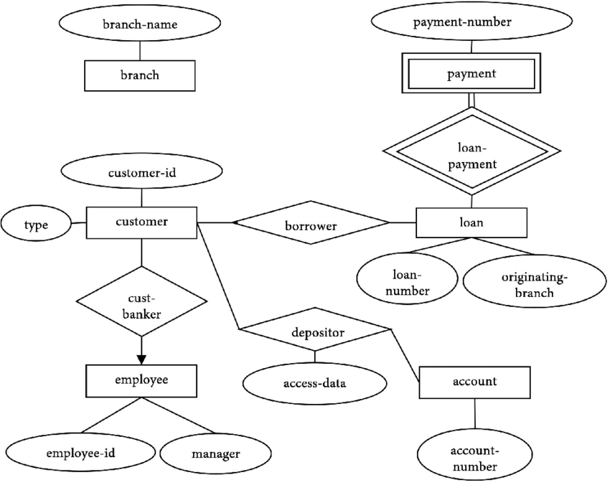

Fig 13: E-R Diagram

14. DATA FLOW DIAGRAM
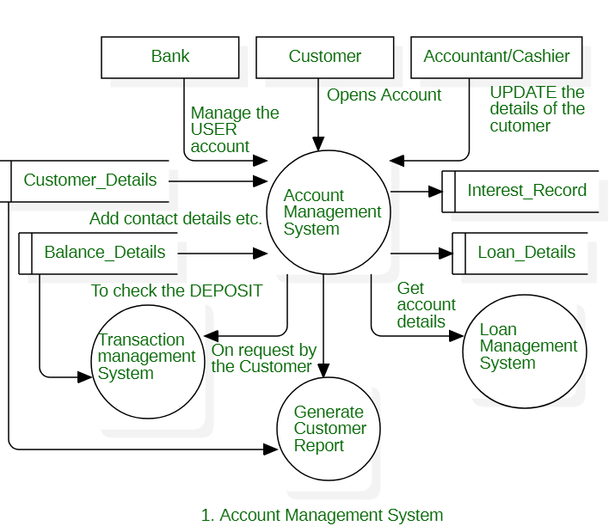
Fig.14:DFD

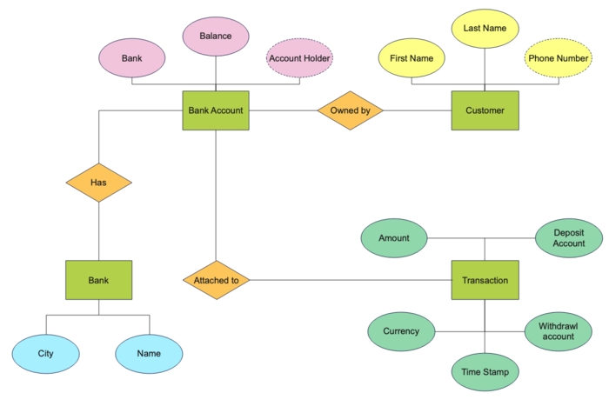
Fig 14.1 : Level 1

Fig 14.2 : Level 2

15. DATABASE DESIGN

1. Data Entities:

1.1. Customer:
- Attributes: CustomerID (Primary Key), FirstName, LastName, DateOfBirth, Address, Phone, Email, etc.

1.2. Account:
- Attributes:
AccountID (Primary Key), AccountNumber, AccountType, Balance, Status (Active/Inactive), OpenDate, CustomerID (Foreign Key), etc.

1.3 Transaction:
-Attributes:
TransactionID (Primary Key), TransactionType (Deposit/Withdrawal/Transfer), Amount, Date, AccountID (Foreign Key), etc.

1.4 Beneficiary:
- Attributes: BeneficiaryID (Primary Key), Name, AccountNumber, BankName, CustomerID (Foreign Key), etc.

2. Relationships:
2.1. One-to-Many Relationship:
- Each customer can have multiple accounts (One-to-Many relationship between Customer and Account).
- Each account can have multiple transactions (One-to-Many relationship between Account and Transaction).

- Each customer can have multiple beneficiaries (One-to-Many relationship between Customer and Beneficiary).

2.2. Foreign Key Constraints:

- The CustomerID attribute in the Account table is a foreign key referencing the Customer table, establishing a relationship between customers and their accounts.
- The AccountID attribute in the Transaction table is a foreign key referencing the Account table, linking transactions to specific accounts.
- The CustomerID attribute in the Beneficiary table is a foreign key referencing the Customer table, associating beneficiaries with their respective customers.

3. Indexes:
- Create indexes on foreign key columns and frequently queried columns to improve query performance.

4. Constraints:
- Define constraints such as primary keys, foreign keys, unique constraints, and check constraints to enforce data integrity and maintain consistency.

5. Normalization:
- Ensure that the database schema is normalized to minimize redundancy and improve data integrity.

16. SCREENSHOTS
Create New Account: The process of opening an account in the bank is very easy

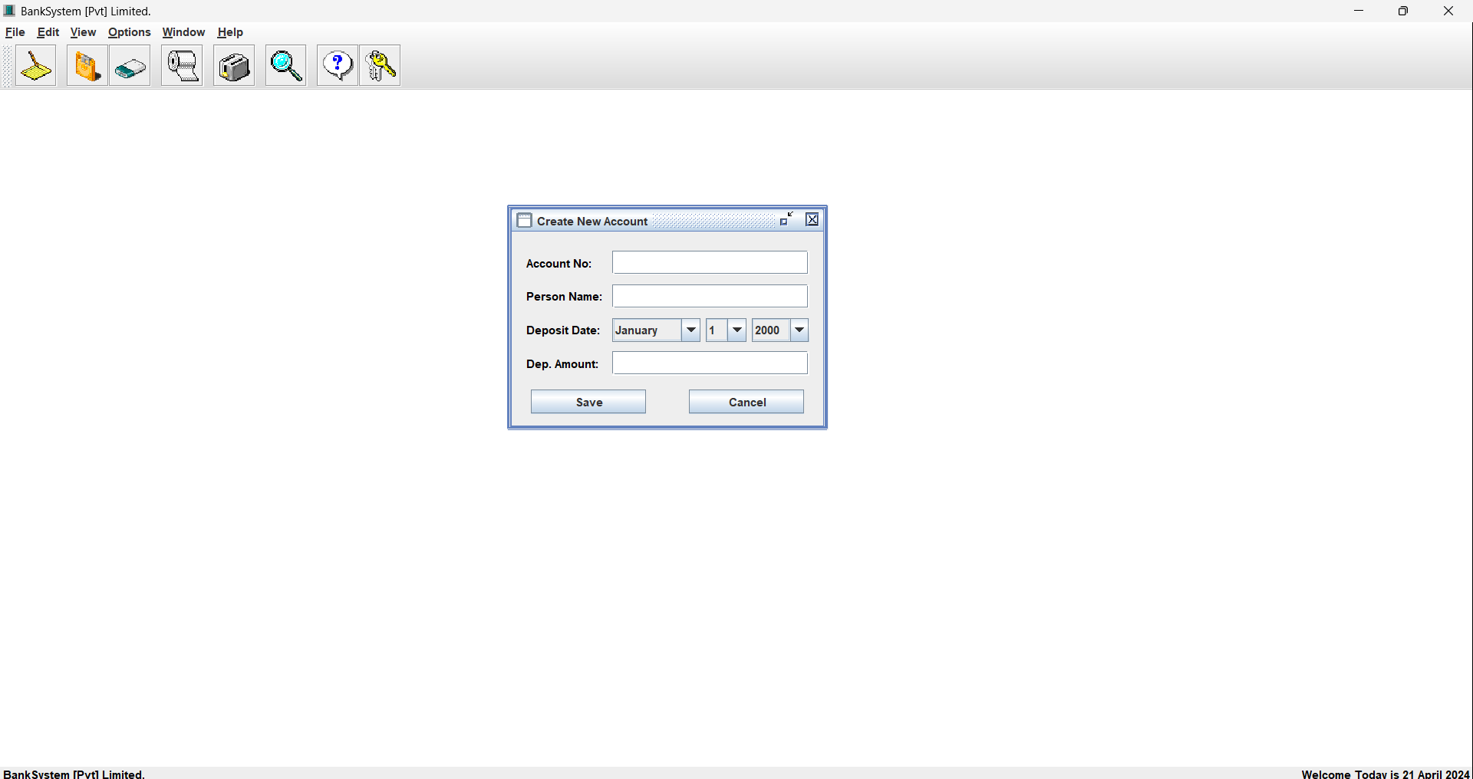
Fig.1

View Account Holders:- To "view all account holders," you are essentially asking how to identify
the owner(s) of an account.

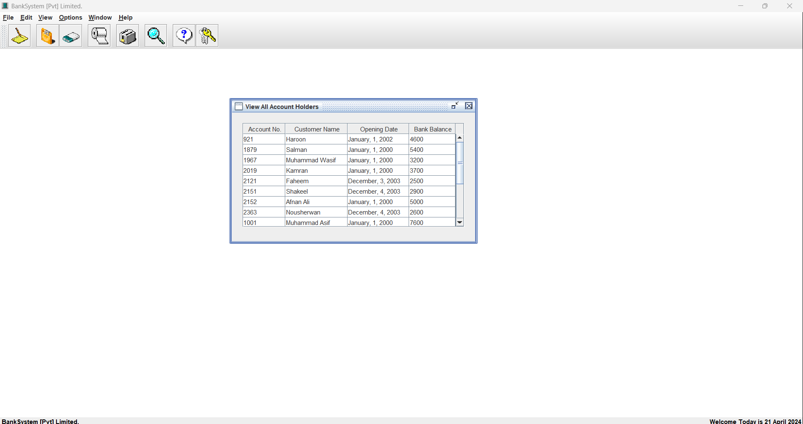
Fig. 1

Delete Account Holder:- This form will require details about the account (number, type, etc.) the
account holder(s) to be deleted,

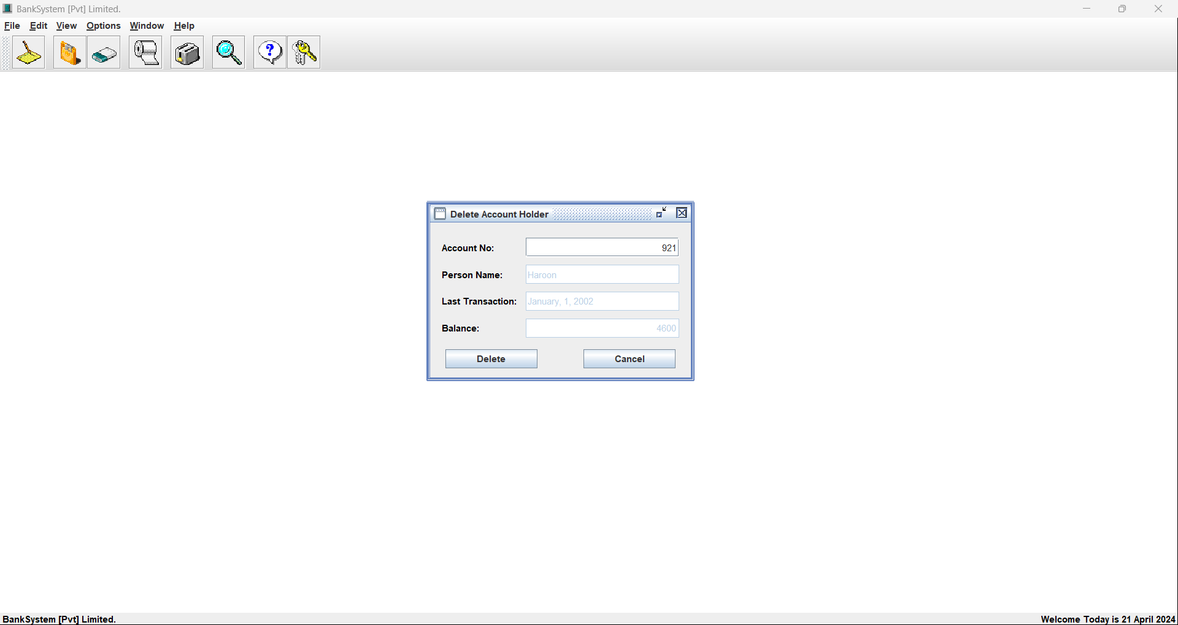
Fig. 2

17. CODING

import java.awt.*;
import javax.swing.*;
import java.awt.event.*;
import java.io.*;
import javax.swing.table.DefaultTableModel;
public class ViewCustomer extends JInternalFrame {
private JPanel jpShow = new JPanel ();
private DefaultTableModel dtmCustomer;
private JTable tbCustomer;
private JScrollPane jspTable;
private int row = 0;
private int total = 0;
//String Type Array use to Load Records into File.
private String rowData[][];
private FileInputStream fis;
private DataInputStream dis;
ViewCustomer () {
//super(Title, Resizable, Closable, Maximizable, Iconifiable)
super ("View All Account Holders", false, true, false, true);
setSize (475, 280);
jpShow.setLayout (null);
populateArray ();
tbCustomer = makeTable ();
jspTable = new JScrollPane (tbCustomer);
jspTable.setBounds (20, 20, 425, 200);
//Adding the Table to Panel.

jShow.add (jspTable);

//Adding Panel to Window.
getContentPane().add (jpShow);
//In the End Showing the New Account Window.
setVisible (true);
}
//Function use to load all Records from File when Window Open.

void populateArray () {
//String Type Array use to Load Records into File.
String rows[][] = new String [500][6];
try {
fis = new FileInputStream ("Bank.dat");
dis = new DataInputStream (fis);
//Loop to Populate the Array.
while (true) {
for (int i = 0; i < 6; i++) {
rows[row][i] = dis.readUTF ();
}
row++;
}
}
catch (Exception ex) {
total = row;
rowData = new String [total][4];
if (total == 0) {
JOptionPane.showMessageDialog (null, "Records File is Empty.\nEnter Records to Display.",
"BankSystem - EmptyFile", JOptionPane.PLAIN_MESSAGE);
}
else {
for (int i = 0; i < total; i++) {
rowData[i][0] = rows[i][0];
rowData[i][1] = rows[i][1];

rowData[i][2] = rows[i][2] + ", " + rows[i][3] + ", " + rows[i][4];
rowData[i][3] = rows[i][5];
}
try {
dis.close();
fis.close();
}
catch (Exception exp) { }
}
}
}
//Function to Create the Table and Add Data to Show.
private JTable makeTable () {
//String Type Array use to Give Table Column Names.
String cols[] = {"Account No.", "Customer Name", "Opening Date", "Bank Balance"};
dtmCustomer = new DefaultTableModel (rowData, cols);
tbCustomer = new JTable (dtmCustomer) {
public boolean isCellEditable (int iRow, int iCol) {
return false; //Disable All Columns of Table.
}
};
//Sizing the Columns of Table.
(tbCustomer.getColumnModel().getColumn(0)).setPreferredWidth (180);
(tbCustomer.getColumnModel().getColumn(1)).setPreferredWidth (275);
(tbCustomer.getColumnModel().getColumn(2)).setPreferredWidth (275);
(tbCustomer.getColumnModel().getColumn(3)).setPreferredWidth (200);
tbCustomer.setRowHeight (20);
tbCustomer.setSelectionMode (ListSelectionModel.SINGLE_SELECTION);
return tbCustomer;
}
}
import java.awt.*;
import java.awt.event.*;
import javax.swing.*;
import java.io.*;
public class WithdrawMoney extends JInternalFrame implements ActionListener {
private JPanel jpWith = new JPanel();
private JLabel lbNo, lbName, lbDate, lbWithdraw;
private JTextField txtNo, txtName, txtWithdraw;
private JComboBox cboMonth, cboDay, cboYear;
private JButton btnSave, btnCancel;
private int recCount = 0;
private int rows = 0;
private int total = 0;
private int curr;
private int withdraw;
//String Type Array use to Load Records From File.
private String records[][] = new String [500][6];
private FileInputStream fis;
private DataInputStream dis;
WithdrawMoney () {
// super(Title, Resizable, Closable, Maximizable, Iconifiable)
super ("Withdraw Money", false, true, false, true);
setSize (335, 235);
jpWith.setLayout (null);
lbNo = new JLabel ("Account No:");
lbNo.setForeground (Color.black);
lbNo.setBounds (15, 20, 80, 25);
lbName = new JLabel ("Person Name:");
lbName.setForeground (Color.black);
lbName.setBounds (15, 55, 80, 25);
lbDate = new JLabel ("With. Date:");
lbDate.setForeground (Color.black);
lbDate.setBounds (15, 90, 80, 25);
lbWithdraw = new JLabel ("With. Amount:");
lbWithdraw.setForeground (Color.black);
lbWithdraw.setBounds (15, 125, 80, 25);
txtNo = new JTextField ();
txtNo.setHorizontalAlignment (JTextField.RIGHT);
//Checking the Accunt No. Provided By User on Lost Focus of the TextBox.

txtNo.addFocusListener (new FocusListener () {
public void focusGained (FocusEvent e) { }
public void focusLost (FocusEvent fe) {
if (txtNo.getText().equals ("")) { }
else {
rows = 0;
populateArray (); //Load All Existing Records in Memory.
findRec (); //Finding if Account No. Already Exist or Not.
}
}
}
);
txtNo.setBounds (105, 20, 205, 25);
txtName = new JTextField ();
txtName.setEnabled (false);
txtName.setBounds (105, 55, 205, 25);
txtWithdraw = new JTextField ();
txtWithdraw.setHorizontalAlignment (JTextField.RIGHT);
txtWithdraw.setBounds (105, 125, 205, 25);
//Restricting The User Input to only Numerics in Numeric TextBoxes.
txtNo.addKeyListener (new KeyAdapter() {
public void keyTyped (KeyEvent ke) {
char c = ke.getKeyChar ();
if (!((Character.isDigit (c) || (c == KeyEvent.VK_BACK_SPACE)))) {
getToolkit().beep ();
ke.consume ();

}
}
}
);
txtWithdraw.addKeyListener (new KeyAdapter() {
public void keyTyped (KeyEvent ke) {
char c = ke.getKeyChar ();
if (!((Character.isDigit (c) || (c == KeyEvent.VK_BACK_SPACE)))) {
getToolkit().beep ();
ke.consume ();

}
}
}
);
//Creating Date Option.
String Months[] = {"January", "February", "March", "April", "May", "June",
"July", "August", "September", "October", "November", "December"};
cboMonth = new JComboBox (Months);
cboDay = new JComboBox ();
cboYear = new JComboBox ();
for (int i = 1; i <= 31; i++) {
String days = "" + i;
cboDay.addItem (days);
}
for (int i = 2000; i <= 2015; i++) {
String years = "" + i;
cboYear.addItem (years);
}
//Aligning The Date Option Controls.
cboMonth.setBounds (105, 90, 92, 25);
cboDay.setBounds (202, 90, 43, 25);
cboYear.setBounds (250, 90, 60, 25);
//Aligning The Buttons.
btnSave = new JButton ("Save");
btnSave.setBounds (20, 165, 120, 25);
btnSave.addActionListener (this);
btnCancel = new JButton ("Cancel");
btnCancel.setBounds (185, 165, 120, 25);
btnCancel.addActionListener (this);
//Adding the All the Controls to Panel.
jpWith.add (lbNo);
jpWith.add (txtNo);
jpWith.add (lbName);
jpWith.add (txtName);
jpWith.add (lbDate);
jpWith.add (cboMonth);
jpWith.add (cboDay);

jpWith.add (cboYear);
jpWith.add (lbWithdraw);
jpWith.add (txtWithdraw);
jpWith.add (btnSave);
jpWith.add (btnCancel);

//Adding Panel to Window.
getContentPane().add (jpWith);
populateArray (); //Load All Existing Records in Memory.
//In the End Showing the New Account Window.
setVisible (true);
}
//Function use By Buttons of Window to Perform Action as User Click Them.
public void actionPerformed (ActionEvent ae) {
Object obj = ae.getSource();
if (obj == btnSave) {
if (txtNo.getText().equals("")) {
JOptionPane.showMessageDialog (this, "Please! Provide Id of Customer.",
"BankSystem - EmptyField", JOptionPane.PLAIN_MESSAGE);
txtNo.requestFocus();
}
else if (txtWithdraw.getText().equals("")) {
JOptionPane.showMessageDialog (this, "Please! Provide Withdraw Amount.",
"BankSystem - EmptyField", JOptionPane.PLAIN_MESSAGE);
txtWithdraw.requestFocus ();
}
else {
withdraw = Integer.parseInt (txtWithdraw.getText ());
if (curr == 0) {
JOptionPane.showMessageDialog (this, txtName.getText () + " doesn't have any Amount in Balance.",
"BankSystem - EmptyAccount", JOptionPane.PLAIN_MESSAGE);
txtClear ();
}

else if (withdraw > curr) {
JOptionPane.showMessageDialog (this, "Withdraw Amount can't greater than Actual Balance.",
"BankSystem - Large Amount", JOptionPane.PLAIN_MESSAGE);
txtWithdraw.setText ("");
txtWithdraw.requestFocus ();
}
else {
editRec (); //Update the Contents of Array.
}
}
}
if (obj == btnCancel) {
txtClear ();
setVisible (false);
dispose();
}
}
//Function use to load all Records from File when Application Execute.
void populateArray () {
try {
fis = new FileInputStream ("Bank.dat");
dis = new DataInputStream (fis);
//Loop to Populate the Array.
while (true) {
for (int i = 0; i < 6; i++) {
records[rows][i] = dis.readUTF ();
}
rows++;
}
}
catch (Exception ex) {
total = rows;
if (total == 0) {
JOptionPane.showMessageDialog (null, "Records File is Empty.\nEnter Records First to Display.",
"BankSystem - EmptyFile", JOptionPane.PLAIN_MESSAGE);
btnEnable ();
}

else {
try {
dis.close();
fis.close();
}
catch (Exception exp) { }
}

}
}
//Function use to Find Record by Matching the Contents of Records Array with ID TextBox.
void findRec () {
boolean found = false;
for (int x = 0; x < total; x++) {
if (records[x][0].equals (txtNo.getText())) {
found = true;
showRec (x);
break;
}
}
if (found == false) {
String str = txtNo.getText ();
txtClear ();
JOptionPane.showMessageDialog (this, "Account No. " + str + " doesn't Exist.",
"BankSystem - WrongNo", JOptionPane.PLAIN_MESSAGE);
}
}
//Function which display Record from Array onto the Form.
public void showRec (int intRec) {
txtNo.setText (records[intRec][0]);
txtName.setText (records[intRec][1]);
curr = Integer.parseInt (records[intRec][5]);
recCount = intRec;

}
//Function use to Clear all TextFields of Window.
void txtClear () {
txtNo.setText ("");
txtName.setText ("");
txtWithdraw.setText ("");
txtNo.requestFocus ();
}
//Function use to Edit an Element's Value of the Array.
public void editRec () {
records[recCount][0] = txtNo.getText ();
records[recCount][1] = txtName.getText ();
records[recCount][2] = "" + cboMonth.getSelectedItem ();
records[recCount][3] = "" + cboDay.getSelectedItem ();
records[recCount][4] = "" + cboYear.getSelectedItem ();
records[recCount][5] = "" + (curr - withdraw);
editFile (); //Save This Array to File.
}
//Function use to Save Records to File After editing the Record of User Choice.
public void editFile () {
try {
FileOutputStream fos = new FileOutputStream ("Bank.dat");
DataOutputStream dos = new DataOutputStream (fos);
if (records != null) {
for (int i = 0; i < total; i++) {
for (int c = 0; c < 6; c++) {
dos.writeUTF (records[i][c]);
if (records[i][c] == null) break;
}
}
JOptionPane.showMessageDialog (this, "The File is Updated Successfully",
"BankSystem - Record Saved", JOptionPane.PLAIN_MESSAGE);
txtClear ();
dos.close();

fos.close();
}
}
catch (IOException ioe) {
JOptionPane.showMessageDialog (this, "There are Some Problem with File",
"BankSystem - Problem", JOptionPane.PLAIN_MESSAGE);
}
}
//Function use to Lock all Buttons of Window.
void btnEnable () {
txtNo.setEnabled (false);
cboMonth.setEnabled (false);
cboDay.setEnabled (false);
cboYear.setEnabled (false);
txtWithdraw.setEnabled (false);
btnSave.setEnabled (false);
}
}

import java.awt.*;
import java.awt.event.*;
import javax.swing.*;
import java.io.*;
public class NewAccount extends JInternalFrame implements ActionListener {
private JPanel jpInfo = new JPanel();
private JLabel lbNo, lbName, lbDate, lbDeposit;
private JTextField txtNo, txtName, txtDeposit;
private JComboBox cboMonth, cboDay, cboYear;
private JButton btnSave, btnCancel;
private int count = 0;
private int rows = 0;
private int total = 0;
//String Type Array use to Load Records From File.

private String records[][] = new String [500][6];
//String Type Array use to Save Records into File.
private String saves[][] = new String [500][6];
private FileInputStream fis;
private DataInputStream dis;
NewAccount () {
// super(Title, Resizable, Closable, Maximizable, Iconifiable)
super ("Create New Account", false, true, false, true);
setSize (335, 235);
jpInfo.setBounds (0, 0, 500, 115);
jpInfo.setLayout (null);
lbNo = new JLabel ("Account No:");
lbNo.setForeground (Color.black);
lbNo.setBounds (15, 20, 80, 25);
lbName = new JLabel ("Person Name:");
lbName.setForeground (Color.black);
lbName.setBounds (15, 55, 80, 25);
lbDate = new JLabel ("Deposit Date:");
lbDate.setForeground (Color.black);
lbDate.setBounds (15, 90, 80, 25);
lbDeposit = new JLabel ("Dep. Amount:");
lbDeposit.setForeground (Color.black);
lbDeposit.setBounds (15, 125, 80, 25);
txtNo = new JTextField ();
txtNo.setHorizontalAlignment (JTextField.RIGHT);
txtNo.setBounds (105, 20, 205, 25);
txtName = new JTextField ();
txtName.setBounds (105, 55, 205, 25);
txtDeposit = new JTextField ();
txtDeposit.setHorizontalAlignment (JTextField.RIGHT);
txtDeposit.setBounds (105, 125, 205, 25);
//Restricting The User Input to only Numerics in Numeric TextBoxes.
txtNo.addKeyListener (new KeyAdapter() {
public void keyTyped (KeyEvent ke) {

char c = ke.getKeyChar ();
if (!((Character.isDigit (c) || (c == KeyEvent.VK_BACK_SPACE)))) {
getToolkit().beep ();
ke.consume ();
}
}
}
);
txtDeposit.addKeyListener (new KeyAdapter() {
public void keyTyped (KeyEvent ke) {
char c = ke.getKeyChar ();
if (!((Character.isDigit (c) || (c == KeyEvent.VK_BACK_SPACE)))) {
getToolkit().beep ();
ke.consume ();
}
}
}
);
//Creating Date Option.
String Months[] = {"January", "February", "March", "April", "May", "June",
"July", "August", "September", "October", "November", "December"};
cboMonth = new JComboBox (Months);
cboDay = new JComboBox ();
cboYear = new JComboBox ();
for (int i = 1; i <= 31; i++) {
String days = "" + i;
cboDay.addItem (days);
}
for (int i = 2000; i <= 2024; i++) {
String years = "" + i;
cboYear.addItem (years);
}
//Aligning The Date Option Controls.
cboMonth.setBounds (105, 90, 92, 25);
cboDay.setBounds (202, 90, 43, 25);

cboYear.setBounds (250, 90, 60, 25);
//Aligning The Buttons.
btnSave = new JButton ("Save");
btnSave.setBounds (20, 165, 120, 25);
btnSave.addActionListener (this);
btnCancel = new JButton ("Cancel");
btnCancel.setBounds (185, 165, 120, 25);
btnCancel.addActionListener (this);
//Adding the All the Controls to Panel.
jpInfo.add (lbNo);
jpInfo.add (txtNo);
jpInfo.add (lbName);
jpInfo.add (txtName);
jpInfo.add (lbDate);
jpInfo.add (cboMonth);
jpInfo.add (cboDay);
jpInfo.add (cboYear);
jpInfo.add (lbDeposit);
jpInfo.add (txtDeposit);
jpInfo.add (btnSave);
jpInfo.add (btnCancel);
//Adding Panel to Window.
getContentPane().add (jpInfo);
//In the End Showing the New Account Window.
setVisible (true);
}
//Function use By Buttons of Window to Perform Action as User Click Them.
public void actionPerformed (ActionEvent ae) {
Object obj = ae.getSource();
if (obj == btnSave) {
if (txtNo.getText().equals("")) {
JOptionPane.showMessageDialog (this, "Please! Provide Id of Customer.",
"BankSystem - EmptyField", JOptionPane.PLAIN_MESSAGE);

if (total == 0) { }
else {
try {
dis.close();
fis.close();
}
catch (Exception exp) { }
}
}
}

//Function use to Find Record by Matching the Contents of Records Array with ID TextBox.
void findRec () {
boolean found = false;
for (int x = 0; x < total; x++) {
if (records[x][0].equals (txtNo.getText())) {
found = true;
JOptionPane.showMessageDialog (this, "Account No. " + txtNo.getText () + " is Already Exist.",
"BankSystem - WrongNo", JOptionPane.PLAIN_MESSAGE);
txtClear ();
break;
}
}
if (found == false) {
saveArray ();
}
}
//Function use to add new Element to Array.
void saveArray () {
saves[count][0] = txtNo.getText ();
saves[count][1] = txtName.getText ();
saves[count][2] = "" + cboMonth.getSelectedItem ();
saves[count][3] = "" + cboDay.getSelectedItem ();

saves[count][4] = "" + cboYear.getSelectedItem ();
saves[count][5] = txtDeposit.getText ();
saveFile (); //Save This Array to File.
count++;
}
//Function use to Save new Record to the File.
void saveFile () {
try {
FileOutputStream fos = new FileOutputStream ("Bank.dat", true);
DataOutputStream dos = new DataOutputStream (fos);
dos.writeUTF (saves[count][0]);
dos.writeUTF (saves[count][1]);
dos.writeUTF (saves[count][2]);
dos.writeUTF (saves[count][3]);
dos.writeUTF (saves[count][4]);
dos.writeUTF (saves[count][5]);
JOptionPane.showMessageDialog (this, "The Record has been Saved Successfully",
"BankSystem - Record Saved",

JOptionPane.PLAIN_MESSAGE);
txtClear ();
dos.close();
fos.close();
}
catch (IOException ioe) {
JOptionPane.showMessageDialog (this, "There are Some Problem with File",
"BankSystem - Problem", JOptionPane.PLAIN_MESSAGE);
}
}
//Function use to Clear all TextFields of Window.
void txtClear () {
txtNo.setText ("");
txtName.setText ("");

txtDeposit.setText ("");
txtNo.requestFocus ();
}
}

18. TESTING
Unit Testing:
Perform unit tests on individual code components to ensure their correctness. Test data retrieval, data processing, and numerical models for accuracy.

Integration Testing:
Test the integration of different system modules to verify data flow and communication. Validate that data from various sources are correctly processed and fed into the models.

User Testing:
Conduct usability tests with end-users to evaluate the user interface's functionality and user experience. Gather user feedback to make improvements.

System Testing:
Perform comprehensive system testing to validate the entire system's functionality. Validate the notification system and user customization features.

19. IMPLEMENTATION

1. Software Development:

Requirements Analysis:
Review the requirements gathered during the analysis phase and prioritize them based on business needs and user expectations.

System Design:
Translate the requirements into a detailed system design, including the user interface design, database schema, system architecture, and data flow diagrams.

Development:
Use appropriate programming languages and development frameworks to implement the BAMS according to the system design. Follow best practices for code quality, documentation, and version control.

Testing:
Conduct thorough testing of the BAMS to identify and fix any bugs, errors, or issues. Perform unit testing, integration testing, and system testing to ensure that the software meets quality standards and requirements.

2. Database Implementation:

Database Creation:

Set up the database management system (DBMS) and create the database schema based on the design specifications. Define tables, columns, indexes, constraints, and relationships as per the database design.

Data Population:
Populate the database with sample data for testing and validation purposes. Ensure that the data accurately represents real-world scenarios and covers various use cases and edge cases.

3. Deployment:

Environment Setup:
Prepare the deployment environment, including servers, networks, and infrastructure components, to host the BAMS software.

Installation:
Deploy the BAMS software on the production environment, following deployment procedures and best practices. Configure the system settings, security parameters, and integration points as required.

Data Migration:
If migrating from an existing system, perform data migration to transfer data from the old system to the new BAMS. Validate the integrity and consistency of migrated data to ensure a smooth transition.

4. User Training:

Training Materials:

Develop training materials, user manuals, and documentation to educate users on how to use the BAMS effectively.

Training Sessions:
Conduct training sessions for end-users, including bank staff, administrators, and customers, to familiarize them with the BAMS features, functionalities, and workflows.

Support Services:
Provide ongoing support and assistance to users to address any questions, issues, or concerns they may encounter while using the BAMS.

5. Rollout and Adoption:

Pilot Rollout:
Deploy the BAMS in a pilot environment or select branches to gather feedback and identify any issues or challenges before full-scale rollout.

Gradual Rollout:
Roll out the BAMS gradually across all branches or units of the bank, monitoring its performance and user feedback to ensure a smooth adoption process.

User Adoption Strategies:
Implement user adoption strategies, such as incentives, rewards, and recognition programs, to encourage users to embrace the BAMS and incorporate it into their daily workflows.

6. Monitoring and Maintenance:

Performance Monitoring:
Monitor the performance of the BAMS in real-time, tracking system uptime, response times, and resource utilization to identify any performance bottlenecks or issues.

Bug Fixing and Updates:
Address any bugs, errors, or issues reported by users promptly, releasing patches, updates, and bug fixes as necessary to maintain system stability and reliability.

Continuous Improvement:
Gather user feedback and insights to identify areas for improvement and enhancement of the BAMS. Implement continuous improvement initiatives to enhance user experience and meet evolving business needs.

20. MAINTENANCE

1. Regular Monitoring:

System Performance:
Monitor the performance of the BAMS, including response times, resource utilization, and database performance, to identify any bottlenecks or issues affecting system performance.

Security Monitoring:
Implement monitoring tools and techniques to detect and respond to security threats, such as unauthorized access attempts, data breaches, and malware attacks.

Availability Monitoring:
Monitor the availability of the BAMS, ensuring that it remains accessible to users and customers at all times. Implement failover mechanisms and redundancy solutions to minimize downtime.

2. Software Updates and Patch Management:

Vendor Updates:
Stay up-to-date with software updates and patches released by vendors for the operating system, database management system (DBMS), web server, and other software components used in the BAMS.

Security Patches:
Prioritize the installation of security patches to address vulnerabilities and mitigate security risks. Schedule regular patch management activities to ensure timely updates without disrupting system operations.

3. Database Maintenance:

Data Integrity Checks:
Perform regular data integrity checks to ensure that data stored in the database remains accurate, consistent, and reliable. Identify and resolve any data anomalies or discrepancies promptly.

Database Optimization: Optimize database performance by tuning database queries, indexing frequently accessed columns, and archiving or purging outdated data to improve query response times and reduce storage overhead.

4. Backup and Disaster Recovery:

Regular Backups:
Implement a robust backup strategy to regularly backup critical data and system configurations, including customer account information, transaction logs, and system settings.

Offsite Storage:
Store backup copies of data in secure offsite locations to protect against data loss due to hardware failures, natural disasters, or other catastrophic events.

Disaster Recovery Plan:
Develop and maintain a comprehensive disaster recovery plan outlining procedures for restoring system functionality and data integrity in the event of a system outage or data loss.

5. User Support and Training:

Helpdesk Support:
Provide ongoing helpdesk support to address user inquiries, technical issues, and system-related questions promptly. Establish a dedicated support team to handle user support requests effectively.

User Training:
Conduct regular training sessions and workshops to educate users on new features, system updates, and best practices for using the BAMS. Provide training materials, user manuals, and online resources to facilitate self-learning.

6. Compliance and Regulatory Updates:

Regulatory Compliance:
Stay informed about changes to regulatory requirements and industry standards governing banking operations, data privacy, and information security. Ensure that the BAMS remains compliant with relevant regulations, such as GDPR, PCI-DSS, and banking regulations.

Audits and Assessments:
Conduct periodic audits and security assessments of the BAMS to evaluate compliance with regulatory requirements, identify potential vulnerabilities, and implement remediation measures as needed.

7. Continuous Improvement:

User Feedback:

Solicit feedback from users and stakeholders on their experience with the BAMS, including usability issues, feature requests, and performance concerns. Use this feedback to prioritize improvements and enhancements.

Software Enhancements:
Implement regular software updates and enhancements to address user feedback, improve system usability, and introduce new features and functionalities that add value to users and customers.

21. LIMITATIONS

1. Security Risks: Despite stringent security measures, BAMS is susceptible to security breaches, fraud, and cyber-attacks. Hackers may exploit vulnerabilities in the system to gain unauthorized access to sensitive financial information or carry out fraudulent transactions.

2. Dependence on Technology: BAMS relies heavily on technology infrastructure, including servers, networks, and software applications. Any technical glitches, system failures, or disruptions in IT services can disrupt banking operations and affect customer service.

3. Transaction Processing Delays: High transaction volumes or system overload may lead to delays in processing transactions, causing inconvenience to customers and impacting service quality. Peak times, such as month-end or holiday seasons, can exacerbate this issue.

4. Limited Accessibility: While online and mobile banking platforms offer convenience, some customers, particularly in rural or remote areas, may face challenges accessing banking services due to limited internet connectivity or lack of digital literacy.

5. Data Privacy Concerns: BAMS collects and stores vast amounts of sensitive customer data, including personal and financial information. Ensuring data privacy and compliance with regulations such as GDPR and CCPA presents challenges, particularly in the context of data breaches or unauthorized access.

6. Transaction Errors: Human errors or system glitches can result in transaction errors, such as incorrect debits or credits, duplicate transactions, or processing delays. Resolving such errors may require manual intervention and can impact customer trust and satisfaction.

7. Dependency on Third-Party Providers: BAMS may rely on third-party service providers for various functions, such as payment processing, data storage, or security services. Any disruptions or service outages from these providers can affect the reliability and performance of the BAMS.

8. Regulatory Compliance Burden: Banks must adhere to stringent regulatory requirements and compliance standards imposed by government authorities. Ensuring compliance with regulations such as Basel III, Anti-Money Laundering (AML), and Know Your Customer (KYC) adds complexity and operational costs to BAMS.

9. Scalability Challenges: As banks grow and expand their customer base, BAMS must scale to accommodate increasing transaction volumes, user accounts, and system

complexity. Scaling the infrastructure and software architecture while maintaining performance and reliability can be challenging.

10. Customer Support Limitations: While BAMS provides self-service options and automated support features, some customers may require personalized assistance for complex issues or inquiries. Providing timely and effective customer support across various channels can be resource-intensive.

22. FUTURE SCOPE

1. Enhanced Security Measures: With the increasing threat of cyber-attacks and fraud, BAMS will focus on implementing advanced security measures such as biometric authentication, multi-factor authentication, and blockchain technology to ensure the integrity and confidentiality of customer data and transactions.

2. Personalized Banking Experience: BAMS will leverage data analytics and artificial intelligence (AI) to deliver personalized banking experiences tailored to individual customer preferences and behavior. This includes personalized product recommendations, targeted marketing campaigns, and proactive financial advice.

3. Mobile and Digital Banking: The proliferation of smartphones and digital devices will drive the adoption of mobile and digital banking channels. BAMS will continue to invest in mobile app development, responsive web design, and seamless omnichannel integration to provide customers with convenient access to banking services anytime, anywhere.

4. Open Banking and APIs: Open banking initiatives and the adoption of application programming interfaces (APIs) will enable BAMS to integrate with third-party financial services providers, fintech startups, and other ecosystem partners. This will facilitate innovation, collaboration, and the development of new banking products and services.

5. Real-Time Payments: BAMS will enable real-time payment processing capabilities, allowing customers to make instant payments and transfers, 24/7, across different payment networks and channels. This includes peer-to-peer (P2P) payments, bill payments, and merchant transactions.

6. Data Privacy and Compliance: BAMS will continue to prioritize data privacy and regulatory compliance, ensuring adherence to strict data protection laws such as GDPR, CCPA, and PSD2. This includes implementing robust data encryption, anonymization techniques, and privacy-by-design principles.

7. Financial Inclusion: BAMS will play a key role in promoting financial inclusion by expanding access to banking services for underserved and unbanked populations. This includes offering low-cost banking accounts, digital payment solutions, and financial literacy programs tailored to the needs of marginalized communities.

8. Environmental Sustainability: BAMS will focus on environmental sustainability by adopting green banking practices, reducing paper usage, and minimizing carbon footprint. This includes offering electronic statements, digital receipts, and eco-friendly banking initiatives to promote environmental conservation.

9. Voice and Conversational Banking: BAMS will leverage voice recognition technology and natural language processing (NLP) to enable voice-enabled banking interactions and conversational interfaces. This includes voice-activated commands, chatbots, and virtual assistants to assist customers with inquiries and transactions.

10. Predictive Analytics and Risk Management: BAMS will utilize predictive analytics and machine learning algorithms to assess credit risk, detect fraudulent activities, and prevent financial crimes in real-time. This includes transaction monitoring, anomaly detection, and predictive modeling to identify potential risks and vulnerabilities.

23. CONCLUSION

In conclusion, the Bank Account Management System (BAMS) stands as a cornerstone in the modern banking landscape, facilitating efficient and secure management of financial transactions and customer accounts. Through this system, banks can streamline operations, enhance customer experience, and ensure regulatory compliance.

BAMS has revolutionized banking by transitioning from traditional brick-and-mortar branches to digital platforms accessible anytime, anywhere. It has empowered customers with convenient self-service options, personalized banking experiences, and real-time access to financial information.

Despite its many benefits, BAMS faces challenges such as security risks, scalability issues, and regulatory compliance burdens. However, ongoing advancements in technology, regulatory frameworks, and risk management practices continue to address these challenges and drive innovation in the banking industry.

Looking ahead, the future of BAMS holds promise with advancements in areas such as enhanced security measures, personalized banking experiences, real-time payments, and financial inclusion initiatives. As banks embrace digital transformation and customer-centric innovation, BAMS will play a pivotal role in shaping the future of banking, driving efficiency, innovation, and customer satisfaction.

In essence, the Bank Account Management System is not just a tool for managing financial transactions; it is a catalyst for transforming the way banks interact with customers, deliver services, and drive value in the digital age. With its continued evolution and adaptation to changing market dynamics, BAMS will remain at the forefront of banking innovation, empowering banks and customers alike to thrive in an increasingly digital world.

24. BIBLIOGRAPHY

1. Ahrens, C. Donald. "Meteorology Today: An Introduction to Weather, Climate, and the Environment." Cengage Learning, 2020.

2. Kalnay, Eugenia. "Atmospheric Modeling, Data Assimilation, and Predictability." Cambridge University Press, 2003.

3. Pielke Sr., Roger A. "Mesoscale Meteorological Modeling." Academic Press, 2002.

4. Kuo, Hung-Tse. "Numerical Weather and Climate Prediction." Cambridge University Press, 2018.

5. Wilks, Daniel S. "Statistical Methods in the Atmospheric Sciences." Academic Press, 2011.

6. ECMWF - European Centre for Medium-Range Weather Forecasts. "Numerical Weather Prediction." Accessed from https://www.ecmwf.int/en/forecasts/documentation-and-support/numerical-weather-prediction.

7. NOAA - National Oceanic and Atmospheric Administration. "Introduction to Numerical Weather Prediction Models." Accessed from https://www.weather.gov/jetstream/nummod.

8. WRF - Weather Research and Forecasting Model. "WRF User's Guide." Accessed from https://www2.mmm.ucar.edu/wrf/users/docs/user_guide/.

9. Wang, Jianjie, et al. "Machine Learning for Geophysical and Geochemical Data Exploration: Methods and Applications." AGU, 2019.

10. Gagne II, David J., and Adam P. Kellner. "Machine Learning in R for Spatial, Environmental, and Geosciences Data Analysis." Springer, 2020.

11. OpenWeatherMap API Documentation. Accessed from https://openweathermap.org/api.

12. National Weather Service Data Catalog. Accessed from https://www.ncdc.noaa.gov/cdo-web/datasets.

25. REFERENCES

When referencing sources for a weather forecasting project, it's essential to include a list of all the materials, studies, data sources, and tools used. Here's how you can format the references:

1.Books:

- Ahrens, C. D. (2020). *Meteorology Today: An Introduction to Weather, Climate, and the Environment*. Cengage Learning.
- Kalnay, E. (2003). *Atmospheric Modeling, Data Assimilation, and Predictability*. Cambridge University Press.
- Wilks, D. S. (2011). *Statistical Methods in the Atmospheric Sciences*. Academic Press.

2.Academic Papers:

- Kuo, H. T. (2018). Numerical Weather and Climate Prediction. *Journal of Meteorological Research*, 32(3), 301-315.
- Pielke Sr., R. A. (2002). Mesoscale Meteorological Modeling. *Journal of the Atmospheric Sciences*, 59(6), 518-548.

3.Online Resources:

- ECMWF - European Centre for Medium-Range Weather Forecasts. (n.d.). Numerical Weather Prediction. Retrieved from [https://www.ecmwf.int/en/forecasts/documentation-and-support/numerical-weather-prediction](https://www.ecmwf.int/en/forecasts/documentation-and-support/numerical-weather-prediction).
- NOAA - National Oceanic and Atmospheric Administration. (n.d.). Introduction to Numerical Weather Prediction Models. Retrieved from [https://www.weather.gov/jetstream/nummod](https://www.weather.gov/jetstream/nummod).

4.APIs and Data Sources:

- OpenWeatherMap API Documentation. (n.d.). Retrieved from [https://openweathermap.org/api](https://openweathermap.org/api).
- National Weather Service Data Catalog. (n.d.). Retrieved from [https://www.ncdc.noaa.gov/cdo-web/datasets](https://www.ncdc.noaa.gov/cdo-web/datasets).

