TASK 1
1.Find the top 10 customers by credit limit
select customername,creditlimit
from customers
order by creditlimit desc
limit 10;
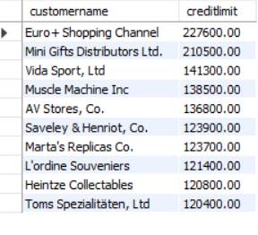

2.Find the average credit limit for customers in each country
Select country,avg(creditlimit)
from customers
group by country
order by avg(creditlimit);
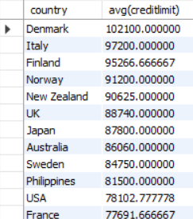
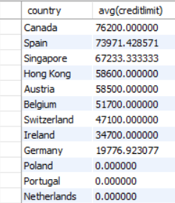
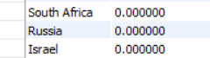

3.Find the number of customers in each state
select state, count(customernumber)
from customers
group by state;
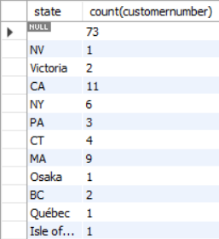
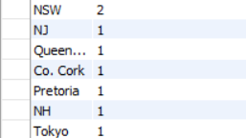

4.Find the customers who haven’t placed any orders
select c.customerName,c.customernumber
from customers c
left join
orders o
on c.customernumber=o.customernumber
where o.ordernumber is null;
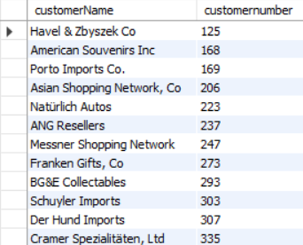
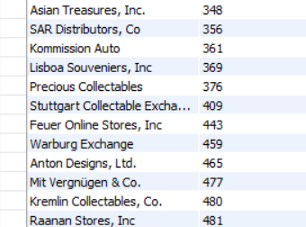

5.Calculate total sales for each customer
select c.customerName,c.customernumber,
count(o.ordernumber) as total_orders
from customers c
join orders o
on c.customernumber=o.customernumber
group by customernumber
order by total_orders desc;
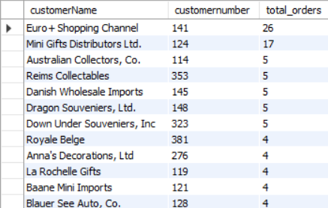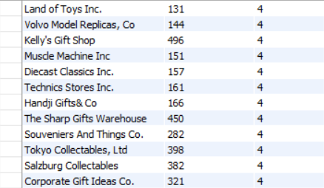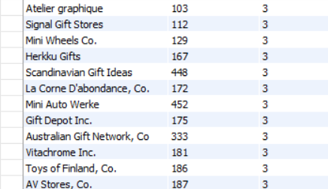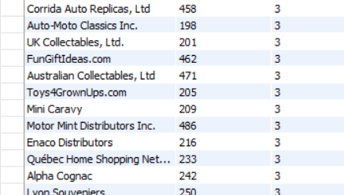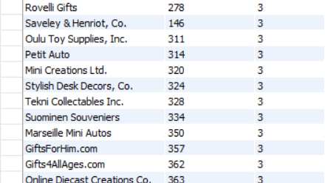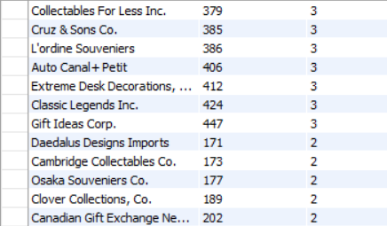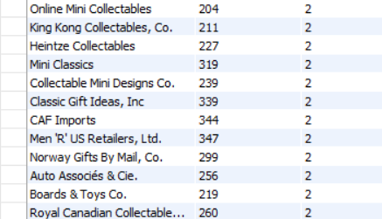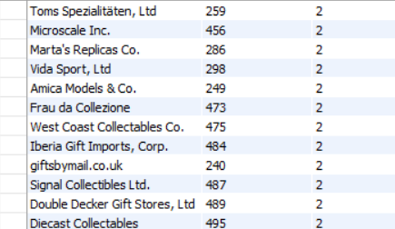

6.List the customers with their assigned sales representatives.
select c.customerName,c.customernumber,
c.salesrepemployeenumber,e.firstname,e.lastname
from customers c
join employees e
on c.salesrepemployeenumber=e.employeenumber;
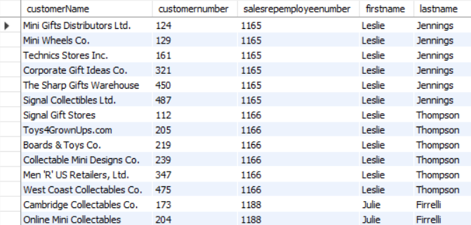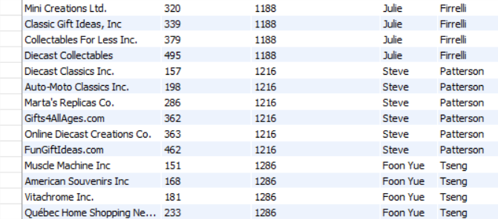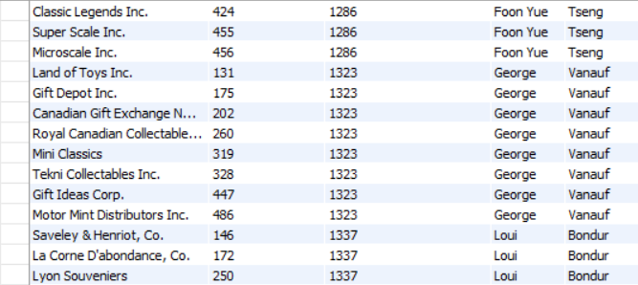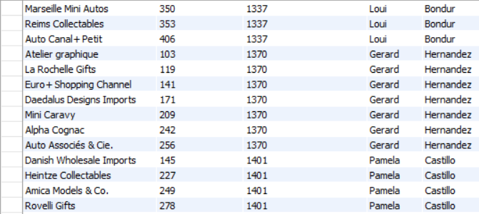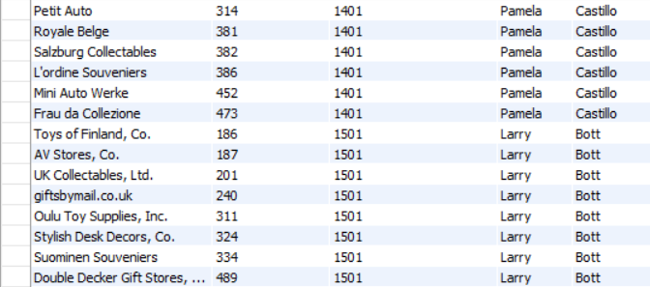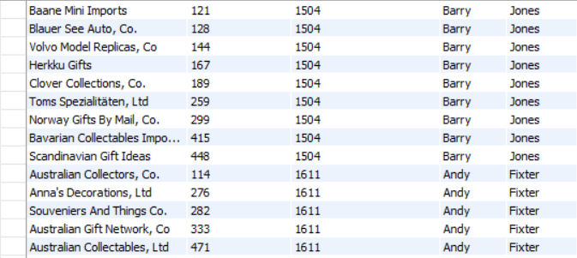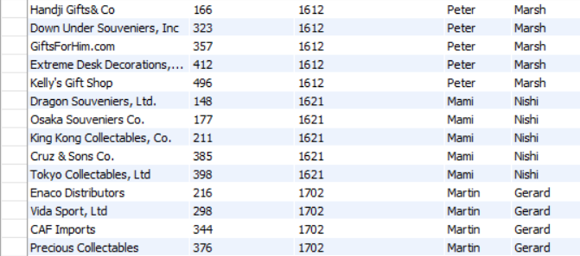

7.Retrieve customer information with their most recent payment details
Select c.customerName, c.customerNumber,
(select max(p.paymentDate) from payments p
where p.customerNumber = c.customerNumber) as payment_date
from customers c;

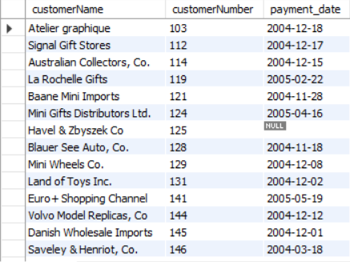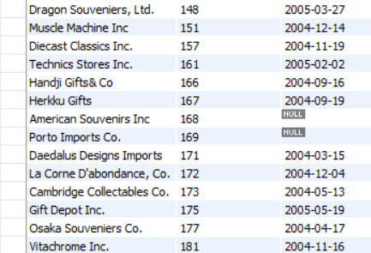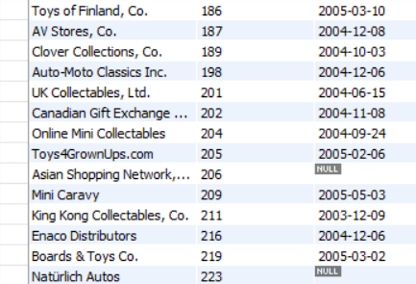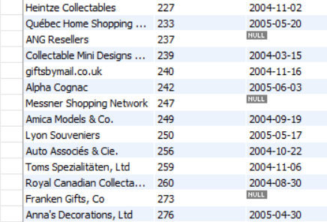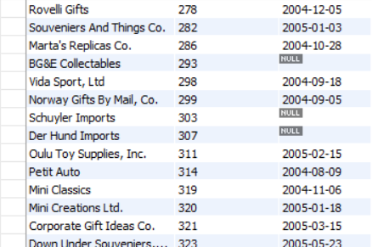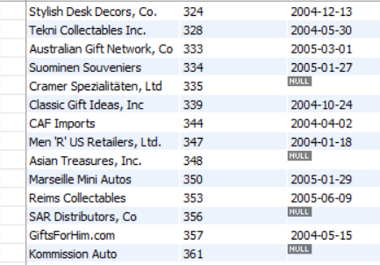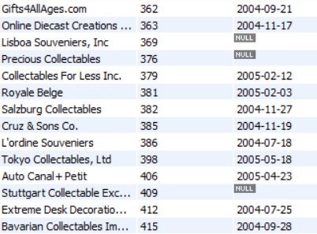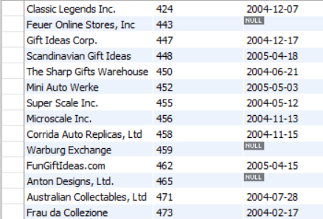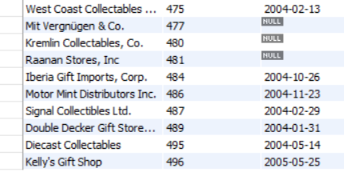

8.Identify the customers who have exceeded their credit limit
select c.customerName, c.customerNumber,c.creditlimit,
sum(p.amount)
from customers c
join payments p
on c.customernumber=p.customernumber
group by c.customerName,c.customernumber,c.creditlimit having sum(p.amount)>creditlimit; 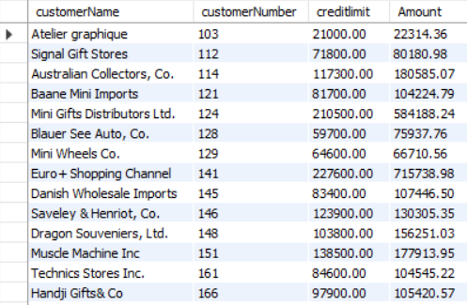 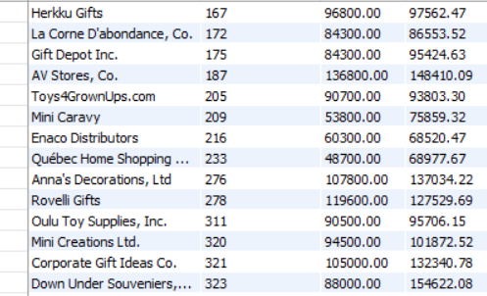 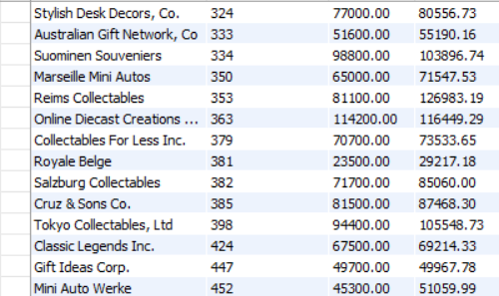 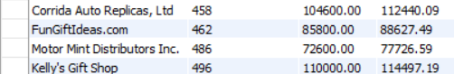

9.Find the names of all customers who have places an order for a product from specific productline.
Select distinct c.customerName
from customers c
join orders o on c.customerNumber = o.customerNumber
join orderdetails od on o.orderNumber = od.orderNumber
join products p on od.productCode = p.productCode
where p.productline = 'Vintage Cars'
and p.productName = '1911 Ford Town Car';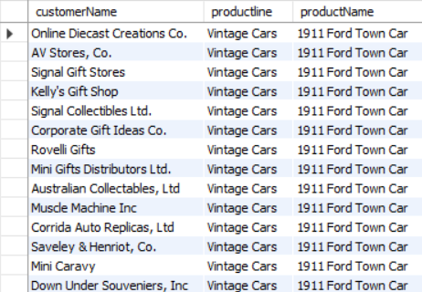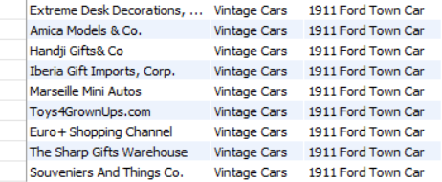

10.Find the names of all customers who have placed an order for the most expensive product.
Select distinct c.customerName, p.productName, p.buyPrice
from customers c
join orders o on c.customerNumber = o.customerNumber
join orderdetails od on o.orderNumber = od.orderNumber
join products p on od.productCode = p.productCode
where p.buyPrice = (select max(buyPrice) from products);
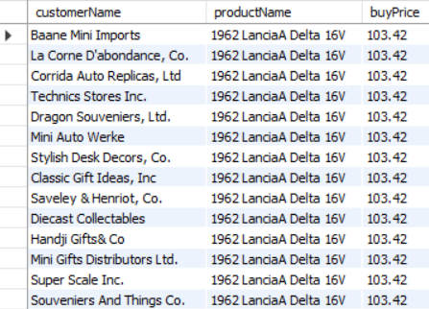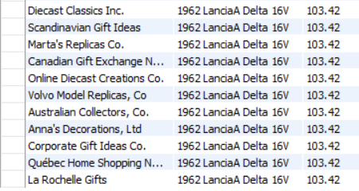

TASK 2
1.Count the number of employees working in each office
select o.officecode,count(e.employeenumber) AS employee_count from
employees e
join offices o
on o.officecode=e.officecode
group by officecode;
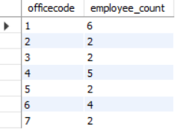

2.Identify the offices with less than a certain number of employees
select o.officecode,
count(*) AS employee_count
from employees e
join
offices o
on o.officecode=e.officecode
group by officecode having count(e.employeenumber)<5;
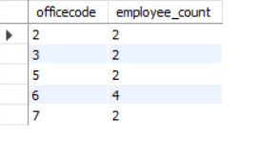

3.List offices along with their assigned territories
select officecode,city,state,territory
from offices;
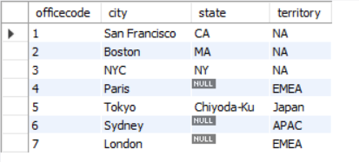

4.Find the offices that have no employees assigned to them
select o.officecode,count(e.employeenumber)
from offices o
left join employees e
on o.officecode=e.officecode
group by officecode having count(e.employeenumber)=0;
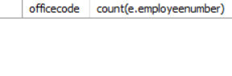

5.Retrieve the most profitable office based on total sales
select o.officecode,o.city,sum(p.amount)
from offices o
join employees e on o.officecode=e.officecode
join customers c on c.salesrepemployeenumber=e.employeenumber
join payments p on p.customernumber=c.customernumber
group by o.officecode,o.city
order by sum(p.amount) desc
limit 1;
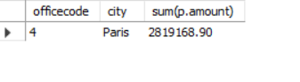

6.Find the office with highest number of employees
select o.officecode,o.city,count(e.employeenumber)
from offices o
join employees e
on o.officecode=e.officecode
group by officecode
order by count(e.employeenumber) desc
limit 1;
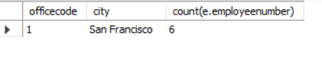

7.Find the average credit limit of customers in each office
select o.officecode,o.city, avg(c.creditlimit) as Average_creditlimit
from offices o
join employees e on o.officecode=e.officecode
join customers c on c.salesrepemployeenumber=e.employeenumber
group by officecode;
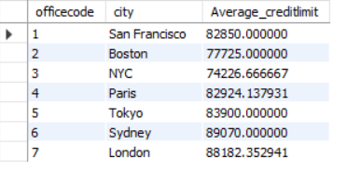

8.Find the number of offices in each country
select o.country,count(o.officecode)
from offices o
group by country
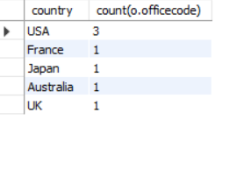

TASK 3
1.Count the number of products in each productline
select productline, count(*) as numberofproduct
from products
group by productline
order by numberofproduct desc;
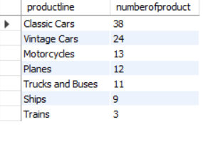

2.Find the product line with the highest average product price
select productline, avg(MSRP)
from products
group by productline
order by avg(MSRP) desc
limit 1;
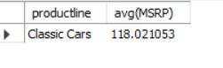

3.Find all products with a price above or below a certain amount
select productname,msrp
from products
where 50<msrp and msrp<100
order by msrp desc;
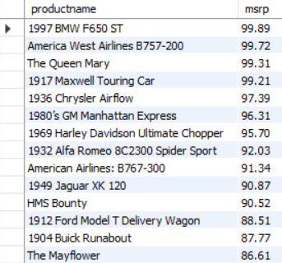
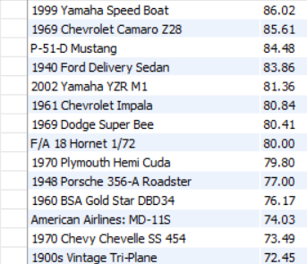
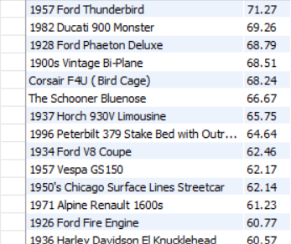
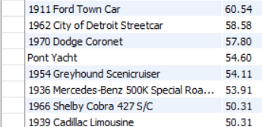

4.Find the total sales amount for each product line
select pr.productline,
sum(p.amount) as total_sales_amount
from products pr
left join orderdetails o on o.productcode=pr.productcode
left join orders s on s.ordernumber=o.ordernumber
left join payments p on p.customernumber=s.customernumber
group by productline;
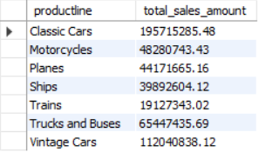

5.Identify products with low inventory level (less than a specific threshold value of 10 for quantityinstock)
select distinct p.productname,p.productline
from products p
where quantityinstock <10;
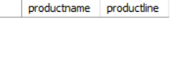

6.Retrieve the most expensive product based on MSRP
select pr.productname,pr.productline,max(pr.msrp)
from products pr
group by pr.productname,pr.productline
order by max(pr.msrp) desc
limit 1;
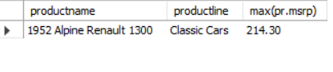

7.Calculate total sales for each product
select pr.productname,
sum(p.amount) as total_sales_amount
from products pr
left join orderdetails o on o.productcode=pr.productcode
left join orders s on s.ordernumber=o.ordernumber
left join payments p on p.customernumber=s.customernumber
group by productname;
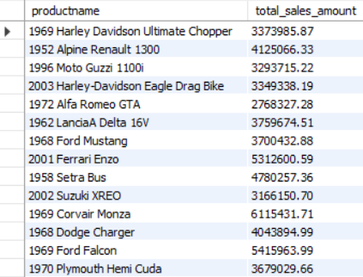
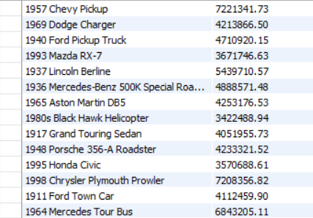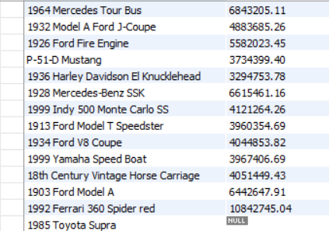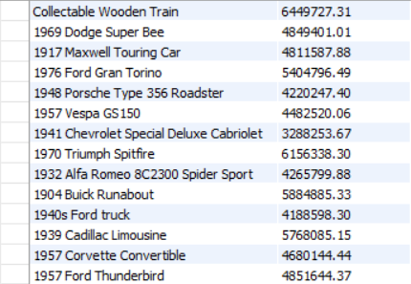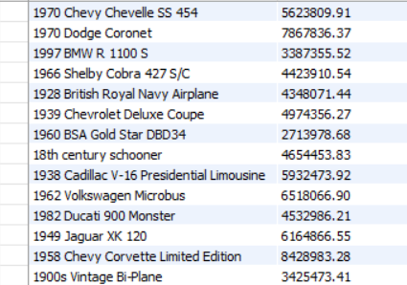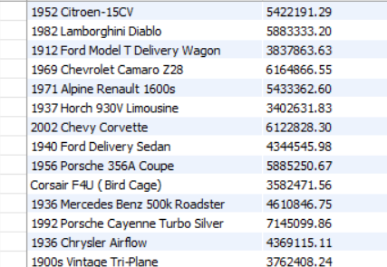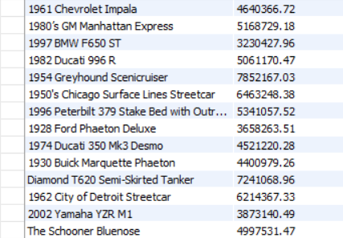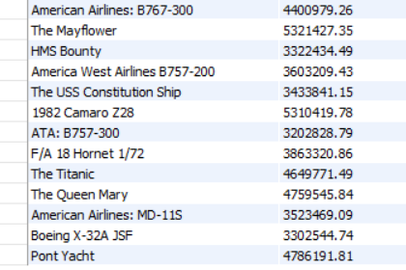

8.Identify the top selling product based on total quantity ordered using a stored procedure.The procedure should accept an input parameter to specify the number of top selling product to retrieve
CREATE DEFINER=`root`@`localhost` PROCEDURE `top_selling_products`(in topN int)
BEGIN
select p.productname ,sum(o.quantityordered) as total_quantity
from products p
join orderdetails o
on p.productcode=o.productcode
group by p.productname
order by total_quantity desc
limit topN;
END

Call top_selling_products(5);
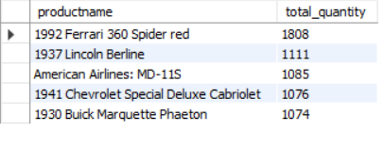

9.Retrieve products with low inventory level(less than a threshold value of 10 for quantityinstock ) within specific productlines(‘classic cars’,’Motorcycles’)
Select p.productName, p.productline, p.quantityInStock
from products p
where p.productline in ('classic cars', 'Motorcycles')
and p.quantityInStock < 10;
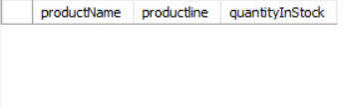

(if quantity in stock is less than 100)
Select p.productName, p.productline, p.quantityInStock
from products p
where p.productline in ('classic cars', 'Motorcycles')
and p.quantityInStock < 100;

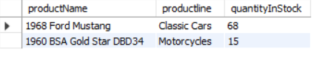

10.Find the names of all products that have been ordered by more than 10 customers
select p.productName,count(distinct o.customernumber) as customer_count
from products p
join orderdetails od on od.productcode=p.productcode
join orders o on o.ordernumber=od.ordernumber
group by p.productname having count(distinct o.customernumber)>10
order by count(distinct o.customernumber) desc;
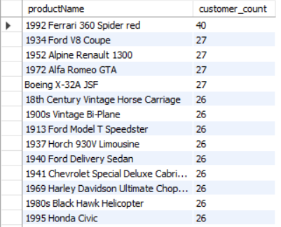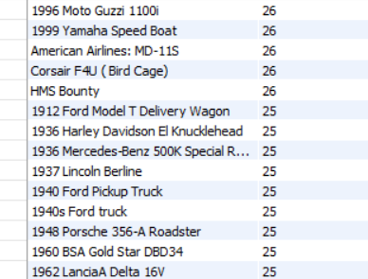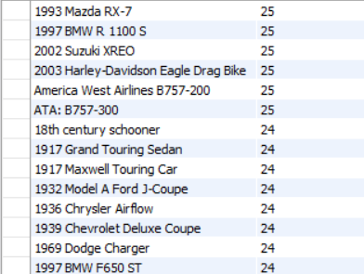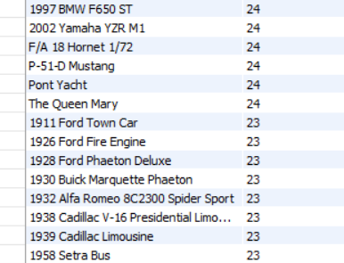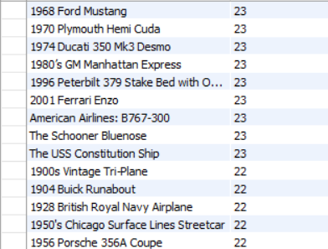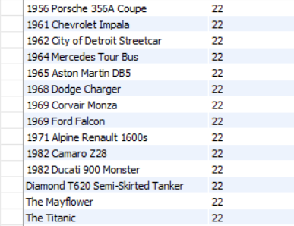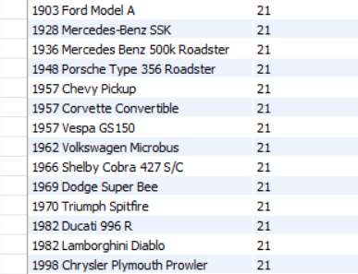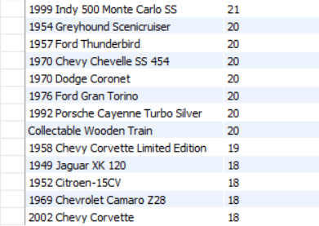

11.Find the names of all products that have been ordered more than the average number of orders for their productline.
select p.productname,pl.productline,
count(distinct o.ordernumber) as totalorders
from products p
join productlines pl on p.productline = pl.productline
join orderdetails od on p.productcode = od.productcode
join orders o on od.ordernumber = o.ordernumber
join (select productline,
avg(product_order_count) as avg_orders
from (select p2.productline,
count(distinct o2.ordernumber) as product_order_count
from products p2
join orderdetails od2 on p2.productcode = od2.productcode
join orders o2 on od2.ordernumber = o2.ordernumber
group by p2.productcode, p2.productline) as product_orders
group by productline) as avg_table on p.productline = avg_table.productline
group by p.productcode, p.productname, pl.productline, avg_table.avg_orders
having count(distinct o.ordernumber) > avg_table.avg_orders;

