ANUJA BHATTA

PROFILE
• Energetic and passionate computer engineering student
• Strong interest in technology, UI/UX, and problem-solving
• Always eager to learn and take on new challenges

EDUCATION
SAGARMATHA ENGINEERING COLLEGE, SANEPA
LALITPUR
Bachelor in Computer Engineering (2080 -Present)
NATIONAL SCHOOL OF SCIENCES, LAINCHOUR
KATHMANDU
+2 (2078 – 2080)

EXPERIENCE
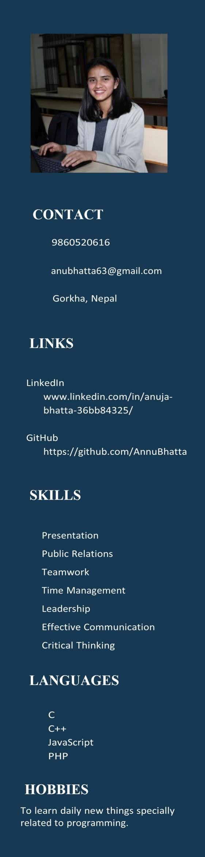
Participated in UI/UX competition
Attended Gemini workshop organized by GDC
Attended Web development Session
Attended UI/UX workshop and session
Volunteered at orbit engineering hacks/expo

PROJECT
CRUD System (MySQL, PHP)
Simple Calculator (C)
MCQ Pattern (C++)
Websites from HTML and CSS
ACHIEVEMENTS
Best presentation on UI/UX competition

INTEREST
Human-Centered Problem Solving through Technology, Full stack

