Annuj Kumar
23BCE1935

Graph-Augmented Retrieval-Based Intelligent Code Review System
Using AST-Driven Dependency Analysis and Large Language Models

Github Links :-
Backend Logic :- https://github.com/AnnujKumar/ReviewSenseBackend
Frontend Logic :- https://github.com/AnnujKumar/ReviewSpacesFrontend
1. Project Title
Graph-Augmented Retrieval-Based Intelligent Code Review System Using AST-Driven Dependency Analysis and Large Language Models
Short Title: GraphRAG Code Reviewer — An AI-Powered Pull Request Analysis Engine with Impact-Aware Dependency Traversal
2. Abstract
Manual code reviews are important to modern software teams, but can take a lot of manual effort and lack rigor and consistency. Further, manual reviews are not great at surfacing integration-level defects which occur across multiple files. In this project, we will develop a new approach to automated code review based on Retrieval-Augmented Generation (RAG) coupled with graph-based dependency information. This will enable natural-language queries of codebases, as well as context-aware, impact-sensitive pull request reviews.
Our system will be built as a Github App that subscribes to webhook events(pulls, pushes, installations). Upon installation to a repository, it clones the entire repo and ingests it into a three-stage pipeline: (1) parse the code into an AST with Babel, which will emit function-level symbols and their call dependency relationships. (2) Build the code dependency graph and store it as a pg(GraphSQL, database(Neon). (3) Compute semantic embeddings for each function-level symbol with the sentence-transformers/all-mpnet-base-v2 model from HuggingFace and store those embeddings in a Pinecone vector store.
When a pull request is opened, we will parse the Git diff to determine line number ranges that have changed. We can map those line ranges to code symbols that were affected using an overlap detection algorithm against our previously stored graph. We can then inflate the radius of our impact set by performing a graph traversal to find all functions downstream of our changing code that depend on it. We then lookup the source code for these functions in our vector store and use the combination of context (the diff + all impacted downstream functions) as input to our language model. We will use Google's Gemini LLM (Gemma 3 12B Instruction-Tuned) with a hand-crafted prompt that instructs the model to find logical regressions, breaking API changes, and other integration-level defects.Early results demonstrate the system’s ability to identify breaking changes that conventional line-by-line review tools miss — specifically, cases where a function signature changes but its callers in other files remain unmodified. The system also supports a conversational RAG query endpoint for semantic codebase exploration.
The major contributions lie in:
(i) symbol-level embedding, in which text chunking is avoided in favor of AST-based code decomposition
(ii) diff-to-graph impact retrieval, in which PR changes are mapped to downstream dependencies before LLM analysis
(iii) microservices-based architecture with BullMQ-based asynchronous job processing.
3. Introduction
3.1 Problem Statement
Code Review is an important aspect of Quality Assurance in Software Engineering. However, it is plagued by several challenges:
•Mechanized code reviews are labor-intensive and vary from person to person.
•Today’s automatic code review tools are syntactical and do not capture logical changes across files.
•A majority of AI-powered code review tools utilizing Large Language Models do not give the model enough context, as they only pass the diff information and do not capture the overall impact of the changes made on the rest of the codebase.
•There is a need for a tool that offers a combined solution of code dependency graph analysis and semantic search with LLM.
3.2 Motivation
Let's take a common situation: a programmer modifies the signature of a utility function—say, adds a new required argument or changes the return type. The diff looks good in isolation. A typical AI review would pass the difference becase it looks good in isolation. However, in real, there are 15 other functional in the codebase that call this utility function, and none of those have been updates. That's an integration-level failure.
The inspiration for this project comes from the need to address precisely this gap: how do we build a code review tool that not only understands what happened in the code change, but also understands what else in the codebase depends on what was changed, and whether those dependencies have also been updated or not.
3.3 Domain Connection
The domain for this project is connected with:
• Software Engineering, specifically automatic code review and static analysis
• Natural Language Processing, particularly retrieval-augmented generation
• Graph Theory, particularly constructing and walking a dependency graph
• DevOps / CI-CD, particularly developing a GitHub App and using webhook automation

3.4 Objectives
The objectives for this project are:
• Building a system for automatic code review integrated with GitHub, beyond the surface level.
• Construct a code dependency graph based on AST analysis and determine the impact radius of the changes made in a pull request.
• Achieve high-quality automatic code review by combining graph-based impact retrieval with vector-based semantic search and reasoning through LLM.
• Develop a highly scalable event-driven system for deployment in a real-world environment with message queues and microservices architecture.
• Create a query conversation for the codebase using the best of the worst RAG-powered API endpoint.
4. Background Study
4.1 Abstract Syntax Trees (AST)
AST is a data structure that is used to represent thesis source code of a programming language. A tree-like structure is composed of nodes where each node represents a construct in the source code of a programming languages . We can programmatically extract information from source code by parsing it into an AST. In this project, a Babel parser is utilized to produce abstract syntax trees for JavaScript and TypeScript source files. The traverse function from Babel is utilized to traverse the abstract syntax tree and extract symbols like functions, classes, methods, and dependencies like function calls and imports.
4.2 Retrieval-Augmented Generation (RAG)
RAG is a paradigm in which context is added to the prompts for LLMs from external sources prior to generation. Instead of relying on the model’s parametric memory, which may “hallucinate” information, the model retrieves documents or code from a knowledge base and adds them to the prompt. This ensures the model’s output is based on factual and updated information. Our system utilizes the RAG paradigm for two purposes: for the code query endpoint, it’s semantic search and answer generation, and for PR reviews, it’s graph-based impact retrieval and review generation.
4.3 Vector Databases and Semantic Embeddings
The semantics embedding are densed numerical representations that encode the meaning of the text/code. Code fragment with similarity will have embedding that are closer in the vector space. A vector database like Pinecone stores these embeddings and allows for similarity search over the data using approximate nearest neighbor algorithms. For this project, the embeddings for each code symbol (function, class, method) are created using the sentence-transformers/all-mpnet-base-v2 model, which is 768-dimensional, and stored in Pinecone with rich metadata informations.
4.4 Code Dependency Graphs
A “code dependency graph” is a data structure that shows how code entities are related to one another. Node is symbols (functions, classes, methods), and the edges represent dependencies (function calls, module imports). By building such a graph, we can answer questions such as “What functions calls function X?” or “If function X changes, what might break?” This project stores a dependency graph in a PostgreSQL (Neon) database as two tables: symbols and edges.

4.5 Large Language Models for Code Understanding
An LLM that was trained on code (such as the Gemma family of models developed by Google) is capable of logical reasoning about programming logic, bug detection, and the generation of natural language explanations of the logic behind the code. With the right amount of context provided – the diff, the downstream code that was affected, and the instructions – the LLM is capable of performing code review of the same quality as that of a senior engineer.
4.6 Message Queues and Asynchronous Processing
The decoupling of event producers from event consumers is facilitated by message queues such as BullMQ using Redis. In the case of a system using webhooks, the events are not necessarily continuous. There are periods when the system is flooded with events. There is a corresponding time taken to process the events. However, the system is able to provide reliability through the use of retries and backoffs. It is able to scale through the workers. It is able to respond through the immediate return from the webhooks.
5. Literature Survey
5.1 Review of Related Work
[1] M. Tufano, C. Watson, G. Bavota, M. Di Penta, M. White, and D. Poshyvanyk, “An Empirical Study on Learning Bug-Fixing Patches in the Wild,” in Proc. ACM/IEEE 40th Intl. Conf. on Software Engineering (ICSE), 2018, pp. 506-517.
Summary: This work studied automated program repair by learning from historical bug-fixing commits. The approach treats bug fixing as a neural machine translation task (buggy code → fixed code).
Research Gap: The system operates on isolated code fragments and does for not consider inter-files dependencies or the broader impact of changed
[2] P. Lewis, E. Perez, A. Piktus, et al., “Retrieval-Augmented Generation for Knowledge-Intensive NLP Tasks,” in Advanced in Neural Information Processing Systems (NeurIPS), 2020.
Summary: This foundationed paper introduced the RAG paradigm, demonstrating that combining a retrieval component with a generated models significantly improves factual accuracy on knowledge-intensive tasked.
Research Gap: The RAG framework was designed for natural languages documents, not source codes. Code has structural properties (ASTs, scopes, types) that pure text retrieval does not exploit.
[3] Y. Li, D. Choi, J. Chung, et al., “Competition-Level Code Generation with AlphaCode,” Science, vol. 378, no. 6624, pp. 1092-1097, 2022.
Summary: DeepMind’s AlphaCode demonstrated that LLMs can generate competitive-level programming solutions when given problem descriptions and example test cases.
A significant gap in current research is the system's ability to create code from scratch. However, it doesn't review existing code or assess how code changes affect a live codebase.
[4] S. Lu, D. Guo, S. Ren, et al., “CodeBERT: A Pre-Trained Model for Programming and Natural Languages,” in Proc. Findings of EMNLP 2020, pp. 1536-1547.
Summary: CodeBERT is a bimodal pre-trained model for both programming and natural languages, achieving strong performance on code search and documentation generation tasks.
Research Gap: CodeBERT provides embeddings and classification but lacks the generative review capability and graph-based impact analysis that a full code review system requires.
[5] A. Svyatkovskiy, S. K. Deng, S. Fu, and N. Sundaresan, “IntelliCode Compose: Code Generation Using Transformer,” in Proc. ACM Joint European Software Engineering Conference and Symposium on the Foundations of Software Engineering (ESEC/FSE), 2020, pp. 1433-1443.
Summary: Microsoft’s Intelli used GPT-based transformers for multi-token code completion within IDEs, demonsating practal LLM deployment for developers.
Research Gap: Focused on code completion rather than reviewed . Does not analyze the impact of code changed on the broader repository or generats structures reviewed feedback.
[6] R. Li, L. B. Allal, Y. Zi, et al., “StarCoder: May the Source Be with You,” arXiv preprint arXiv:2305.06161, 2023.
Summary: StarCoder is a 15B-parameter code-generation LLM trained on permissively licensed GitHub data, supporting 80+ languages with an 8K context window.
Research Gap: While powerful for code generation and infilling, StarCoder does not incorporate repository-level context, dependency graphs, or diff-aware analysis for code review.
[7] C. S. Xia and L. Zhang, “Automated Program Repair via Conversation-Driven LLMs,” in Proc. ACM/IEEE 45th Intl. Conf. on Software Engineering (ICSE), 2023.
Summary: This work uses conversational LLM interactioned to iteratively refine program repair patches, achieving state-of-the-art results on standard benchmarked
Research Gap: Repair focus is on isolated bugs rather than holistic PR review. Does not construct or traverse dependency graphs to find integration-level defects.
[8] J. Austin, A. Odena, M. Nye, et al., “Program Synthesis with Large Language Models,” arXiv preprint arXiv:2108.07732, 2021.
Summary: Google’s study on using LLMs for program synthesis from docstrings, establishing the HumanEval benchmark for evaluating code-generation quality.
Research Gap: Evaluation is limited to isolated function synthesis. Does not address the challenge of reviewing code changes within the context of a full repository and it is the dependency structure.
5.2 Summary of Research Gaps
There have been many advances reported in the literature in the domain of code generation, completion and repair using LLMs. However, there seems to be a knowledge gap for code review systems that utilize structural code analysis with semantic retrieval and LLM reasoning:
•That integrate code analysis with semantic retrieval and LLM reasoning
•That offer diff-aware impact analysis of code changes before using LLMs
• Are fully-fledged first class GitHub applications with serious architectures - This project fixes all three gaps.

6. Proposed System
6.1 Core Contribution
The proposed system for the automated code review based on the Graph-Augmented RAG system has three unique features compared to the current state of the art systems.
Symbol-Level Embeddings Instead of Text Chunks Traditional RAG systems segment the document into text chunks of a fixed size (say 500 tokens). Instead, we use an AST (Abstract Syntax Tree) parser to extract structural blocks of code such as individual functions, classes, and methods, which can be embedded as unique vectors.
Impact Retrieval Using Diff to Graph Our work uses a deterministic path from Diff Text to Parse Changed Line Ranges to Map to AST Symbols (Overlap Detection) to Traverse Dependency Graph (Expand Impact) to Fetch Dependent Code from Vector Store as opposed to the traditional “related code search” that heavily relies on semantic similarity. In this path, our Large Language Model (LLM) is guaranteed to know not only the diffs that were introduced, but the actual code that depends on those diffs.
Dual Database Design for Graph Search and Semantic Search In the single database design, the dependency graph containing all the symbols and edges is stored in a PostgreSQL (Neon) database. The semantic search engine is stored in a Pinecone database. The reason for this design choice is due to the differing nature of access patterns to the two types of data.
6.2 Workflow Overview
There are 3 main game modes, and 1 bonus mode. They are described in the steps below.

Mode 1 - Repository Ingestion, triggered by GitHub App installation

1. Fetch all JavaScript and TypeScript files from the repository using the GitHub API Tree Endpoint.
2. Use Babel to parse and convert the file into an Abstract Syntax Tree (AST) which is a tree representation of the source code of programming languages.
3. Extract the symbols of functions, classes, methods and arrow functions, along with their line ranges and the source code location.
4. Identify the function calls and the imports with the caller and callee information.
5. Save symbols and edges in the Neon PostgreSQL database, specifically in the code dependency graph.
6. Using the Hugging Face library we generate 768-dimensional embeddings for each of our symbols.
7. Save embeddings with metadata in the Pinecone vector database.

Mode 2 - Incremental Update, triggered by push event on default branch

8. Identify deleted and updated files from the push event.
9. Delete the nodes and vectors corresponding to deleted files in Pinecone vector database.
10. To maintain data efficiency delete nodes and vectors in the Pinecone vector database and re-ingest the data again with the 3 phase process with the full pipeline for updated files.

Mode 3: Pull Request Review (Triggered by PR open/reopen/sync)

1. Download the raw diff using the GitHub API.
The next step is: 2. Analyze the diff to get a list of file paths and line ranges of modified code (using OLD file coordinate info to match the pre-PR database info).
3. Search the symbol table for information about variables, functions or labels which might have overlapped with any of the modified code ranges. Overlap is defined as follows: (SymbolStart <= RangeEnd && SymbolEnd >= RangeStart)
4. After that, by walking through the outgoing edges of affected nodes in the dependency graph for all the symbols called by the modified code, it calculates the extent of the modifications.
5. Download the source code of all impacted symbols using Pinecone.
6. Pass the diff and context code affected to the LLM along with a prompt to classify the detected bugs into several categories and to analyze the impact, and also for getting the feedback with the specified categories (Critical/Suggestion/Commendation).
7. Post the generated review as a comment on the GitHub PR.
Bonus Mode — Codebase Querying (Triggered via API endpoint)
1. Accept the natural language query and the repository identifier.
2. Embed the query and perform the semantic search using Pinecone.
3. Retrieve the top k matching symbols and their source codes.
4. Generate the natural language response using the output of the LLM over the context that has been selected and extracted.
6.3 Novelty Highlights
Three-Phase AST-Driven RAG Pipeline: Parse, Graph, Embed where every vector in the database is mapped to a valid code unit (word) instead of a free-form token.
Work item details: Description - Overlap-Based Diff-to-Symbol Mapping • OverlapBetweenDiffAndSymbolAreas (10826) Overlap-Based Diff-to-Symbol Mapping Overlap detection is used to determine the presence of mathematical overlap between the diff line range and the symbol line range to pinpoint the changed code elements accurately.
The analysis uses several methodologies. Dependency Graph Expansion works by walking the outgoing call edges from a set of starting variables which were flagged by the other two analysis techniques.
• Old-File Coordinate Alignment: When we first introduced Diff operations, the design choice was made to use the old file line numbers to record the diff, to make sure the record is aligned to the right state in the pre-PR (Patch-Review) database, in order to avoid potential bugs in coordinate alignment.
• Cascading Delete Safety : In this case, we use PostgreSQL foreign key constraints with CASCADE, to delete the symbols and the associated edges.
• Algorithm to represent the Symbol Stack for Nested Scopes in a program.
• One model, two temperatures: We are using the dual-Temperature Latent LLM (LLM) strategy where temperature 0.2 is set for Q&A that will allow some creative freedom for explanations, and temperature 0.1 is used for the PR review output that needs to adhere to the strict logical framework and should have close to zero hallucinations.
• BullMQ asynchronous architecture for production: BullMQ workers configured with desired concurrency and exponential backoff retry with job deduplication to prevent GitHub webhook retry from being pushed to GitHub.com twice.
7. System Architecture
7.1 High-Level Architecture Diagram
This diagram shows the full system architecture. We’ve added the data path for the data from GitHub, which goes via the webhook and the RAG into the external databases and AI models.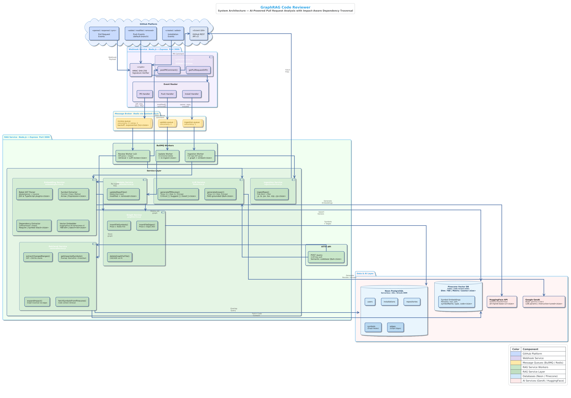
Figure 1 :- Architecture Diagram

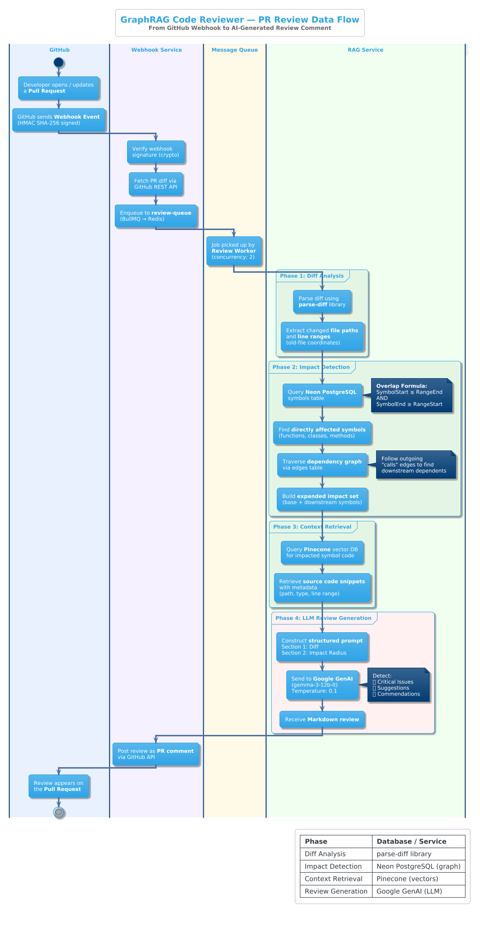
Figure 2:- Data Flow Diagram

External Services:
Service | Technology | Purpose
Relational Database | Neon PostgreSQL (Serverless) | Code dependency graph (symbols + edges), user/repo metadata
Vector Database | Pinecone (768-dim, cosine) | Semantic code embeddings with rich metadata
LLM Provider | Google GenAI (Gemma 3 12B IT) | PR review generation, codebase Q&A
Embedding Model | HuggingFace all-mpnet-base-v2 | 768-dimensional semantic code embeddings
Message Broker | Redis via Upstash (TLS) | BullMQ job queue backend

7.2 Module Descriptions
Module 1: Webhook Service
Listener of HTTP requests from a webhook of a GitHub repository via HTTPS. Verifies the webhook’s signature using a provided secret via HMAC SHA-256. Routes webhook events to BullMQ queues based on event type. Completely stateless – no real work is done in this class.
Module 2: Ingestion Worker
Authenticates as a GitHub App using the installation ID. Retrieves the full file tree for the repository using the GitHub Trees API. It then filters the files by type and only considers the JavaScript and TypeScript files (.js, .jsx, .ts, .tsx, .mjs, .cjs). It then downloads the file contents as blobs encoded as base64. It then invokes the embedding service for AST parsing and vectorization.
Module 3: Embedding Service (AST Pipeline)
Uses @babel/parser with JSX and TypeScript plugins to parse source code into an Abstract Syntax Tree (AST). Scans the AST for symbols such as FunctionDeclaration, ClassDeclaration, ClassMethod, ArrowFunctionExpression, and FunctionExpression. Scans the AST for dependencies such as CallExpression for function calls and ImportDeclaration/require for module imports. Uses a symbol stack to correctly manage nested scope. Generates 768 dimensional vector embeddings using the HuggingFace Inference API. Uploads the vector embeddings in batches of 50 to Pinecone.

Module 4: Graph Service
CRUD interface for the symbol-edge graph in PostgreSQL. Adding symbols and edges to the graph happens in two stages. Foreign key constraints allow for cascading deletes. ON CONFLICT DO NOTHING is used for safe insertion.
Module 5: Retrieval Service (Impact Analysis Engine)
This diff parser hook takes the diff output of git-diff --no-color --numstat and uses parse-diff library to parse the diff, and the parsed diff is then used to translate the diff chunks into line coordinates on the old file using the positions of h1 lines and symbols table and overlap formula. The patch set is then expanded into the affect set of edges in the graph which are defined as the "calls" edges. The affected source lines are fetched from Pinecone cache of the files corresponding to the path of the hook.
Module 6: LLM Service
Extracts the impact context into the relevant sections of the prompt. We use two different prompt templates, one for the Q&A mode and one for the PR Review mode. In the PR Review mode, the prompt will ask the LLM to: diff the changes introduced in the upstream code to the affected downstream code and to categorize them. Tune the output parameters of the LLM (such as temperature, topP and topK).
Module 7: Update Service
Reprocess data on push on default branch using delete and insert flow model. It targets re-ingested files and cleans up the uploaded files that were removed in the Git repo.8. Protocol Stack
The system’s communication is organized into the following layered protocol stack, described from the application layer down:
Layer | Name | Components
Layer 7 | Application Layer | GitHub Webhook Events (JSON/HTTPS); REST API Endpoints (POST /query, POST /api/webhook); GitHub REST API v3 (Octokit SDK); Google GenAI API; HuggingFace Inference API; Pinecone REST API
Layer 6 | Authentication & Authorization | GitHub App Auth (JWT + Installation Tokens); Webhook Signature Verification (HMAC SHA-256); API Key Auth (X-API-Key header); Pinecone API Key; Google GenAI API Key
Layer 5 | Message Queue Layer | BullMQ Job Queues (ingestion, update, review); JSON serialization; Exponential backoff (5s base, 3 attempts); Concurrency control (review x2, others x1); Job deduplication via unique IDs
Layer 4 | Data Access Layer | Drizzle ORM (type-safe SQL for PostgreSQL); Connection pooling via pg.Pool with SSL; Pinecone SDK (vector operations + metadata filtering); ioredis (TLS-encrypted)
Layer 3 | Data Storage Layer | PostgreSQL/Neon: users, installations, repositories, symbols, edges (B-tree indexes, unique constraints); Pinecone: 768-dim vectors, cosine similarity; Redis/Upstash: job queue persistence
Layer 2 | Transport Layer | HTTPS/TLS 1.2+ for all external APIs; TLS-encrypted Redis; SSL-required PostgreSQL; TCP via Node.js HTTP agent and pg.Pool
Layer 1 | Network / Infrastructure | Node.js runtime (Express HTTP servers); Microservice deployment (webhook + RAG services); Cloud-hosted databases (Neon, Pinecone, Upstash); GitHub Cloud (webhook delivery)

9. Testbed / Experimental Setup
9.1 Development Environment
Runtime: Node.js (v18+)
Language: JavaScript (ES Modules + CommonJS interop)
Package Manager: npm
IDE: Visual Studio Code
9.2 Cloud Services and Infrastructure
Service | Provider / Technology | Details
Database | Neon PostgreSQL (serverless) | Stores dependency graph, user data, installation metadata, repository records. ORM: Drizzle with drizzle-kit migrations.
Vector Database | Pinecone (managed, serverless) | Index: code-review-index; Dimensions: 768; Metric: Cosine. Stores semantic embeddings of code symbols.
Message Broker | Redis via Upstash (TLS) | Backs BullMQ job queues: ingestion-queue, update-queue, review-queue.
LLM Provider | Google GenAI | Model: gemma-3-12b-it (12B params, instruction-tuned, open-weights). Generates PR reviews and Q&A answers.
Embedding Model | HuggingFace Inference API | Model: sentence-transformers/all-mpnet-base-v2; Dimension: 768.
Version Control | GitHub | GitHub App (scoped permissions per installation). Events: pull_request, push, installation. Auth: JWT + installation tokens.

9.3 Software Libraries and Frameworks
Category | Library | Version | Purpose
HTTP Server | Express | 5.2.1 | REST API framework
GitHub Integration | @octokit/app | 13.1.8 | GitHub App SDK
GitHub API Client | octokit | 5.0.5 | REST API calls
AST Parser | @babel/parser | 7.29.0 | JS/TS AST generation
AST Traversal | @babel/traverse | 7.29.0 | Symbol extraction
LLM Client | @google/genai | 1.40.0 | Google GenAI SDK
LangChain Core | @langchain/core | 1.1.19 | RAG framework
LangChain Embeddings | @langchain/community | 1.1.11 | HuggingFace embeddings
Text Splitting | @langchain/textsplitters | 1.0.1 | Text chunking utilities
HuggingFace Client | @huggingface/inference | 4.13.11 | Embedding API client
Vector DB Client | @pinecone-database/pinecone | 6.1.0 | Pinecone SDK
ORM | drizzle-orm | 0.45.1 | Type-safe SQL ORM
Schema Migrations | drizzle-kit | 0.31.9 | DB migration tooling
PostgreSQL Driver | pg | 8.18.0 | Native PG client
Job Queue | bullmq | 5.69.3 | Redis-backed job queue
Redis Client | ioredis | 5.9.3 | Redis protocol client
Diff Parser | parse-diff | 0.11.1 | Git diff parsing
Env Configuration | dotenv | 16.6.1 | Environment variables

9.4 Database Schema Specification
Table | Role | Key Fields | Constraints / Indexes
users | User accounts (synced from Clerk) | clerkId, email, fullName, avatarUrl, githubId, tier, credits | Unique: clerkId, githubId
installations | GitHub App installations | userId (FK→users), githubInstallationId, accountLogin, accountType | Unique: githubInstallationId; CASCADE on user delete
repositories | Indexed repositories | installationId (FK→installations), githubRepoId, name, fullName, url, private, isIndexed | Unique: (installationId, githubRepoId); CASCADE
symbols | Graph Nodes (AST symbols) | repositoryId (FK→repositories), filePath, symbolName, symbolType, startLine, endLine | Unique: (repoId, filePath, symbolName, startLine); Index: idx_symbols_repo; CASCADE
edges | Graph Edges (dependencies) | repositoryId (FK→repositories), fromSymbolId (FK→symbols), toSymbolId (FK→symbols), edgeType | Unique: (repoId, from, to, type); Indexes: idx_edges_repo, idx_edges_from, idx_edges_to; CASCADE

9.5 Testing Infrastructure

•Mock Payloads (mockPayload.js): Simulates full repository structure (utils.js, service.js, controller.js) for ingestion testing.
•Mock Update Payloads (mockUpdatePayload.js): Simulates push events with modified and deleted files.Test Server (testServer.js): Provides standalone endpoints for isolated testing of ingestion, query, and impact analysis pipelines.
•Test Server (testServer.js): Offers standalone endpoints for isolated testing of ingestion, query, and impact analysis pipelines.
•SDK Smoke Tests (sdkTest.js): Tests Pinecone vector database connectivity.9.6 Queue Configuration Details
Queue | Concurrency | Retry Attempts | Backoff Strategy | Job Removal
review-queue | 2 (parallel PR processing) | 3 | Exponential (base: 5000ms) | Completed jobs auto-removed
ingestion-queue | 1 (sequential) | Default | Default | Completed jobs auto-removed
update-queue | 1 (sequential) | Default | Default | Completed jobs auto-removed

9.7 Security Measures

•Webhook Signature Verification: Using HMAC SHA-256 with a secret key ensures that only GitHub can trigger processing.
•API Key Authentication: The X-API-Key header is required for the /query endpoint to ensure that only authorized users can use the API.
•TLS Encryption: Using TLS for encryption of data in transit is enabled for database and cache connections.
•GitHub App Scoping: Scoping permissions by installation follows the principle of least privilege.
•Environment Variable Isolation: All secrets are stored within environment files (.env) instead of hard-coding.
•Cascading Deletes: Using foreign keys with cascade constraints prevents orphaned data from existing within the database.

