Week – 4
Annuj Kumar
23BCE1935

Activity Diagram – Bharat Pashudhan Project

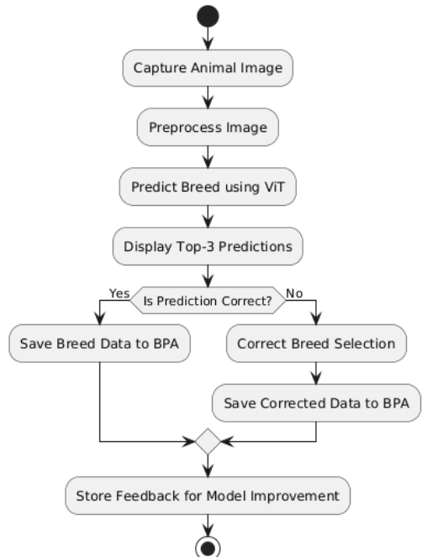

Sequence Diagram

